電通二乙微處理器實驗 實驗結報

實驗名稱 | 中斷控制與超音波測距
組別 | 20 | 組員 | 彭崇智

- 實驗目的
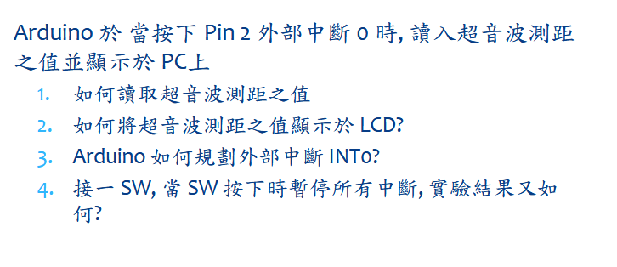
- 實驗步驟
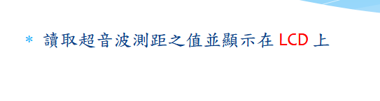
- 程式碼
#include <LiquidCrystal.h>
LiquidCrystal lcd(12, 11, 5, 4, 3, 2);
const int trig = 6;
const int echo = 7;
int inter_time = 1000;
int time = 0;

void setup() {
Serial.begin(9600);
lcd.begin(16, 2);
pinMode (trig, OUTPUT);
pinMode (echo, INPUT);
}

void loop() {
float duration, distance;
digitalWrite(trig, HIGH);
delayMicroseconds(1000);
digitalWrite(trig, LOW);
duration = pulseIn (echo, HIGH);
distance = (duration/50);
lcd.setCursor (0,0);
lcd.print("Data No.");
lcd.print (time);
time = time +1;
lcd.setCursor(0, 1);
lcd.print ("Distance:");
lcd.print(distance);
lcd.print ("cm");
delay(900);
lcd.clear();
delay(100);
}
- 實驗結果及分析
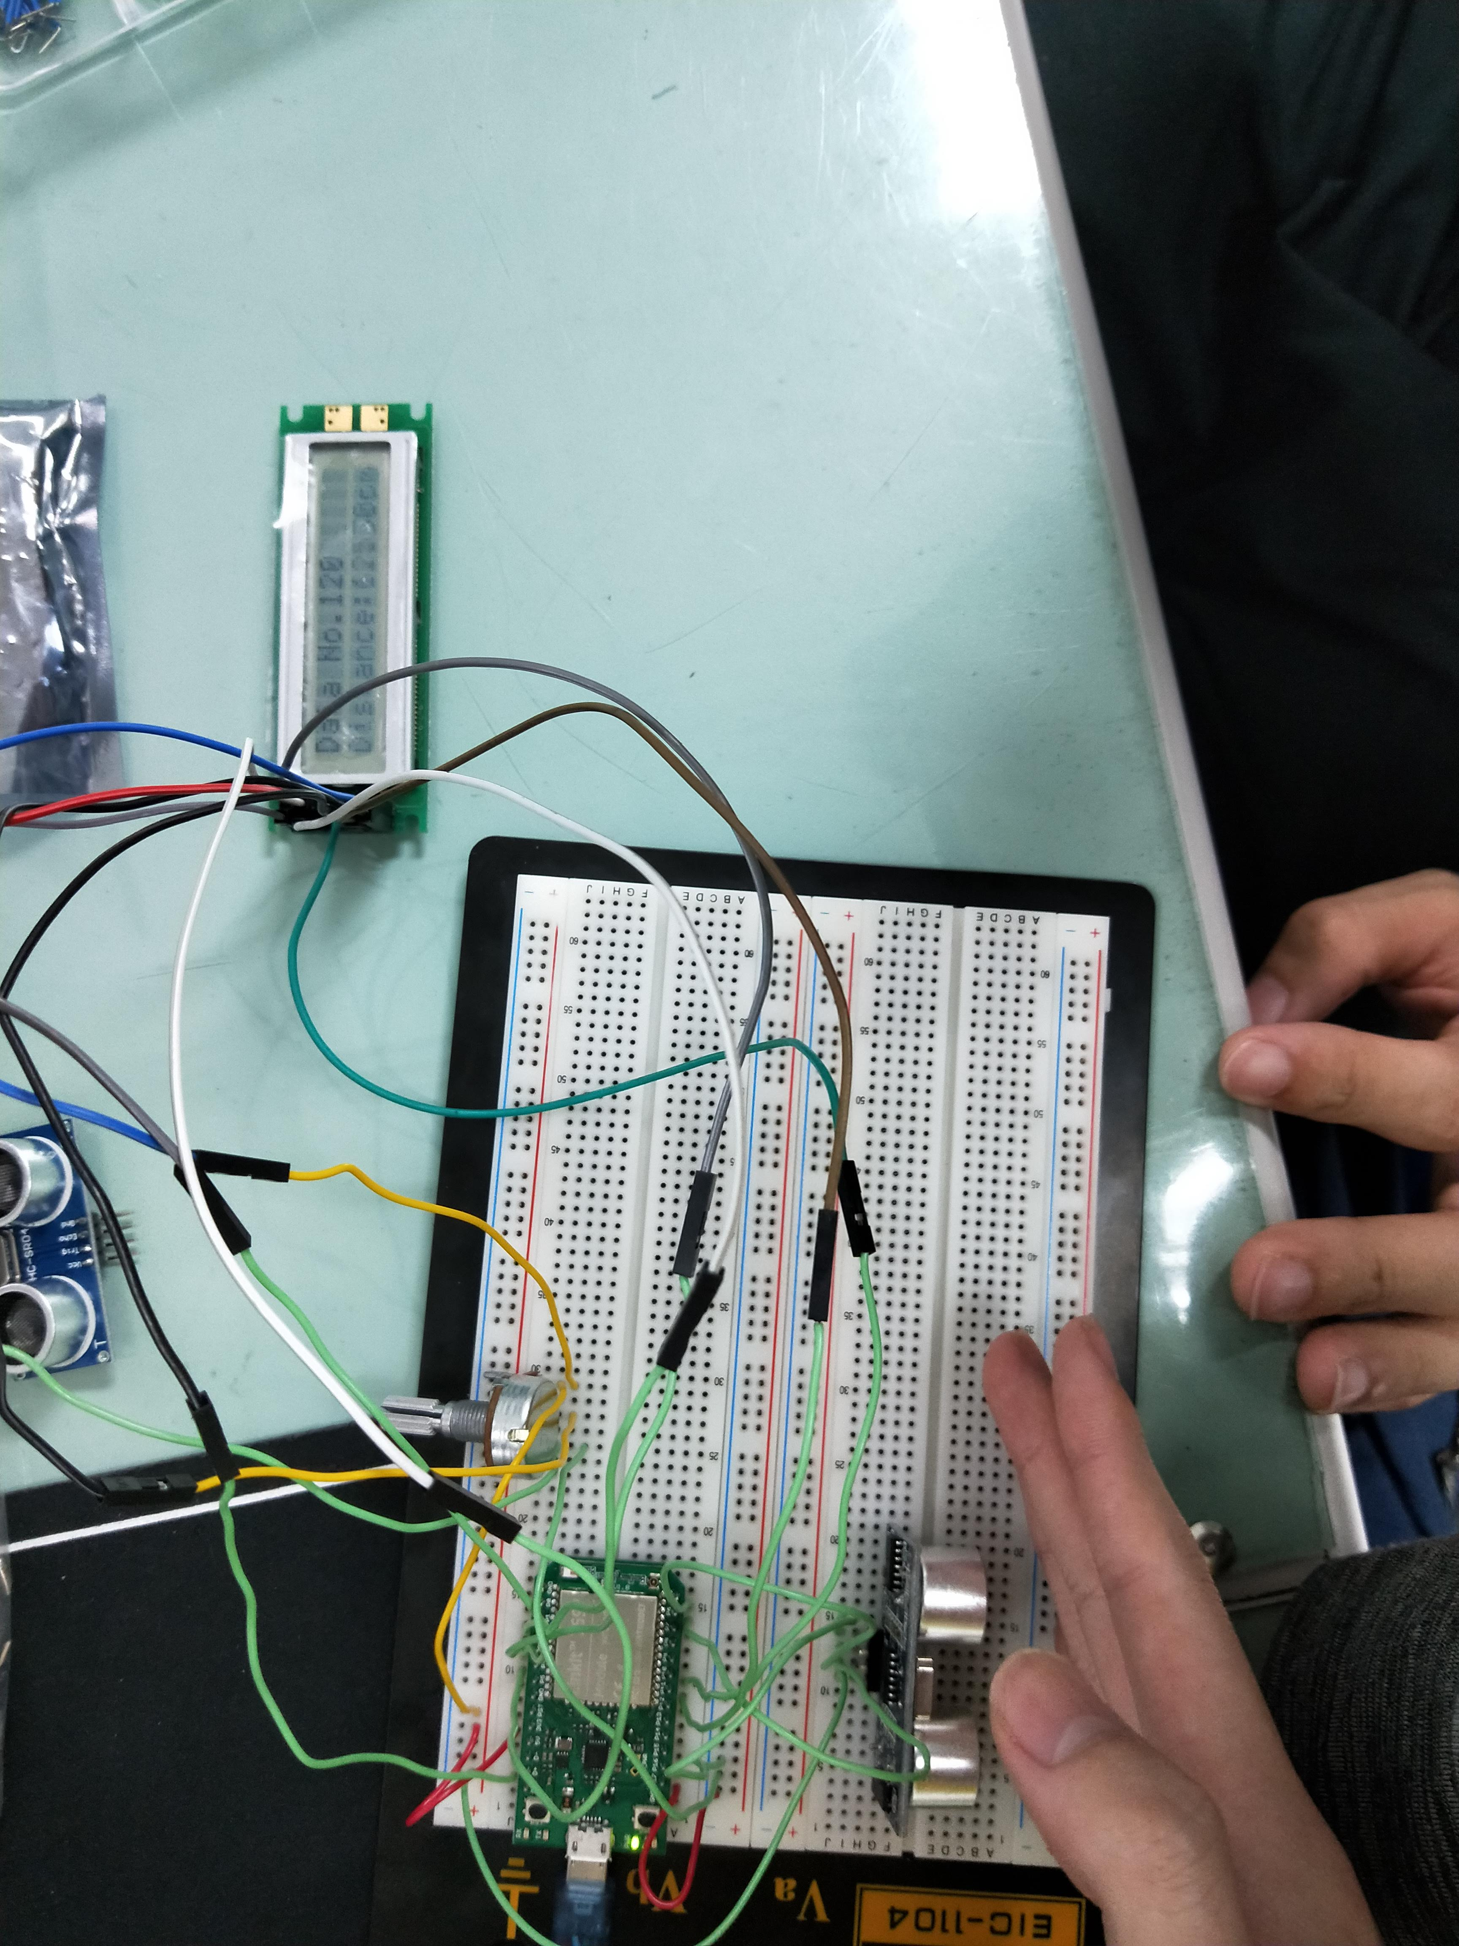
- 心得討論
線路接髮有些小技巧因為接錯可能就會燒毀器材
修正電路圖
- 修正程式碼

