電通二乙微處理器實驗 實驗結報

實驗名稱 | Bluetooth low energy
組別 | 20 | 組員 | 彭崇智

- 實驗目的
用手機藍芽連到7697
- 實驗步驟
下載範例程式 BeaconAdvertisement
修改 configAsIBeacon 中的 Major/Minor為自己學號後四碼
執行範例程式 EddystonURLadvertisement
將 URL 修改為自己的網址
由手機 App 搜尋 7697 Beacon
- 下載範例程式 SimplePeripheral
- 將 UUID 前八碼 ”19B10010” 改成自己的學號”
- 將所有 “BLE LED” 字串改成自己的名字;

- 程式碼
Serial.println("BLE begin");

LBLE.begin();

while (!LBLE.ready()) {

delay(100);

}

Serial.println("BLE ready");

// configure our advertisement data as iBeacon.

LBLEAdvertisementData beaconData;

// This is a common AirLocate example UUID.

LBLEUuid uuid("E2C56DB5-DFFB-48D2-B060-D0F5A71096E0");

beaconData.configAsIBeacon(uuid, 10, 26, -40);

Serial.print("Start advertising iBeacon with uuid=");

Serial.println(uuid);

// start advertising it

LBLEPeripheral.advertise(beaconData);

}

void loop() {

// The underlying framework will advertise periodically.

// we simply wait here.

//

// You can use iBeacon apps such as

// "Locate Beacon" by Radius Networks on iOS devices

// to locate this beacon.

delay(3000);

}

- 實驗結果及分析
- 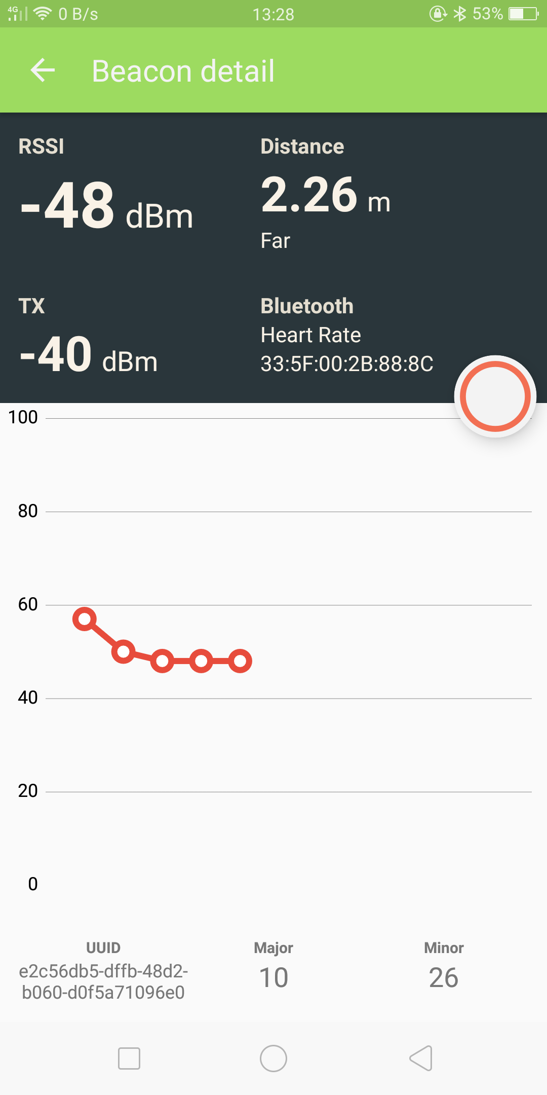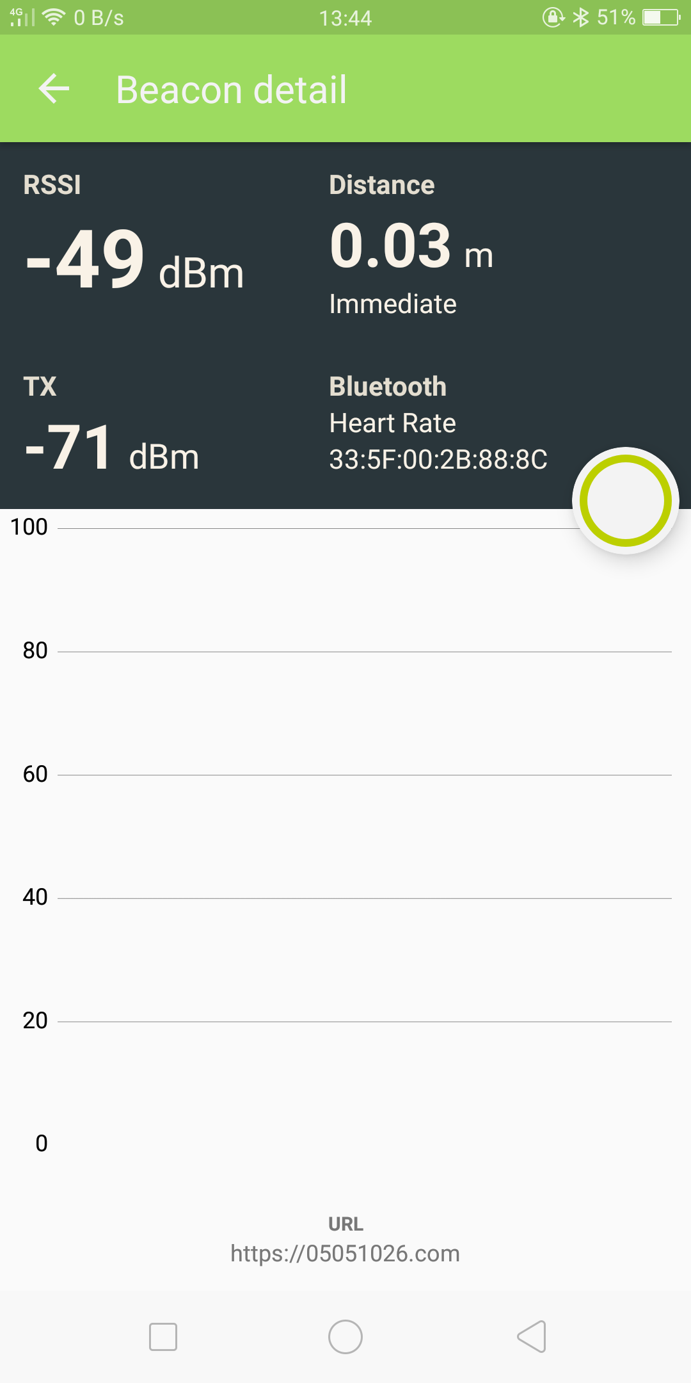
- 心得討論
這次實驗算比較簡單，只需要會用app程式

- 修正電路圖
- 修正程式碼

/*

This example configures LinkIt 7697 to send Eddyston-URL advertisement data.

You should be able to search this beacon with tools such as "Beacon Tools" on iOS or

"Physical Web" app on Android.

created April 2017

*/

#include <LBLE.h>

#include <LBLEPeriphral.h>

void setup() {

//Initialize serial and wait for port to open:

Serial.begin(115200);

// Initialize BLE subsystem

Serial.println("BLE begin");

LBLE.begin();

while (!LBLE.ready()) {

delay(100);

}

Serial.println("BLE ready");

// configure our advertisement data as iBeacon.

LBLEAdvertisementData beaconData;

// make an Eddystone-URL beacon that board casts

// https://labs.mediatek.com

// Note 1: You can obmit the suffix and tail part, e.g.

// https://goo.gl/Aq18zF

// can be constructed with

// configAsEddystoneURL(EDDY_HTTPS, "goo.gl/Aq18zF");

// Note 2: Note that total url length must not exceed 17 bytes.

//

// Please refer to https://github.com/google/eddystone/tree/master/eddystone-url#url-scheme-prefix

// to know how the prefix/suffix/tails are expanded.

beaconData.configAsEddystoneURL(EDDY_HTTPS, "05051026", EDDY_DOT_COM);

Serial.print("Start advertising Eddystone-URL");

// start advertising it

LBLEPeripheral.advertiseAsBeacon(beaconData);

}

void loop() {

// The underlying framework will advertise periodically.

// we simply wait here.

//

// You should be able to search this beacon with tools such as "Beacon Tools" on iOS or

// "Physical Web" app on Android.

delay(3000);

}
/*

This example configures LinkIt 7697 to act as a simple GATT server with 1 characteristic.

To use it, open AppInventor project:

*

Build & install it on Android id

created Mar 2017

*/

#include <LBLE.h>

#include <LBLEPeriphral.h>

// Define a simple GATT service with only 1 characteristic

LBLEService ledService("05051026-E8F2-537E-4F6C-D104768A1214");

LBLECharacteristicInt switchCharacteristic("19B10011-E8F2-537E-4F6C-D104768A1214", LBLE_READ | LBLE_WRITE);

void setup() {

// Initialize LED pin

pinMode(LED_BUILTIN, OUTPUT);

digitalWrite(LED_BUILTIN, LOW);

//Initialize serial and wait for port to open:

Serial.begin(9600);

// to check if USR button is pressed

pinMode(6, INPUT);

// Initialize BLE subsystem

LBLE.begin();

while (!LBLE.ready()) {

delay(100);

}

Serial.println("BLE ready");

Serial.print("Device Address = [");

Serial.print(LBLE.getDeviceAddress());

Serial.println("]");

// configure our advertisement data.

// In this case, we simply create an advertisement that represents an

// connectable device with a device name

LBLEAdvertisementData advertisement;

advertisement.configAsConnectableDevice("tony");

// Configure our device's Generic Access Profile's device name

// Ususally this is the same as the name in the advertisement data.

LBLEPeripheral.setName("tony");

// Add characteristics into ledService

ledService.addAttribute(switchCharacteristic);

// Add service to GATT server (peripheral)

LBLEPeripheral.addService(ledService);

// start the GATT server - it is now

// available to connect

LBLEPeripheral.begin();

// start advertisment

LBLEPeripheral.advertise(advertisement);

}

void loop() {

delay(1000);

Serial.print("conected=");

Serial.println(LBLEPeripheral.connected());

if (digitalRead(6))

{

Serial.println("disconnect all!");

LBLEPeripheral.disconnectAll();

}

if (switchCharacteristic.isWritten()) {

const char value = switchCharacteristic.getValue();

switch (value) {

case 1:

digitalWrite(LED_BUILTIN, HIGH);

break;

case 0:

digitalWrite(LED_BUILTIN, LOW);

break;

default:

Serial.println("Unknown value written");

break;

}

}

}

