電通二乙微處理器實驗 實驗結報

實驗名稱 | I2C通訊
組別 | 20 | 組員 | 彭崇智

- 實驗目的
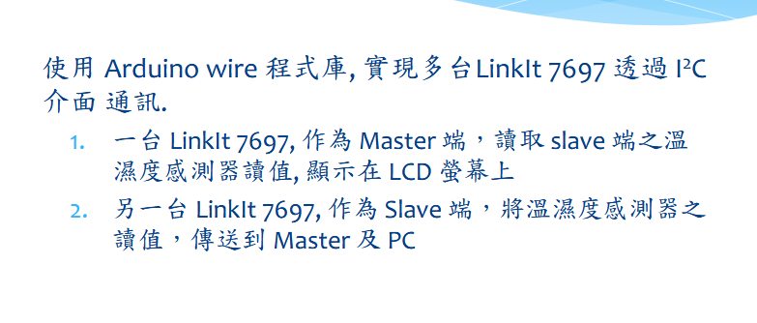
- 實驗步驟
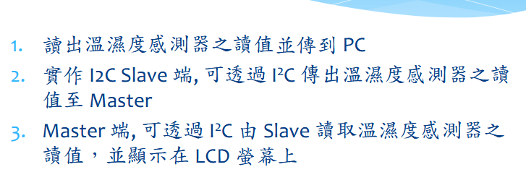
- 程式碼
#include <dht.h>

#define dht_dpin 2 //no ; here. Set equal to channel sensor is on

dht DHT;

void setup(){
Serial.begin(9600);
delay(300);//Let system settle
Serial.println("Humidity and temperature\n\n");
delay(700);//Wait rest of 1000ms recommended delay before
//accessing sensor
}//end "setup()"

void loop(){
//This is the "heart" of the program.
DHT.read11(dht_dpin);

Serial.print("Current humidity = ");
Serial.print(DHT.humidity);
Serial.print("% ");
Serial.print("temperature = ");
Serial.print(DHT.temperature);
Serial.println("C ");
delay(1000);//Åª¨ú¸ê®ÆªºÀW²v
}// end loop()
- 實驗結果及分析
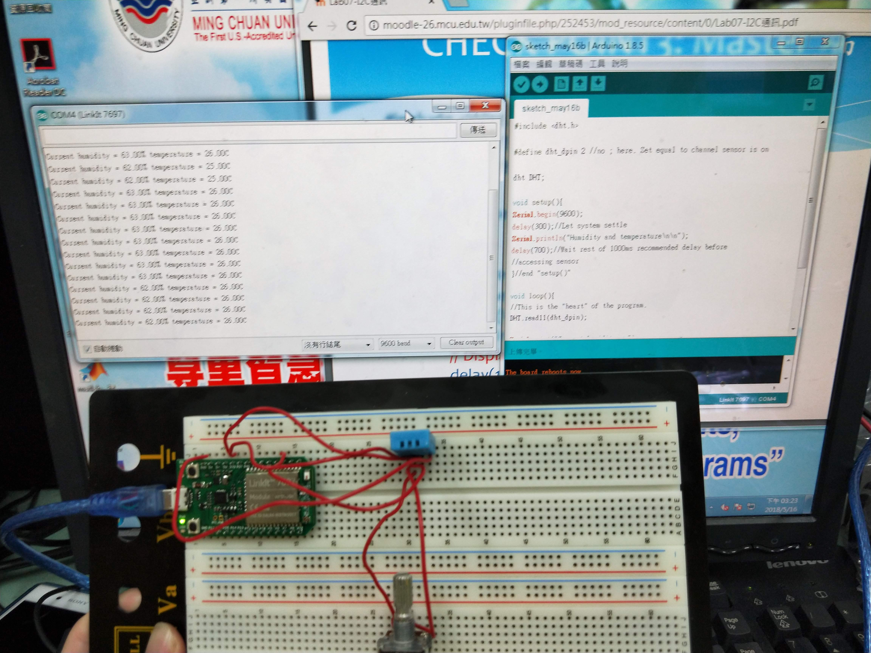
- 心得討論
摸不著程式的寫法因此只做出一個。
修正電路圖
- 修正程式碼

