# The USB

## Functions:

The USB is an electronic device witch a lot of functions.

* You can use to
  + Unlock some pages accounts with a special function call USB Key
  + You can also store information
  + An USB can transform into a Boot USB to install an operating system

## Characteristics:

* Must be a small device
* USB has a characteristic called Plug and Play that means you can connect an use at the moment
  + This technology start to use with the USB port because after that you need to reboot the computer to use de device.
* USB should be portable devices

## How to Set Up:

Use a USB device is very simple, the set up can change depends on the use you want; the most common use is storage information and boot operating system, both uses are very similar but has some different.

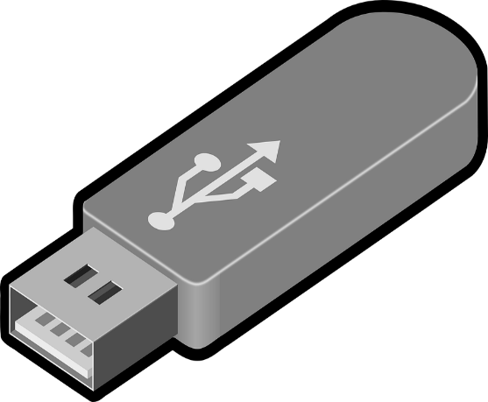First you need to take the package of the device and see de specifications and search the standard how use, could be 2.0 or 3.0, the best is 3.0 because is fastest than 2.0 generation, also you need to search the storage capacity, could be between 32 GB and 500 GB but if you search you can find any around 1 TB. Then you unpackage the USB and connect into de computer, search the new device and see if has any content on it, if it hasn´t any content its ready, you can storage any file until the USB is full. If you want to make a boot USB you need to make a empty device, a software like Ruffus and the ISO of the operating system you want, when you have all options you must follow the Ruffus instructions.