Watan++: Catan AI Project Plan

1. Strategy & Approaches

Approach 1: Machine Learning (ML)
- Concept: Train a model to predict everything.
- Pros: Cheap to run (inference).
- Cons: Expensive to train, requires massive dataset.

Approach 2: Artificial Intelligence (AI)
- Concept: Logic-based reasoning and search.
- Pros: Potentially best performance due to reasoning capabilities; cheaper to train.
- Cons: Expensive to predict (inference compute).

Approach 3: Analog / Heuristic
- Concept: Hard-coded rules and heuristics.
- Pros: Fast.
- Cons: Hardest to implement well; lacks flexibility; rigid.

Desired Strategy
Hybrid AI/ML: Mainly AI-driven (reasoning/search) with ML features for pattern recognition and probability maps. Multi-agent architecture is the preferred direction.

2. Player Modelling
To effectively play against humans, the AI must model opponent behavior:
- Noise: frequency of suboptimal choices.
- Lag: Accuracy of their perception relative to the current board state.
- Risk Tolerance: Willingness to hold cards (e.g., holding >7 cards) or take risks.
- Play Style: Preference for Road building vs. OWS (Ore-Wheat-Sheep) / Cities.
- Trade Behavior:
  - Intensity: Frequency of offers/accepting trades.
  - Balance/Urgency: Do they trade for immediate action vs. long-term value? Do they take bad trades to unblock themselves? Are they impatient?
- Tracking: How accurately do they track opponent hands, anticipate Road Building (RB) plays, or dodge Monopolies?
- Psychology/Meta: Ability to table-talk (“Aura”), dissuade robbers, etc.

3. Model Architecture

Settlement Logic Structure
(Note: Numbers are placeholders)
The settlement decision process is a pipeline of evaluators:
- Settle Options (Generator)
  - Use math and AI to generate a list of reasonable settlement spots.
- Simple Settle Predictor (Fast Simulation)
  - Input: Board state.
  - Process: Simulates how the board fills up after a chosen settlement.
  - Output: Settled locations and likelihoods.
  - Tech: Fast, non-AI algorithm.
- Simple Settle Evaluator (Heuristic)
  - Input: Board state (after first 8 settles).
  - Process: Estimates advantage based on resources, production, and vulnerability (robber).
  - Tech: Fast, non-AI heuristic.
- Settle Evaluator (Deep Analysis)
  - Input: Board state.
  - Process: Detailed analysis of win rates, conditions, races, and trading values across roll combinations.
  - Tech: Expensive, uses Math + AI.
Workflow: 1. Get reasonable options using Settle Options. 2. For each option, use Simple Settle Predictor to simulate end-of-phase board states (keep top 50 scenarios). 3. Run Settle Evaluator on the top 10 outcomes. 4. Run Simple Settle Evaluator on the remaining outcomes. 5. Normalize probabilities and calculate Expected Value (EV) win rate. 6. Select the option with the highest EV.

Knowledge Requirements
- Inference: How to conclude facts from a database of implications cheaply.
- Board Understanding: Converting board state (image or data) into semantically meaningful context.
- Opponent Prediction: We need a model to predict where others will settle.
  - Solution: A Probability Map generated by an ML model (similar concept to YOLO/CNN for pattern recognition on the board).

4. Data Structure & Design

Requirements
- Efficiency: Easy, cheap, and optimized for AI ingestion (token-efficient).
- Context: “Cheap explanation” or Semantic Compression—requires fewer tokens for the AI to understand the game state.
- Database Integration: Structured for easy storage and retrieval.
- Uncertainty Handling: Must capture probabilistic data (e.g., card/dev card uncertainties, “unplayed dev” tracking). Note: The structure stores probabilities; logic updates them.

Spec: High-Density Catan State (HDCS)
This structure is designed to strictly adhere to requirements (Card-level probability tracking, Dice history, Unplayed Dev tracking) while maintaining “Semantic Compression”.

1. Core Data Structure (JSON Payload)
- Dice History: Queue of last 8 sums.
- Global Tracking: dev_rem tracks global odds of drawing specific Dev cards.
- Card-Level Granularity: Tracks specific unknown cards in a player’s hand using tuples.
- Tuple Logic:
  - Resource: [P_Wood, P_Brick, P_Wool, P_Grain, P_Ore]
  - Dev Card: [Age, P_Knight, P_VP, P_Road, P_Year, P_Mono]
- Board Representation (Dual Graph):
  - Tiles: Primary unit, including Ocean. identified by ID (0-36).
  - Nodes (Settlements): Defined by the 3 adjacent tiles [T1, T2, T3].

Board Definition Example
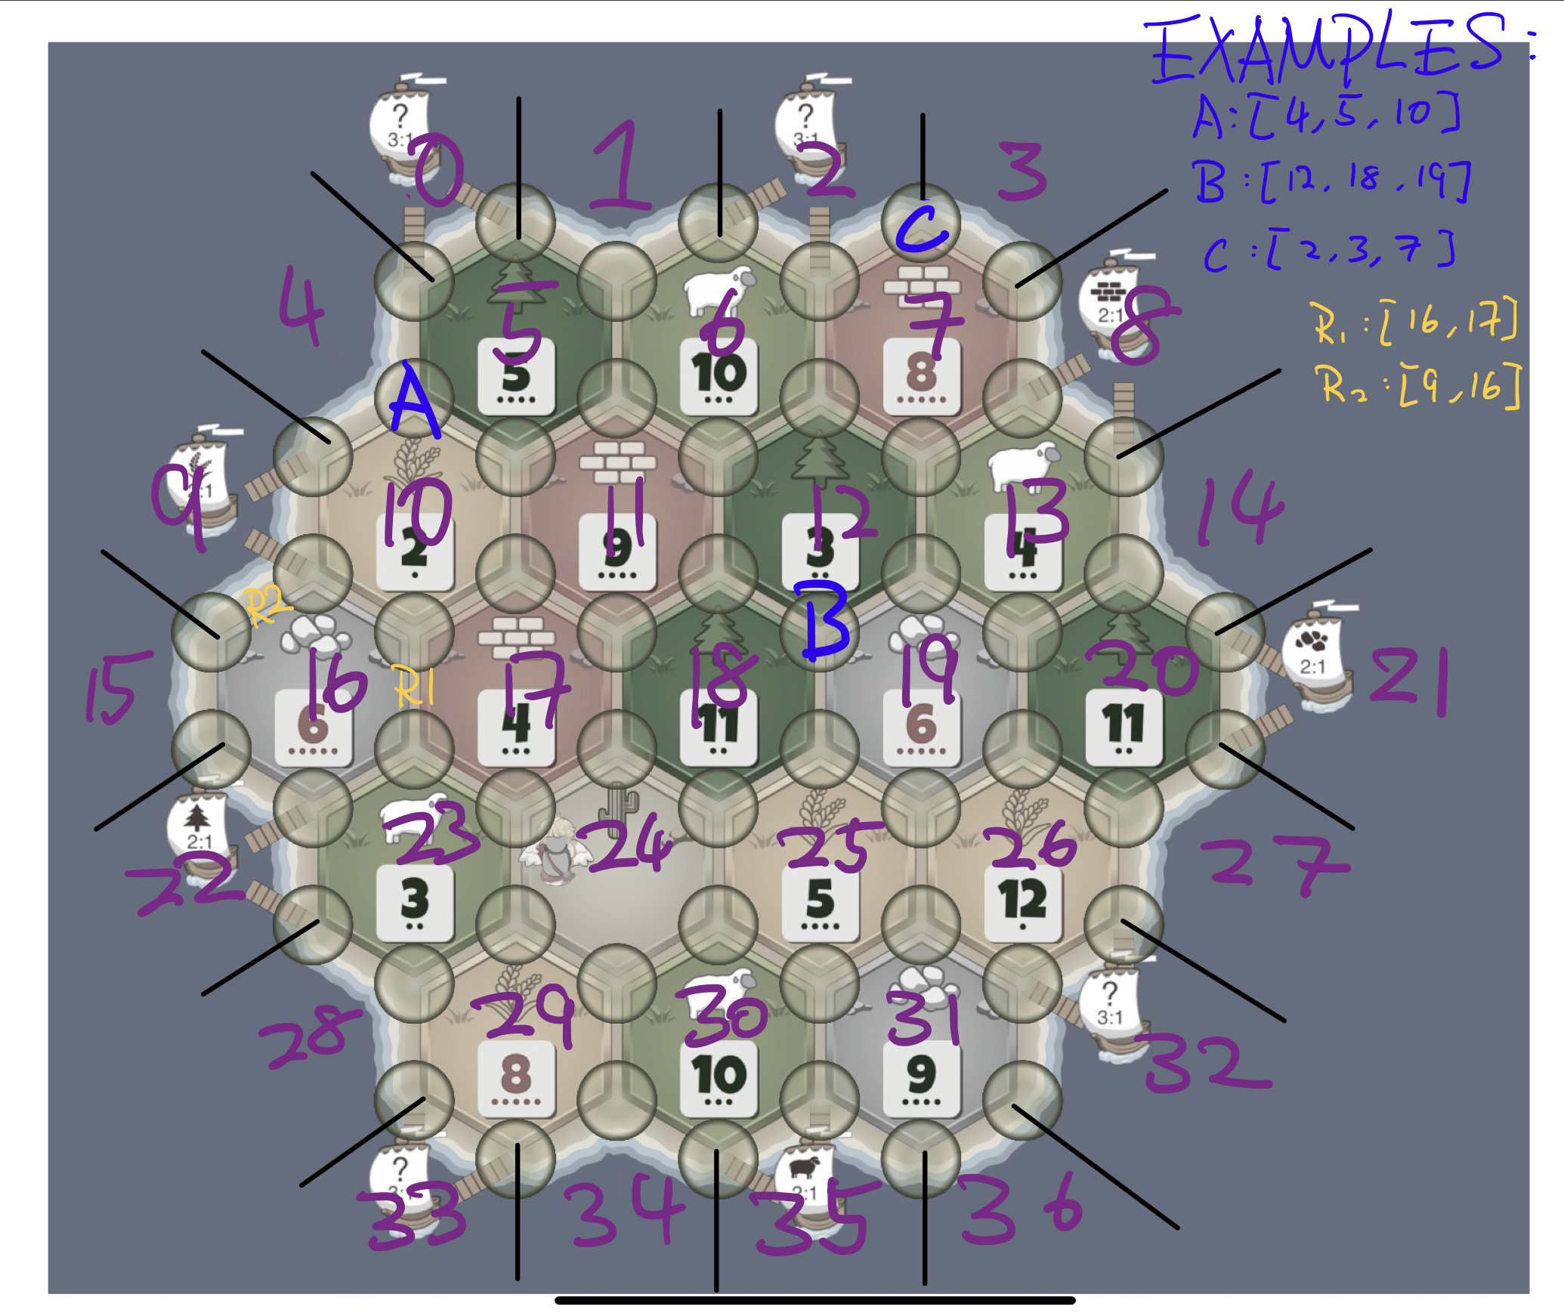
alt text
{
// Note: VP=Victory Point, RB=Road Building, YOP=Year of Plenty, MONO=Monopoly
// Assume: I am player 0
"meta": {
"t": 45, // Current Turn
"p_curr": 1, // Active Player ID
"phase": "main", // main=in-game, settle=pre-game settlement
// HISTORY: Last 8 rolls (Newest -> Oldest)
"dice": [7, 4, 6, 8, 11, 3, 5, 9],
// GLOBAL TRACKER: Cards NOT YET PLAYED (Deck + All Hands)
// [Knight, VP, RB, YOP, MONO]
"dev_rem": [5, 2, 1, 0, 0]
},
"map": {
"robber": 18, // Tile ID of the robber
// STATIC BOARD DATA (Layout)
// Tiles: List of [ResourceID, NumberToken] indexed by TileID (0-36).
// Each entry is a pair because a tile has both a Resource Type AND a Dice Number.
// Examples: [6, 0] = Ocean (No number), [4, 6] = Ore with an 6.
// ResourceIDs: 0=Wood, 1=Brick, 2=Wool, 3=Grain, 4=Ore, 5=Desert, 6=Ocean
// IDs 0-36 follow the specific layout (Ocean outer ring -> Center)
"tiles": [
[6, 0], [6, 0], ... [4, 6], ... // 0=Ocean, 18=Middle Tile
],
// Ports: Map of NodeTuple -> PortType
// Key: "T1_T2_T3" (Sorted Tile IDs of the settlement spot)
// PortType: 0-4 (2:1 Specific Resource), 5 (3:1 Any)
// Port Locations (Pairs of Access Spots):
// [{0_1_5, 0_4_5}, {1_2_6, 2_6_7}, {7_8_13, 8_13_14}, {14_20_21, 20_21_27},
// {26_27_32, 26_31_32}, {30_31_35, 30_34_35}, {28_29_33, 29_33_34},
// {16_22_23, 22_23_28}, {4_9_10, 9_10_16}]
"ports": {
// 3:1 Ports (Type 5)
"0_1_5": 5, "0_4_5": 5,
"14_20_21": 5, "20_21_27": 5,
"28_29_33": 5, "29_33_34": 5,
"4_9_10": 5, "9_10_16": 5,
// 2:1 Ports (Types 0=Wood, 1=Brick, 2=Wool, 3=Grain, 4=Ore)
"1_2_6": 2, "2_6_7": 2, // Wool
"7_8_13": 4, "8_13_14": 4, // Ore
"26_27_32": 3, "26_31_32": 3, // Grain
"30_31_35": 1, "30_34_35": 1, // Brick
"16_22_23": 0, "22_23_28": 0 // Wood
},
// DYNAMIC STATE
// Nodes: "T1_T2_T3" (Sorted) -> [PlayerID, BuildingType]
// BuildingType: 1=Settlement, 2=City
"nodes": { "4_5_10": [0, 1], "10_11_17": [1, 2] },
// Edges: "T1_T2" (Sorted) -> PlayerID
"edges": { "4_5": 0, "5_10": 0 }
},
"players": [
// PLAYER 0 (ME - Perfect Information)
{
"id": 0,
"public": [5, 0, 6, 4], // [VP, Army, Road_Len, Res_Count]
// KNOWN RESOURCES (Integer Counts)
// [Wood, Brick, Wool, Grain, Ore]
"res_k": [2, 0, 1, 3, 0],
// UNKNOWN RESOURCES (Empty for me)
"res_u": [],
// DEV CARDS (My Hand)
// [Age, Knight, VP, Road, Year, Mono]
"devs": [
[3, 1.0, 0, 0, 0, 0], // A Knight bought 3 turns ago
[0, 0, 1.0, 0, 0, 0] // A VP just bought (Age 0)
]
},
// PLAYER 1 (OPPONENT - Probabilistic)
{
"id": 1,
"public": [4, 1, 4, 3],
// KNOWN RESOURCES (Facts)
"res_k": [0, 0, 1, 0, 0],
// UNKNOWN RESOURCES (Card-Level Probability)
// They have 2 unknown cards. Each is a 5-tuple probability.
// [P_Wood, P_Brick, P_Wool, P_Grain, P_Ore]
"res_u": [
// Card A: Likely Ore
[0.1, 0.0, 0.1, 0.1, 0.7],
// Card B: Random distribution
[0.2, 0.2, 0.2, 0.2, 0.2]
],
// DEV CARDS (Hidden Hand)
// [Age, P_Knight, P_VP, P_Road, P_Year, P_Mono]
"devs": [
// Held for 12 turns. Likely VP or Monopoly
[12, 0.1, 0.6, 0.0, 0.0, 0.3]
]
}
]
}

2. Context Injection (System Prompt)
Inject this schema definition into the System Prompt so the AI understands compliance:
“You are a Catan Engine. Interpret the Game State JSON as follows: 1. Arrays are positional. Do not hallucinate keys. * res index: 0:Wood, 1:Brick, 2:Wool, 3:Grain, 4:Ore * dev index: 0:Knight, 1:VP, 2:Road, 3:Year, 4:Mono 2. Dice: List of last 8 sums (Index 0 is most recent). 3. Player res_u (Unknown Resources): A list of tuples. Each tuple represents ONE specific card in the player’s hand and the probability of it being each resource type. 4. Player devs: A list of tuples. Each tuple is ONE card: [Age_in_Turns, Prob_Knight, Prob_VP, Prob_Road, Prob_Year, Prob_Mono]. 5. Map Data (Dual Graph): * Tiles: List of [ResourceID, Number]. IDs 0-36. * Resource 6 = Ocean. * Nodes (Settlements): Keys are T1_T2_T3 (Sorted Tile IDs). * Edges (Roads): Keys are T1_T2 (Sorted Tile IDs). * Ports: Keys are Node IDs (T1_T2_T3) where the port exists. PortType 0-4 = 2:1, 5 = 3:1.”

2a. Board Topology & Coordinate System
The board uses a Vertex-Face Dual Graph rather than Axial/Cube coordinates. * Tiles (Faces): 37 Hexes (IDs 0-36). * Structure: Includes the 19 Resource Tiles AND the surrounding ring of 18 Ocean Tiles. * Row-Major Indexing: * Row 0: 0-3 (Ocean) * Row 1: 4 (Ocean), 5-7 (Res), 8 (Ocean) * … * Row 6: 33-36 (Ocean) * Nodes (Intersections): Defined strictly by the Ordered Tuple of 3 Adjacent Tile IDs. * Example: Settlement at [4, 5, 10]. * Validity: Any set of 3 mutually adjacent tiles is a valid node (excluding 3-Ocean sets). * Edges (Roads): Defined strictly by the Ordered Tuple of 2 Adjacent Tile IDs. * Example: Road between [4, 5]. * Validity: Any pair of adjacent tiles is a road, UNLESS both tiles are Ocean (Bridge).

3. Python Implementation (Pydantic Models)
Validates “Mixed Type” logic (Known vs. Unknown) for DB and AI.
from pydantic import BaseModel, Field, field_validator
from typing import List, Dict, Union, Optional
# --- TYPE DEFINITIONS ---
# Tuple: [P_Wood, P_Brick, P_Wool, P_Grain, P_Ore]
# Represents probability of an unknown card being a specific resource.
# Example: [0.1, 0.0, 0.1, 0.1, 0.7] (Likely Ore)
ResProbTuple = List[float]
# Tuple: [Age, P_Knight, P_VP, P_Road, P_Year, P_Mono]
# Age in turns held. Probabilities sum to 1.0 (unless Age=0, then 0.0 until next turn).
# Example: [3, 1.0, 0.0, 0.0, 0.0, 0.0] (Known Knight bought 3 turns ago)
# Example: [12, 0.1, 0.6, 0.0, 0.0, 0.3] (Old hidden card, likely VP)
DevCardTuple = List[Union[int, float]]
# --- SUB-MODELS ---
class PlayerState(BaseModel):
id: int
# [VP, Army, Road_Len, Res_Count]
# Example: [5, 0, 6, 4]
public: List[int]
# Known Resources (Integer counts)
# Index: 0=Wood, 1=Brick, 2=Wool, 3=Grain, 4=Ore
# Example: [2, 0, 1, 3, 0] (2 Wood, 1 Wool, 3 Grain)
res_k: List[int]
# Unknown Resources (List of probability tuples)
# One tuple per unknown card in hand.
# Example: See ResProbTuple
res_u: List[ResProbTuple]
# Dev Cards Hand (List of card tuples)
# Example: See DevCardTuple
devs: List[DevCardTuple]
class MapState(BaseModel):
robber: int # Tile ID (0-36)
# Static Data
# List of [ResourceID, NumberToken] indexed by TileID (0-36)
# ResourceIDs: 0=Wood, 1=Brick, 2=Wool, 3=Grain, 4=Ore, 5=Desert, 6=Ocean
# Example Entry: [6, 0] (Ocean), [4, 6] (Ore, 6-pip)
tiles: List[List[int]]
# Key: "T1_T2_T3" (Sorted Tile IDs) -> PortType
# PortType: 0-4 (2:1 Specific Resource [W,B,L,G,O]), 5 (3:1 Any)
# Example: "0_1_5": 5 (3:1 Port at intersection of tiles 0, 1, 5)
ports: Dict[str, int]
# Dynamic State
# Key: "T1_T2_T3" (Sorted) -> [PlayerID, BuildingType]
# BuildingType: 1=Settlement, 2=City
# Example: "4_5_10": [0, 1] (Player 0 built Settlement at 4-5-10)
nodes: Dict[str, List[int]] = Field(default_factory=dict)
# Key: "T1_T2" (Sorted) -> PlayerID
# Example: "4_5": 0 (Player 0 built Road between tiles 4 and 5)
edges: Dict[str, int] = Field(default_factory=dict)
class MetaState(BaseModel):
t: int # Current Turn (e.g., 45)
p_curr: int # Active Player ID (e.g., 1)
phase: str # "main", "settle"
# Last 8 dice sums (Newest -> Oldest)
# Example: [7, 4, 6, 8, 11, 3, 5, 9]
dice: List[int]
# Cards NOT YET PLAYED (Deck + All Hands)
# [Knight, VP, RB, YOP, MONO]
# Example: [5, 2, 1, 0, 0]
dev_rem: List[int]
# --- ROOT MODEL ---
class GameState(BaseModel):
meta: MetaState
map: MapState
players: List[PlayerState]
def to_ai_payload(self):
# Optimization: Round floats to 2 decimals to save Tokens
json_str = self.model_dump_json()
return json_str

4. Storage Strategy (SQLite)
Use Relational Table for metadata (fast lookup) and JSONB for state.
CREATE TABLE game_snapshots (
-- Composite Primary Key
game_id TEXT,
turn_id INTEGER,
-- Fast Access Metadata
active_player INTEGER,
dice_roll INTEGER,
-- The Full State (Compressed JSON)
state_payload JSONB,
-- Analytics Hooks
p1_win_prob REAL,
PRIMARY KEY (game_id, turn_id)
);

5. Token Efficiency Analysis
- Decoupled Knowledge (res_k vs res_u): Only send heavy probability tuples for cards that are truly unknown. As cards are played, res_u shrinks.
- Float Truncation: Rounding to 2 decimals (e.g., 0.33) saves chars. High precision is not needed for AI inference.
- Positional Arrays: Eliminating keys saves ~20 tokens per card.

5. Data Acquisition: Colonist.io Packet Sniffing
To build a live recorder for Colonist.io, we use a JavaScript Injector to intercept WebSocket traffic and convert it to HDCS.

Architecture
- Interceptor: Monkey-patch WebSocket to read messages.
- State Machine: JS object tracking the board state from Deltas.
- Exporter: Sends clean JSON to local AI Agent (e.g., localhost:5000).

Step 1: The Sniffer Script
(Run in Console or Tampermonkey)
(function() {
// 1. WebSocket Hook: Intercepts network traffic
const OriginalWebSocket = window.WebSocket;
window.WebSocket = function(url, protocols) {
const ws = new OriginalWebSocket(url, protocols);
ws.addEventListener('message', (event) => {
try {
const data = JSON.parse(event.data);
processPacket(data);
} catch (e) { /* Ignore non-JSON */ }
});
return ws;
};
// 2. The State Machine
let hdcs_state = {
meta: { turn: 0, phase: "init" },
board: [],
players: {},
map_state: { nodes: {}, edges: {} }
};
// 3. Packet Processor
function processPacket(packet) {
if (packet.id === 'GAME_SETUP' || packet.type === 'init') {
initializeBoard(packet.payload);
}
if (packet.id === 'UPDATE') {
updateState(packet.payload);
}
}
function initializeBoard(raw_data) {
// Map TileTypes and Ports to HDCS format
// Capture static board layout: Tiles (Res + Number) and Port Locations
console.log("Initializing HDCS Board...");
}
function updateState(delta) {
if (delta.action === 'BUILD_ROAD') {
// Convert Hex coords to Tile Pair "T1_T2"
}
sendToAI(hdcs_state);
}
// 4. Exporter
function sendToAI(state) {
fetch('http://localhost:5000/update_state', {
method: 'POST',
headers: {'Content-Type': 'application/json'},
body: JSON.stringify(state)
}).catch(err => console.error("AI Agent offline"));
}
console.log("Colonist Sniffer Active...");
})();

Step 2: Translation Layer (The “Rosetta Stone”)
- Resource Mapping: Colonist [1..5] -> HDCS [0..4] (Enum - 1).
- Coordinate Conversion: Map Cube (q,r,s) coords to Tile ID (0-36).
  - Derive Components: Calculate adjacent Tile IDs to form Node keys (T_a_b_c) and Edge keys (T_a_b).

Step 3: Handling Hidden Information
Since we sniff Client traffic, we are bound by Fog of War. * Strategy: The Javascript recorder records Events (e.g., “Player 2 stole from Player 1”). * Backend Logic: The Python AI maintains the res_u Probability Distributions using Bayesian updates (e.g., “Player 2 stole -> Remove 1 random from P1 res_k, Add 1 weighted tuple to P2 res_u”).

Step 4: Deployment
- Python Server: Flask app receiving JSON.
- Browser: Tampermonkey script on Colonist.io.

