

**The Experiment Report of**

***Machine Learning***

**College Software College**

**Subject Software Engineering**

**Members**   **洪海滨**

**Student ID 201530611586**

**E-mail Ocean233@live.com**

**Tutor**   **谭明奎**

**Date submitted** **2017.12.6**

1. **Topic:**

Linear Regression, Linear Classification and Gradient Descent

1. **Time:**

2017.12.2

1. **Reporter:**

洪海滨

**4. Purposes:**

Further understand of linear regression and gradient descent.

Conduct some experiments under small scale dataset.

Realize the process of optimization and adjusting parameters.

1. **Data sets and data analysis:**

Linear Regression uses Housing in LIBSVM Data, including 506 samples and each sample has 13 features.

Linear classification uses australian in LIBSVM Data, including 690 samples and each sample has 14 features.

1. **Experimental steps:**

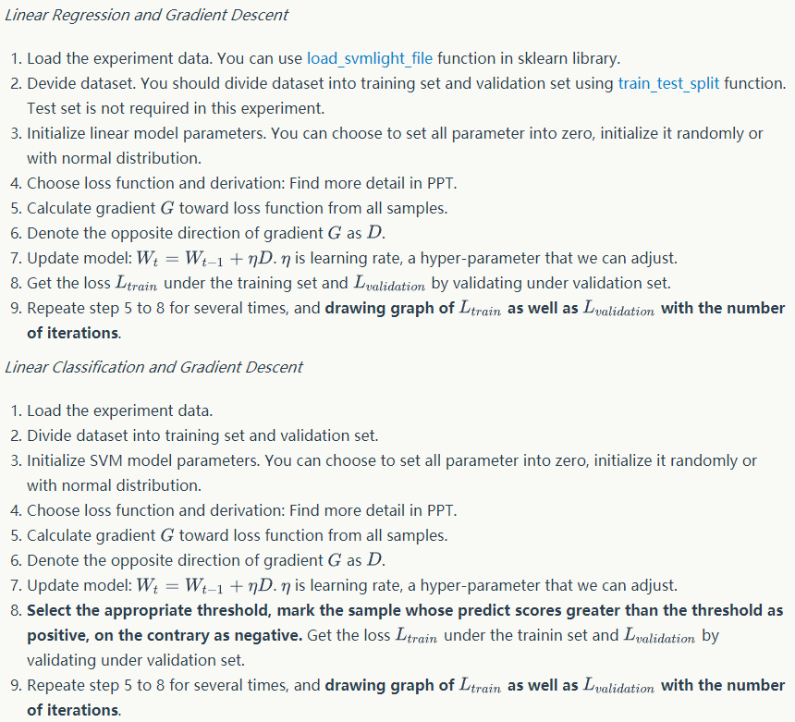

1. **Code:**

Linear Regression:

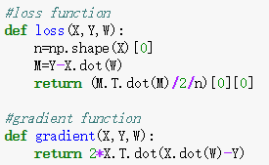

Linear Classification:

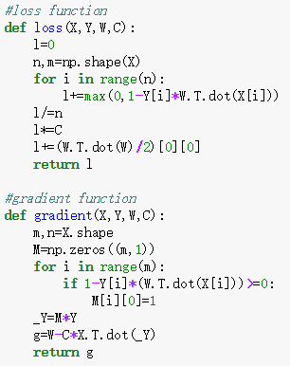

1. **Selection of validation (hold-out, cross-validation, k-folds cross-validation, etc.):**

hold-out

1. **The initialization method of model parameters:**

Linear Regression：Initialize parameters with zero

Linear Classification：Initialize parameters with zero

1. **The selected loss function and its derivatives:**

Linear Regression：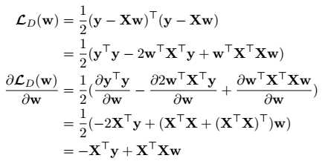

Linear Classification：

loss function:

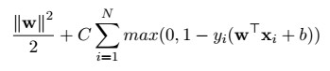

derivatives:



**11. Experimental results and curve:**

## Hyper-parameter selection (η, epoch, etc.):

Linear Regression：epoch=1500,lr(learning reate)=1e-4

Linear Classification：epoch=1500,lr=1e-6,C=10

## Assessment Results (based on selected validation):

Linear Regression：

lr=1e-6

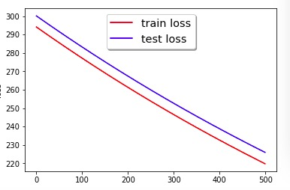

lr=1e-3

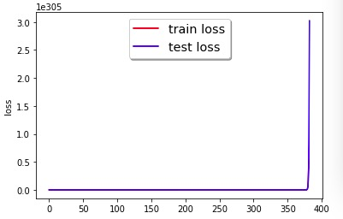

lr=1e-4

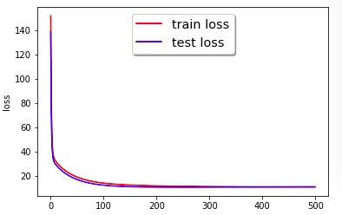

Linear Classification：

lr=1e-6,C=1

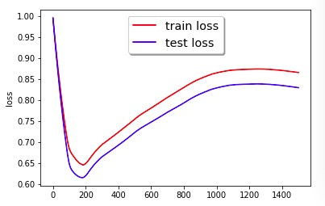

lr=1e-6,C=10

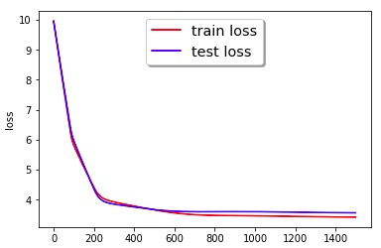

lr=1e8,C=10

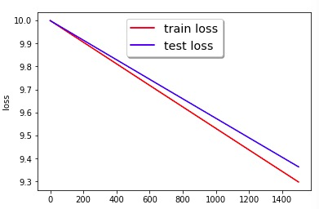

## Predicted Results (Best Results):

Linear Regression：min_loss≈10

Linear Classification：min_loss≈3.5

## Loss curve:

Linear Regression：



Linear Classification：



**12. Results analysis:**

Linear regression:At the first 100 iterations, train loss and test loss decrease rapidly from 140 to 20, and then both converge to about 10.

Linear classification:At the first 200 iterations, train loss and test loss decrease rapidly from 10 to 4, and then both converge to about 3.5.

**13. Similarities and differences between linear regression and linear classification:**

Similarities:They have the same model(linear model)

Differences:Linear regression is used for predicting, linear classification is used for classification. Their also different from loss function and gradient function.

**14. Summary:**

Linear model could be used in different ways including regression and classification.

In gradient decent, if the learning rate is very large we will skip the optimal solution. If it is too small we will need too many iterations to converge to the best values. So using a good learning rate is crucial.