

**SOFTWARE ENGINEERING II**

**EMPIRICAL TESTING WORKSHOP**

**Date:** 11/06/2020

**Team:** W5

**Members:**

Daniel Garcia Baño

David Neira Martrus

Jorge Pinargote Figueroa

Milton Garcia Cox

**2020 1S – P01**

**Contents**

**1.** **Algorithm** 3

**2.** **Test cases** 4

**3.** **Assumptions** 5

**4.** **Implementation** 5

# **Algorithm**

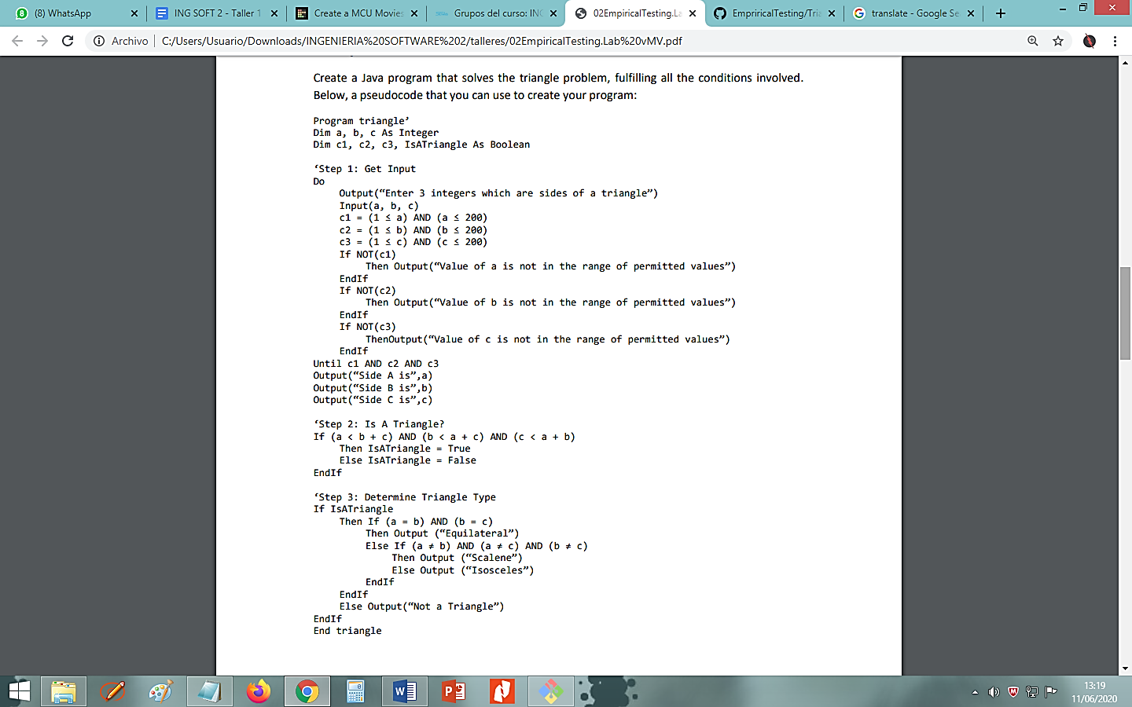

# **Test cases**

|  |  |  |
| --- | --- | --- |
| **TEST ID** | **INPUT VALUES (a,b,c)** | **EXPECTED OUTPUT** |
| 1 | 18, 18, 9 | “Isoceles” |
| 2 | 24, 24, 24 | “Equilateral” |
| 3 | 54, 58, 62 | “Escalene” |
| 4 | 0, 0, 0 | “Value not in the range” |
| 5 | 15.4, 5 , 1.6 | “Invalid input” |
| 6 | “W”, 4, “Q” | “Invalid input” |
| 7 | -7, 14, 25 | “Value not in the range” |
| 8 | “”, “”, “” | “Invalid input” |
| 9 | “G”, “G”, “G” | “Invalid input” |

# **Assumptions**

* The input of this program only supports integer values between 1 and 200.
* Non-numeric characters are not allowed, therefore they are invalid.
* Float and Double values are not allowed, therefore they are invalid.
* Empty values are not allowed, therefore they are invalid.
* This program only can determine 3 types of triangles: Isoceles, Equilateral, Escalene.

# **Implementation**

You can find our implementation of the algorythm and the testings with Java in this repository:

* <https://github.com/demonpo/EmpriricalTesting>