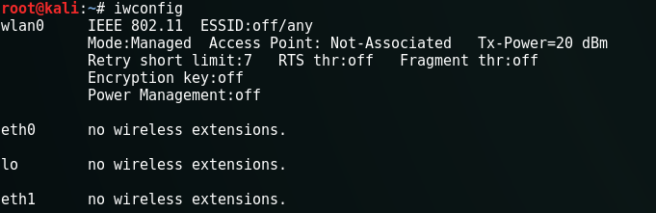

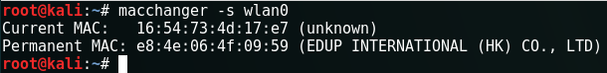

start monitor mode, The wlan0 will be changed to wlan0mon

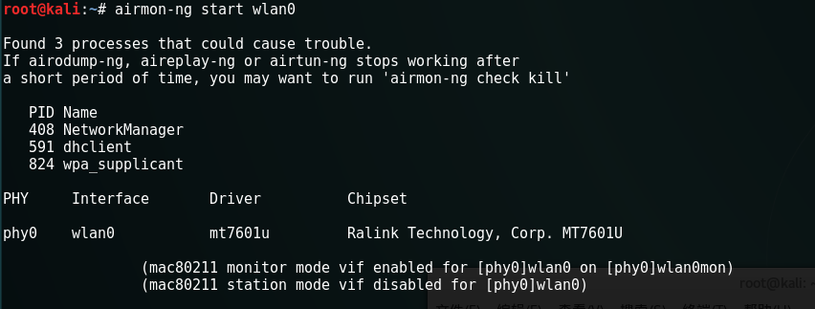

airodump wlan0mon

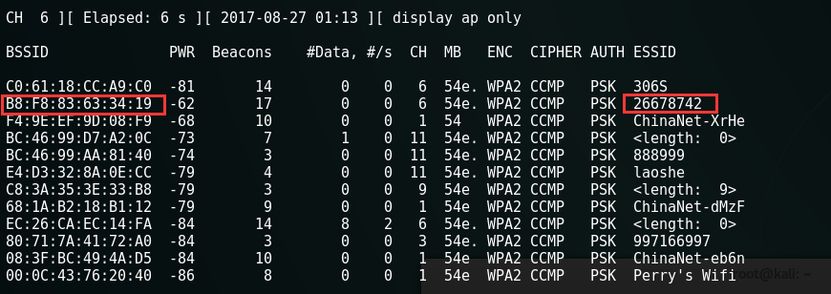

airodump-ng wlan0mon --bssid B8:F8:83:63:34:19 -c 6 --ivs -w hello

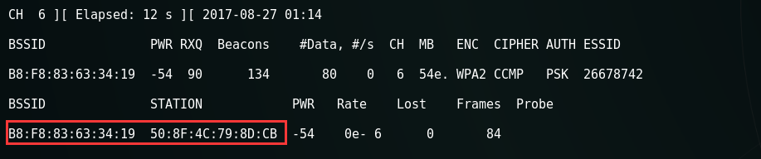

beigin attack the client !!! To accelerate get the hanshark package

