GPS and/or GDI? Part 1 – Measuring difference
A check on Scopus shows that our original article on the GPS (Baker et al., 2009) has now been cited 33 times and Mike’s paper on the GDI 53 times (Schwartz & Rozumalski, 2008). 20 of these cite both papers – although I haven’t had the time to look to see whether both indices were used. So should we use one or the other or both?
There are basically two differences – doing the maths and scaling the result. I’ll break this blog into two parts in the hope that this makes things clearer.
Computing the GDI is based on an analysis of a very large dataset including examples of all the different gait patterns you are likely to come across. From this a number of gait features are identified. The first feature represents the average gait trace amongst the whole population (not just people without pathology). All the other features represent different deviations from that average. You can represent any individual’s gait pattern as a combination of the different features. Mike showed that just using the 15 most common features allowed you to get very close to any given measured gait pattern. This actually means that any individual’s entire kinematic gait pattern can be represented by just 15 numbers which is kind of cool and could save a huge amount of computer storage. Having gone through this process you can take the root mean square (RMS) difference of the 15 numbers that represent your patient and those that represent healthy individuals with no gait pathology of a measure of how different your abnormal your patient’s gait is.
The GPS is just computed as the root mean square difference of the individual’s kinematic data from the “normal” reference data across relevant kinematic variables and the whole gait cycle. It can be visualised as representing the total area contained between the traces representing your patient and those for the reference dataset (see Figure below). Clearly the larger the difference between the traces, the bigger this area becomes.
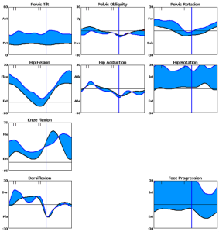
This sounds radically different to the GDI but Mike did some work (which has been lodged as an electronic appendix to the GPS article) which shows that actually the two are very nearly identical and would be exactly the same if the GDI analysis was extended to include all 459 features and not just the first 15. This subtle difference leads to the scatter on the graph of GPS plotted against GDI (reproduced from the GPS article below). You can see from this that the differences are certainly small and probably random. There doesn’t seem any particular reason to claim that one is superior to the other.
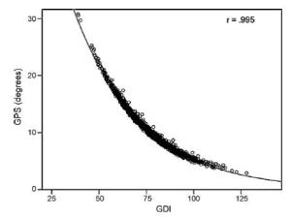
Now that Mike has done all the hard work in the feature analysis the computation of the GDI isn’t much more complicated than that of the GPS and there are a number of spreadsheets in circulation that allow the calculation of one or the other or both. The main advantage of the on which the GDI is based is the data compression but this isn’t particularly relevant if all you want to do is calculate a gait index. The derivation of the GPS is more straight forward and easier to explain and understand. Following Ockham’s razor that the simplest explanation is generally the best, then the GPS maths probably wins out.
The advantages of the GPS derivation are perhaps clearest if analogous indices are to be produced for other variables. Deriving an equivalent of the GDI would require data from a population big enough to contain examples of all possible different gait patterns. Deriving an equivalent of the GPS only requires a population big enough to establish the average pattern for the healthy population reasonably accurately.

Baker, R., McGinley, J. L., Schwartz, M. H., Beynon, S., Rozumalski, A., Graham, H. K., & Tirosh, O. (2009). The gait profile score and movement analysis profile. Gait Posture, 30(3), 265-269.
Schwartz, M. H., & Rozumalski, A. (2008). The gait deviation index: A new comprehensive index of gait pathology. Gait Posture, 28(3), 351-357.

GPS and/or GDI? Part 2 – Scaling the result
In the last post we looked at the different mathematical approaches that the GDI (Schwartz & Rozumalski, 2008) and GPS (Baker et al., 2009) use to derive the underlying measure of difference. These result in the scatter of data about the trend line in the graph below. In this post we’re going to look at the difference in scaling between the two measures which explains the characteristic shape of this curve. There are two major differences.
First is the logarithmic transform. When you look at the distribution of the GPS across either a GMFCS category (Wood & Rosenbaum, 2000)) or FAQ level (Novacheck, Stout, & Tervo, 2000) you find a skewed distribution. The figure below illustrates this for GMFCS II kids. It is clear that the data is not normally distributed and should be log transformed before subjecting to any parametric statistical tests. I’ve got a hunch that the skewing in the data is telling us something useful and would prefer to leave the index as it is (but recommend the transform as an additional step before performing the stats). Mike is less convinced and thinks incorporating the log transform in the derivation of the index is a lot tidier.
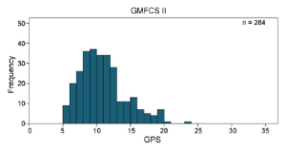
It is this log transform that gives the curve in the first figure its characteristic shape. The graph is steeper to the left which means that GPS will tend to record proportionally greater changes between people with more abnormal gait patterns than the GDI. It is flatter to the right meaning that this will be reversed in people with less abnormal gait patterns. Having said this most patients have a GDI of between 50 and 80 (GPS between 8° and 20°) and the relationship is reasonably linear within this range.
The second difference in the scaling is the way the GDI is transformed so that a normal score is 100 and for each standard deviation away from this the score drops by 10 points. It is this that leads to the quite different magnitudes of the two indices. Again there is logic to both approaches. Scoring this way gives a number that can be interpreted without any understanding of the underlying measure. On the other hand some people who do understand that the measure derives from angular measurements might be interested in the actually size of this which is lost in the GDI.
After several years’ experience using the GPS I’ve become less convinced of the usefulness of this. The averaging of the deviations over the gait cycle and different joint angles tends to make the absolute value of the score less meaningful. Having said this it is often appropriately sobering to find that differences that appear highly significant can represent average changes of just a couple of degrees.
In summary there is little to choose between the two scaling options. I used to think there were strong reasons for preferring the GPS scaling but the older I get the more I see this as essentially a matter to personal preference. The GDI was published first and maybe that should give it the edge.

Schwartz, M. H., & Rozumalski, A. (2008). The gait deviation index: A new comprehensive index of gait pathology. Gait Posture, 28(3), 351-357.
Baker, R., McGinley, J. L., Schwartz, M. H., Beynon, S., Rozumalski, A., Graham, H. K., & Tirosh, O. (2009). The gait profile score and movement analysis profile. Gait Posture, 30(3), 265-269.
Wood, E., & Rosenbaum, P. (2000). The gross motor function classification system for cerebral palsy: a study of reliability and stability over time. [Research Support, Non-U.S. Gov’t]. Dev Med Child Neurol, 42(5), 292-296.
Novacheck, T. F., Stout, J. L., & Tervo, R. (2000). Reliability and validity of the Gillette Functional Assessment Questionnaire as an outcome measure in children with walking disabilities. Journal of Pediatric Orthopaedics, 20(1), 75-81.

GPS and/or GDI? Part 3 – A decision?
In the last two posts I’ve looked at the differences between the GDI (Schwartz & Rozumalski, 2008) and GPS (Baker et al., 2009). The broad conclusion is that they are very minor. Much less important than I thought when we published the GPS paper in 2009. The derivation of the GPS is much simpler than that of the GDI and this is what I really like about it (but takes no less time to calculate once you’ve got the software). I prefer the way the GPS is scaled but now accept that this is simply personal preference and the requirement to log transform data before performing statistical tests is clumsy (and I suspect is being ignored in many applications). On balance we should probably have published an alternative derivation of the GDI rather than proposing an alternative index.
The other issue, of course, is the Movement Analysis Profile. This is an obvious and extremely useful extension of the GPS. There are technical reasons why an equivalent doesn’t flow from the derivation of the GDI. If we’d published an alternative derivation of the GDI in 2009 as opposed to a different index, however, then it would have been the easiest thing in the world to define similarly scaled variables for the different joints and different planes. We’d then have a MAP that was equivalent to the GDI.
In conclusion what we should have done in 2009 was to propose an alternative derivation of the GDI and extended that to develop a MAPGDI. Hindsight is a wonderful thing – we didn’t. We’re thus stuck with two indices that are very much the same but different. Some research groups have understood the subtleties of the differences and opted for one or the other for a good reason. Others may have tossed a coin. Other groups have chosen to report both. There is an argument that we should try and roll back the clock by proposing MAPGDI now but I don’t know what stomach there is for even more new indices in the community. It might be interested see what comments this post prompts from you. Should we try and tidy this up by doing what we should have done in 2009 or will this just cause even more confusion?
What is clear is that there is little point any study reporting the results of both GPS and GDI (they are too similar for this to be useful). There is absolutely no point performing statistical tests on both because they should give identical results (as long as the log transform is applied to the GPS). People should choose which they prefer and report that. Mike and I have submitted a joint paper to GCMAS next year which includes the formulae required to convert one index to the other.
Perhaps even more important – research should not focus solely on either measure. Whilst the indices provide a simple number that describes how different the kinematics are from normal there is a lot more to walking than looking like everyone else. Gait speed is an extremely important measure of gait function and how this depends on cadence and step length provides basic clinical insight. Simply taking the rather poorly defined “self-selected” walking speed used in most gait analysis tests may be the easiest measure of speed but it is not necessarily the best. Endurance is also important and the 6-minute walk test that is becoming standard in other areas of exercise physiology is combines elements of speed and endurance that have considerable face validity. In many cases it is also important to assess dependence on walking aids (as in the FMS, Graham, Harvey, Rodda, Nattrass, & Pirpiris, 2004) and orthoses. Whilst GDI and GPS greatly enhance our ability to characterise gait kinematics they should not be used to the exclusion of other measures.
Graham, H. K., Harvey, A., Rodda, J., Nattrass, G. R., & Pirpiris, M. (2004). The Functional Mobility Scale (FMS). J Pediatr Orthop, 24(5), 514-520.
Schwartz, M. H., & Rozumalski, A. (2008). The gait deviation index: A new comprehensive index of gait pathology. Gait Posture, 28(3), 351-357.
Baker, R., McGinley, J. L., Schwartz, M. H., Beynon, S., Rozumalski, A., Graham, H. K., & Tirosh, O. (2009). The gait profile score and movement analysis profile. Gait Posture, 30(3), 265-269.

GPS and/or GDI? Part 4 – the equations
I’ve just been reviewing some of my earliest posts from when I first started this blog which were a discussion of the relative merits of the GDI and GPS and recognise that there is a little unfinished business. In the last of those posts I talked of the equations that allow a conversion between GPS and GDI that Mike Schwartz and I were intending to present at GCMAS last year. I didn’t include them in the blog at the time because it seemed appropriate to make the conference presentations first. In fact we presented similar papers at both GCMAS and ESMAC.
The basis of this is to acknowledge that both GPS and GDI are essentially measures of the RMS difference between two traces. GPS is a direct calculation and GDI first expresses the data as a linear combination of gait features. If this was all that was done then the RMS difference would be identical but the GDI uses only the first 15 features which results in a small difference. If we used the direct RMS differences between the two curves but applied the same scaling as the GDI we would have another measure which we’ll call GDI* which is very close in value to the actual GDI. You can see how close the agreement is from the figure below.
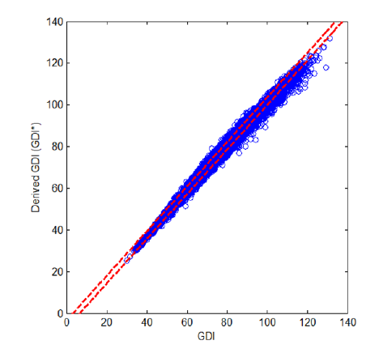
Scatter plot of derived GDI (GDI*) against original GDI. GDI* = -6.6+1.1*GDI, r2=0.996.
A new method for computing the Gait Deviation Index and Motion Analysis Profile, Schwartz MH, Rozumalski A, Baker, R. Proceedings of the Gait and Clinical Movement Analysis Society, Cincinnati, 2013.
If we do this then we can also write down equations that allow a conversion from GDI* to GPS which will also be a very good approximation to the relationship between GDI and GPS. These are:
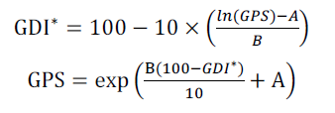
where A=mean(ln(ΔRMS)) and B=sd(ln(ΔRMS)) calculated over the control group used for the computation. In this case the values are A=1.677 and B=0.263. So there you go. If you want to compare your results for GDI and GPS you can now just use these equations to convert one to the other.
As a final note for Visual3D users you might be interested to know that the C-Motion web-site now includes a tutorial on how to create a pipeline to calculate the GPS. It’s all gobbledygook to me. I’d be interested to hear of anyone who may have used it though.
Have a happy Christmas. I think its unlikely I’ll get another post out before next Wednesday now and even less likely that anyone will be interested in reading it if I did.

GPS, MAP and GDI calculators

Click here to download
This is an Excel spreadsheet to help people calculate the GPS, MAP and GDI. I’ve been a little reluctant to make this available because my main motivation in developing the scores was to have a simple measure that could be easily implemented. It disappoints me a bit that despite the simplicity of their simplicity people still seem dependent on someone like me to provide the technology for calculation.
We didn’t put the actual equations in our original paper because we though the concept of root mean square difference was explicit and didn’t require it. We were clearly mistaken in this and it a later paper (Baker et al. 2012) we have included the equations.
I’ve prepared these spreadsheets in Excel form so they are independent of the gait analysis hardware and software used. You will almost certainly have to jump through a number of hurdles to get data out of any particular system and format it appropriately to enter it into this spreadsheet. If you have any data processing or programming skills a firmly recommend that you use this as a basis for writing your own code to calculate the scores rather than to format the data to continue using this spreadsheet.
As with all my software I’ve done the best I can to ensure it is correct but it is the responsibility of individual users to ensure that this is the case. If you find any mistakes then kindly contact me and I’ll attempt to rectify them as soon as possible. From now on I’ll use this site as the primary record of any such issues and how they have been resolved.

Known issues:
v3.1 had errors in calculating pelvic tilt MAP component and hence GPS. Also had error in calculating GDI for any data but those in the first column. These have been corrected in version 3.2.
v3.2 includes formatting changes so it is a good illustration for my screencast “Formatting spreadsheets to analyse gait data”.
.
Baker, R., McGinley, J. L., Schwartz, M., Thomason, P., Rodda, J., & Graham, H. K. (2012). The minimal clinically important difference for the Gait Profile Score. Gait Posture, 35(4), 612-615.

Normative databases: Part 1 – the numbers game
I get quite a few queries from people asking about how they should construct normative databases with which to compare their measurements. The first question to address is what you want the normative database for. As you’ll read in my book or in a paper that has just been accepted for Gait and Posture (based on the paper I presented at GMCAS last year) I’m not convinced by the traditional arguments that we all have different ways of doing things and that we need to compensate for this by comparing clinical data to our own normative data. The whole history of measurement science, which really started at the time of the French revolution, has been about standardisation and the need to make measurements the same way. I don’t see any reason why gait analysts should be allowed to opt out of this.
I’d suggest that the main reason for collecting normative data should be to demonstrate that our measurement procedures are similar to those used in other labs rather than to make up for the idiosyncrasies that have developed for whatever reasons. Our paper shows that there are very small differences in normative data from two of the best respected children’s gait analysis services on different sides of the planet (Gillette Children’s Speciality Healthcare in Minneapolis and the Royal Children’s Hospital in Melbourne). The paper should be available electronically very soon (a couple of weeks) and will include the two normative datasets (mean and standard deviations) for others to download and compare with.
There are two important elements for comparison. Differences between the mean traces of two normative datasets will represent a combination of systematic differences between the participants and between the measuring techniques in different centres. If you find large differences here you should compare detailed description of your technique with that from the comparison centre and try and work towards more consistent techniques. Differences in the standard deviations represent differences in variability in the participants and in the measurement techniques. High standard deviations are likely to represent inconsistent measurement techniques within a given centre and require work within the centre to try and reduce this.
Having defined why we want to collect the data you can then think about how to design the dataset. The most obvious question is how many participants to include? The 95% confidence limits of the mean trace are very close to twice the standard error of the mean which is the standard deviation divided by the the square root of the sample size. I’ve plotted this on the figure below (the blue line). Thus if you want 95% confidence that your mean is within 2° of the value you have measured you’ll need just under 40 in the sample. If you want to decrease this to 1° you’ll need to increase the number to about 130. I’d suggest this isn’t a very good return for the extra hassle in including all those extra people.
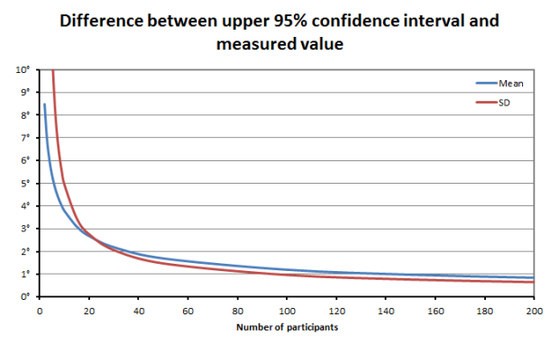
Calculating confidence limits on the standard deviations is a little different (but not a great deal more complicated) because they are drawn from a chi-distribution rather than a normal distribution (see Stratford and Goldsmith, 1997). We’re not really interested in the lower confidence limit (how consistent our measurements might be in a best case scenario) but on the upper confidence limit (how inconsistent they might be in the worst case). We can plot a similar graph (based on the true value of the standard deviation being 6°). It is actually quite similar to the mean with just over 30 participants required to have 95% confidence that the actual SD is within 2 degrees of the measured SD and just under a hundred to reduce this to 1°.
In summary aiming to have between 30 and 40 people in the normative dataset appears to give reasonably tight confidence intervals on your data without requiring completely impractical numbers for data collection. You should note from both these curves that if you drop below about 20 participants then there is quite high potential that your results will not be representative of the population you have sampled from.
That’s probably enough for one post – I’ll maybe address some of the issues about the population you should sample from in the next post.
Just a note on the three day course we are running in June. Places are filling up and if you want to book one you should do so soon.
.
Stratford, P. W., & Goldsmith, C. H. (1997). Use of the standard error as a reliability index of interest: An applied example using elbow flexor strength data. Physical Therapy, 77, 745-750.

