EquationThe mathematical relationship between the GDI and the GPS
An electronic appendix to:
The Gait Profile Score and Movement Analysis Profile

Change of Basis
Following the terminology and conventions used by Schwartz and Rozumalski¹, consider gait data expressed as a vector
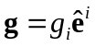. MERGEFORMAT
Where 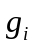 are the usual joint/segment Cardan angle values expressed every 2% of the gait cycle, and (e-basis) is a set of 459 orthonormal vectors (each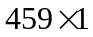) as shown below:
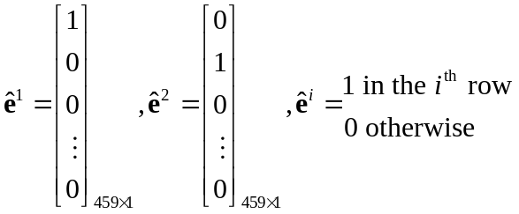. MERGEFORMAT
Now consider gait data as expressed using the f-basis. The f-basis is derived by applying a rotation to the e-basis.
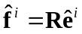 MERGEFORMAT
Therefore
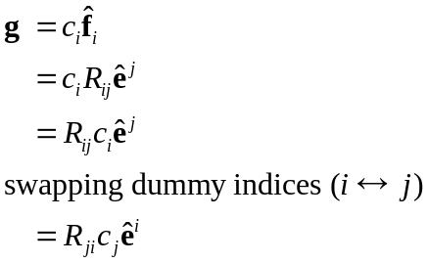 MERGEFORMAT
Comparing and it is clear that
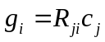. MERGEFORMAT
Or more simply put
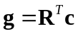 MERGEFORMAT
In other words, the f-basis is simply a rotation of the e-basis.

Calculating the difference measure using f-basis and e-basis
Let be the mean control gait data (i.e. 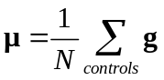). Then the difference between a subject data and the control data (i.e. the point-by-point difference) is
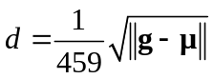, MERGEFORMAT
where 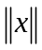 is the Euclidean norm of .
We know that the Euclidean norm is invariant under rotation therefore,
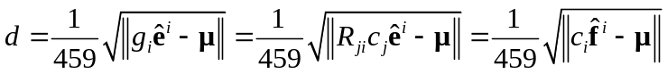 MERGEFORMAT
That is, it makes no difference which orthonormal basis we choose to express our gait data, we get the same difference measure. It’s the equivalent of expressing two points in Cartesian vs. Polar coordinates and computing the distance between them.

Truncation
The GDI, however, does not use the complete f-basis. The point of the approach is compress the data by choosing the f-basis in such a way that most of the variation in the data can be accounted for using a subset of the f-basis. This can be alternatively stated as finding a rotation such that the new the f-basis gives the maximum variation accounted for (VAF) in the data using the minimum number of features. It is found that just 15 features (rather than the entire 459) are required to give a 98% VAF in the “native” data (that data from which the f-basis was derived).
If, instead of using the entire f-basis we decide to truncate to the first 15 terms, the second equals sign in now becomes an approximation
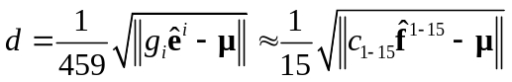. MERGEFORMAT
The quality of the approximation is estimated by either VAF or the Φ measure (reconstruction fidelity) described in the article, around 98% on average.

1. Schwartz MH, Rozumalski A. The gait deviation index: A new comprehensive index of gait pathology. Gait Posture 2008;28:351-7.

We don’t usually think of a “basis” when listing out the joint angles. However, once we arrange them in a vector, the notion of a basis becomes more natural.

