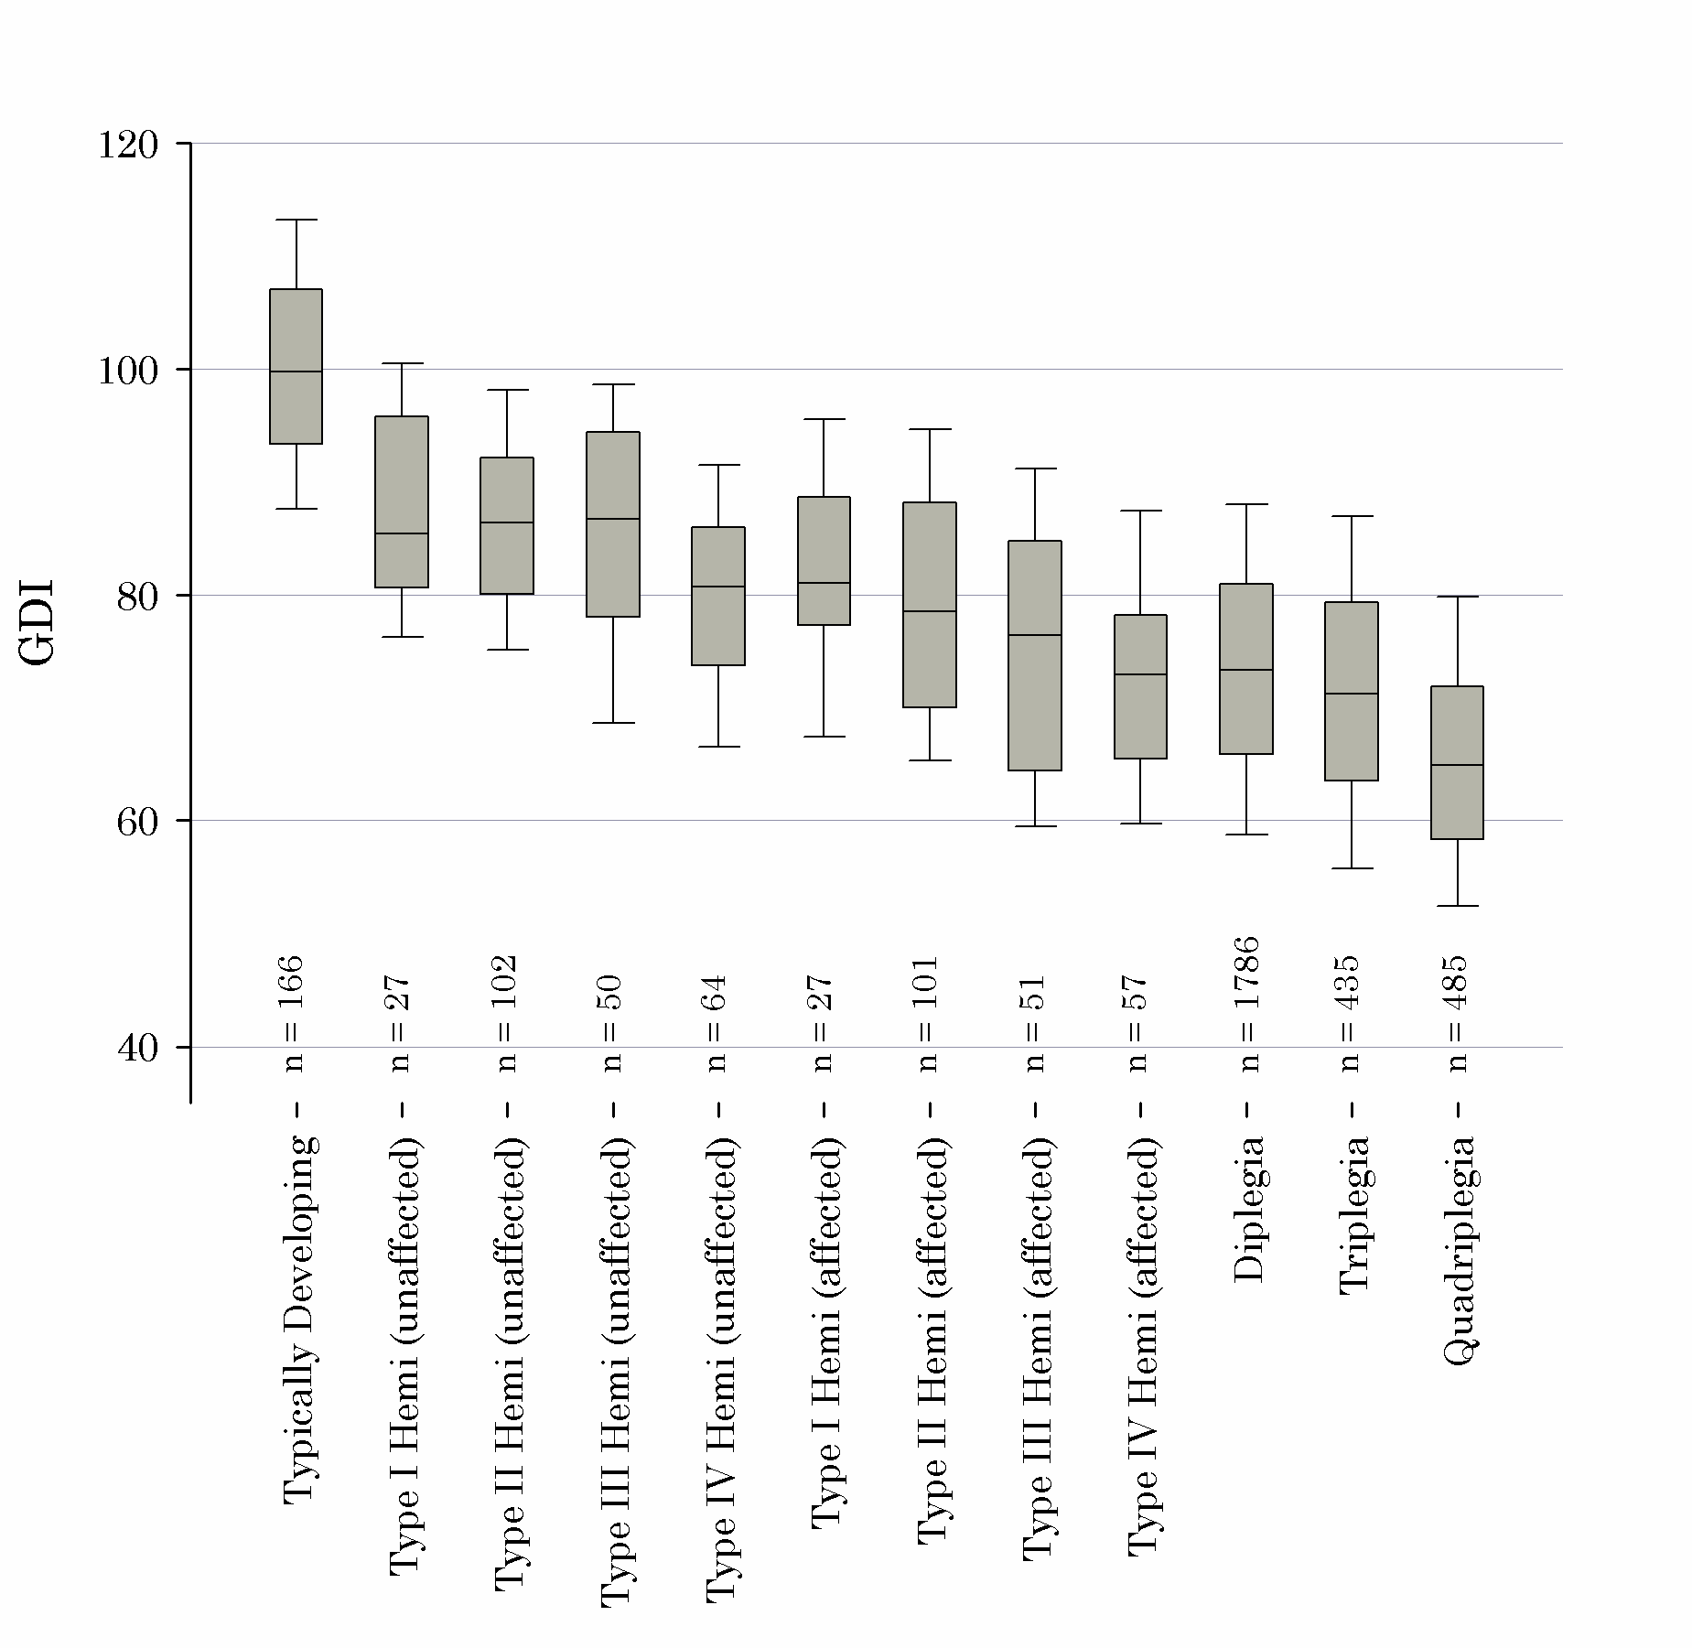
Supplementary Fig. S1. Box plots show the GDI stratified by topographic sub-categories within the diagnosis of Cerebral Palsy (CP). Overall clinical severity increases from left to right (though this is a subjective assessment). The boxes show the 25th to 95th percentile, the whiskers show the 10th and 90th percentile, and the horizontal line within the box indicates the median value. As was the case with the FAQ, the GDI scales appropriately with diagnostic severity. The GDI is sensitive enough to discern between the affected and contralateral sides in Hemiplegia, while also showing that the contralateral (“unaffected”) side does not function at a typical level.

