1. <https://developer.grammarly.com/>

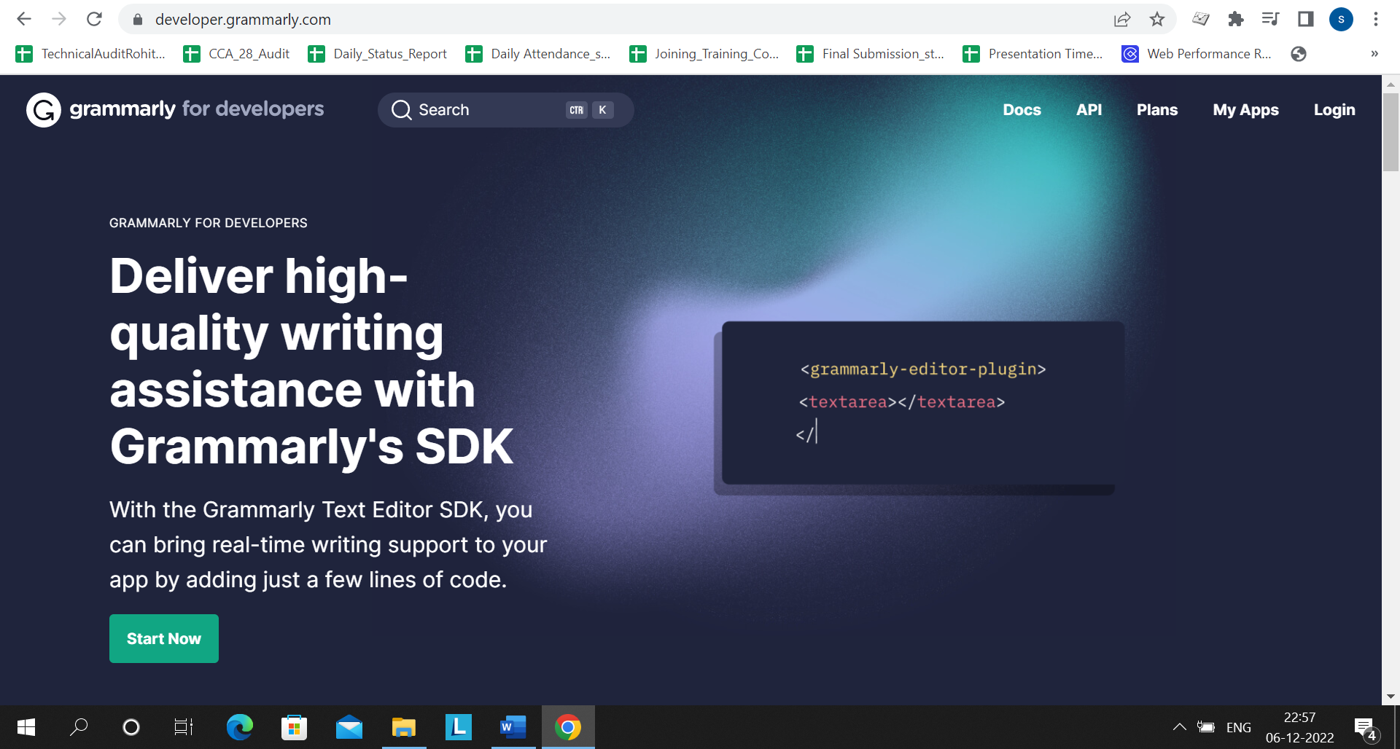

1. <https://developer.grammarly.com/apps>

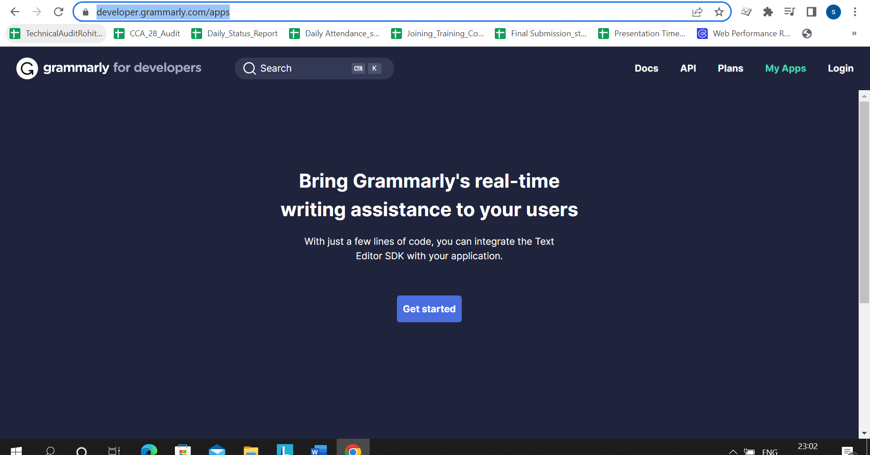

1. <https://developer.grammarly.com/apps?pageStyle=developer&allowUtmParams=true&targetPage=_redirectService>

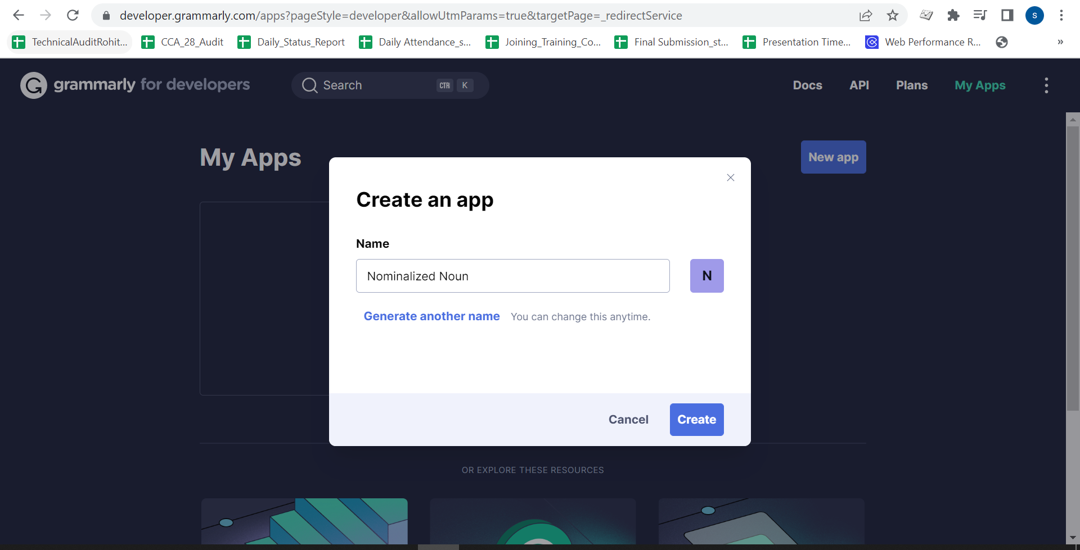

1. <https://developer.grammarly.com/apps/app_FrU5CqBv48JEVhbbUZokHL/clients/client_NG84FFXQD2VB6Au1iTiXW8>

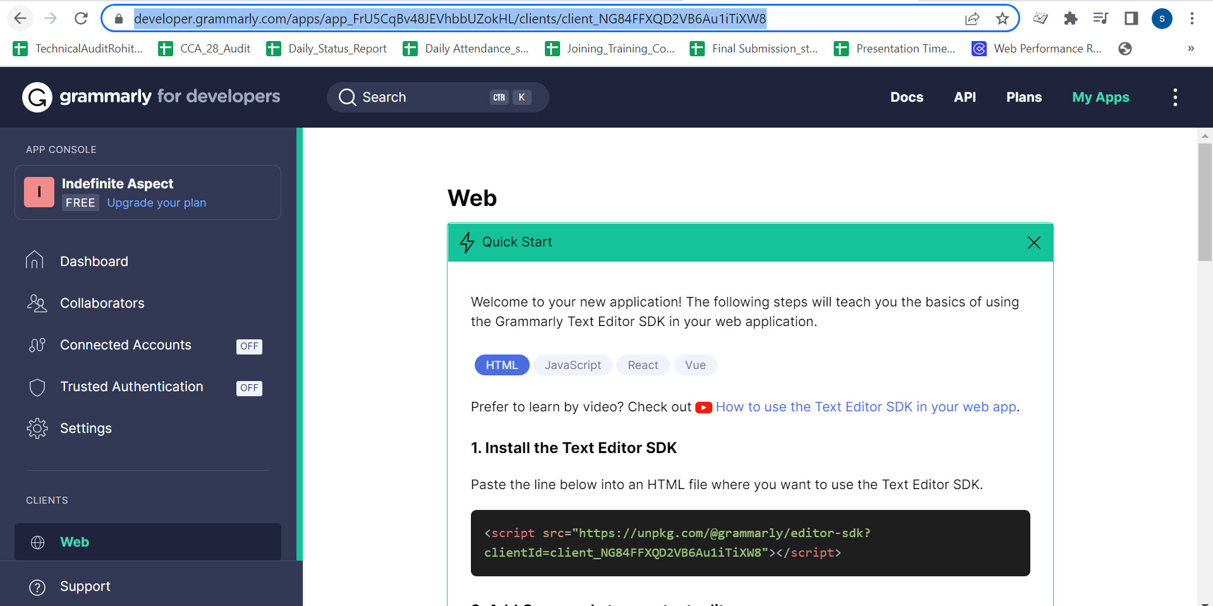

<script src="https://unpkg.com/@grammarly/editor-sdk?clientId=client\_NG84FFXQD2VB6Au1iTiXW8"></script>

As of now we are creating react js , so I can use Grammarly npm packages:

### 1. Install the Text Editor SDK

npm install @grammarly/editor-sdk-react

### 2. Add Grammarly to your text editors

Wrap an editor with the [GrammarlyEditorPlugin](https://developer.grammarly.com/docs/api/editor-sdk-react/grammarlyeditorplugin.html" \t "_blank) component:

import React from 'react'

import { GrammarlyEditorPlugin } from '@grammarly/editor-sdk-react'

export function GrammarlyEditor() {

return (

<GrammarlyEditorPlugin clientId="client\_NG84FFXQD2VB6Au1iTiXW8">

<textarea />

</GrammarlyEditorPlugin>

)

}

The [GrammarlyEditorPlugin](https://developer.grammarly.com/docs/api/editor-sdk-react/grammarlyeditorplugin.html" \t "_blank) can wrap the following types of elements:

* <input type='text'>
* <textarea>
* elements with attribute contenteditable="true"

My Client ID: client\_NG84FFXQD2VB6Au1iTiXW8

<https://codesandbox.io/s/romantic-rubin-8rmfdd?file=/src/App.js>

<https://8rmfdd.csb.app/>

<https://codesandbox.io/s/ckeditor-5-react-forked-92479w?file=/src/index.js:237-276>

<https://app.netlify.com/sites/luxury-tarsier-a5e827/settings/general>