

**Milestone 1**

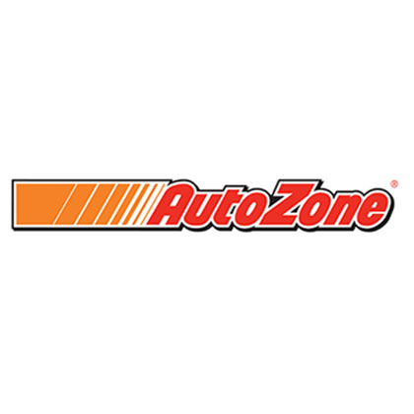

\

By: Patrick Dempsey, Jeanine Buonopane, & Kevin Le

1. System Planning and Selection

1.1. Service Request Form ……………………………………………………….. Page 2

1.2. Scenario…………………………………………………………………….. Page 3-5

1.2.1. Describing the project scope

1.2.2. Describing the project alternatives

1.2.3. Describing the project feasibility

1.2.3.1. Economic feasibility (Provide details in 1.4 and 1.5)

1.2.3.2. Operational feasibility

1.2.3.3. Technical feasibility

1.2.3.4. Schedule feasibility

1.2.3.5. Legal and contractual feasibility

1.2.3.6. Political feasibility

1.3. Dividing the project into manageable tasks (Gantt, PERT, Estimated Total Time, Critical Path, Slacks) …………………………………………………………………….Page 5-6

1.4. Estimating tangible costs and benefits and creating a preliminary budget... Page 6-7

1.5. Calculating ROI (%), break-even time in year, month and day format along with a break-even chart using Excel worksheet……………………………………...Page 7

1.6. Developing a communication plan……………………………………..Page 7-8

1.7. Determining project standards and procedures………………………...Page 9

1.8. Identifying and assessing risk………………………………....………...Page 9

1.9. Setting up a Baseline Project Plan……………………………....………Page 9-10

1.10. Preparing a project scope statement…………………………....……Page 10

2. User Requirements…………………………………………………………….Page 10

3. Systems Requirements………………………………………………………….Page 10

Systems Planning and Selections

1.1. Service Request Form

Autozone Customize Auto Part. System Service Request

Requested By: Kevin Le, Jeanine Buonopane, Patrick Dempsey Date: 02/04/19

Department: IT System Development

Location: Lowell MA

Contact: Patrick_Dempsey@student.uml.edu

TYPE OF REQUEST:

|  |  |
| --- | --- |
| [ x ] New System | [ ] immediate – Operations are impaired or Opportunity lost |
| [ ] System Enhancement | [ ] Problems exists, but can be worked around |
| [ ] System Error Correction | [ ] New System |

PROBLEM STATEMENT:

Our old shopping system is inadequate in several ways. The first of which is that it does not order the parts in terms of vehicles. This causes the customer to feel as though they may not be selecting the correct part for their car and has caused many returns. It also takes them much longer to find what they need for the job at hand. Finally, the customers are unable to see many of the same parts for the given vehicle to compare brands and price together.

SERVICE REQUEST:

We request an analysis of our current operations to help design a new information system to better organize information for the customers. The new system should be able to specifically allow the customer to select the vehicle and part they are looking for and compare pricing and availability. This will increase the ease of shopping and will lead to better customer experience on our website and thus more sales. This will also decrease the likelihood of returns and increase revenue as well.

--------------------------------TO BE COMPLETED BY SYSTEMS PRIORITY BOARD -----------------

[ ] Request approved

Assigned to. .________________________

Start Date. ._________________________

[ ] Recommend revision

[ ] Suggest user development

[ ] Reject for reason __________________________

**1.2 Scenario**

As a team, we have picked a business application from our collective work experiences (not necessarily data processing). We as team plan to improve the system by designing and implementing better features. We as a team will implement the necessary codes or application development tools. We as a team hope we will learn the tools and techniques of analysis and design and understand the process and people issues of systems development to be able to use in our future careers.

**1.2.1 Project Scope**

Opportunity:

Our goal is to help improve the customer's experience in buying their auto parts hassle free. Having the ability to select the correct part for their vehicles will reduce our return rate and increase our customer satisfaction. By doing this, it will help the customer feel more satisfied with their product in which they have chosen the correct product for their vehicle. We will also give the customer the ability to compare their preferred brands of products and also price match their demanded products.

Objectives:

* Reduce returns
* Cuts labor costs within returns
* Happy customers will lure more customers
* Hassle free

Benefits:

* Improves customer satisfaction
* Increase sales
* Reduce returns

Requirements for completion:

Once our project is finished, we will have the website organized for our customers to access with an easier and faster way to find their auto parts needs. We will give our customers the choice to input their vehicle into their “garage” selection and then they can search for their specific part they will need. For instance, if they need an alternator then they can insert “alternator”. Then it will automatically give the customer a list of different prices and brands to choose from within the specific product they insert.

**1.2.2 Project Alternatives**

An alternative application would be where we can have the customer order the part online. Once they order the part, they can have the choice to have it delivered to them by the customer putting their current location into the order. It can be delivered to them within the hour of ordering. By doing this, it will help the customer with their needs based on their demands needs of time and repairs. This will also help customers with their traveling times and delivery times. In terms of customer satisfaction, we will also provide a GPS tracker application for the customer to track their shipment with every movement just so they can see the estimated time of arrival. By doing this, it will give the customer a sign of trust and loyalty on how fast the shipping will arrive in and how we will keep our word to our customers.

**1.2.3 Describing the Project Feasibility**

The project is feasible because there are a few simple improvements that can be made to the ordering system. The system is key to fight off competition from other big-name online retailers that are taking over. It is also an area of opportunity to show improve customer experience and decrease losses with returns. Many other competitors do have the ability to track their shipment but not so precise and exact where we will give the customers a choice to download the GPS tracking app to track their shipment of where exactly it will be.

**1.2.3.1 Economic Feasibility**

Economic feasibility is shown here in the excel spreadsheet. There is a huge room for improvement given the fact that the average return rate in retail is ten percent and the cost of goods sold is about half of the revenue. This shows that there is a great deal of markup in the products and they are very profitable to sell so any lost revenue is a big issue. With that being said there are a lot of fraudulent or damaged returns as well meaning that they are not only a loss in revenue but a loss in the goods themselves so that the business must write off the product itself.

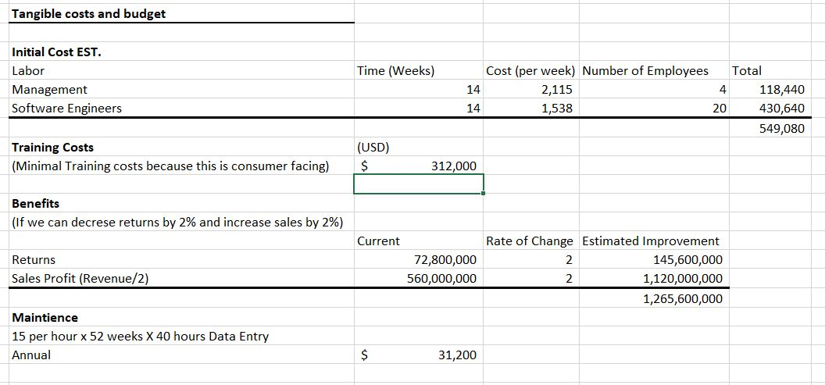

**1.2.3.2. Operational feasibility**

This applies to our auto parts store will show lots of improvement to the customer satisfaction industry. This product will go into action on a daily basis where the customer will use our new functions to find their auto parts where it will be a lot easier for anyone to find instead of googling their product and having the possibility of receiving the wrong part. This will be a hassle free function where the customer will input their specific model and year vehicle and then the part itself.

**1.2.3.3. Technical feasibility**

This product will require some coding through SQL database and some of the Autozone hardware that they are using today. We will need software installations where we will receive our customer information. There will be updates later on through our process of launching the product so that we will stay up to date with our software and databases.

**1.2.3.4. Schedule feasibility**

Our schedule will be completed as stated within our Ghant and Pert charts. The Gannt and Pert charts show us the schedule that is estimated through completion. Once the product is launched we will have a great customer service support for our customers so that if there are any errors we will fix them as soon as possible.

**1.2.3.5. Legal and contractual feasibility**

There will be no legal problems or contractual problems with this new project. That is because all of our resources will be through our UMass Lowell. We will not need many new systems for this where we will need to design the product. If needed, we can have other systems from other organizations.

**1.2.3.6. Political feasibility**

This application will contain no political issues where these new shortcuts to the auto parts industry will only benefit the customers and the company. In other words, This system will only be constrained for customer orders and no political issues.

**1.3. Dividing the project into manageable tasks**

PERT:

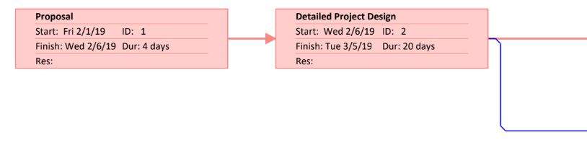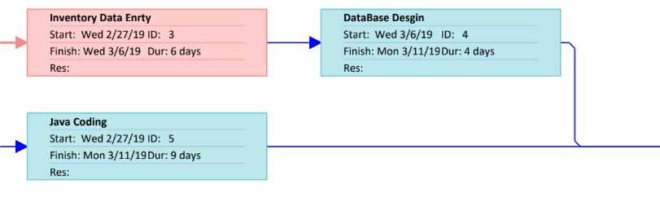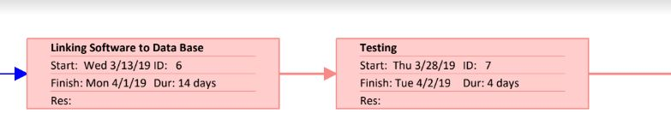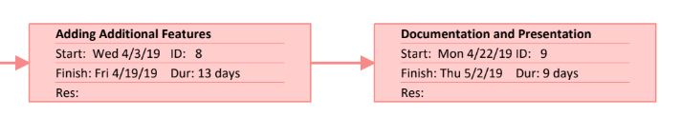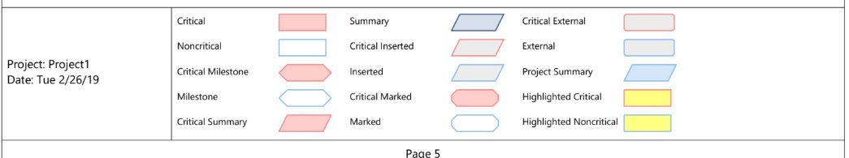

Gannt: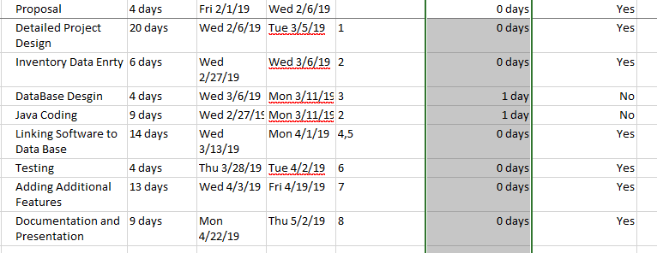

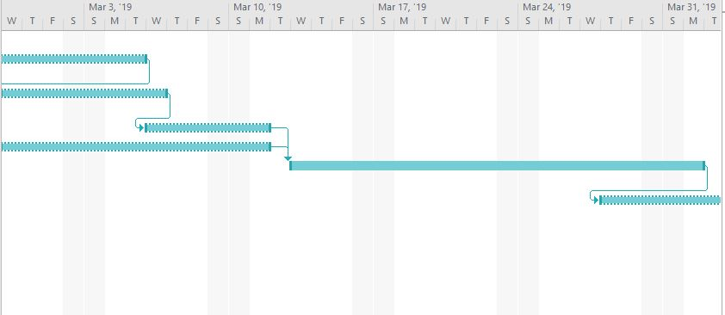

Estimated Total Time: 83 days

Critical Path:

Slacks:

**1.4. Estimating tangible costs and benefits and creating a preliminary budget**

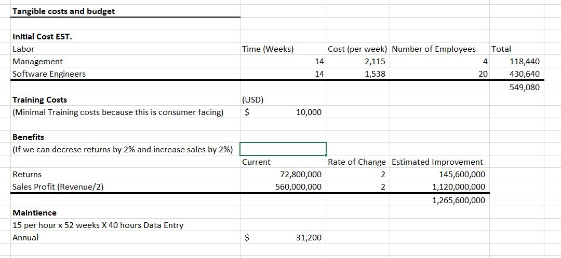

**1.5. Calculating ROI (%), break-even time in year, month and day format along with a break-even chart using Excel worksheet.**

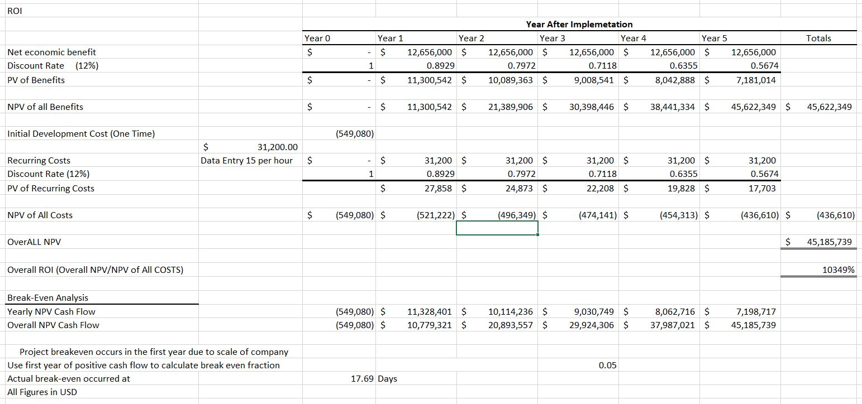

**1.6 Developing a communication plan**

|  |  |  |  |  |  |
| --- | --- | --- | --- | --- | --- |
| Communication | Method | Frequency | Goal | Owner | Audience |
| Project status report | Email/ Text Message | Weekly | Review the status of the project and discuss possible issues or delays | Team Leader | Project team & Project sponsor |
| Team standup | Meeting | After class Tuesday/ Thursday | Discuss what each team member is working on and what they plan to work on this week | Team Leader | Project team |
| Project review | Meeting | At milestones | Present project deliverables, gather feedback from groupmates, and discuss next steps | Team Leader | Project team & Project sponsor |
| Post-mortem | Meeting | At end of the project | Assess what each member contributed, what actions were not completed and key takeaways from this project | Team Leader | Project team |
| Task progress updates | Meeting | After class Tuesday/ Thursday | Share daily progress made on project task | Team Leader | Project team |

**1.7. Determining project standards and procedures**

The proposal will take four days to complete. Detailing the project design is designed to be completed in twenty days. The inventory data entry and java coding will begin on the same day. Inventory data entry will reach completion in six days while java coding will reach completion three days later. Database design will begin March 6th and finish on the 11th. On March 13th linking software to database and reach completion April 1st. While linking software to the database is in its final days that testing will begin and finish April 2nd. Through the testing phase, there could be the discovery of needing additional features it will reach completion. Documentation and presentation will begin to take place on April 22nd and reach completion on May 2nd. In this project, communication is important for each task because there are many tasks that coincide with each other at the same time.

**1.8. Identifying and assessing risk**

In identifying risk through each step through the project.

Operational feasibility: Our assessment is not clear in our understanding of how our solution applies to the current day-to-day operations of the organization. An example of this would be our proposal being too specific or board.

Technical feasibility: For technical feasibility in the implementation of a new system there can be small coding issues that can cause software to fail. In anticipation of this possibility for this issue, we have graced our self with four days of testing.

Schedule feasibility: In scheduling for any project can be hard to predict for how long each task may take. For example, when coding for this system for this project we could have a piece of our code that does not work. The coding problem it could take more than a day or two to solve.

**1.9. Setting up a Baseline Project Plan**

Introduction: Our overall goal is to improve the customer's satisfaction in their auto parts buying experience. We want to create an environment that an easier experience on the user. By creating this environment it will reduce our return rate while increasing positive brand recognition by having customers being satisfied with our hassle-free auto parts buying experience.

System description: Our system will offer customers the ability to compare their preference in brands of products. While giving the option to price match the products they desire.

Feasibility assessment:

*Operational feasibility*

The creation of this new system will create huge improvements in customer’s morale in our industry. The system will make an easier experience for the user instead of the user searching for the product by using another site that does not have specific enough filter for the product. That user may receive the wrong product by using the other site. Our system will offer the function for the user to best specify the specific model and year vehicle of the part needed.

*Technical feasibility*

This product will require some coding through SQL database and some of the Autozone hardware that they are using today. We will need software installations where we will receive our customer information. There will be updates later on through our process of launching the product so that we will stay up to date with our software and databases.

*Schedule feasibility:*

Our group is using Ghant and Pert charts to estimated our completion dates. When we launch our system will offer our customers the best customer service support we can. We will rectify any issues that come up as soon as they are brought to our attention.

*Legal and contractual feasibility:*

We have no legal problems or contractual problems with this new project because we are using our resources through UMass Lowell. We creating a design of the product and not an not the need for creation of multiple new systems. If in our development we realize need assistance from other systems from other organizations then we look further into what we would need for legal and contractual partnerships.

*Political feasibility:*

In our application there contain no political issues. Our application generates new shortcuts in purchasing auto parts in the industry. These new shortcuts will be beneficiation for the customers and the company.

*Management issues:*

Our application establishes new shortcuts. The possible management issues that may arise due to failure to communicate in full detail where each member is at in their project piece creates the environment the inability to meet project deadlines.

**1.10. Preparing a project scope statement**

UMass Lowell Prepared by Patrick Dempsey Kevin Le Jeanine Buonopane

Date 2/25/19

Fast Auto Part Order

Autozone

The opportunity to expand sales revenue as well as decrease return rates will be critical in maintaining a customer base in an ever increasingly competitive industry. Our system highlights the opportunity and importance of a good system in a large corporation. With revenues in the billions a small change in a system can mean millions of dollars in the bottom line for the company.

Our objective is to make the ordering system easier and faster for the the do it yourself mechanic. Customer satisfaction will increase the loyalty of our customer base. Our system will track the product when it is out for our industry first consumer 1 hour delivery system.

**2. User Requirements**

Our only requirement is for the user is to be open-minded to use our product and to be patient with us well we work out any issues that we may run into during our testing phase. As well as giving us feedback on our product so we can verify that we are meeting customers at their full satisfaction level and that if we are not how we can best improve our product so we better meet their satisfaction.

**3. Systems Requirements**

We require 1 GHZ processor with 512MB of ram Windows XP Service pack 2 or Mac OSX to be able to make the updates to the system that we need to.