Cookery Project Proposal

Dempsey Evans

Capstone Project Proposal

Grand Canyon University

Professor Landreth

Revision: 3

May 18th, 2025

**ABSTRACT**

Cookery, a Spring Boot web application, aims to make the common chore of meal planning and budgeting easier and quicker. Using Thymleaf, and CSS for a user-friendly interface as well as a MySQL database, the application will allow users to create and manage their personal recipes and ingredients. The users will be able to add price ranges to ingredients, allowing the application to give them a general cost for each recipe. Cookery will also include an auto-generator that will give the user randomized recipes for quicker meal planning. Users will have an option to add constraints to the generator, such as the maximum price range or available ingredients to better match their needs. To access the applications the user will first need to register with an unused email and then log in. User authentication and user data will be secured using Spring Security, ensuring unregistered users can only access the login and registration pages.

Aligning with scrum methodology, the project will accomplish its goals by breaking the development phase into carefully planned sprints. Each sprint focuses on a different task, such as environment setup and core functionalities, which is further broken down within the sprint. This allows for more accurate time estimations and more effective planning ensuring each completion date is met. The application is user-focused, so user feedback is highly important to the project. User requirements will be used to create goals and make changes throughout the project.. After development the application will enter a testing period where acceptance testing will be used to ensure that the application meets the users’ needs.

|  |
| --- |
| History and Signoff Sheet |

**Change Record**

|  |  |  |
| --- | --- | --- |
| **Date** | **Author** | **Revision Notes** |
| 10/26/2024 | Dempsey Evans | Initial Proposal |
| 12/15/2024 | Dempsey Evans | Revision 2 – modified to align with requirement updates |
| 05/05/2025 | Dempsey Evans | Revision 3 – milestone 6 modifications |

|  |
| --- |
| **Overall Instructor Feedback/Comments** |

|  |
| --- |
| **Overall Instructor Feedback/Comments** |

**Integrated Instructor Feedback into Project Documentation**

Yes  No

**Project Approval**

Professor Mark Reha

**TABLE OF CONTENTS**

Project Overview and Project Objectives 5

Project Scope 7

Project Success Measures 8

Project High-Level Solution 9

Project Controls 15

Project Cost and Schedule 17

Appendix A – References 19

Appendix B – Copyright Compliance 20

Project Overview and Project Objectives

**State the Problem and Background**

As technology and social platforms grow, it has become common for every-day cooks to save their recipes in multiple places. This may be handwritten recipes, images on their phone, or platforms such as Pinterest. In 2021 a global survey found that 43% of Generation X and Boomer generations found their recipes online and 44% of Generation Z and Millennials found their recipes online (Dixon, 2022). This makes the process of finding recipes and planning meals longer and adds more stress to this daily responsibility. The application is intended to allow its users to consolidate and manage recipes on one platform as well as plan meals more efficiently. This application requires an understanding of user needs, which can be learned using user feedback. Users will be able to create recipes with descriptors, which will allow the user to quickly search for various types of recipes using the search functionality. The user will be able to save ingredients in the database with average prices, giving the user a general price for each recipe after its creation. Using the recipe generator, the user will also be able to randomly generate recipes, making planning meals easier. While no criteria is required to generate a recipe, the user may also insert specific criteria to make the generator meet their current needs.

**Christian Worldview**

The Christian worldview values include the importance of stewardship and caring for our families and community. Making a meal can be seen as an act of love or care for another person and their wellbeing. It shows that the cook cares that the receiver is nourished and cared for. However, in the modern world the process often feels more like a daily chore. By easing the steps before cooking, the user is able to put more focus on opportunities in the planning and cooking process to express care for another in their family or community.

**Project Objectives**

Objectives that will be used to measure project success are user feedback, accepting testing, and functional behavior testing. User feedback will be collected using client interviews and a user feedback form placed in the application. This will allow the team to understand client satisfaction and needs. A fully successful application will have an approval rating of 90% or better. Any approval rating below 80% will be considered a failure. Acceptance testing will also ensure that user needs have been met, and functional behavior testing will ensure the functional requirements are met.

**Challenges**

One challenge of this project will be effectively implementing Spring Security as well as a complex recipe form and auto-generator. These challenges are based on developer experience and will require more planned time to manage issues in these areas to mitigate the risk of falling behind.

**Benefits and Opportunities**

Using this application will allow users to find convenience in managing recipes and meal planning. Rather than searching through multiple platforms, screenshots, and written cards for a specific recipe, the user can search through a singular list of recipes. A user-friendly form allows users to quickly add recipes and ingredients, which are used to calculate and display a price range for the recipe. This feature is particularly helpful for those who are cooking on a budget or desire to know their meal price range. By adding descriptors to each recipe, the user is able to easily search for recipes in ways that are unique to them, making the experience more personal and allowing users to find recipes more efficiently. The recipe generator feature provides convenience in meal planning by allowing users to find recipes that fit their needs quickly. Many people find the process of meal planning to be time consuming and tedious. In the moment it can be difficult to think of recipes for the future or that align with available ingredients. This application lessens the burden of this responsibility by providing the user with meals from their own list of recipes that match their current needs.

If this product is successful, it will be full of possibilities for growth. For example, creating a shopping list from chosen recipes and providing an option to third-party delivery services or allowing users to connect and share recipes and ideas. The application could take whatever direction is desired to match current trends and provide financial opportunities through third-party connections, such as grocery delivery services. Subscription services could be provided for additional features like a more complex meal planning feature or educational lessons.

Project Scope

The application is a Spring Boot web application that will allow users to manage recipes more efficiently. Thymleaf and CSS will allow for a user-friendly interface and a MySQL database will be used to store the data. Sprint Security will be used to handle data security and user authentication so that users can manage their own recipe data securely. All of the data will come from the user when they manage recipes and ingredients or input information for the recipe auto-generator. The data will be manipulated to find the price range of each recipe as well as for sorting recipes in the search and using the recipe generator functionality. Reports which can be produced from the application and data include user feedback and user activity reports to track performance and user needs.

|  |  |  |
| --- | --- | --- |
| Stakeholder Name | Role(s) | Responsibilities |
| Dempsey Evans | Project Manager/Development/User | Development and Documentation |

|  |  |  |  |  |  |  |  |  |  |  |
| --- | --- | --- | --- | --- | --- | --- | --- | --- | --- | --- |
| Work Breakdown Structure | | | | | | | | | | |
| ID | Task | Dependencies | Status | Effort Hours | Cost | Start Date | Planned Completion | Estimate to Completion | Actual Completion | Resource |
| 1 | Proposal | None | Completed | 7 | $0 | 10/22/2024 | 10/24/2024 | 10/25/2024 | 11/01/2024 | Project Manager |
| 2 | Requirements Analysis | None | Completed | 6 | $0 | 10/28/2024 | 11/15/2024 | 11/20/2024 | 11/24/2024 | Project Manager |
| 3 | Architectural Plan | None | Completed | 6 | $0 | 11/18/2024 | 12/14/2024 | 12/14/2024 | 12/18/2024 | Project Manager |
| 4 | Create GitHub repository | None | Completed | 2 | $0 | 12/30/2024 | 12/30/2024 | 12/30/2024 | 12/30/2024 | Development Team |
| 5 | Environment Setup | None | Completed | 3 | $0 | 12/30/2024 | 12/31/2024 | 12/30/2024 | 12/30/2024 | Development Team |
| 7 | Spring Security Implementation | 1 | Completed | 5 | $0 | 01/01/2025 | 01/07/2025 | 01/03/2025 | 01/03/2025 | Development Team |
| 8 | Core Recipe Functionality | 1 | Completed | 6 | $0 | 01/08/2025 | 01/22/2025 | 03/16/2025 | 04/17/2025 | Development Team |
| 9 | Ingredient Management Functionality | 1, 2 | Completed | 5 | $0 | 01/23/2025 | 01/30/2025 | 01/30/2025 | 01/03/2025 | Development Team |
| 10 | Recipe cost functionality | 2 | Completed | 5 | $0 | 01/31/2025 | 02/05/2025 | 02/04/2025 | 02/04/2025 | Development Team |
| 11 | Recipe generator functionality | None | Completed | 8 | $0 | 02/06/2025 | 02/13/2025 | 03/22/2025 | 04/09/2025 | Development Team |
| 12 | Quality Assurance Testing | None | Completed | 3 | $0 | 02/14/2025 | 02/16/2025 | 04/28/2025 | 05/11/2025 | Testing |
| 12 | User acceptance testing | None | Completed | 3 | $0 | 02/16/2025 | 02/21/2025 | 04/28/2025 | 05/11/2025 | Testing |

Project Success Measures

The application is driven by user feedback, making user requirements an important tool for measuring project success. The success of the project will also be measured by the applications passing the acceptance test, which will test functional behaviors such as the user’s ability to register, login, and perform CRUD operations. Quantitative metrics will also measure success using metrics such as the quality of the code, bug count, and sprint velocity.

|  |
| --- |
| Project Completion Criteria |
| 1 – All functions and features related to recipe management, item management, and the auto-generator feature behave appropriately. |
| 2 – User feedback shows satisfaction in the applications performance. |
| 3- The project aligns with the planned timeline. |
| 4- All user acceptance test pass. |

|  |  |  |  |  |  |
| --- | --- | --- | --- | --- | --- |
| Assumptions and Constraints | | | | | |
| ID | Description | Comments | Type | Status | Date Entered |
| 1 | All users have stable access to the internet. | Users require stable connection to the internet to access the application. | Assumption | Planned | 10/26/2024 |
| 2 | Users will correctly complete forms and input data. | Correct data and cost calculations are dependent on the user correctly inputting information. | Assumption | Planned | 10/26/2024 |
| 3 | There will be no major changes throughout the project. | To remain true to the scope, there will be no major changes to the application or process of completing the project. | Assumption | Planned | 10/26/2024 |
| 4 | The project must be completed by 05/2025 | The project must be finished before its completion date, estimated to be near May 2025. | Constraint | Planned | 10/26/2024 |
| 5 | The project has no budget. | The application is intended to be completed with no initial financial cost by using the free Azure credits the developer has. | Constraint | Planned | 10/26/2024 |
| 6 | Spring Security must effectively secure user data. | Spring security will support user authentication and data integrity. | Constraint | Planned | 10/26/2024 |

Project High-Level Solution

**Introduction**

The challenge addressed by this application is easing the difficulties in recipe management and struggles with meal planning efficiently. With endless resources for new recipes, it can be difficult to organize and plan meals. This application allows users to personalize and store recipes for quicker access and easier management. It is known that users need a simple and efficient way to create and manage recipes. The recipe management portions of the application will allow users to add, edit, view, and delete recipes using a user-friendly form and table. Using Thymelaf and CSS will allow for a responsive and clean user interface for easy navigation and use.

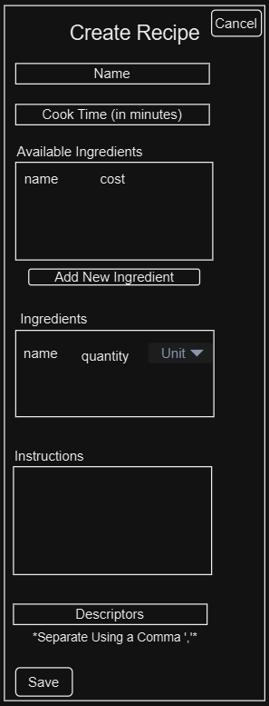 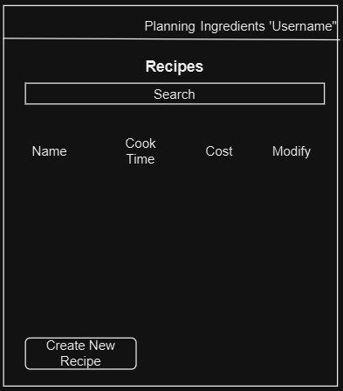

Recipe Form Wireframe Recipe Management Page

It is also known that users want cost information for their recipes. To solve this the user will input a price range for new ingredients, which will be stored in the database for use in future recipes. The price range for each ingredient in the recipe will then be calculated to display the estimated price range of each recipe. A page dedicated to displaying ingredients saved in the database will be available to the user with functionality to add, edit, and delete ingredients.

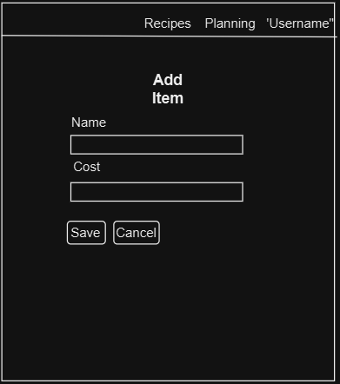

Ingredient Management Page Add Ingredient Form

Users also desire a solution for more efficient meal planning. Using a recipe generator the user will have the option to input criteria, then the recipes will be sorted through and a random recipe from the database that matches the criteria will be displayed to the user. Spring Security will be used to manage the need for secure data and user authentication.

Meal Generator Wireframe

This project assumes that users will have stable internet access and that the user inputs data accurately. These assumptions are made as the application is web-based and its use is dependent on access to the internet. The effectiveness of the application is also dependent on the accuracy of the user’s data. To calculate an accurate estimated price for recipes the ingredients price must be accurate, and to successfully search for or pull random recipes, the recipe descriptors and ingredients for each recipe must exist and be correct.

**Solution**

This Spring Boot web-application uses the Model View Controller (MVC) architecture for easier code management and scalability. The intentions and functionality of this application are user-driven to meet user needs in recipe management. Using the MVC architecture will allow the application to support modularity and scalability for easier management and potential growth. In using the architecture, the repositories will communicate with the database and perform CRUD methods, and the service classes will implement the data with the business logic and pass it to the controller to be sent to the view. Thymeleaf and CSS allow for a user-friendly interface that consist of registration, recipe, and ingredients forms, buttons, tables, and a navigation bar on each page.

MVC Architecture Business Logic Flow Chart

MySQL database supports data management, and Spring Security keeps the data secure. User data will include personal information such as username, password, first name, last name, and email, as well as recipe and ingredient information. For user authorization, the user will use their username and password to access the application after registering. Each user account will be required to have a unique email.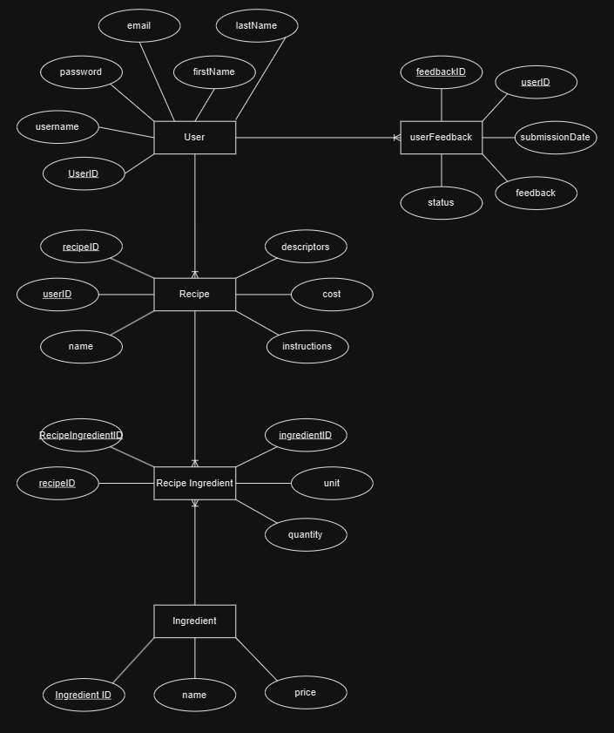

Entity Relationship

Login Flow Chart

The application will output the total cost for each recipe and generated recipes. This will be calculated by totaling the price of each ingredient in the recipe if each ingredient in the recipe has an associated price. For these calculations to be accurate it is essential that the user input data is as accurate as possible. After the user submits the information, the data makes its way through Thymleaf and the controller, to the Spring Boot service layer. Here it is processed, and calculations can be performed. Then, if necessary, the repository layer updates the database, and any relevant methods are called to update the users display. This project will also require a Github account and established repository to store and maintain the application.

Project Controls

|  |  |  |  |  |
| --- | --- | --- | --- | --- |
| Risk Management | | | | |
|  | **Risk Probability** | **Risk Impact** |  |  |
| **Event Risk** | **(high, medium, low)** | **Risk Mitigation** | **Contingency Plan** |
| Data Loss | Low | Loss of user data | Perform regular backups for the data | Use backed up data |
| Timeline delays | Medium | Development setback | Detailed documentation and tasks breakdowns. | Utilize all resources to set reasonable goals in the timeline. Review the sprint plans to ensure that time estimates are appropriate and reprioritize tasks if necessary. |

|  |  |  |  |  |  |  |  |  |
| --- | --- | --- | --- | --- | --- | --- | --- | --- |
| Issues Log | | | | | | | | |
| **ID** | **Description** | **Project Impact** | **Action Plan/Resolution** | **Owner** | **Importance** | **Date Entered** | **Date to Review** | **Date Resolved** |
| 1 | Development understanding of recipe generator. | Delay in recipe auto-generator functionality | Learn more on how to best implement searching through recipes using criteria then choosing a random recipe. | Development Team | *High* | *10/26/2024* | *10/30/2024* | *11/02/2024* |
| 2 | Questionable timeline | Improper development plan, potentially impacting end dates. | Frequently review the timeline to ensure that it is realistic and aligns with deadlines. | Resource Manager | Medium | 10/26/2024 | 10/27/2024 | 10/27/2024 |
| 3 | Scope Modification | Miscommunication later in the project | Include what is out of scope | Project Manager | High | 10/30/2024 | 11/02/2024 |  |
| 4 | Project Success Measures | Unable to determine quantitative success. | Include scores, rating, and test pass rates. | Project Manager | High | 10/30/2024 | 11/02/2024 |  |
| 5 | Update Timeline | Inaccurate work schedule | Update the timeline to match the updated work breakdown table | Resource Manager | Medium | 10/30/3025 | 11/02/2024 | 11/10/2024 |
| 6 | Forgotten User Password | Inability for users to access application | Add ability for users to proceed after forgetting their password | Development Team | High | 11/1/2025 | 11/10/2024 | 11/10/2024 |
| 7 | Ingredient Quantities | Missing functionality for successful application use | Add Ingredient Quantity functionality | Development Team | High | 11/23/2025 | 11/23/2025 |  |

At this stage in development there have not been any unexpected changes, but there are changes that are anticipated. Changes are also expected to appear after user feedback is collected. These changes are likely to impact visuals or functionality.

|  |  |  |  |  |  |  |  |  |  |
| --- | --- | --- | --- | --- | --- | --- | --- | --- | --- |
| Change Control Log | | | | | | | | | |
| **ID** | **Change Description** | **Priority** | **Originator** | **Date Entered** | **Date Assigned** | **Evaluator** | **Status** | **Date of Decision** | **Included in Rev. #** |
| 1 | Potential timeline changes | Medium | Development Team | 10/25/2024 | 10/25/2024 | Development Team | Anticipated |  |  |
| 2 |  |  |  |  |  |  |  |  |  |

|  |  |  |  |
| --- | --- | --- | --- |
| Roles and Responsibilities | | | |
| Name | Team | Project Role | Responsibility |
| Dempsey Evans | Development | Project Developer | Development and Documentation |
| Customer | Client | App User | Provide feedback for requirements |
| Dempsey Evans | Development | Project Manager | Manage/Supervise the project |
| Professor Webster | Development | Sponsor | Provide support throughout the project |
| Dempsey Evans | Development | Testing | Perform testing throughout development and after deployment |
| Dempsey Evans | Development | Resource Manager | Manage the project resources and timeline |

Project Cost and Schedule

By using the free IDE and MySQL database, it is believed that this project can be completed at no cost.

|  |  |  |  |  |  |  |
| --- | --- | --- | --- | --- | --- | --- |
| ID | Task | Description | Effort Hours | Start Date | Planned Completion | Sprint |
| 1 | Setup Environment | Configure the Spring Boot environment | 3 | 12/30/2024 | 12/30/2024 | 1 |
| 2 | Create MySQL Database Tables | Create tables for use with entities | 1 | 12/30/2024 | 01/02/2025 | 1 |
| 3 | Implement Spring Security | Create login and registration for Spring Security use | 5 | 01/01/2025 | 01/07/2025 | 2 |
| 4 | Core Recipe Functionality | Create, read, update, and delete methods for recipes | 6 | 01/08/2025 | 01/10/2025 | 2 |
| 5 | Create Recipe Form | Frontend and backend functionality to create a new recipe | 4 | 01/11/2025 | 01/13/2025 | 2 |
| 6 | Core Functionality for Ingredients | Create, update, and delete ingredients | 5 | 01/23/2025 | 01/28/2025 | 3 |
| 7 | Create Ingredient Form | Form to create new ingredients | 3 | 01/29/2025 | 01/30/2025 | 3 |
| 8 | Recipe Cost Calculation | Add logic for cost calculations | 5 | 01/31/2025 | 02/05/2025 | 4 |
| 9 | Recipe Generator Functionality | Logic for random recipe generation | 8 | 02/06/2025 | 02/09/2025 | 4 |
| 10 | Recipe Generator interface | Create page for recipe generator | 3 | 02/06/2025 | 02/13/2025 | 4 |
| 11 | User Acceptance Testing | Test that application meets user requirements | 3 | 02/14/2025 | 02/16/2025 | 5 |

Appendix A – References

Dixon, Stacy (2022). Share of internet users who get meal inspiration from various online sources worldwide as of November 2021, by generation. <https://www.statista.com/statistics/1288261/global-sources-meal-inspiration-by-generation/>

Appendix B – Copyright Compliance