**Rezultati**

Statistics were calculated using the R software [REF]. We set the significance threshold to 0.05 (α=0.05). Values are summarized with their mean value or with percentages where applicable, for uncertainty estimation we used 95% confidence intervals (95% CI). When we could not simply calculate the SD from the sample (e.g., when working with group level proportions) we used bootstraping to estimate the uncertainty.

When comparing proportions between groups we used the proportions test. The Wilcoxon test was used when working with paired samples, while the Mann-Whitney test was used when working with independent samples. For survival analysis we used the Kaplan-Meier estimator. For analysing correlations between variables, we used (multivariate) linear regression models.

All the code for our analysis along with anonymized data is published at https://github.com/demsarjure/vein_ablation.

*REF = R Core Team (2021). R: A language and environment for statistical computing. R Foundation for Statistical Computing, Vienna, Austria. URL https://www.R-project.org/.*

**1. Demografski podatki**

|  |  |  |  |
| --- | --- | --- | --- |
|  | **close** | **high density** | **p** |
| **age** | 63.05 [58.99, 66.88] | 62.61 [59.83, 65.34] | 0.57 |
| **gender** | 50% [33.33%, 66.67%] | 65.52% [48.28%, 82.76%] | 0.29 |
| **bmi** | 29.69 [27.73, 31.75] | 27.98 [26.42, 29.57] | 0.46 |
| **la_volume_index** | 39.87 [35.93, 43.93] | 39.38 [35.72, 43.17] | 0.62 |
| **la_size** | 41.1 [39.7, 42.53] | 41.38 [39.21, 43.59] | 0.95 |
| **lvedvi** | 60.6 [57.87, 63.33] | 58.78 [55.63, 61.89] | 0.64 |
| **lvef** | 66.57 [64.57, 68.63] | 65.22 [62.63, 67.78] | 0.47 |
| **class_III_drugs** | 33.33% [16.67%, 50%] | 27.59% [13.79%, 44.83%] | 0.84 |
| **class_I_drugs** | 43.33% [26.67%, 60%] | 31.03% [13.79%, 48.28%] | 0.48 |
| **beta_blockers** | 56.67% [40%, 73.33%] | 55.17% [37.93%, 72.41%] | 1 |
| **anticoagulant** | 83.33% [70%, 96.67%] | 82.76% [68.97%, 96.55%] | 1 |
| **probnp** | 255.21 [195.28, 319.46] | 323.3 [168.57, 534.33] | 0.34 |
| **chf** | 3.33% [0%, 10%] | 3.45% [0%, 10.34%] | 1 |
| **hypertension_history** | 56.67% [40%, 73.33%] | 41.38% [24.14%, 58.62%] | 0.36 |
| **age_75** | 13.33% [3.33%, 26.67%] | 3.45% [0%, 10.34%] | 0.37 |
| **diabetes_history** | 13.33% [3.33%, 26.67%] | 10.34% [0%, 24.14%] | 1 |
| **vascular_disease** | 10% [0%, 23.33%] | 3.45% [0%, 10.34%] | 0.63 |
| **age_65_74** | 50% [33.33%, 66.67%] | 37.93% [20.69%, 55.17%] | 0.5 |
| **cha2ds2vasc** | 2 [1.5, 2.53] | 1.31 [0.93, 1.69] | 0.06 |

**2. Proceduralni podatki**

|  |  |  |  |
| --- | --- | --- | --- |
|  | **close** | **high density** | **p** |
| **skin_skin_time** | 131.47 [121.8, 141.03] | 144.1 [135.93, 152.93] | 0.08 |
| **la_dwell_time** | 114.47 [106.67, 122.53] | 124.79 [117.83, 132.41] | 0.06 |
| **ablation_time** | 29.45 [26.65, 32.23] | 31.41 [28.26, 34.57] | 0.46 |
| **ablation_time_hd** | / | 2.27 [1.51, 3.08] | / |
| **hd_map_time** | / | 20.28 [17.76, 22.97] | / |
| **numer_of_rf_lesions_pvi** | 89.7 [82.6, 96.77] | 89.45 [82.45, 96.76] | 0.96 |
| **additional_lesions_hd** | / | 6.86 [4.52, 9.45] | / |
| **first_pass_rspv** | 76.67% [60%, 90%] | 86.21% [72.41%, 96.55%] | 0.54 |
| **first_pass_ripv** | 83.33% [70%, 96.67%] | 89.66% [75.86%, 100%] | 0.74 |
| **first_pass_lspv** | 83.33% [70%, 96.67%] | 96.55% [89.66%, 100%] | 0.21 |
| **first_pass_lipv** | 100% | 96.55% [89.66%, 100%] | 0.99 |
| **first_pass_per_patient** | 60% [43.33%, 76.67%] | 79.31% [62.07%, 93.1%] | 0.18 |
| **cti** | 6.67% [0%, 16.67%] | 13.79% [3.45%, 27.59%] | 0.64 |

**3. Segmenti in dormanti**

|  |  |  |  |
| --- | --- | --- | --- |
| **lokacija** | | **število** | **delež** |
| **RPV** | **rspv_rr** | 7 [3, 12] | 24.14% [10.34%, 41.38%] |
|  | **rspv_ra** | 7 [2, 13] | 24.14% [6.9%, 44.83%] |
|  | **rspv_rp** | 5 [1, 9] | 17.24% [3.45%, 31.03%] |
|  |  |  |  |
|  | **ripv_ra** | 1 [0, 3] | 3.45% [0%, 10.34%] |
|  | **ripv_rp** | 2 [0, 5] | 6.9% [0%, 17.24%] |
|  | **ripv_ri** | 1 [0, 3] | 3.45% [0%, 10.34%] |
|  |  |  |  |
|  |  |  |  |
| **LPV** | **lspv_lr** | 2 [0, 5] | 6.9% [0%, 17.24%] |
|  | **lspv_lrg** | 3 [0, 7] | 10.34% [0%, 24.14%] |
|  | **lspv_lp** | 3 [0, 7] | 10.34% [0%, 24.14%] |
|  |  |  |  |
|  | **lipv_la** | 2 [0, 5] | 6.9% [0%, 17.24%] |
|  | **lipv_li** | 1 [0, 3] | 3.45% [0%, 10.34%] |
|  | **lipv_lp** | 1 [0, 3] | 3.45% [0%, 10.34%] |

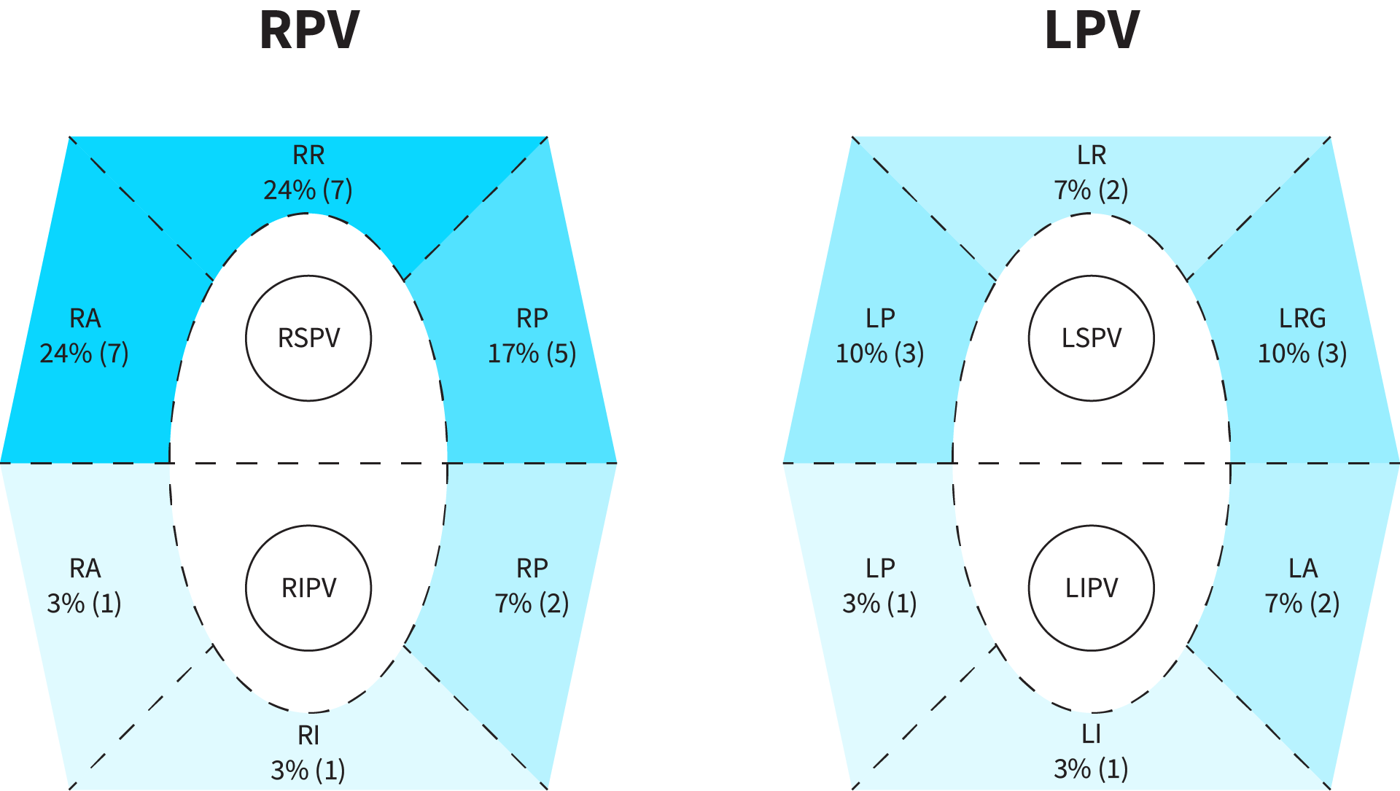

**4. UZ meritve po 12 mesecih**

|  |  |  |  |
| --- | --- | --- | --- |
| **la_volume_index_12** | **la_volume_index** | **razlika** | **p** |
| 41.27 [38.61, 44.03] | 39.63 [36.95, 42.39] | 1.64 [-0.71, 4] | 0.25 |

**5. Čas drugega posega**

|  |  |  |
| --- | --- | --- |
| **close** | **high_density** | **p** |
| 415.08 [389.88, 440.54] | 386.76 [349.76, 421.1] | 0.09 |

**6. Število izoliranih ven**

|  |  |  |  |
| --- | --- | --- | --- |
|  | **close** | **high density** | **p** |
| **number of isolated veins** | 3.23 [2.87, 3.53] | 3.69 [3.41, 3.9] | **0.01** |
| **percentage of isolated veins** | 80.83% [72.5%, 88.33%] | 92.24% [85.34%, 97.41%] | **0.02** |
| **all four veins isolated** | 46.67% [30%, 63.33%] | 79.31% [62.07%, 93.1%] | **0.02** |

**Slika 1:**

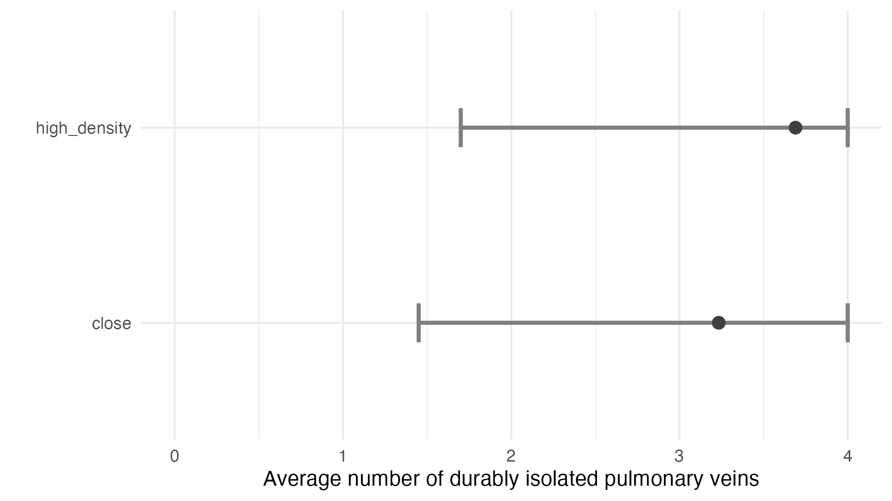

**Slika 2:**

**Slika 3:**

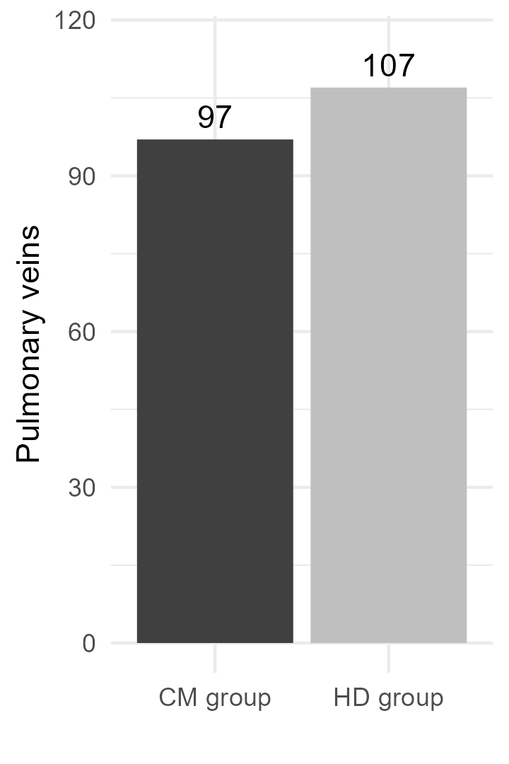

**7. Čas in število lezij**

|  |  |  |  |
| --- | --- | --- | --- |
|  | **close** | **high density** | **p** |
| **skin_skin_time2** | 83.97 [73.2, 95.33] | 72.04 [60.89, 83.82] | 0.15 |
| **ablate_reisolization_time** | 3.63 [2.45, 5.1] | 3.52 [1.93, 4.97] | 0.79 |
| **ablate_removal_time_dormant** | 3.27 [2.55, 4.17] | 4 [2.6, 5.59] | 0.84 |
| **rf_lesion_number_isolation** | 13.5 [10.25, 16.88] | 10.5 [6.33, 14.67] | 0.39 |
| **rf_lesion_number_gap** | 13.59 [10.68, 16.77] | 10.14 [6.14, 14.43] | 0.32 |

**8. Incidenca neizoliranih mest**

|  |  |  |  |  |  |  |
| --- | --- | --- | --- | --- | --- | --- |
| **lokacija** | | **close %** | **close** | **high_density %** | **high_density** | **p** |
| **RPV** | **rspv_rr** | 10% [0%, 20%] | 3 [0, 7] | 0% | 0 | 0.25 |
|  | **rspv_ra** | 13.33% [3.33%, 26.67%] | 4 [1, 8] | 6.9% [0%, 17.24%] | 2 [0, 5] | 0.7 |
|  | **rspv_rp** | 10% [0%, 20%] | 3 [0, 7] | 6.9% [0%, 17.24%] | 2 [0, 5] | 1 |
|  | **carina** | 10% [0%, 20%] | 3 [0, 7] | 0% | 0 | 0.25 |
|  |  |  |  |  |  |  |
|  | **ripv_ra** | 3.33% [0%, 10%] | 1 [0, 3] | 0% | 0 | 1 |
|  | **ripv_rp** | 10% [0%, 20%] | 3 [0, 7] | 0% | 0 | 0.25 |
|  | **ripv_ri** | 0% | 0 | 0% | 0 | 1 |
|  | **carina** | 10% [0%, 20%] | 3 [0, 7] | 0% | 0 | 0.25 |
|  |  |  |  |  |  |  |
| **LPV** | **lspv_lr** | 3.33% [0%, 10%] | 1 [0, 3] | 3.45% [0%, 10.34%] | 1 [0, 3] | 1 |
|  | **lspv_lrg** | 3.33% [0%, 10%] | 1 [0, 3] | 3.45% [0%, 10.34%] | 1 [0, 3] | 1 |
|  | **lspv_lp** | 6.67% [0%, 16.67%] | 2 [0, 5] | 3.45% [0%, 10.34%] | 1 [0, 3] | 1 |
|  | **carina** | 0% | 0 | 0% | 0 | 1 |
|  |  |  |  |  |  |  |
|  | **lipv_la** | 6.67% [0%, 16.67%] | 2 [0, 5] | 0% | 0 | 0.49 |
|  | **lipv_li** | 0% | 0 | 3.45% [0%, 10.34%] | 1 [0, 3] | 0.99 |
|  | **lipv_lp** | 3.33% [0%, 10%] | 1 [0, 3] | 3.45% [0%, 10.34%] | 1 [0, 3] | 1 |
|  | **carina** | 0% | 0 | 0% | 0 | 1 |

Primerjava med skupinama po venah:

|  |  |  |  |  |  |
| --- | --- | --- | --- | --- | --- |
| **vena** | **close %** | **close** | **high_density %** | **high_density** | **p** |
| **rspv** | 10.83% [5.83%, 16.67%] | 13 [7, 20] | 3.45% [0.86%, 6.9%] | 4 [1, 8] | **0.05** |
| **ripv** | 5.83% [1.67%, 10%] | 7 [2, 12] | 0% | 0 | **0.02** |
| **lspv** | 3.33% [0.83%, 6.67%] | 4 [1, 8] | 2.59% [0%, 6.03%] | 3 [0, 7] | 1 |
| **lipv** | 2.5% [0%, 5.83%] | 3 [0, 7] | 1.72% [0%, 4.31%] | 2 [0, 5] | 1 |

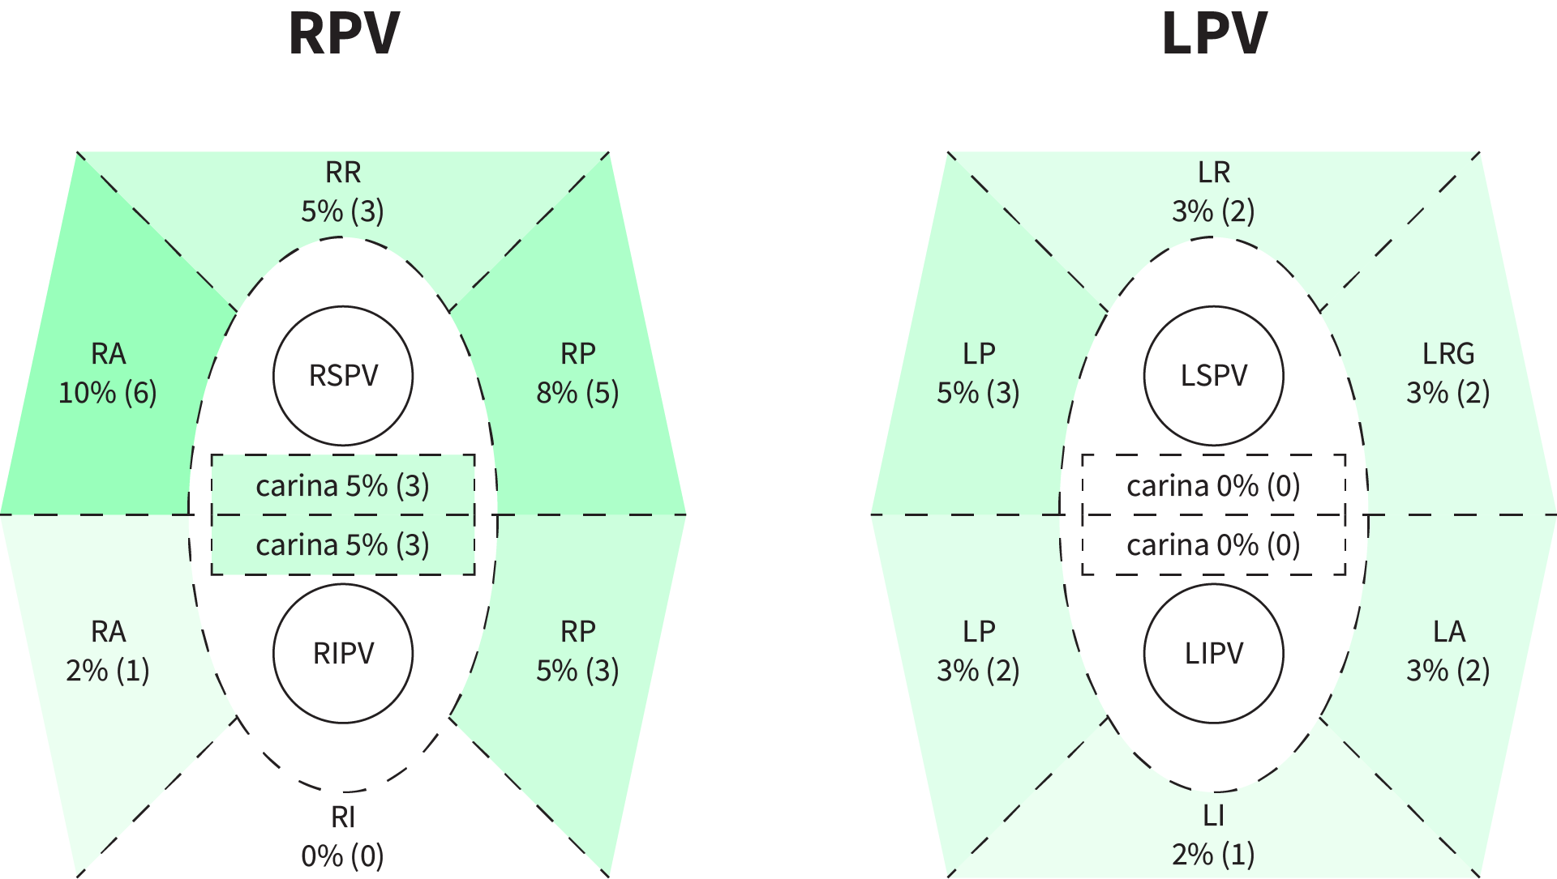

**9. Dormant conduction**

|  |  |  |  |  |
| --- | --- | --- | --- | --- |
| **lokacija** | | **close** | **high_density** | **p** |
| **RPV** | **rspv_rr** | 6 [2, 11] | 1 [0, 3] | **0.047** |
|  | **rspv_ra** | 3 [0, 7] | 2 [0, 5] | 0.65 |
|  | **rspv_rp** | 4 [1, 8] | 1 [0, 3] | 0.17 |
|  |  |  |  |  |
|  | **ripv_ra** | 0 | 0 | 1 |
|  | **ripv_rp** | 4 [1, 8] | 2 [0, 5] | 0.4 |
|  | **ripv_ri** | 0 | 0 | 1 |
|  |  |  |  |  |
|  |  |  |  |  |
| **LPV** | **lspv_lr** | 1 [0, 3] | 0 | 0.33 |
|  | **lspv_lrg** | 5 [1, 9] | 1 [0, 3] | 0.09 |
|  | **lspv_lp** | 4 [0, 9] | 0 | 0.08 |
|  |  |  |  |  |
|  | **lipv_la** | 4 [1, 8] | 0 | **0.04** |
|  | **lipv_li** | 0 | 0 | 1 |
|  | **lipv_lp** | 3 [0, 6] | 0 | 0.08 |

Primerjava med skupinama čez vse lokacije:

|  |  |  |
| --- | --- | --- |
| **close** | **high_density** | **p** |
| 34 [24, 44] | 7 [3, 12] | **0.00002** |

Primerjava med skupinama po venah:

|  |  |  |  |  |
| --- | --- | --- | --- | --- |
| **lokacija** | | **close** | **high_density** | **p** |
| **rspv** | | 13 [7, 20] | 4 [1, 8] | **0.02** |
|  | **ripv** | 4 [1, 8] | 2 [0, 5] | 0.41 |
|  | **lspv** | 10 [4, 17] | 1 [0, 3] | **0.01** |
|  | **lipv** | 7 [3, 13] | 0 | **0.01** |

Close

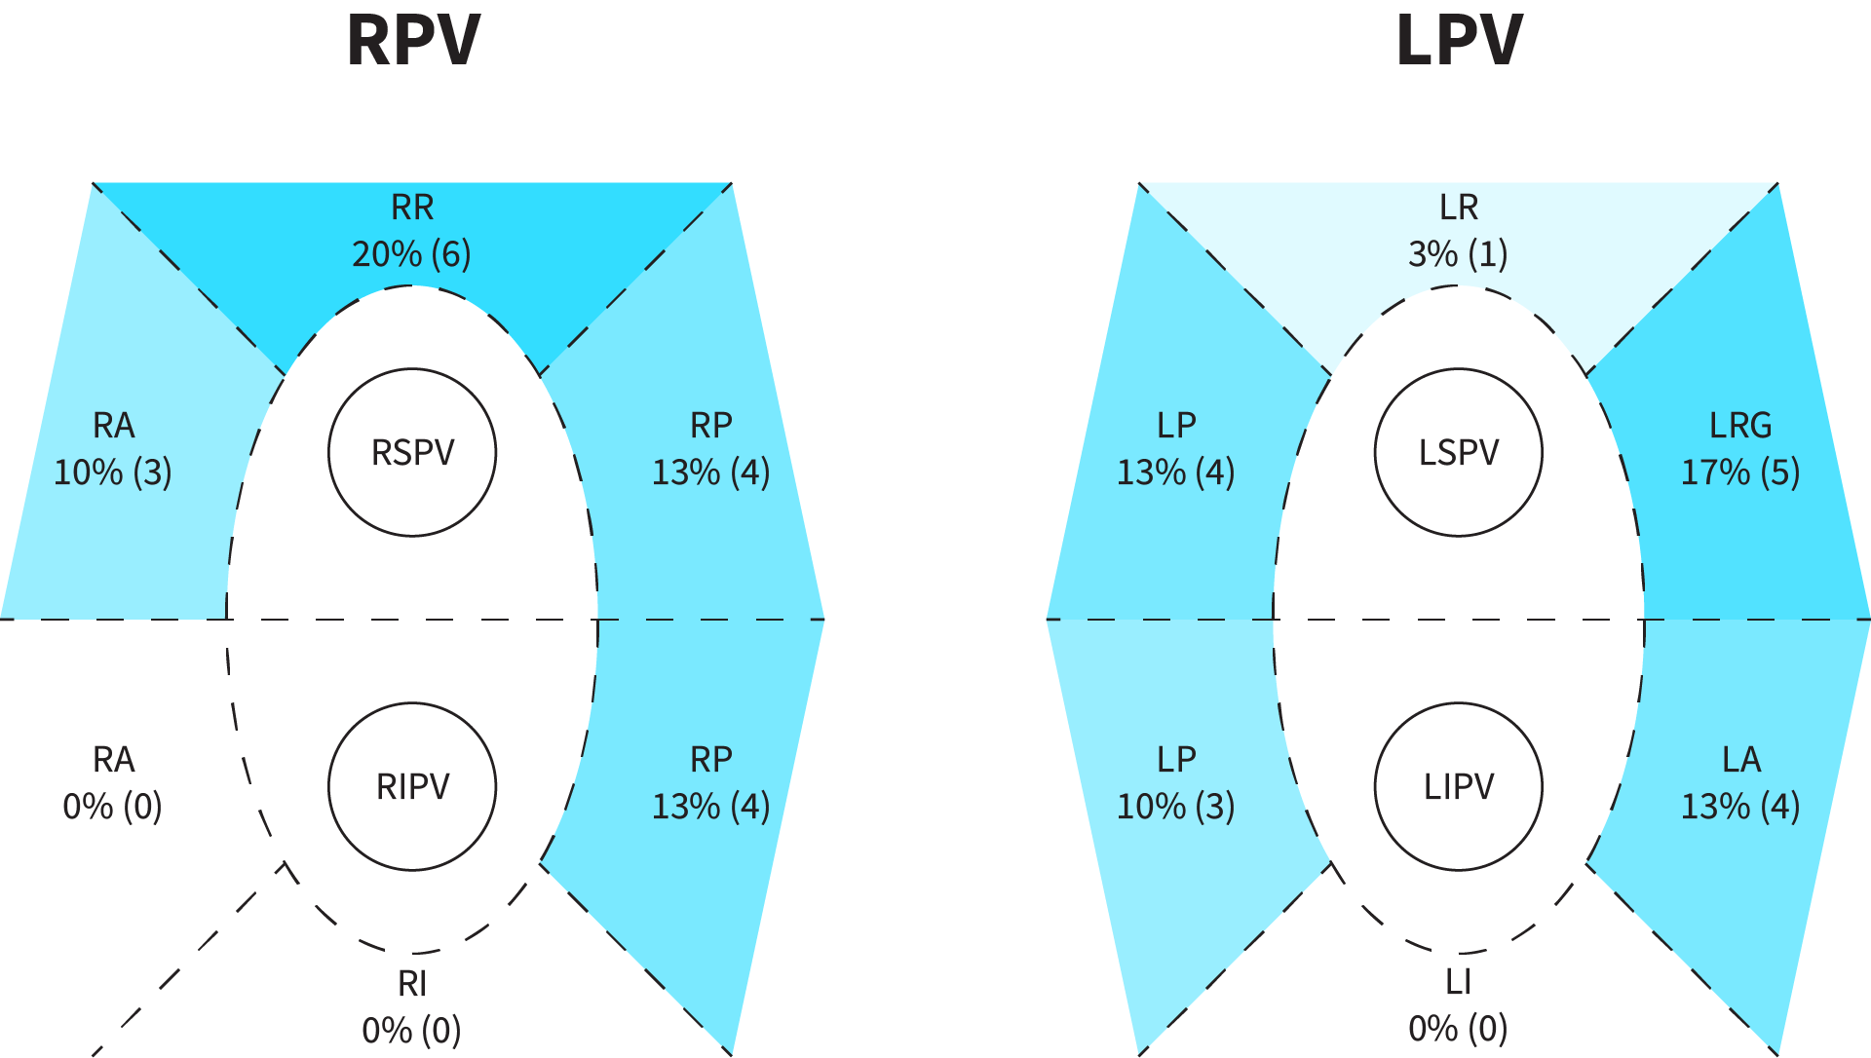

High density

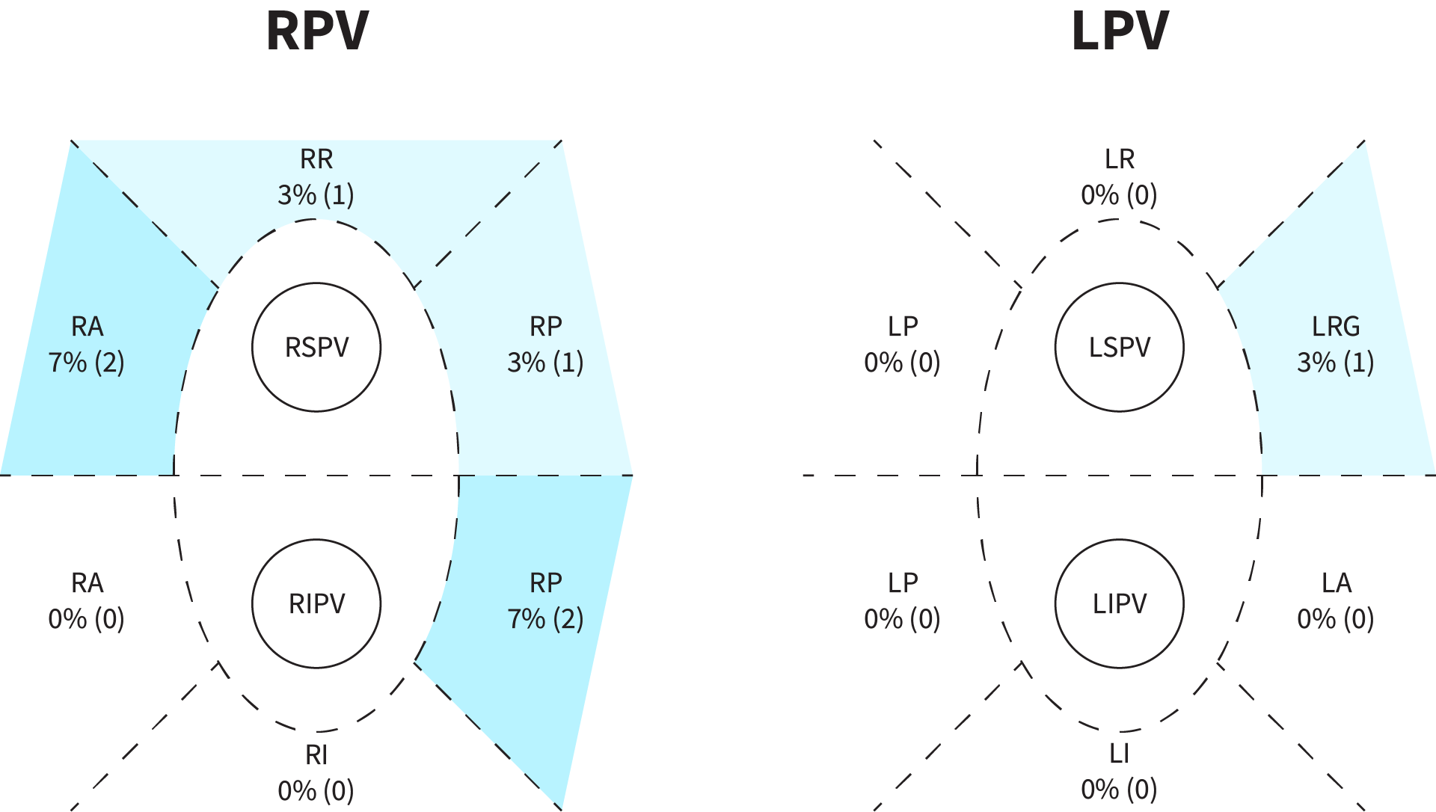

**10. Klinični recidivi**

Število/procent recidivov:

|  |  |  |  |
| --- | --- | --- | --- |
|  | **close** | **high density** | **p** |
| **number of recidivs** | 10 [5, 15] | 7 [3, 12] | 0.44 |
| **percentage of recidivs** | 33.33% [16.67%, 50%] | 24.14% [10.34%, 41.38%] | 0.62 |

Razlika od posega do recidiva v dnevih, **gledamo samo tiste, ki so imeli recidiv**:

|  |  |  |
| --- | --- | --- |
| **close** | **high_density** | **p** |
| 224.6 [168.3, 286.3] | 149.29 [107.57, 200.71] | **0.04** |
|  |  |  |

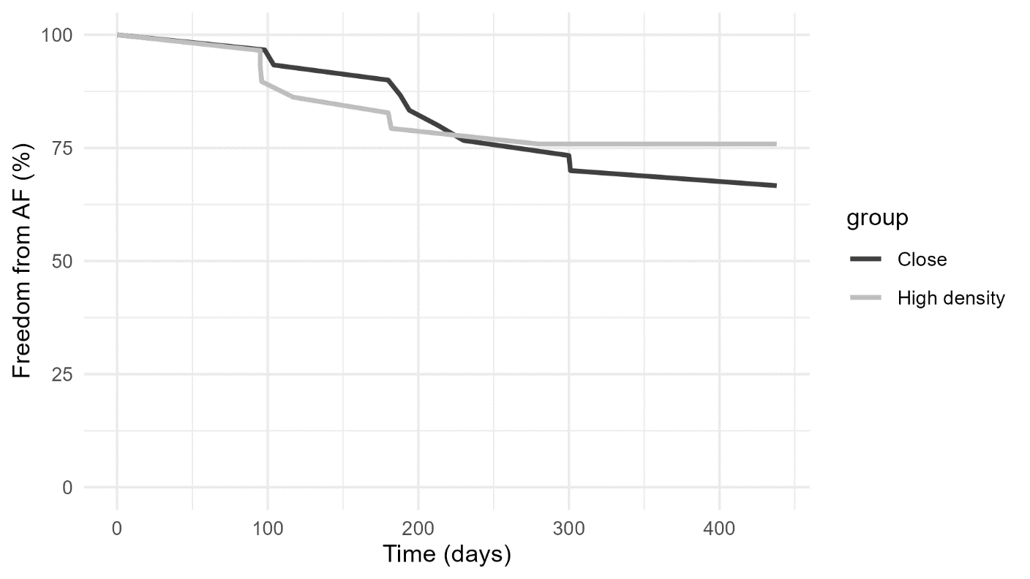

*Ali so pacienti z recidivom imeli v povprečju rekonektiranih več ven kot tisti, ki niso imeli recidiva?*

|  |  |  |  |
| --- | --- | --- | --- |
|  | **recidiv** | **no_recidiv** | **p** |
| **number of reconnected veins** | 0.76 [0.24, 1.41] | 0.45 [0.29, 0.64] | 0.76 |

*Ali so pacienti z recidivom imeli v povprečju več dormantov kot tisti, ki niso imeli recidiva?*

|  |  |  |  |
| --- | --- | --- | --- |
|  | **recidiv** | **no_recidiv** | **p** |
| **dormants** | 0.06 [0.03, 0.1] | 0.06 [0.04, 0.08] | 0.65 |

**11. Lokacije pred/po**

**a.**

*In total the high density procedure was used on 29 patients, since each patient has 12 vein locations this means that the high density procedure could be applied to 348 locations in total. During the first procedure, we found 1 or more dormants at a given location in 34 cases, while we found only 7 dormant locations during the second procedure. In only one case the dormant in the second procedure was found at the same location as during the first procedure, while in 33 cases where there was a dormant during the first procedure at a given location there was no dormant during the second procedure at the same location. Thus, our results suggest that it is more likely that there will be no dormant on the same location during the second procedure (p < 0.0001).*

**b.**

*In total the high density procedure was used on 29 patients, since each patient has 4 main pulmonary veins this means that the high density procedure could be applied to 116 main pulmonary veins in total. During the first procedure, we found 1 or more dormants at a given main pulmonary vein in 30 cases, while we found only 7 dormants in total during the second procedure. In only one case the dormant in the second procedure was found at the same main pulmonary vein as during the first procedure while in 29 cases where there was a dormant during the first procedure in a given main pulmonary vein there was no dormant during the second procedure at the same vein. This means that our results suggest that it is more likely that there will be no dormant on the same location during the second procedure (p < 0.0001).*

**c.**

*Same analysis as* ***b****, but we are looking at dormants and their veins during the index (first) procedure and dormants + unisolated veins during the second procedure. We have 30 veins with dormants in the first procedure and 16 veins with dormants or unisolated veins in the second procedure. In 4 cases we have a dormant or an unisolated vein at the main pulmonary vein where we found a dormant during the first procedure, while there was no dormant or unisolated veins in 26 cases when there was a dormant during the first procedure. Again, this suggests that finding a dormant in a given main pulmonary vein during the first procedure does not indicate that we will have a dormant or unisolated veins in the same main pulmonary vein during the second procedure (0.0001).*

**12. Rekonektirane vene**

Ali demografski podatki (J-AH) napovedujejo rekonektirane vene. Gledamo stolpec all 4 veins, 0 pomeni da je bilo rekonektirano. Tukaj sem gledal čez vse podatke, nisem nič razbijal po skupinah.

Uporabil sem naslednje demografske spremenljivke:

* age,
* gender,
* bmi,
* la_volume_index,
* la_size,
* lvedvi,
* anticoagulant,
* probnp,
* chf,
* hypertension_history,
* age_75,
* diabetes_history,
* vascular_disease,
* age_65_74,
* cha2ds2vasc.

Nič pametnega ne dobimo, BMI ima najnižjo p vrednost (0.098).

Enako samo za proceduralne parametre:

* skin_skin_time,
* la_dwell_time,
* ablation_time,
* number_of_rf_lesions_pvi,
* first_pass_rspv,
* first_pass_ripv,
* first_pass_lspv,
* first_pass_lipv,
* first_pass_per_patient,
* all_4_veins_isolated.

Nič pametnega, p za vse parametre je nad 0.2.