Linking MySQL Database to Django Project

Online Resources:

* <https://medium.com/@omaraamir19966/connect-django-with-mysql-database-f946d0f6f9e3>
* <https://pythonsansar.com/how-connect-mysql-database-django-using-mysqlclient-package/>

1. Create a python virtual environment via “python3 -m venv <name>”
2. Activate the environment via “source <name>/bin/activate”
3. Install Django “python -m pip install django”
4. Install mysqlclient “python -m pip install mysqlclient”
   1. For this to work on my Mac I had to have mysql installed which I just did with brew “brew install mysql”
5. Then create Django project “Django-admin start project <project name>”

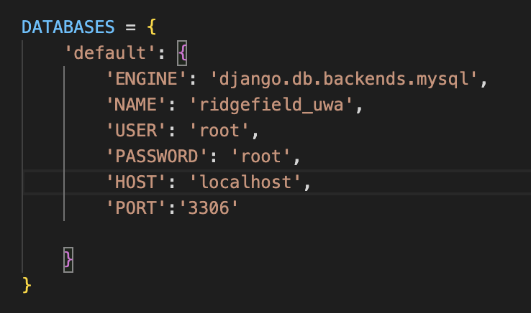

Figure 1

1. Go to the “settings.py” file within this project
2. Edit the values to match the requirements of the database (I will get these and edit this document soon.) Refer to Figure 1, and on what to do.
3. Finally Migrate these changes with “python manage.py migrate”