# Preenchimento de falhas

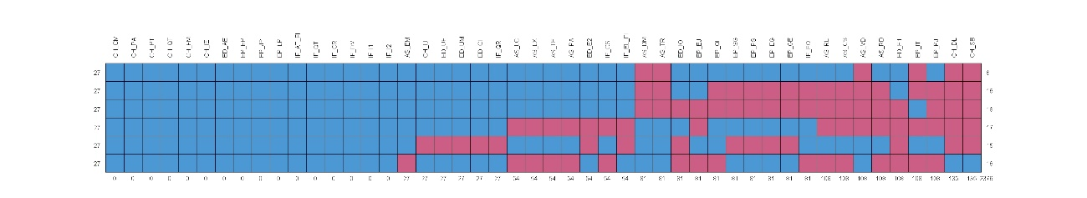

pobs = Proportion observed, influx = Influx

outflux = Outflux

ainb = Average inbound statistic

aout = Average outbound statistic

fico = Fraction of incomplete cases among cases with Yj observed

|  |  |  |  |  |  |  |
| --- | --- | --- | --- | --- | --- | --- |
|  | **pobs** | **influx** | **outflux** | **ainb** | **aout** | **fico** |
| AS_EM | 0.8333333 | 0.160 | 0.8181818 | 0.6808511 | 0.3063830 | 1 |
| AS_LC | 0.6666667 | 0.315 | 0.6250000 | 0.6702128 | 0.2925532 | 1 |
| AS_LX | 0.6666667 | 0.315 | 0.6250000 | 0.6702128 | 0.2925532 | 1 |
| AS_TE | 0.6666667 | 0.315 | 0.6250000 | 0.6702128 | 0.2925532 | 1 |
| AS_PA | 0.6666667 | 0.315 | 0.6250000 | 0.6702128 | 0.2925532 | 1 |
| AS_RL | 0.3333333 | 0.625 | 0.2386364 | 0.6648936 | 0.2234043 | 1 |
| AS_CS | 0.3333333 | 0.625 | 0.2386364 | 0.6648936 | 0.2234043 | 1 |
| AS_DM | 0.5000000 | 0.520 | 0.5454545 | 0.7375887 | 0.3404255 | 1 |
| AS_VD | 0.3333333 | 0.675 | 0.3522727 | 0.7180851 | 0.3297872 | 1 |
| AS_RD | 0.3333333 | 0.625 | 0.2386364 | 0.6648936 | 0.2234043 | 1 |
| AS_TR | 0.5000000 | 0.520 | 0.5454545 | 0.7375887 | 0.3404255 | 1 |
| CH_CM | 1.0000000 | 0.000 | 1.0000000 | 0.0000000 | 0.3120567 | 1 |
| CH_PA | 1.0000000 | 0.000 | 1.0000000 | 0.0000000 | 0.3120567 | 1 |
| CH_PT | 1.0000000 | 0.000 | 1.0000000 | 0.0000000 | 0.3120567 | 1 |
| CH_QT | 1.0000000 | 0.000 | 1.0000000 | 0.0000000 | 0.3120567 | 1 |
| CH_FM | 1.0000000 | 0.000 | 1.0000000 | 0.0000000 | 0.3120567 | 1 |
| CH_IE | 1.0000000 | 0.000 | 1.0000000 | 0.0000000 | 0.3120567 | 1 |
| CH_IJ | 0.8333333 | 0.165 | 0.8295455 | 0.7021277 | 0.3106383 | 1 |
| CH_DL | 0.1666667 | 0.840 | 0.1818182 | 0.7148936 | 0.3404255 | 1 |
| CH_SB | 0.1666667 | 0.840 | 0.1818182 | 0.7148936 | 0.3404255 | 1 |
| ED_AE | 1.0000000 | 0.000 | 1.0000000 | 0.0000000 | 0.3120567 | 1 |
| ED_E1 | 0.3333333 | 0.630 | 0.2500000 | 0.6702128 | 0.2340426 | 1 |
| ED_E2 | 0.6666667 | 0.320 | 0.6363636 | 0.6808511 | 0.2978723 | 1 |
| ED_IO | 0.5000000 | 0.475 | 0.4431818 | 0.6737589 | 0.2765957 | 1 |
| ED_UF | 0.8333333 | 0.165 | 0.8295455 | 0.7021277 | 0.3106383 | 1 |
| ED_UM | 0.8333333 | 0.165 | 0.8295455 | 0.7021277 | 0.3106383 | 1 |
| ED_CI | 0.8333333 | 0.165 | 0.8295455 | 0.7021277 | 0.3106383 | 1 |
| EP_EJ | 0.5000000 | 0.465 | 0.4204545 | 0.6595745 | 0.2624113 | 1 |
| EP_EP | 1.0000000 | 0.000 | 1.0000000 | 0.0000000 | 0.3120567 | 1 |
| EP_JP | 1.0000000 | 0.000 | 1.0000000 | 0.0000000 | 0.3120567 | 1 |
| EP_LP | 1.0000000 | 0.000 | 1.0000000 | 0.0000000 | 0.3120567 | 1 |
| EP_IT | 0.3333333 | 0.685 | 0.3750000 | 0.7287234 | 0.3510638 | 1 |
| EP_QI | 0.5000000 | 0.470 | 0.4318182 | 0.6666667 | 0.2695035 | 1 |
| EP_PJ | 0.3333333 | 0.625 | 0.2386364 | 0.6648936 | 0.2234043 | 1 |
| EP_SG | 0.5000000 | 0.475 | 0.4431818 | 0.6737589 | 0.2765957 | 1 |
| EP_PS | 0.5000000 | 0.475 | 0.4431818 | 0.6737589 | 0.2765957 | 1 |
| EP_EG | 0.5000000 | 0.475 | 0.4431818 | 0.6737589 | 0.2765957 | 1 |
| EP_GE | 0.5000000 | 0.475 | 0.4431818 | 0.6737589 | 0.2765957 | 1 |
| IF_AT_FI | 1.0000000 | 0.000 | 1.0000000 | 0.0000000 | 0.3120567 | 1 |
| IF_QT | 1.0000000 | 0.000 | 1.0000000 | 0.0000000 | 0.3120567 | 1 |
| IF_CR | 1.0000000 | 0.000 | 1.0000000 | 0.0000000 | 0.3120567 | 1 |
| IF_CS | 0.6666667 | 0.315 | 0.6250000 | 0.6702128 | 0.2925532 | 1 |
| IF_DV | 1.0000000 | 0.000 | 1.0000000 | 0.0000000 | 0.3120567 | 1 |
| IF_EL_FI | 0.6666667 | 0.320 | 0.6363636 | 0.6808511 | 0.2978723 | 1 |
| IF_I1 | 1.0000000 | 0.000 | 1.0000000 | 0.0000000 | 0.3120567 | 1 |
| IF_I2 | 1.0000000 | 0.000 | 1.0000000 | 0.0000000 | 0.3120567 | 1 |
| IF_QR | 0.8333333 | 0.165 | 0.8295455 | 0.7021277 | 0.3106383 | 1 |
| IF_FO | 0.5000000 | 0.470 | 0.4318182 | 0.6666667 | 0.2695035 | 1 |

# MDS

Cotovelo

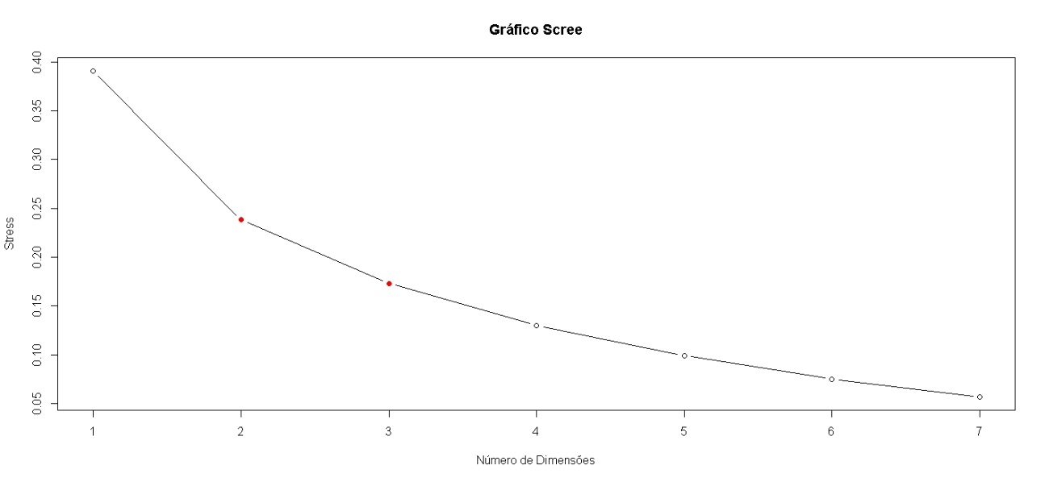

> p_mds(dados_a, 1)

initial value 41.490724

final value 41.489534

converged

P-valor: 1

[1] 1

> p_mds(dados_a, 2)

initial value 24.259448

final value 24.258704

converged

P-valor: 1

[1] 1

> p_mds(dados_a, 3) # <-

initial value 19.761962

final value 19.761296

converged

P-valor: 0

[1] 0

> p_mds(dados_a, 4) # <-

initial value 16.938695

final value 16.938022

converged

P-valor: 0

[1] 0

Correlações

|  |  |  |  |
| --- | --- | --- | --- |
|  | [,1] | [,2] | [,3] |
| AS_EM | 0.232776229 | 0.02833852 | -0.05685880 |
| AS_LC | 0.386552212 | -0.27363850 | -0.24165046 |
| AS_LX | 0.439676876 | 0.10302118 | -0.18783686 |
| AS_TE | 0.646527153 | -0.29327512 | -0.24782674 |
| AS_PA | 0.673084457 | 0.46911861 | 0.13271123 |
| AS_RL | 0.486139928 | -0.29709589 | 0.22032257 |
| AS_CS | 0.780740699 | -0.14820665 | 0.15523493 |
| AS_DM | 0.324276637 | -0.36624276 | 0.06073852 |
| AS_VD | -0.130238214 | 0.03155708 | -0.59866626 |
| AS_RD | -0.331920027 | 0.31419114 | 0.05009450 |
| AS_TR | 0.053088820 | 0.17987119 | -0.52324237 |
| CH_CM | -0.774817094 | 0.40003255 | 0.33647123 |
| CH_PA | 0.632010660 | -0.45673117 | -0.38052867 |
| CH_PT | 0.709684693 | -0.32896940 | -0.35945521 |
| CH_QT | 0.700654806 | -0.45866168 | -0.36547984 |
| CH_FM | 0.904884534 | -0.15377227 | -0.05461041 |
| CH_IE | 0.471971114 | 0.04865671 | 0.23843101 |
| CH_IJ | 0.785469393 | -0.11494052 | 0.07076002 |
| CH_DL | 0.187932421 | -0.19593601 | 0.65807909 |
| CH_SB | 0.436522015 | -0.16623086 | 0.23541053 |
| ED_AE | 0.154612938 | 0.70071354 | -0.20069542 |
| ED_E1 | 0.520294551 | -0.04656925 | 0.16305131 |
| ED_E2 | 0.877673831 | 0.09797213 | -0.08226667 |
| ED_IO | -0.755966339 | -0.04326613 | 0.07415627 |
| ED_UF | 0.295178702 | 0.41533443 | 0.28044332 |
| ED_UM | 0.626388761 | -0.07286309 | -0.08327536 |
| ED_CI | 0.500119817 | 0.49845290 | 0.26389038 |
| EP_EJ | -0.187588003 | -0.66053158 | 0.01406242 |
| EP_EP | 0.557008584 | 0.41745674 | -0.21507623 |
| EP_JP | 0.371384515 | 0.54953875 | -0.05284485 |
| EP_LP | 0.593292909 | 0.58250627 | -0.03718423 |
| EP_IT | 0.251194683 | 0.30505509 | 0.18570410 |
| EP_QI | -0.015264409 | 0.25329034 | 0.05603252 |
| EP_PJ | 0.299246219 | -0.57487878 | -0.09250578 |
| EP_SG | 0.383034341 | 0.19563586 | 0.27825608 |
| EP_PS | 0.490538317 | 0.07357676 | -0.26693567 |
| EP_EG | -0.004302773 | -0.02012903 | -0.16037081 |
| EP_GE | -0.135894918 | -0.20940457 | -0.21658415 |
| IF_AT_FI | 0.878347981 | -0.09834500 | -0.23057502 |
| IF_QT | 0.354006475 | 0.10070234 | 0.32527406 |
| IF_CR | 0.476125950 | 0.24094551 | 0.21763739 |
| IF_CS | -0.354710969 | 0.05598674 | -0.21219639 |
| IF_DV | 0.561339768 | 0.12204123 | -0.38254461 |
| IF_EL_FI | 0.582765787 | 0.22113631 | 0.18207885 |
| IF_I1 | -0.080137116 | -0.41695794 | 0.22187936 |
| IF_I2 | 0.192006308 | 0.58475276 | 0.01449167 |
| IF_QR | 0.567279572 | 0.07897790 | 0.05373567 |
| IF_FO | 0.534991888 | -0.13351084 | 0.11423164 |