Task1.Part1

1. Log in to the system as root.

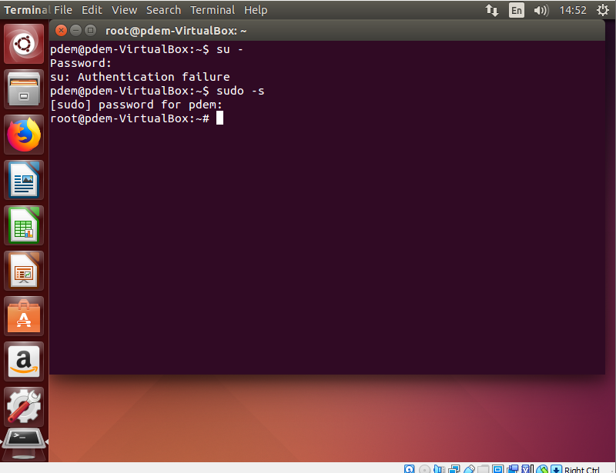

2) Use the passwd command to change the password. Examine the basic

parameters of the command. What system file does it change *?

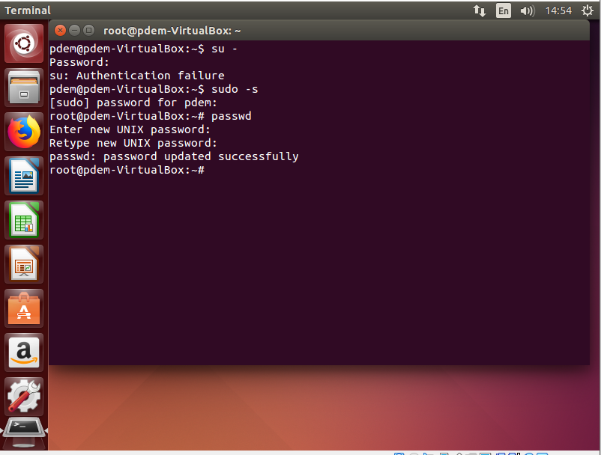

Flags

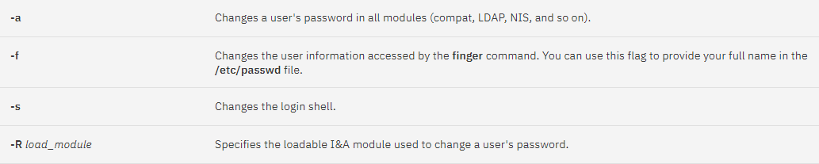

following restrictions

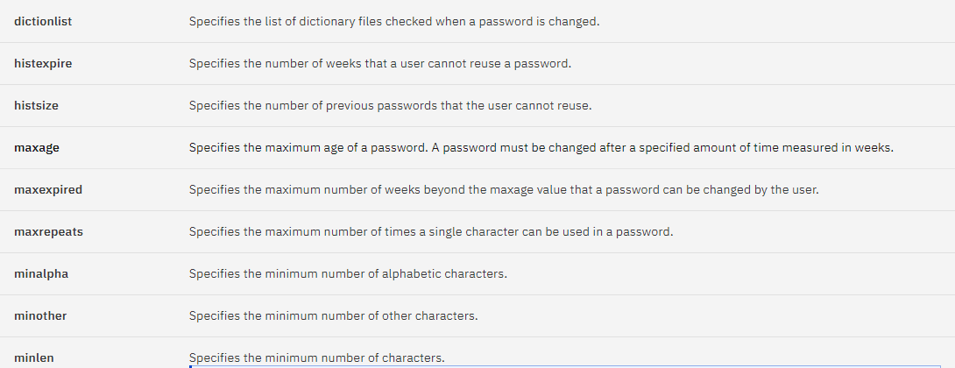

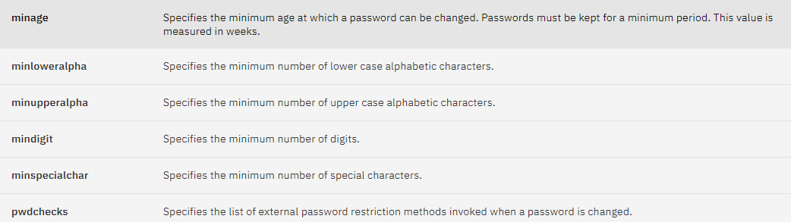

3. Determine the users registered in the system, as well as what commands they

execute. What additional information can be gleaned from the command

execution?

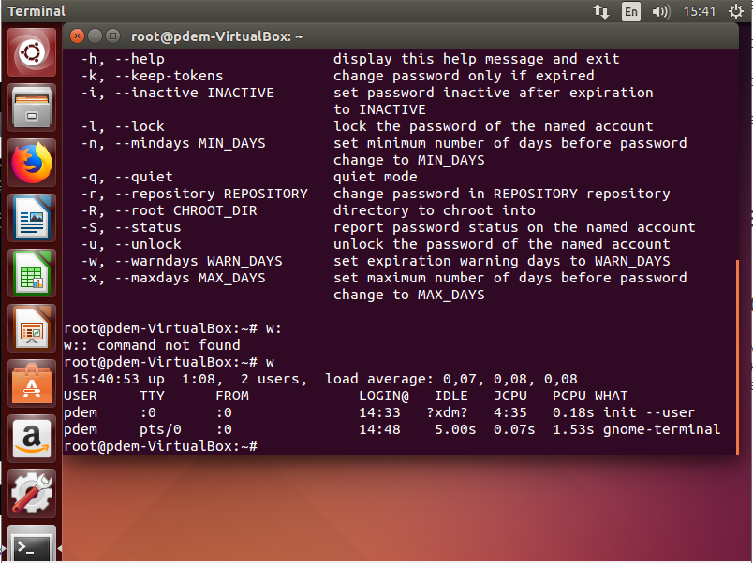

we can see when a user is logged in, what function it performs, username, etc.

4) Change personal information about yourself.



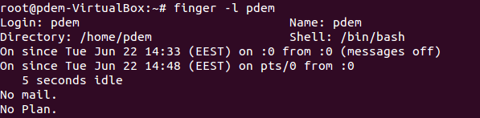

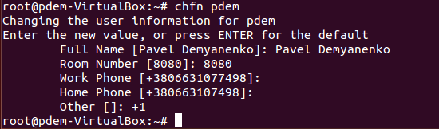

4. Become familiar with the Linux help system and the man and info commands.

Get help on the previously discussed commands, define and describe any two

keys for these commands. Give examples.

Man chfn

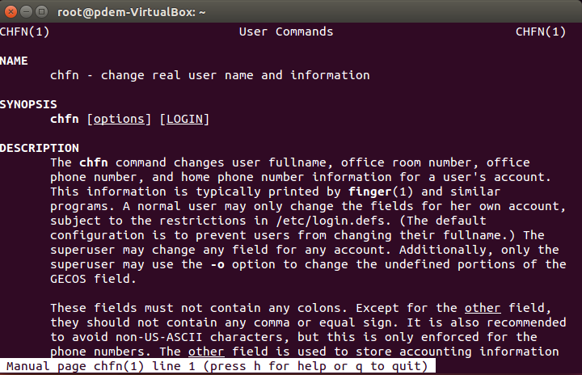

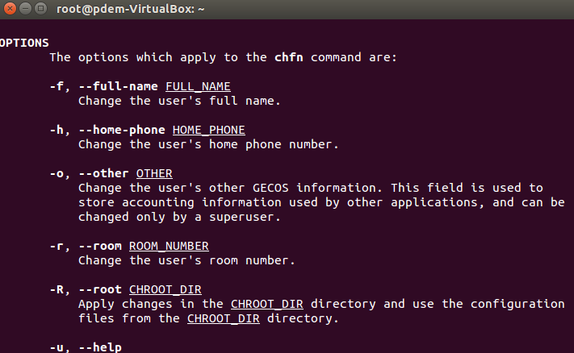

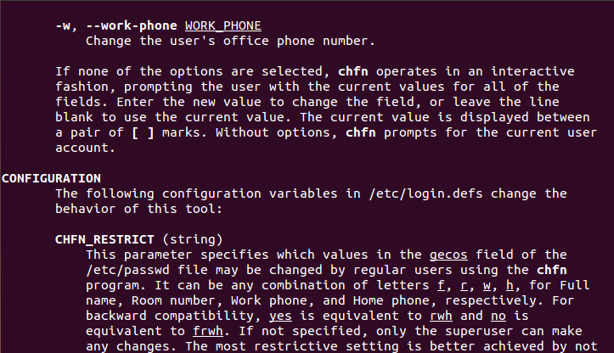

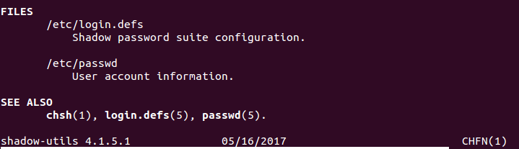

Info sudo

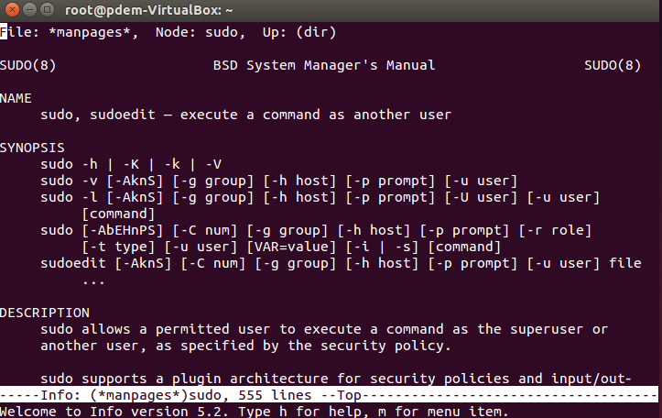

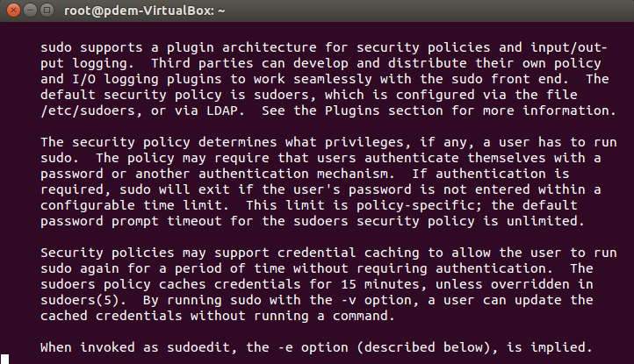

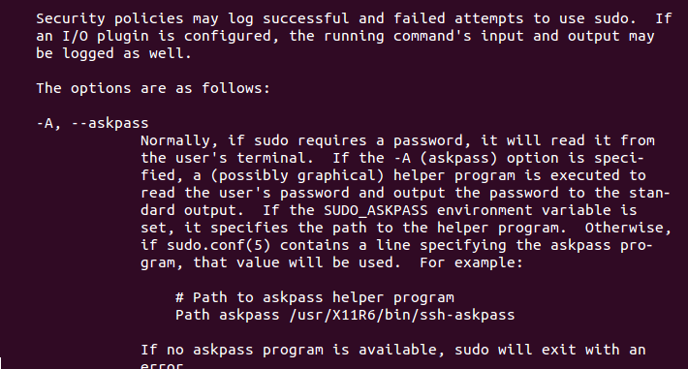

И т.д. там очень большая документация для sudo



5. Explore the more and less commands using the help system. View the contents

of files .bash* using commands.

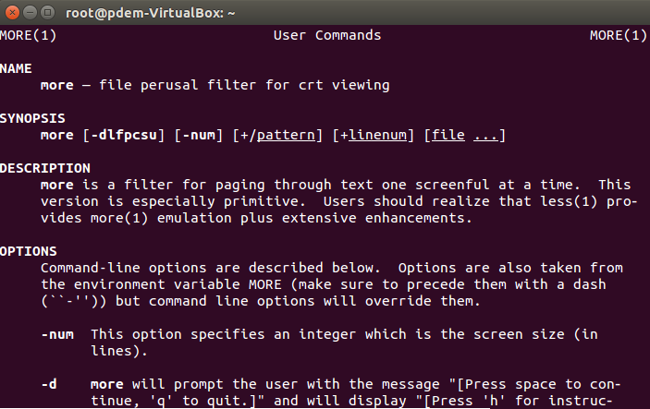

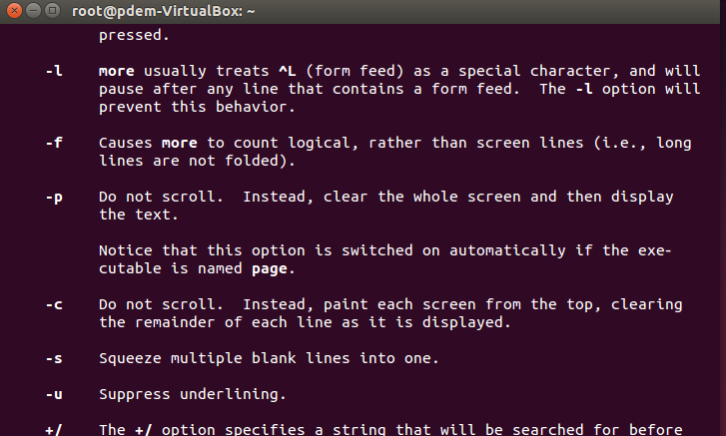

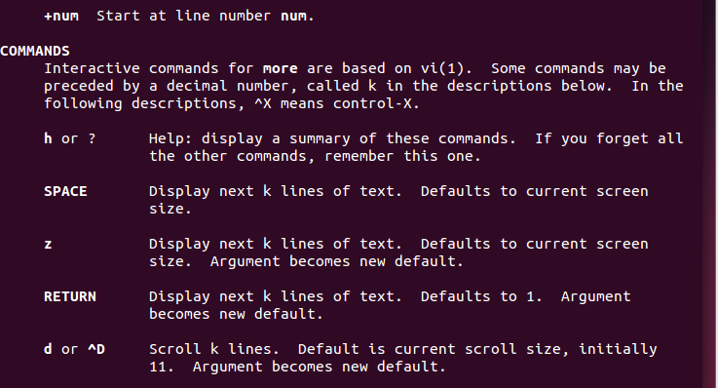

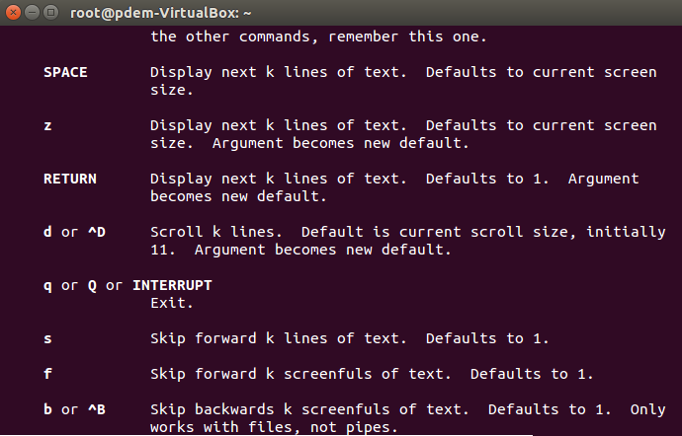 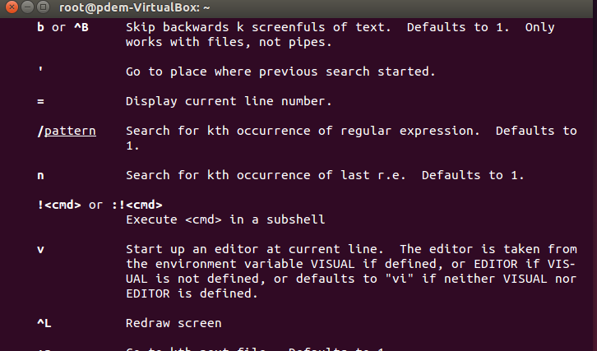 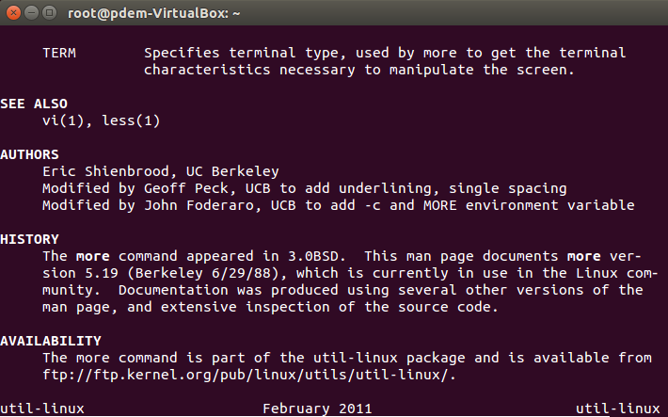

Man less

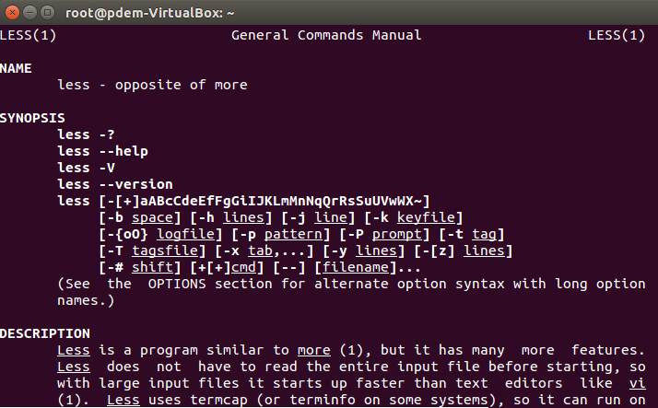 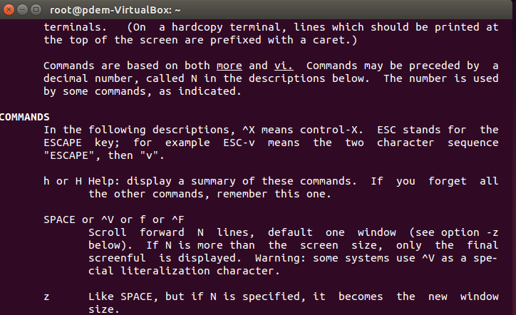 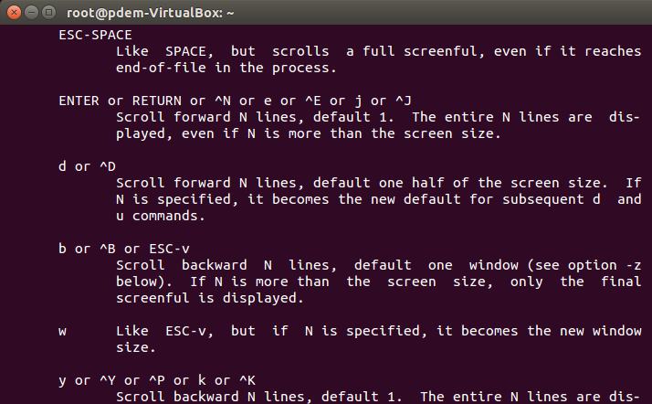

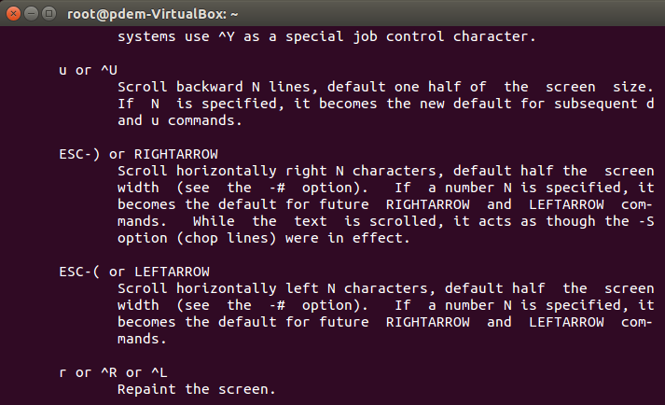

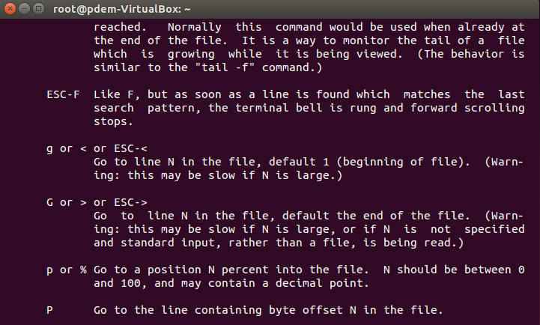

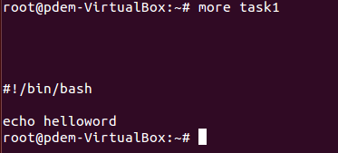

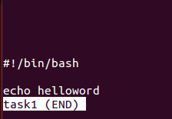

* Describe in plans that you are working on laboratory work 1. Tip: You should

read the documentation for the finger command.

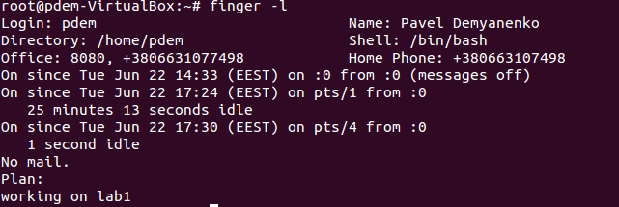

* List the contents of the home directory using the ls command, define its files

and directories. Hint: Use the help system to familiarize yourself with the ls

command.

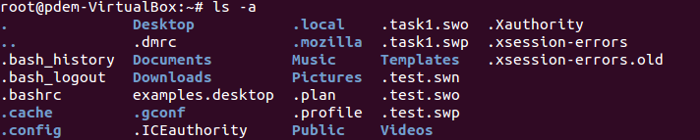

То что в конце с символами «/» – каталог , остальное файлы

Task1.Part2

1) Examine the tree command. Master the technique of applying a template, for

example, display all files that contain a character c, or files that contain a

specific sequence of characters. List subdirectories of the root directory up to

and including the second nesting level.

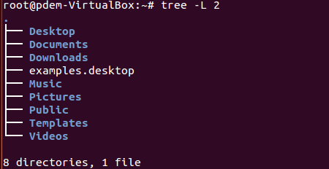

What command can be used to determine the type of file (for example, text or

binary)? Give an example.

Команда file * . Где есть text или связано с ASCII – текстовый файл, где нет – бинарный.

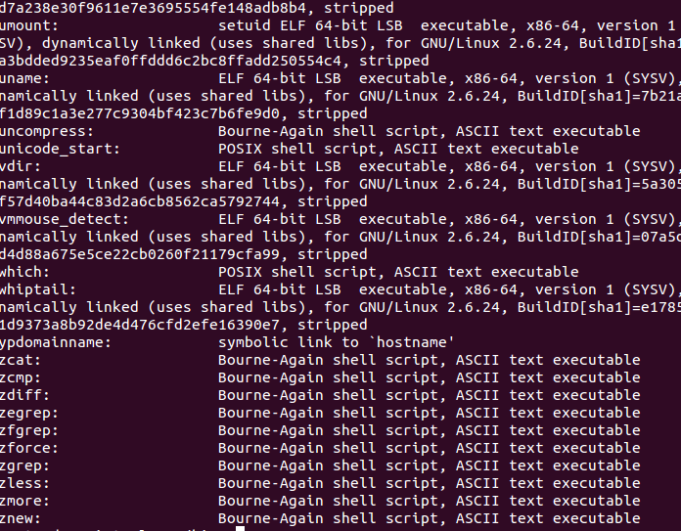

Master the skills of navigating the file system using relative and absolute paths.

How can you go back to your home directory from anywhere in the filesystem?

Всегда можно вернуться просто написав команду cd, из любоо места доставляет в домашнюю директорию.



Become familiar with the various options for the ls command. Give examples

of listing directories using different keys. Explain the information displayed on

the terminal using the -l and -a switches.

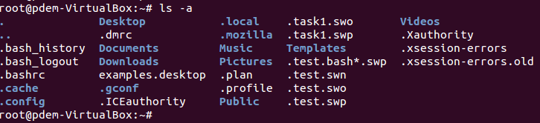

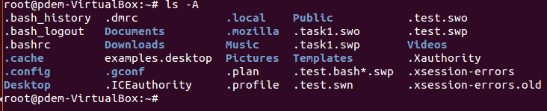

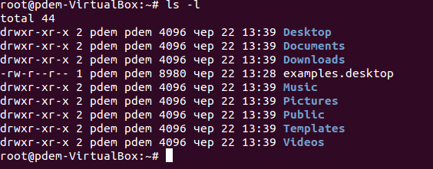

Ls –a выведет все файлы и директории, даже скрытые в текущей директории

Ls – l Вывод в длинном формате: перед именами файлов выдается режим доступа, количество ссылок на файл, имена владельца и группы, размер в байтах и время последней модификации

Perform the following sequence of operations:

- create a subdirectory in the home directory;

- in this subdirectory create a file containing information about directories

located in the root directory (using I/O redirection operations);

- view the created file;

- copy the created file to your home directory using relative and absolute

addressing.

- delete the previously created subdirectory with the file requesting removal;

- delete the file copied to the home directory.



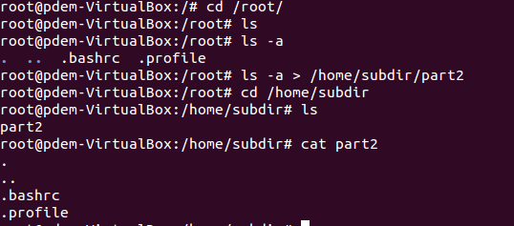







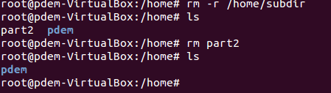

6) Perform the following sequence of operations:

- create a subdirectory test in the home directory;

- copy the .bash_history file to this directory while changing its name to

labwork2;

- create a hard and soft link to the labwork2 file in the test subdirectory;

- how to define soft and hard link, what do these

concepts;

- change the data by opening a symbolic link. What changes will happen and

why

- rename the hard link file to hard_lnk_labwork2;

- rename the soft link file to symb_lnk_labwork2 file;

- then delete the labwork2. What changes have occurred and why?



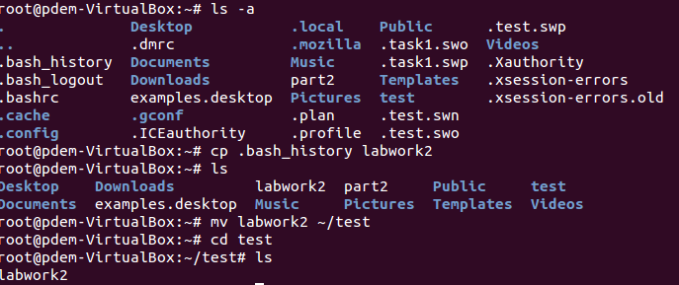

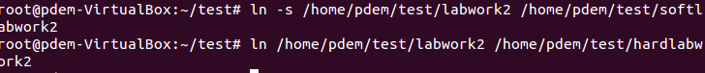

A soft link is a special type of file that contains a link to another file or directory as an absolute or relative path.

A hard link is a structural component of a file that describes its directory entry.

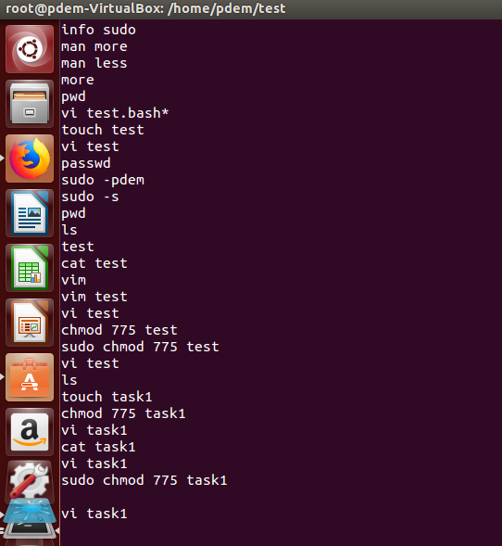

the data in the file has also changed because the hard link and the file for which it was created have the same inode in the file system. A soft link is a special type of file that contains a link to another file or directory as an absolute or relative path.

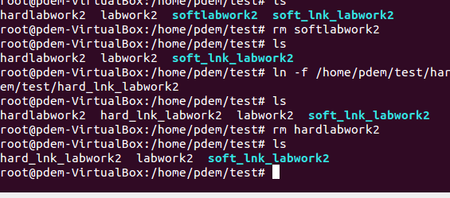

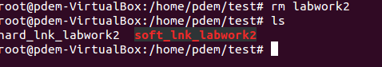

soft link is broken because soft link is a special type of file that contains a link to another file or directory as an absolute or relative path if file was removed soft link are broken too.

7) Using the locate utility, find all files that contain the squid and traceroute

sequence.

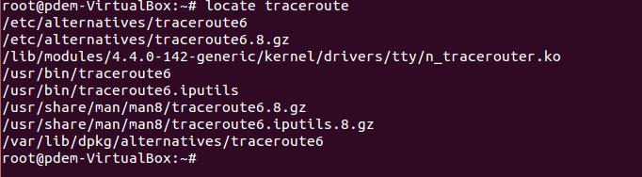

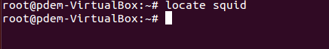

Determine which partitions are mounted in the system, as well as the types of

these partitions.

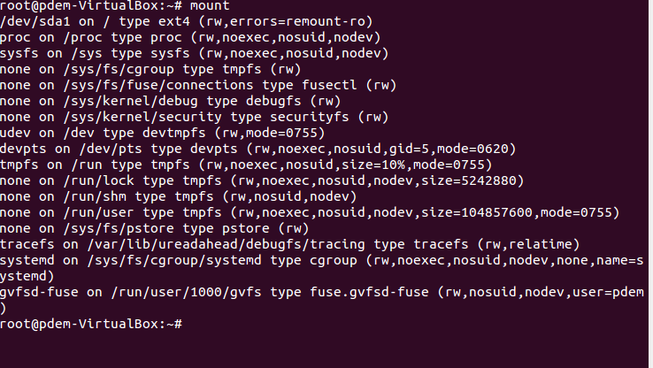

(Не знаю насколько это точно)

9) Count the number of lines containing a given sequence of characters in a given

file.

(не понял в каком файле)

10) Using the find command, find all files in the /etc directory containing the

host character sequence.

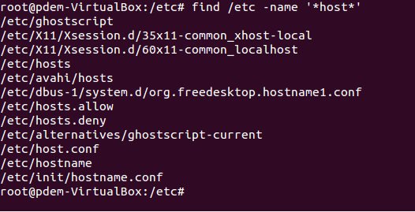

List all objects in /etc that contain the ss character sequence. How can I

duplicate a similar command using a bunch of grep?

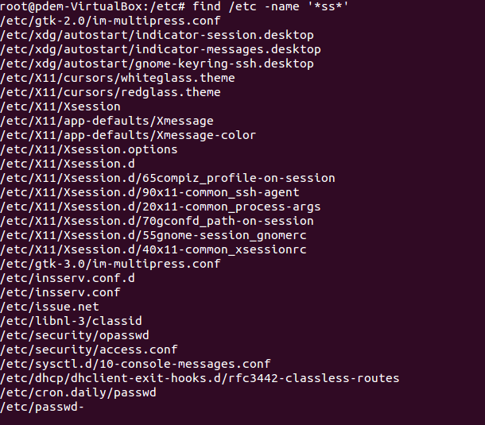

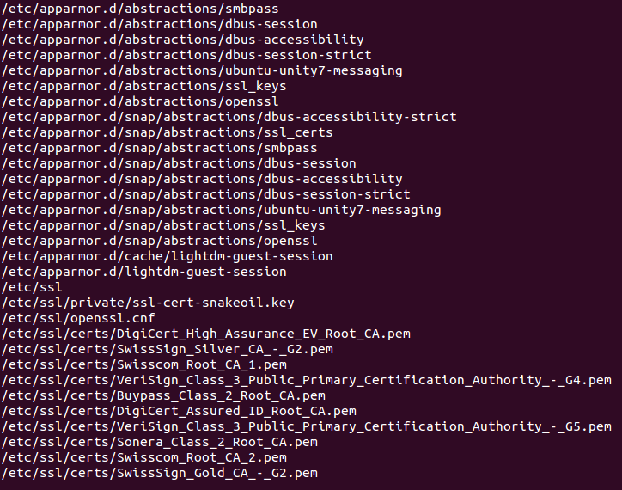

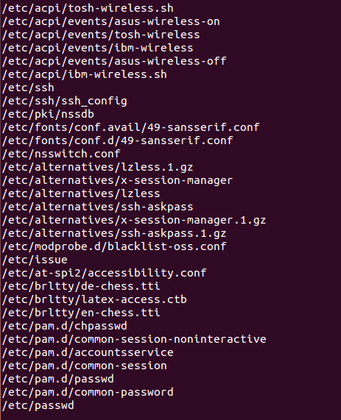



Это не точно

11) Organize a screen-by-screen print of the contents of the /etc directory. Hint:

You must use stream redirection operations.



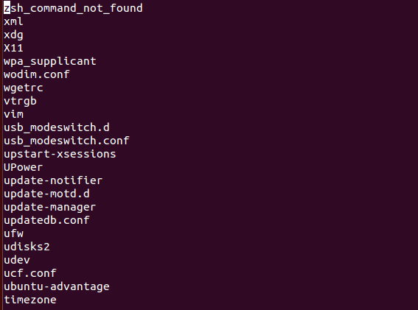

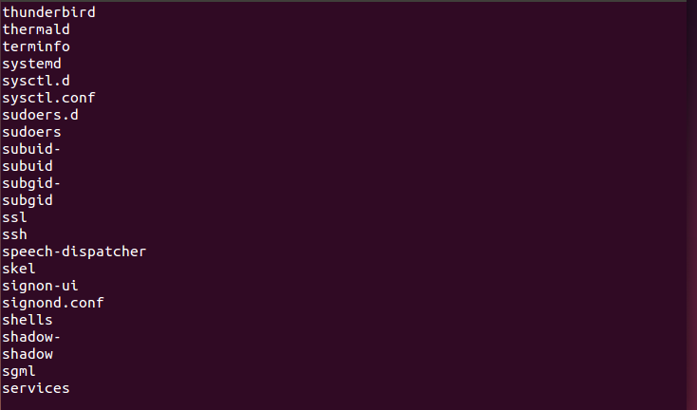

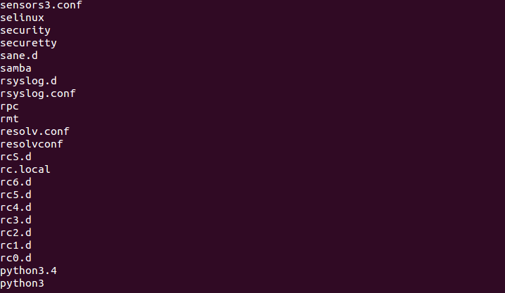

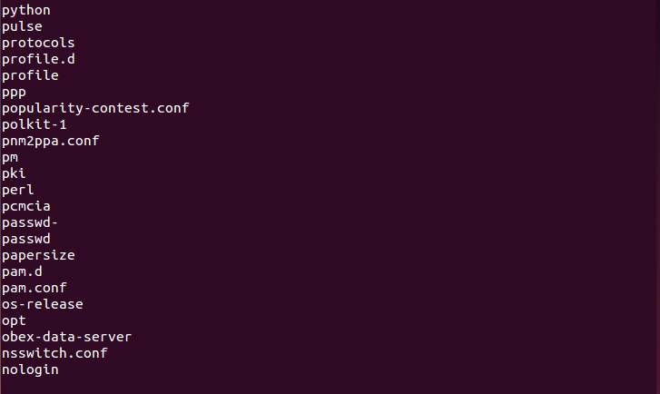

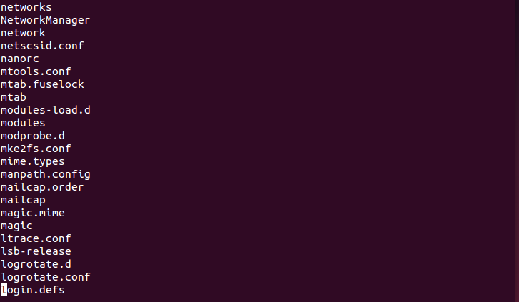

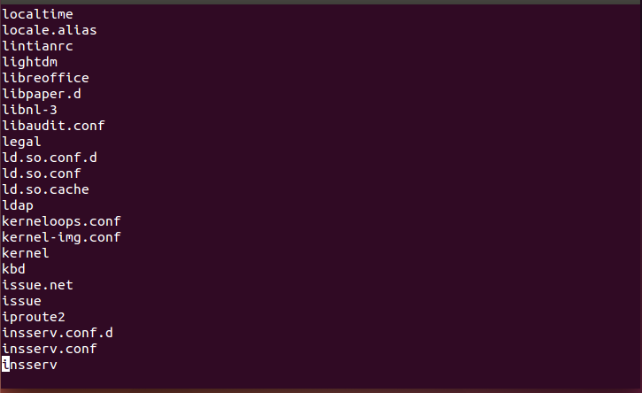

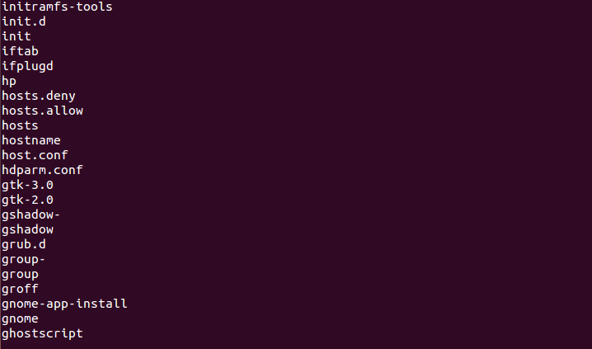

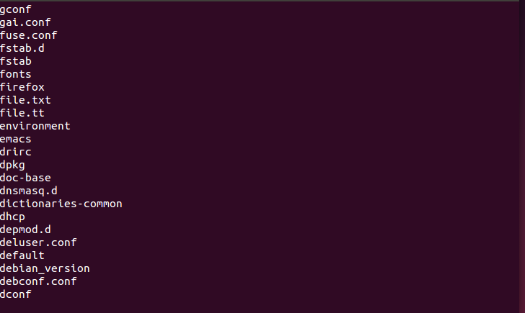

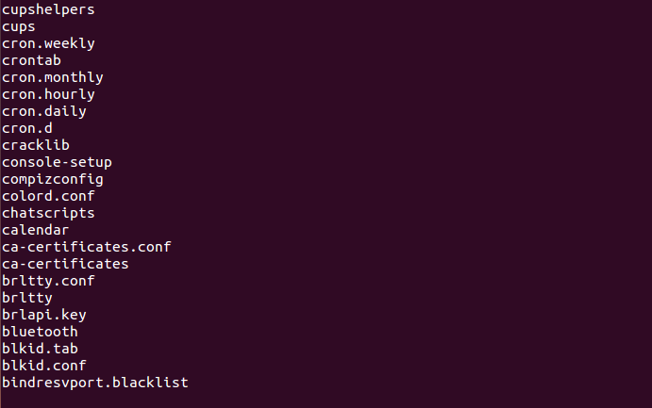

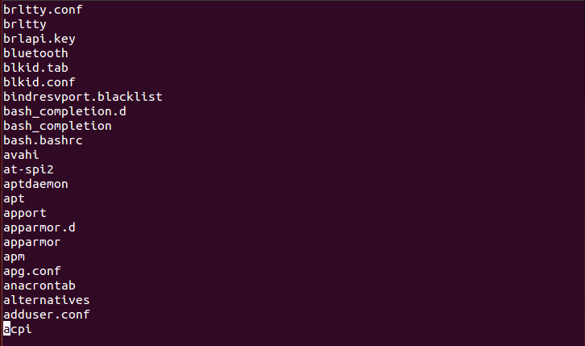

12) What are the types of devices and how to determine the type of device? Give

examples.

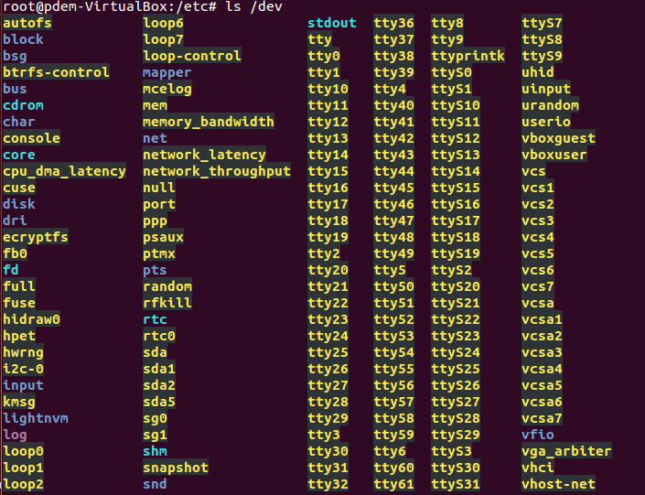

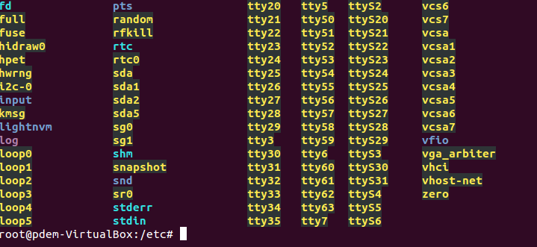

Character (byte-oriented) devices read and write data as a stream of bytes. This includes serial and parallel ports, tape drives, terminals, and sound cards.

block-oriented devices read and write data in blocks of a fixed size. Unlike character devices, block devices provide random access to their data. An example is a hard drive.

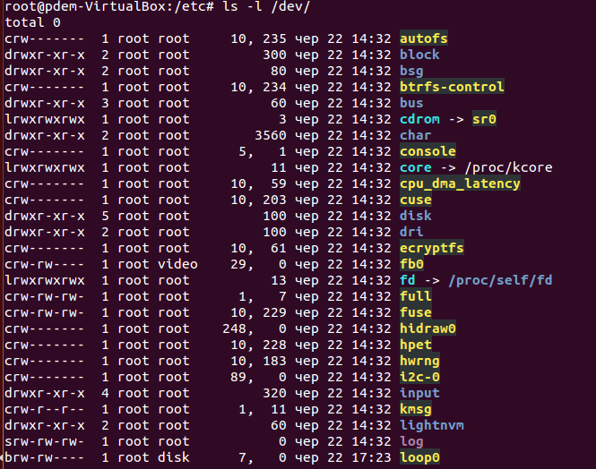

The first character in the extended ls output indicates the device type s bit-oriented b – block

How to determine the type of file in the system, what types of files are there?

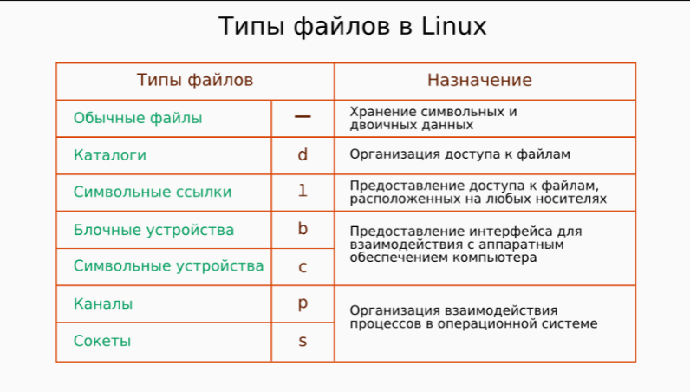

For the determine type of files





List the first 5 directory files that were recently accessed in the /etc

directory.

