Forecasting Indonesian National and Provincial GDP using nighttime light index

Abstract
Economic growth is a central macroeconomic indicator that guides decisions of both governments and private enterprises, yet official GDP figures are released with substantial lag and may be subject to incentive-driven bias. This paper evaluates whether nighttime light (NTL) radiance, sourced from NASA’s Black Marble VIIRS product, can serve as an independent leading indicator for Indonesian GDP at quarterly frequency. Monthly radiance rasters from 2012 to 2024 are aggregated into quarterly year-on-year indices and matched to real GDP from BPS at both the national and provincial levels. At the national level, we estimate OLS and Autoregressive Distributed Lag (ARDL) specifications with alternative treatments of the COVID-19 period, including transitory COVID dummies and a permanent post-2020 scarring dummy. At the provincial level, we exploit fix-effects and dynamic panel estimators (DFE, Mean Group, and Pooled Mean Group). Across specifications, the NTL index enters with a positive and generally significant coefficient, though its estimated elasticity is small and sensitive to how the post-2020 period is modeled. The forecast performance of our preferred ARDL model is in fact driven mostly by lagged GDP and the post-2020 dummy, with NTL contributing only marginally on top of these. Nighttime light alone therefore cannot fully account for GDP variation and is best understood as a complement to, rather than a substitute for, official statistics. We further find suggestive evidence of a post-pandemic scarring effect, though its estimated magnitude is sensitive to how the post-2020 regime is parameterized and should be read as indicative rather than precise. The ARDL model that incorporates the scarring term delivers the best in-sample fit and yields reasonable out-of-sample forecasts, supporting NTL as a useful nowcasting tool for Indonesian growth.

Introduction
GDP and economic growth are arguably the most significant sources of data for the government. Economic growth rate is used as an anchor for various other indicators. It forms the foundation for critical modeling and analysis used by both governments and private investors to make economic decisions and implement policy measures. Because GDP often serves as a crucial performance indicator for the government, there is an incentive to overestimate the growth number (Martínez 2022). It is therefore essential to develop alternative methods to validate and evaluate economic growth data.
One such method lies in the use of nighttime lights as a proxy to nowcast economic growth. The use of satellite imagery, particularly in the form of nighttime lights, has increased in relevance over the last 20 years. Technology has developed to allow for the detection of signals at night coming from common artificial light sources such as streetlights, buildings, and vehicles. This data can then be used to measure human activity, a critical component of economic growth. Nighttime lights growth serves as a good predictor of economic growth at the national and sub-national levels (Henderson, Storeygard, and Weil 2012; Bickenbach et al. 2016; Martínez 2022). Henderson, Storeygard, and Weil (2012) shows how nighttime lights data are able to serve as a better predictor of economic growth than various indicators and proxies in other countries. The fact that nighttime lights data is procured from NASA as an open source ensures full transparency. The data is readily available without any pre-processing or involvement from third parties, meaning it is immune to the fluctuations in perceived credibility that are associated with statistical agencies. The independence from statistical agencies is an important condition that positions nighttime lights well as a leading indicator for GDP growth (Enders 2014).
In this paper, we utilize monthly nighttime lights rasters for Indonesia from NASA’s Black Marble project (Stefanini Vicente and Marty 2023) covering January 2012 to December 2024. The radiance values are extracted at the national and provincial levels, aggregated into quarterly averages, and transformed into year-on-year log growth rates to mirror the real GDP series published by BPS (BPS 2025). At the national level, we fit the nighttime light index on real GDP growth using ECM, VAR, and Autoregressive Distributed Lag (ARDL) framework with lag orders selected by AIC. We estimate six ARDL variants that add transitory COVID-19 dummies, a post-2020 dummy intended to capture a possible scarring effect, and quarterly seasonal dummies in order to test the robustness of the NTLI–GDP relationship to alternative treatments of the pandemic shock. At the provincial level, we exploit cross-sectional variation using pooled panel fixed-effects and, following Mahraddika (2019), dynamic panel estimators (Pesaran and Smith 1995; Pesaran, Shin, and Smith 1999) which let us separate short-run dynamics from the long-run equilibrium relationship. Importantly, we find evidence of a potential structural break post COVID-19, and the ARDL specification with a scarring term delivers the best in-sample fit and reasonable out-of-sample forecasts.
This paper aims to test whether nighttime light alone can serve as a credible proxy for Indonesian GDP growth. Across national and provincial specifications, we find that the nighttime light index generally provides a positive correlation with GDP growth. However, the estimated elasticity is small and sensitive to how the COVID-19 shock is modeled, indicating that nighttime light on its own cannot fully capture GDP variation. Inspecting the ARDL more carefully, the bulk of the forecast fit comes from lagged GDP and the post-2020 dummy: the NTL coefficient is at most marginally significant in the preferred specification. The NTLI, thus, should be read as a complementary input to nowcasting models rather than a stand-alone indicator. We also document suggestive evidence of a scarring effect post-pandemic (Pangestu and Armstrong 2025). The point estimate is consistent with a modest reduction in long-run growth, but we caution against reading the magnitude too literally: it is sensitive to the model’s ARDL dynamics and is identified from a relatively short post-shock window. Among the specifications we consider, the ARDL model augmented with the scarring term delivers the best in-sample fit as well as the most accurate out-of-sample forecasts, suggesting that properly accounting for the structural break is essential for using nighttime lights to validate or nowcast official growth figures. The provincial panel results broadly corroborate the national findings, lending cross-sectional support to the NTLI–GDP link even after allowing for provincial heterogeneity
The paper is organised as follows. We discuss the nighttime lights data collection process and exploratory data analysis section two. The methodology development is covered in section three. Section four discusses the model results, followed by a conclusion in section five.

Data Collection and Processing
NASA Black Marble (Stefanini Vicente and Marty 2023) is a a daily calibrated, corrected, and validated product suite, curated such that nighttime lights data can be used effectively for scientific observations. The product suite takes full advantage of the capabilities of the Visible Infrared Imaging Radiometer Suite (VIIRS) instrument, which is a component of the Suomi National Polar-orbiting Partnership (NPP) satellite. The instrument consists of 22 spectral bands from the ultra-violet to the infrared, of which the day night band (DNB) in particular is used to observe nighttime lights. The DNB is ultra-sensitive, and can detect very dim light that is several times fainter than daylight. The band covers 0.5–0.9 µm wavelengths (visible green to near-infrared), which is exactly the range of light emitted by common artificial sources like streetlights, buildings, vehicles, and even fishing boats.
While the analysis of nighttime lights has become more popular over the last two decades, a surprisingly few number of studies employ the use of data from VIIRS (Gibson, Olivia, and Boe-Gibson 2020). The new nighttime lights data offers a sharper resolution and higher frequency compared to the previous generation of nighttime lights data. Black Marble’s standard science removes cloud-contaminated pixels and and corrects for atmospheric, terrain, vegetation, snow, lunar, and stray light effects on the VIIRS instrument.
The data collection process was performed using the Black Marble Python package developed by the World Bank (Stefanini Vicente and Marty 2023). After mapping and defining Indonesia’s coordinates as the region of interest, we were able to use the blackmarblepy package to access NASA Black Marble as a xarray dataset. NASA’s Black Marble suite offers daily, monthly, and yearly global nighttime lights data. Rasters were able to be created at all three frequency levels. Each xarray dataset contains a nighttime lights tile that is gap-filled and corrected, with a resolution of 500m. Critically, each dataset also contains a main variable representing radiance, a numerical measure of the amount of light energy emitted or reflected from a surface per unit area in a given direction, expressed in watts per square meter per steradian $(W⋅m^{-2}⋅sr^{-1})$. It is this measure that allows for nighttime lights to be compared and used as a proxy for GDP growth.
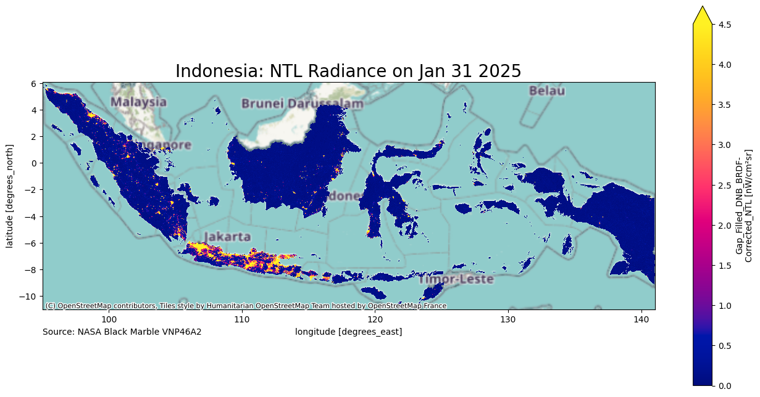
Figure 1: Annual Nighttime Lights in Indonesia, 2023
Figure 1 The figure is a visualization of the yearly raster for nighttime lights in Indonesia in 2023. There is a stark contrast between the nighttime lights activity in Java compared to other islands, which is reflective of significant gaps in various socioeconomic indicators between Java and the rest of Indonesia. The stark difference in economic activity between Java and the rest of Indonesia is well-documented in literature, and is a consequence of the landscape and soil of the island facilitating stronger agricultural yields and population growth.
Black Marble data can also be extracted for multiple time periods. The function will return a raster stack, where each raster band corresponds to a different date. The following code snippet provides examples of getting data across multiple days, for the month of May 2024 in Indonesia. We define a date range using pd.date_range.
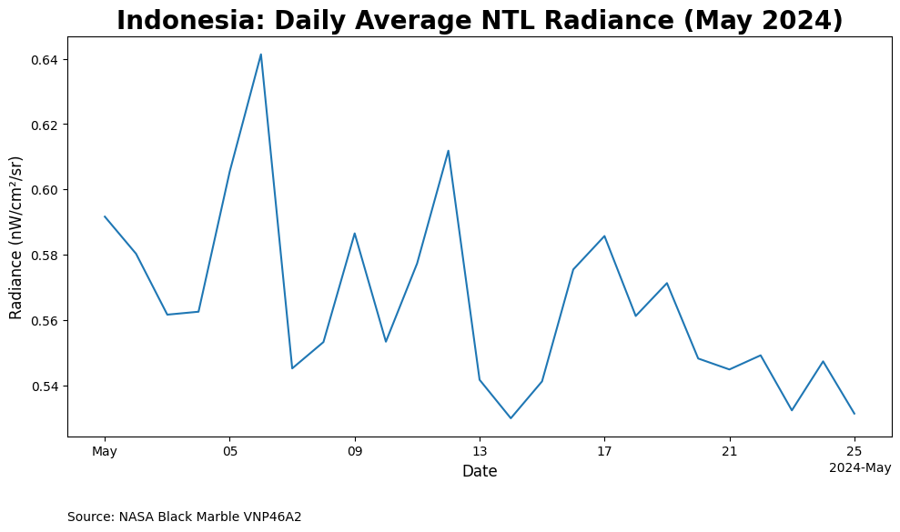
Figure 2: Daily Average Nighttime Light Radiance in Indonesia, May 2024
Here we can see the fluctuations that exist within a given month, fluctuations that may be difficult to pinpoint from monthly or yearly rasters. One advantage of the flexibility of nighttime lights data is the ability to process it to suit the needs of any kind of time series analysis. In this instance, to facilitate the goal of making a proper comparison between nighttime lights and GDP, both series needed to be expressed on the same unit level. In Indonesia, GDP growth is typically reported in quarterly year-on-year terms. To align the nighttime lights data with this format, multiple steps were needed. First, monthly rasters were extracted from January 2012 to December 2024, covering the full period of available Black Marble nighttime lights data. The data was then saved as a .zip file. The radiance values were also extracted and saved as a separate .csv file.
With the radiance values extracted in a monthly form, the next steps involved transforming the data into quarterly year-on-year terms. Nighttime lights data was aggregated into quarterly terms. The data was then lagged and shifted 1 year back, from which the year-on-year change was able to be calculated.
GDP data was straightforward to collect due to the data being readily available from the BPS website (BPS 2025). Quarterly real GDP is used for the purposes of this study. The GDP series includes data from Q1-2010 to Q2-2025, but we will use Q1-2012 as our starting point in line with the availability of nighttime lights data from NASA Black Marble. We also collets the provincial quarterly real GDP for the provincial-level regression.
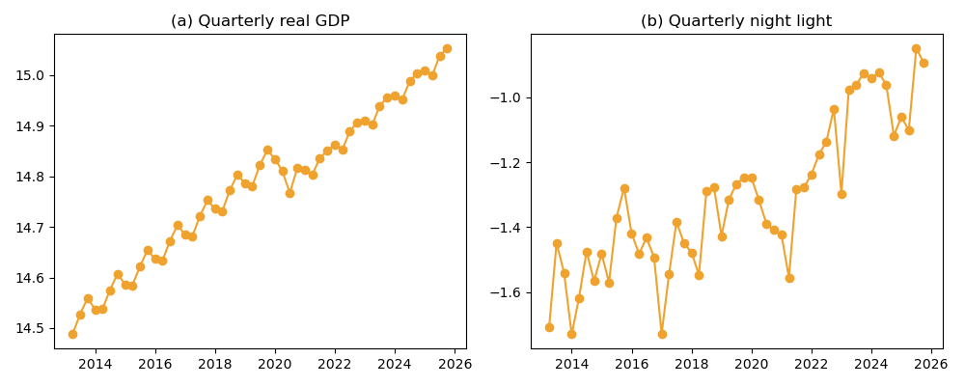
Figure 3: Indonesian economic growth and night light growth
Figure 3 shows our two main variables. The left panel is the national real GDP sourced from BPS (2025) while the right panel is the calculated night lights we gathered via Black Marble python package. Both seems to follow similar trend. However, night light index doesn’t show significant drop during the COVID time, unlike GDP. Additionally, the nightlight index looks to be more stationary before 2022, and then show a positive trend. From the visual inspection, both series seems to be non-stationary.

Methodology
For the national level, we do not have any cross-sectional variation. Therefore, techniques that utilise cross-sectional mean cannot be exploited. Multivariate time series techniques, thus, should be the appropriate method.
First, we try a simple OLS:
$$g_{t}=α_{0}+α_{1}ntli_{t}+ϵ_{t}$$
where $g_{t}$ is the log of quarterly GDP at time $t$, $ntli_{t}$ is the log quarterly night light index at time $t$, $α_{0}$ is the constant term, $α_{1}$ is the coefficient of night light index, and $ε_{t}$ is the error term. We then examine the error term and see if there is a bias in the residuals. It is reasonable to find autocorrelation in the residual with two time series data. We then use ARDL to take into account the autocorrelation (Enders 2014). We use lags determined by AIC.
Augmented Dickey–Fuller tests (reported in the appendix) cannot reject a unit root in log GDP ($p=0.91$) or log NTL ($p>0.99$) at conventional levels, while their first differences are stationary at the 5 and 10 percent levels respectively, consistent with both series being I(1). The two cointegration tests we run disagree: the Engle–Granger residual test on the OLS above rejects the null of no cointegration decisively ($p=0.0003$), while the Johansen trace test fails to reject rank zero ($\text{trace}=9.45$ versus a 5 percent critical value of $15.49$). With only $T=51$ quarterly observations and only two variables, the Johansen test has limited power, but the cointegration evidence is at best borderline rather than decisive, and we treat the long-run relationship with appropriate caution. The ARDL-in-levels approach we adopt is well-defined under the Pesaran–Shin–Smith bounds framework regardless of whether the series are individually I(0) or I(1); a formal bounds test is left for future work.
$$g_{t}=β_{0}+\sum_{p=1}^{P}{β_{i}}g_{t-i}+\sum_{q=0}^{Q}{β_{j}}ntli_{t-j}+ϵ_{t}$$
In addtion to the above specification, we also test with quarter dummy, Covid dummy (2020-2022) and scarring dummy (2020 onwards).
For the regional level analysis allows for a cross-sectional dimension to be added to the time series data. This allows us to use panel data techniques. We can use provincial fixed effect and two-way fixed effect (TWFE) models.
In addition to the cross-sectional techniques, we employ panel distributed lag techniques to account for the dynamic nature of the relationship between nighttime lights and regional GDP as in the national level. Namely, we follow the approach of Mahraddika (2019) by using Dynamic Fixed Effects (DFE), Mean Group (MG) and Pooled Mean Group (PMG) estimators (Pesaran and Smith 1995; Pesaran, Shin, and Smith 1999).

Estimation Results

National-level analysis
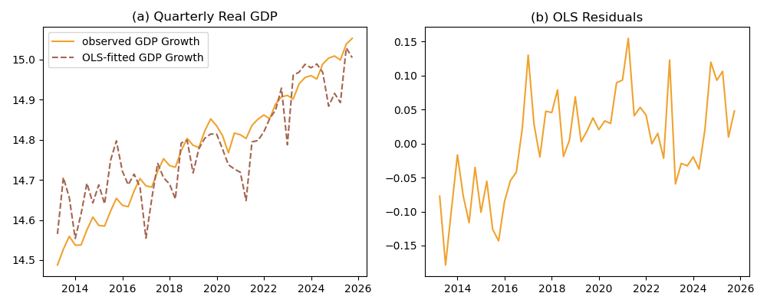
Figure 4: OLS fit and the residuals

Table 1: OLS Regression Results for log real quarterly GDP
Variable | Coefficient
const | 15.4878***
 | (0.0561)
ntlg | 0.5401***
 | (0.0407)
Observations | 55
R-squared | 0.7683
Adj. R-squared | 0.7639
F-statistic | 175.76

Figure 4 shows the OLS fit and the residuals while Table 1 show the regression result. The nighttime light show a strong correlation to the quarterly GDP. 1% increase in nighttime light index corresponds with 0.57% increase in GDP. However, Figure 4 shows a clear bias on the residuals. The model overpredicts GDP pre-2017 and underpredicts GDP post 2017. This suggest that OLS is not the proper method to model these two series.
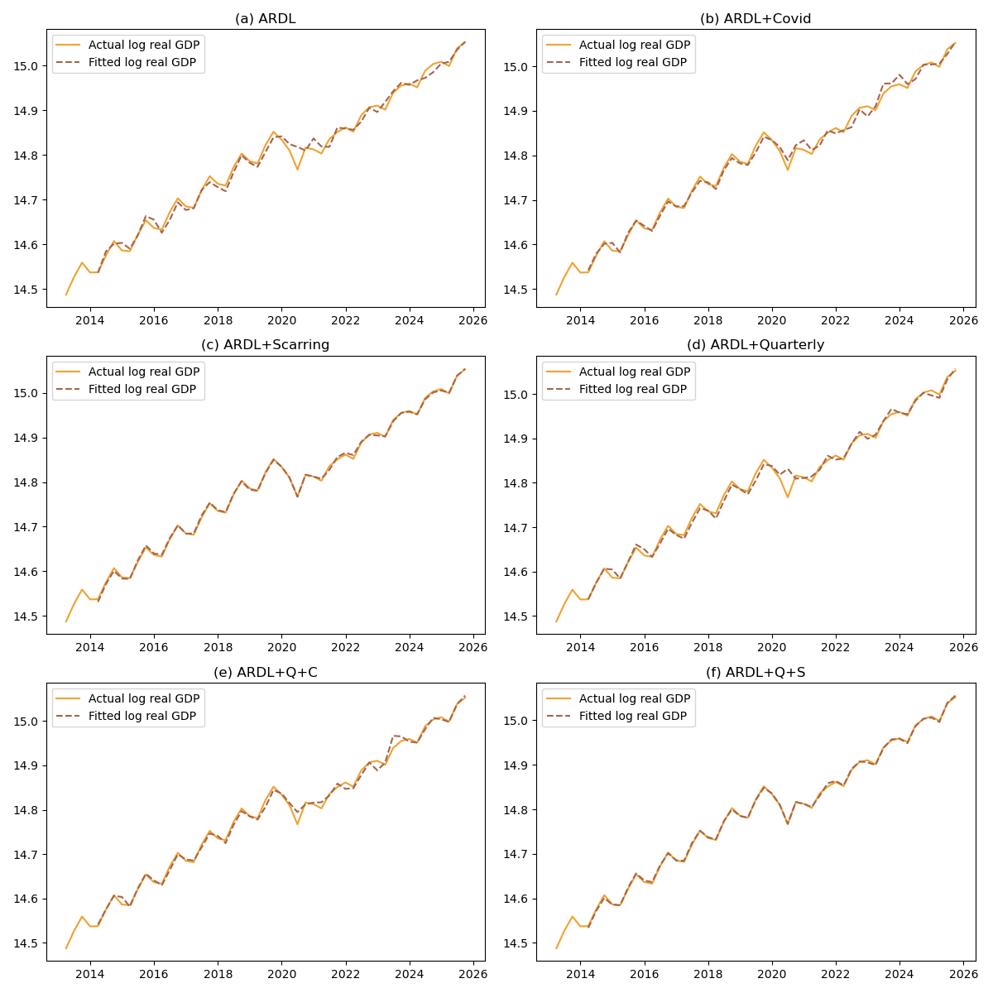
Figure 5: Quarterly real GDP, ARDL
Figure 5 shows the ARDL approach. We ran six different specifications. The panel (a) shows a baseline model with only log GDP and log nighttime light. Panel (b) adds COVID dummies, which consist of values equaling 1 for the year 2020-2022. Panel (c) adds scarring dummies, equaling 1 for all observations beginning from 2020. Panel (d) adds quarterly dummies. Panel (e) combines COVID dummies with quarterly dummies, while panel (f) use scarring dummies and quarterly dummies. The solid line represents the actual GDP data while the dashed line illustrates the predicted GDP.
We can see from the Figure 5 that all predicted values follow the actual GDP very well. However, the GDP value predicted by model with scarring, that is, both panel (c) and (f), looks to have the smallest discrepancy with the actual data.
Table 2: ARDL Regression Results
Variable | Baseline | +Covid | +Scar | +Quarterly | +Q+C | +Q+S
const | 2.2942 | 2.9864 | 49.8166*** | 2.5612* | 2.8221* | 37.7501***
 | (1.5716) | (1.7920) | (5.2152) | (1.3806) | (1.4232) | (4.9545)
trend | 0.0008 | 0.0020 | 0.0424*** | 0.0013 | 0.0020* | 0.0321***
 | (0.0011) | (0.0014) | (0.0045) | (0.0010) | (0.0011) | (0.0042)
g.L1 | 0.5393*** | 0.5947*** | -0.7533*** | 0.6644*** | 0.6247*** | -0.6215***
 | (0.1316) | (0.1331) | (0.1196) | (0.1254) | (0.1061) | (0.1025)
g.L2 | -0.0804 | -0.4507*** | -0.9372*** | 0.1776 | 0.0812 | -0.4841***
 | (0.1638) | (0.1561) | (0.0865) | (0.1660) | (0.1338) | (0.1249)
g.L3 | 0.0036 | 0.2549 | -0.7755*** | -0.2861* | -0.1873 | -0.5542***
 | (0.1682) | (0.1627) | (0.1224) | (0.1691) | (0.1371) | (0.1103)
g.L4 | 0.3857*** | 0.3967*** | 0.0147 | 0.2708** | 0.2861*** | 0.0454
 | (0.1352) | (0.1234) | (0.0766) | (0.1275) | (0.1020) | (0.0631)
covid.L0 |  | -0.0003 |  |  | -0.0031
 |  | (0.0098) |  |  | (0.0082)
covid.L1 |  | -0.0482*** |  |  | -0.0401***
 |  | (0.0129) |  |  | (0.0108)
covid.L2 |  | 0.0370*** |  |  | 0.0318***
 |  | (0.0136) |  |  | (0.0086)
covid.L3 |  | -0.0272*
 |  | (0.0147)
covid.L4 |  | 0.0262**
 |  | (0.0113)
ntlg.L0 | 0.0855*** | 0.0350 | 0.0119* | 0.0571** | 0.0312* | 0.0115**
 | (0.0229) | (0.0227) | (0.0059) | (0.0212) | (0.0183) | (0.0048)
ntlg.L1 | 0.0033 | -0.0350 |  | -0.0275 | -0.0372**
 | (0.0245) | (0.0209) |  | (0.0207) | (0.0176)
ntlg.L2 | -0.0460**
 | (0.0224)
q1.L0 |  |  |  |  |  | -0.0108***
 |  |  |  |  |  | (0.0023)
q2.L0 |  |  |  | 0.0299*** | 0.0273***
 |  |  |  | (0.0077) | (0.0062)
q3.L0 |  |  |  | 0.0293*** | 0.0278*** | 0.0079***
 |  |  |  | (0.0078) | (0.0062) | (0.0025)
scar.L0 |  |  | -0.0201*** |  |  | -0.0204***
 |  |  | (0.0043) |  |  | (0.0035)
scar.L1 |  |  | -0.0965*** |  |  | -0.0937***
 |  |  | (0.0064) |  |  | (0.0053)
scar.L2 |  |  | -0.0621*** |  |  | -0.0400***
 |  |  | (0.0127) |  |  | (0.0114)
scar.L3 |  |  | -0.0679*** |  |  | -0.0308**
 |  |  | (0.0090) |  |  | (0.0115)
scar.L4 |  |  | -0.0342*** |  |  | -0.0276***
 |  |  | (0.0110) |  |  | (0.0094)
Observations | 51 | 51 | 51 | 51 | 51 | 51
AIC | -275.94 | -291.52 | -408.79 | -287.61 | -309.81 | -428.67
BIC | -256.62 | -264.48 | -383.68 | -266.36 | -282.76 | -399.69

Table 2 shows the estimated parameters of the 6 models. Indeed, models with scarring show the lowest AIC and BIC, which suggests these specifications are the most robust compared to the other specifications without scarring. The scarring effect leads to a 2% decrease in quarterly GDP. Importantly, the current nighttime light index is significant for all but the COVID-dummy specification. The base model shows the strongest correlation, where a 1% increase in nighttime light index correlates to a 0.0855% increase in GDP. For the scarring specification, the coefficients are 0.0119 and 0.0115 respectively. That is to say that a 1% increase in nighttime light index correlates with a 0.0119% increase in GDP.
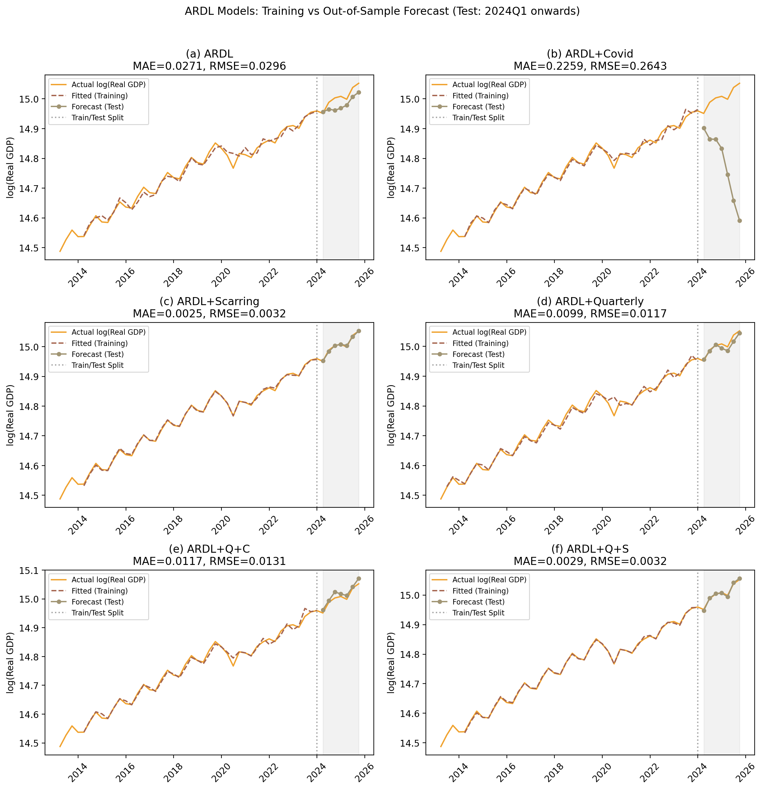
Figure 6: Economic growth prediction with ARDL
To test whether the model can forecast GDP well, we divide the data into a training set consisting all observation prior to 2024, and testing set consists of the remaining data. The result is illustrated in Figure 6. The solid line represents the actual GDP, the dashed line represents the predicted GDP using the training set, and the dotted line represents the forecast using the testing set. We can see from the Figure 6 that the model with scarring dummies can predict with a better fit and smaller error rate.
Notably, the GDP prediction is less sensitive to nighttime lights fluctuations compared to the scarring dummy and the GDP lags. In fact, the nighttime light index becomes less useful as the training size decreases (which is reflected in the AIC and BIC). In the model with scarring dummy, the nighttime light coefficient at time 0 is only significant in 10% with or without quarterly dummies.
Indeed, the past GDP values are more important, with the AR1 coefficient is -0.7 and is significant at 0.1% level. More importantly, the scarring effect shows a 0.1% level significance at all 4 lags. The scarring dummy at time 0 has a coefficient of -0.02, which, taken at face value, would suggest a GDP level roughly 2 percent lower after the pandemic. This magnitude should be interpreted with caution, however: the scarring specification also alters the AR dynamics of the ARDL substantially (the sum of autoregressive coefficients flips sign relative to the other specifications), and the estimate is identified from only a few years of post-shock data. The coefficient is best read as suggestive rather than as a precise long-run penalty.
To assess directly whether nighttime lights carry predictive information about future GDP — the leading-indicator framing implied by our title — we also run pairwise Granger-causality tests between log NTL and log GDP at lags 1 through 4 (full output in the appendix). The results temper the leading-indicator interpretation. NTL Granger-causes GDP only at lag 2 ($F=5.57$, $p=0.007$); at lags 1, 3, and 4 the test cannot reject ($p=0.33$, $0.23$, $0.34$ respectively), so the predictive content is not robust across lag choices. Strikingly, the reverse direction is much stronger: GDP Granger-causes NTL at every lag from 1 through 4, with $p$-values between $0.004$ and $0.018$. Taken together, the bivariate Granger evidence is more consistent with NTL contemporaneously tracking GDP — and possibly responding to GDP with a short lag — than with NTL serving as a robust leading indicator. We therefore frame NTL throughout the paper as a contemporaneous proxy and a candidate input into multi-variable nowcasting models, rather than as a stand-alone leading indicator.

Regional-level analysis
In parallel with the national level specification, we also extended the baseline specification by including dummy variables for the Covid-19 period (2020-2022) and the post-pandemic or the scarring effect period (2022-2025) to assess whether the relationship between provincial GDP and nighttime lights changed during and after the pandemic. We conduct the analysis using a range of econometric models. The analysis begin with pooled OLS as a baseline and further estimation using Fixed Effects (FE), Two-Way Fixed Effects (TWFE), and Dynamic Fixed Effects (DFE). Across all model specifications, the relationship between GDRP and nighttime lights remains consistent, indicating that nighttime light data provides a useful proxy for GDRP.
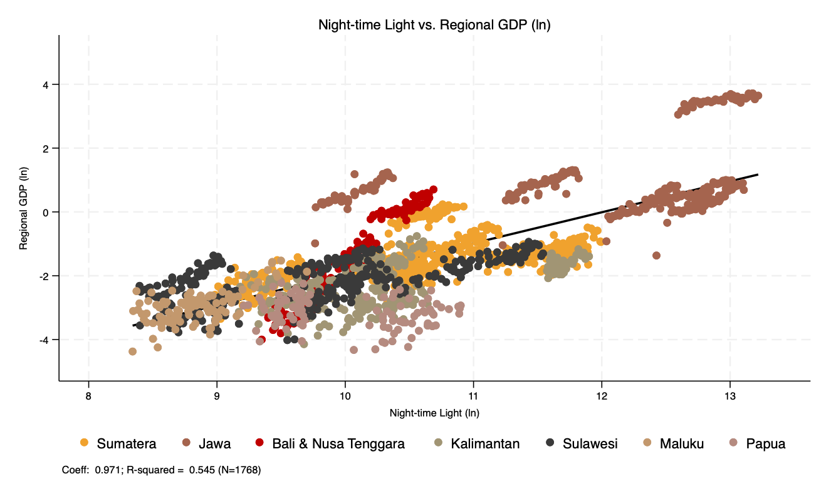
Figure 7: Nighttime-Lights vs. Regional GDP, log
Figure 7 is a scatterplot of nighttime lights against regional GDP for 34 provinces in Indonesia from 2014Q1 to 2024Q4. Java exhibits a stark contrast compared to the rest of Indonesia. NIghttime light index show a substantially higher intensity along with its RGDP (Regional GDP) compared to other island groups. The data points for Java in blue color are clustered toward the higher end of both axes, indicating higher levels of economic activity and luminosity relative to other regions. Conversely, though the linear trend between nighttime light and provincial GDP are still visible, provinces outside Java show greater dispersion. This implies more variation in the relationship between light intensity and GDP possibly due to differences in economic structure or spatial distribution of economic activities. In regions outside Java, the economic structure is dominated by agriculture, plantation activities, and mining industries. While these sectors contribute significantly to regional output, they produce comparatively low levels of nighttime lights.
Table 3: Summary statistics of nighttime lights (ln) and GDRP (ln) at quarterly frequency, 2014-2024
 | Mean | Std. Dev. | Min | Max
Sumatera (10 provinces)
Nighttime lights (ln) | -1.44 | 0.69 | -3.35 | 0.23
GDRP (ln) | 10.59 | 0.80 | 8.82 | 12.01
Java (6 provinces)
Nighttime lights (ln) | 1.03 | 1.17 | -1.36 | 3.71
GDRP (ln) | 12.04 | 1.02 | 9.65 | 13.24
Nusa Tenggara (3 provinces)
Nighttime lights (ln) | -1.43 | 1.33 | -4.00 | 0.70
GDRP (ln) | 10.01 | 0.37 | 9.23 | 10.70
Kalimantan (5 provinces)
Nighttime lights (ln) | -2.30 | 0.69 | -4.14 | -0.75
GDRP (ln) | 10.35 | 0.74 | 9.02 | 11.90
Sulawesi (6 provinces)
Nighttime lights (ln) | -2.15 | 0.67 | -4.01 | -0.93
GDRP (ln) | 9.77 | 0.87 | 8.22 | 11.55
Maluku (2 provinces)
Nighttime lights (ln) | -2.96 | 0.51 | -4.37 | -1.52
GDRP (ln) | 8.79 | 0.33 | 8.19 | 9.77
Papua (2 provinces)
Nighttime lights (ln) | -3.16 | 0.46 | -4.32 | -2.22
GDRP (ln) | 9.98 | 0.52 | 9.09 | 10.89

Table 3 shows the summary statistics of the nighttime light and regional GDP by islands. The table reinforce what is visually apparent in Figure 7: Java is the most developed island in Indonesia, with the highest average nighttime light intensity and regional GDP. It is remains to be seen if the positive relationships are different among provinces.
The varying degree of light-GDP relationship across islands (and, by extension, across provinces) suggests that using nighttime lights as a proxy for economic activity may require adjustments based on regional characteristics. For instance, provinces with economies heavily reliant on non-luminous sectors may not exhibit a strong correlation between light intensity and GDP. This highlights the importance of considering local economic structures when utilizing nighttime lights data for economic analysis. Indeed, potentially looking at national-level only might mask these regional differences.
?@tbl-regols shows the regional panel regression. As the baseline (column OLS), we estimate the correlation between nighttime lights (NTL) and regional GDP using a pooled Ordinary Least Squares (OLS) model. the next three columns employ a fixed-effects (FE) model to control for time-invariant provincial characteristics. The last column show a two-way fixed-effects (TWFE) model that advanced the FE estimation by incorporating year fixed effects to account for common shocks affecting all provinces simultaneously. With applied time fixed-effects, the scarring and COVID dummies are no longer needed.
The regression results show a strong and statistically significant relationship at the 0.1 percent level between regional GDP and nighttime light intensity across all static model specifications. Coefficients from the OLS and fixed-effects models remain positive and stable even after controlling for COVID-19 and post-pandemic scarring effects. The overall elasticity pattern between regional GDP and nighttime light intensity remains consistent over time.
The coefficient on the OLS model corroborates that of the national level OLS. The FE model show a slightly smaller coefficient, suggesting the importance of the provincial difference. Controlling for time fixed effect, the coefficient drops to 0.0649. That is, a 1% increase in nighttime light index corresponds to a 0.0547% increase in regional GDP.
To account for the possibility that the relationship between GDP and nighttime lights evolves dynamically rather than instantaneously, we extend the analysis using a Dynamic Fixed Effects (DFE), Pooled Mean Group (PMG) and Mean Group (MG) error-correction model (Mahraddika 2019; Pesaran and Smith 1995; Pesaran, Shin, and Smith 1999). Unlike the static FE and TWFE specifications, the distributed lag framework allows for short-run fluctuations while modeling a long-run equilibrium relationship between the variables. Specifically, it incorporates lagged adjustments so that deviations from the long-run relationship can gradually converge back to equilibrium. At the same time, the model retains fixed effects (for DFE case) to control for unobserved, time-invariant provincial heterogeneity.
The DFE results provide strong evidence of a stable long-run relationship between the two variables. The error-correction term is negative and statistically significant across all specifications. Importantly, the magnitude and significance of the error-correction coefficient remain robust even after controlling for the post-pandemic scarring periods. This suggests that, although the pandemic caused temporary disruptions, it did not fundamentally alter the long-run linkage between economic activity and nighttime light intensity.
?@tbl-regdfe shows the dynamic fixed effects regression results. The results show a strong and statistically significant relationship at the 0.1 percent level between regional GDP and nighttime light intensity across all static model specifications. Coefficients from the OLS and fixed-effects models remain positive and stable even after controlling for COVID-19 and post-pandemic scarring effects. The overall elasticity pattern between regional GDP and nighttime light intensity remains consistent over time.
The distributed lag results corroborates the national results. That is, the short-term changes in nighttime lights have a weak implication to the GDP’s convergence to its long-term equilibrium. More importantly, while the scarring is not significant in the long-term, the small error-correction term suggesting a slow adjustment to the long-term equilibrium after shocks.
With the ECT value of -0.0374 in the baseline DFE model, it would take approximately 27 quarters (or about 6.75 years) for regional GDP to fully adjust back to its long-run equilibrium after a shock. The results corroborates Reinhart and Rogoff (2014)’s findings on the slow adjustment of GDP to its long-term trend around 6-8 years.
However, when we include the scarring dummy, the ECT value decreases to -0.0169, indicating an even slower adjustment process. In this case, it would take approximately 59 quarters (or about 14.75 years) for regional GDP to fully revert to its long-run equilibrium following a shock. This suggests that the post-pandemic scarring effect has prolonged the time it takes for regional economies to recover and stabilize after disruptions.
Recent studies have highlighted the possibility of a hysteresis, or a long-lasting, potentially permanent impact of a deep crisis (Aikman et al. 2022; Lucidi and Semmler 2023). When an economy face a deep crisis, it can have a lasting impact amid an increase of risk permia which hinders banks from lending to firms. This creates a feedback loop as firms are unable to invest and grow, corroding the economic growth potential. Indonesia’s experience from the 1998 crisis provides a historical precedent for such hysteresis effects, where growth rates never really returned to pre-Asian Financial Crisis level.
It is worth emphasising that the DFE result above is not corroborated by the more flexible PMG and MG estimators in the same table. The long-run NTL coefficient is significant under DFE in both the baseline and the scarring specifications, marginal under PMG, and either insignificant or wrong-signed under MG once the scarring dummy is included. The three estimators differ in how much heterogeneity across provinces they allow. DFE is the most restrictive of the three but only consistent if the long-run NTL–GDP elasticity is genuinely common across all 34 provinces, while MG is consistent under heterogeneity at the cost of efficiency. We argue The Indonesian provincial economy is plainly heterogeneous: Java’s services-and-manufacturing base, Kalimantan and Papua’s mining-driven output, and Sulawesi’s largely agricultural structure each generate very different NTL–GDP elasticities. We therefore present DFE as one specification among several rather than as a preferred estimator, and read the cross-estimator divergence as informative about provincial heterogeneity in the NTL–GDP relationship.
We are unable to causally attribute the post-2020 break to COVID specifically, as the scarring dummy will absorb any persistent post-2020 shift. including BPS methodology changes, commodity-price re-pricing, the Omnibus Law, or other contemporaneous shocks. Interpreting the $-2$ percent coefficient as a precise estimate of pandemic damage, therefore, must be taken with a grain of salt. Finally, the visible disagreement between DFE (significant) and MG (often insignificant or wrong-signed) long-run NTL coefficients in the provincial panel suggests that pooled estimates may be papering over genuine heterogeneity across Indonesian provinces rather than reflecting a common long-run relationship.
There are two potential key takeaways from the national-level analysis. First, accounting for a post-2020 regime shift is critical for forecasting GDP, more than it might be for other indicators. We can see this especially when we use quarterly dummies. From Figure 5, The panel (c) and (f) show that quarterly dummies do not significantly add insight, while panel (d) and (e), panels with quarterly dummies without scarring, show a looser fit. This pattern is consistent with other studies that discuss a potential scarring effect from the COVID pandemic in Indonesia (Pangestu and Armstrong 2025), though we caution that our scarring dummy captures any persistent post-2020 shift and does not, on its own, identify a specific channel or a precise long-run magnitude.
Secondly, the nightlight index does not perform as well as we think. We find that that the nighttime light index fluctuates in a different way compared to GDP. This is most apparent during the COVID-19 pandemic, where GDP drops significantly, while the nighttime light index experiences only a modest drop.
Various potential reasons can explain this phenomenon. On days where the satellite view of the Earth is obstructed by clouds, nighttime lights values are often gap-filled and estimated based on the number of available clear pixels. This means that the nighttime light index might not accurately capture the actual emitted light in Indonesia amid cloud cover, atmospheric conditions, or other factors that affect the quality of satellite imagery especially during the rainy months of the tropical region.
Secondly, the Indonesian government has been increasingly implementing electricity subsidies during hard times. The nighttime lights index is unable to identify situations involving a heavy downturn where the government decided to step in to maintain electricity consumption.

Conclusion
This paper has used Indonesian quarterly real GDP and Black Marble nighttime light radiance from 2012 to 2024 to ask, in a deliberately lean setting, how much economic information about Indonesia can be recovered from satellite light alone. We summarise our findings as a short list of what the analysis does, and does not, support.
Nighttime light is positively and generally significantly correlated with GDP across OLS, ARDL, and provincial panel specifications. Once autocorrelation (ARDL) and provincial heterogeneity (FE/TWFE) are controlled for, the OLS elasticity of about 0.56 falls by an order of magnitude to roughly 0.05 in the within-province dimension, indicating that most of the raw OLS association is between-province rather than time-series identification. There is a clear structural break in the GDP series around 2020, and adding a post-2020 dummy substantially improves both the in-sample fit and the out-of-sample forecast accuracy of the ARDL.
Overall, nighttime light is not a strong stand-alone predictor of GDP. In the preferred ARDL+Scar specification the contemporaneous NTL coefficient is significant only at the 10 percent level, and the bulk of the forecast performance comes from lagged GDP and the post-2020 dummy. We do not find robust Granger-causal evidence that NTL leads GDP either,as pattern more consistent with NTL tracking GDP contemporaneously than leading it. The cointegration evidence is also mixed: Engle–Granger residual ADF rejects the null of no cointegration ($p=0.0003$), but the Johansen trace test fails to reject rank zero.
A pattern suggestive of the scarring effect also appears in the provincial panel. The DFE baseline yields a speed of convergence in line with the literature, and adding the scarring dummy slows it further. We emphasize, however, that this is an associational pattern rather than a causally identified estimate: the dummy captures any persistent post-2020 level shift, and the implied adjustment dynamics should be interpreted with the same caution we flag at the national level. Additionally, the nightlight index is also not as important as we might think, as its short-term dynamics show weak significance.
This NTL–GDP divergence during COVID is more than a curiosity, because it cuts against one of the original motivations for using nighttime lights in the first place. NTL is appealing as an independent validation tool precisely because it is generated outside the statistical agency and is therefore immune to revisions or measurement choices. While that independence become even more valuable during recession period, it is exactly during such episodes (here, the 2020 trough) that NTL departs most visibly from GDP. Whether the gap is driven by cloud cover and gap-filling, by electricity subsidies that decouple lighting from output, by the resilience of household-level lighting during commercial slowdowns, or by some combination of these channels, we cannot tell from the present data.
On balance, our reading is that nighttime lights are a useful but limited input to nowcasting Indonesian growth: a credible component of a multi-variable forecasting model, but not a substitute for official GDP and not, by themselves, a reliable independent check on it.

Reproducibility Statement
The source code and data to reproduce the analysis in this paper are available at https://www.github.com/den-econ/nitelite.

References
Aikman, David, Mathias Drehmann, Mikael Juselius, and Xiaochuan Xing. 2022. The Scarring Effects of Deep Contractions. Bank of Finland Research Discussion Papers 12/2022. Helsinki: Bank of Finland. https://hdl.handle.net/10419/265328.
Bickenbach, Frank, Eckhardt Bode, Peter Nunnenkamp, and Mareike Söder. 2016. “Night Lights and Regional GDP.” Journal Article. Review of World Economics 152 (2): 425–447. https://doi.org/https://doi.org/10.1007/s10290-016-0246-0.
BPS. 2025. [Seri 2010] 4. Laju Pertumbuhan PDB Menurut Pengeluaran, 2025. Diakses Pada 14 September 2025. Https://www.bps.go.id/id/statistics-table/2/MTA4IzI=/-seri-2010–4–laju-pertumbuhan-pdb-menurut-pengeluaran–persen-.html.
Enders, Walter. 2014. Applied Econometric Time Series. Wiley.
Gibson, John, Susan Olivia, and Geua Boe-Gibson. 2020. “Night Lights in Economics: Sources and Uses.” Journal Article. Journal of Economic Surveys 34: 955–980. https://doi.org/https://doi.org/10.1111/joes.12387.
Henderson, J. Vernon, Adam Storeygard, and David N. Weil. 2012. “Measuring Economic Growth from Outer Space.” The American Economic Review 102 (2): 994–1028. http://www.jstor.org/stable/23245442.
Lucidi, Francesco Simone, and Willi Semmler. 2023. “Long-Run Scarring Effects of Meltdowns in a Small-Scale Nonlinear Quadratic Model.” Journal of Macroeconomics 75: 103487. https://doi.org/https://doi.org/10.1016/j.jmacro.2022.103487.
Mahraddika, Wishnu. 2019. “Does International Reserve Accumulation Crowd Out Domestic Private Investment?” Journal Article. International Economics 158: 39–50. https://doi.org/https://doi.org/10.1016/j.inteco.2019.02.003.
Martínez, Luis R. 2022. “How Much Should We Trust the Dictator’s GDP Growth Estimates?” Journal Article. Journal of Political Economy 130 (10): 2731–2769. https://doi.org/10.1086/720458.
Pangestu, Mari, and Shiro Armstrong. 2025. “Is This Time Different? Indonesia’s Response to Uncertainty.” Bulletin of Indonesian Economic Studies 61 (3): 297–332. https://doi.org/10.1080/00074918.2025.2588819.
Pesaran, M. Hashem, Yongcheol Shin, and Ron P. Smith. 1999. “Pooled Mean Group Estimation of Dynamic Heterogeneous Panels.” Journal Article. Journal of the American Statistical Association 94 (446): 621–634. https://doi.org/10.2307/2670182.
Pesaran, M. Hashem, and Ron Smith. 1995. “Estimating Long-Run Relationships from Dynamic Heterogeneous Panels.” Journal Article. Journal of Econometrics 68 (1): 79–113. https://doi.org/https://doi.org/10.1016/0304-4076(94)01644-F.
Reinhart, Carmen M., and Kenneth S. Rogoff. 2014. “Recovery from Financial Crises: Evidence from 100 Episodes.” The American Economic Review 104 (5): 50–55. http://www.jstor.org/stable/42920909.
Stefanini Vicente, Gabriel, and Robert Marty. 2023. BlackMarblePy: Georeferenced Rasters and Statistics of Nighttime Lights from NASA Black Marble. Https://worldbank.github.io/blackmarblepy. https://doi.org/10.5281/zenodo.10667907.

