DEWAN EKONOMI NASIONAL — PHK EARLY WARNING DASHBOARD
PHK Projection: Methodology & Event Verification Summary
Two workstreams, one conclusion: PHK forecasting should stay simple, and PHK spikes are driven by firm- and policy-specific events rather than observable macro trends.

This note draws together two related pieces of work: a media/event verification of the PHK spikes recorded in the dashboard's data between 2022 and 2026, and a statistical test of how best to forecast province-level PHK going forward. The two results align — the event research explains the statistical findings, and the statistical findings confirm the event research. Full methodology, code, and every intermediate test for both pieces are in model_arima/ on the arima-exploration-achmad branch; this note covers the findings relevant to how the dashboard should work, not every step taken to reach them.

Why the Recorded Spikes Happened
Every major PHK spike in the panel — the 2022 textile and tech-sector layoffs, the 2023 coal-price correction, the 2024 Jawa Tengah textile crisis, and the 2025 tariff period — was checked against news coverage, industry association statements, and Kemnaker/BPJS data. The same pattern held across all four episodes: in each case, the cited cause coincided with fragility that was already building, rather than a discrete shock on a stable baseline. Textile-sector distress, for example, was documented as building from the second half of 2022 and continuing through 2024. PHK in the 2025 tariff period peaked in January–February, tied to the Sritex bankruptcy (which traces back to a 2021 debt default), and declined after the tariff took effect in August.
Two specific findings are worth noting. The widely-cited “PT Sai Apparel, 8,000 workers, July 2024” figure does not match the underlying record: the plant union and local government report the actual layoffs at 1,482 workers, executed at the end of 2023, with the 2024 figure reflecting a relocation rather than new job losses. Separately, the Kalimantan Timur spike of December 2022 (5.8 standard deviations above that province's own baseline) has no corroborating event in any source checked, and is more likely a data artifact than a real episode.
The implication is that PHK spikes should not be modeled as discrete, predictable shocks. The statistical testing below reached the same conclusion independently.

What the Statistical Testing Found
The dashboard's technical roadmap proposed ARIMA for PHK projection, on the reasoning that a simple time-series model would outperform a fully specified causal one (“small error > meaningful relationship between variables”). This was tested directly, along two questions.
The first was whether DEN's own macro-pressure variables — NPL, exports, CPI, the same set used in the Poisson model's $PRESSURE block — predict PHK. This was tested nine ways: commodity-price shocks, level and volatility regressions, pooled panel models, and a Markov-switching regime model, the most rigorous of the set, which converged for 33 of 34 provinces. The result was consistently null. The Markov-switching test showed more provinces with a statistically significant effect in the direction opposite to the hypothesis (10) than in the expected direction (5), consistent with no underlying effect.
The second question was whether more model complexity improves forecast accuracy. Plain ARIMA, seasonal ARIMA, ARIMA with the macro-pressure variables, and a simple ensemble of historical mean, exponential smoothing, and ARIMA were evaluated out-of-sample — first against a 12-month-forward test, then a rolling-origin backtest, and finally against realized 2026 data. Summary of results:
Approach | Result
Added complexity (seasonal terms, macro-pressure variable) | Both reduce out-of-sample accuracy rather than improving it — seasonality is real (PHK is higher in September and December) but there isn't enough history per province to model it safely, and the macro-pressure variable adds no reliable signal
Per-province “best method” selection | Does not hold up against new data: only 17 of 34 provinces retained their selected method's performance when checked against realized 2026 data, and 8 showed a clear decline
A tiered ensemble — mean, smoothing, and ARIMA, weighted by each province's own volatility | The best average performer of the methods tested, and the only one confirmed against realized 2026 data

The ensemble's weighting follows the pattern the data supports: quiet provinces weight toward the historical mean, volatile provinces weight toward ARIMA, and provinces in between split between mean and smoothing — ARIMA is not used in that middle tier, since including it there reduced average accuracy rather than improving it.
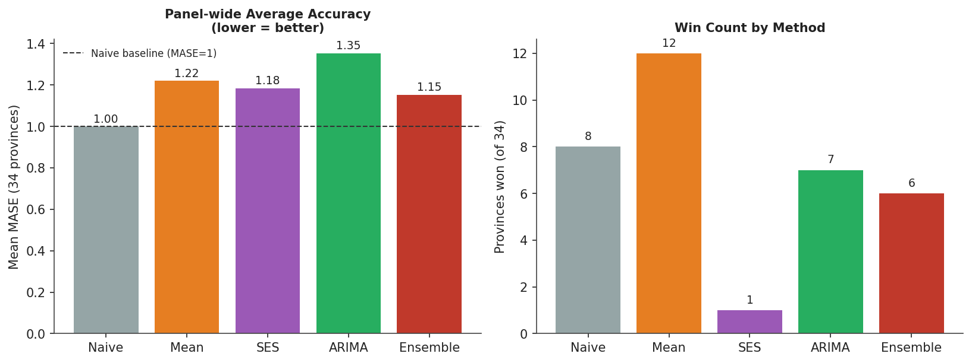
Figure 1. Panel-wide average accuracy (MASE, lower is better) and win count by method, across all 34 provinces. The Ensemble has the best average accuracy despite not winning the most provinces outright.
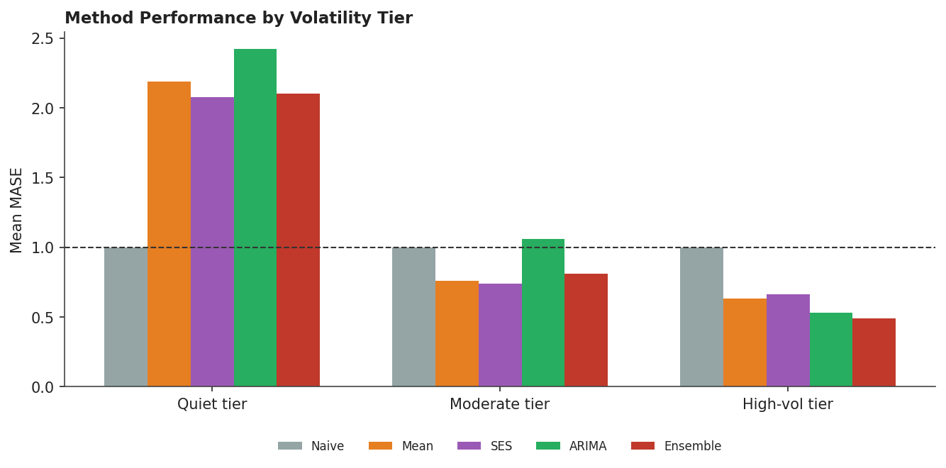
Figure 2. Average accuracy by method within each volatility tier. ARIMA performs best in the High-vol tier; Mean and SES perform best in the Quiet and Moderate tiers, consistent with the Ensemble's weighting.
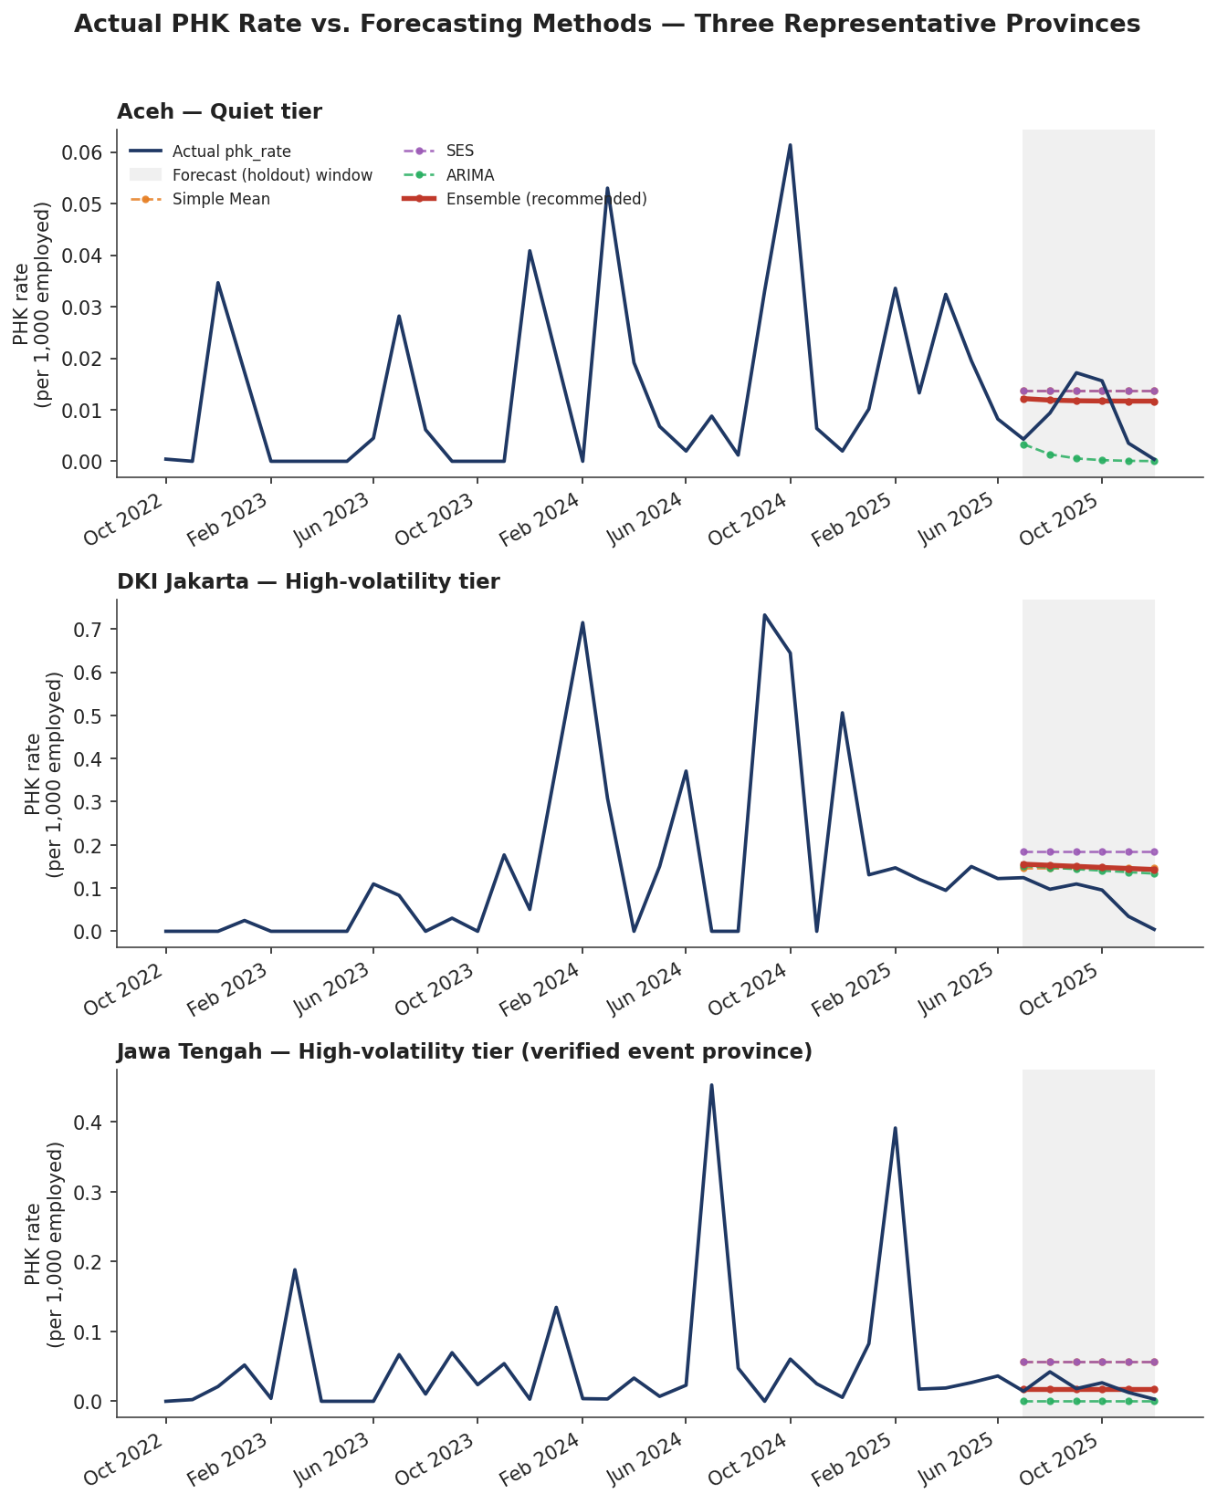
Figure 3. Actual PHK rate against each method's forecast for three provinces — Aceh (quiet tier), DKI Jakarta (high-volatility tier), and Jawa Tengah (the 2024 textile-collapse province). The shaded region is the held-out forecast window. The Ensemble (solid red) tracks the general level in all three but, like every method tested, does not capture the sharp month-to-month spikes.

What This Means Going Forward
The forecasting component of the dashboard should run on this tiered ensemble — implemented in model_arima/03_produce_forecast/ — without the macro-pressure variables, seasonal terms, or per-province re-selection that the testing above does not support. A separate point is that no method tested here, including all nine macro-pressure specifications, anticipated the verified historical spikes before they occurred. This reflects the nature of the data rather than a gap in the modeling: PHK spikes appear to be driven by firm- and policy-specific events not visible in the available macro series, consistent with the event-verification findings above.
This suggests the dashboard's early-warning value should rest primarily on a simple, automatic statistical alert — flagging any province-month more than roughly 2–4 standard deviations above that province's own history — rather than on a model's ability to forecast a crisis in advance. Applied to the most recent data, this alert has already flagged three new, uninvestigated spikes in early 2026 (Sumatera Selatan, Kalimantan Selatan, and Jambi) that would benefit from the same media/event verification applied to the earlier episodes.
This workstream is intended as a complement to the existing Poisson framework, not a replacement for it. It uses the same outcome variable and the same macro-pressure variables Poisson already relies on, and tests specifically whether they add forecasting value in a time-series setting. For the most part, they do not — a finding worth keeping on record for the team.

One Item for the Technical Team
Separately from this workstream: the Layer-2 vulnerability composite's “Pressure” pillar shows an undocumented sign change in its PCA loading, negative in 2022–2023 and positive in 2024–2025. Its input values have very low cross-province variance (standard deviation 0.17–0.63, against Labour and Econ's standardized values of roughly 1.6–1.8), which is consistent with a construction issue — for example, a raw index level used where a growth rate or z-score was intended — rather than a genuine economic shift. Worth checking with whoever built layer2_weights_by_year.csv.

