West Twin Lake

# Introduction

Once each month from July to October of 2017 a survey of over 31 Michigan lakes was taken. At the start of each month, water conditions were recorded, samples were taken, and SPATT bags were deployed or collected. Analysis of the water samples included analysis of nutrients, qPCR for cyanobacteria genes, and MSMS for microcystins and other toxins.

# Microcystin and Aquatic Toxin Summary

The information collected reflects the conditions at the time of sampling, but toxins recovered from the SPATT bags are indicative of toxin levels during the weeks between sampling. The SPATT bags were deployed for the month-long period between sampling events and then collected. SPATT data are represented by the total toxins collected during the period. The reported concentrations are from the analytical procedures used on the SPATT bags and are not directly indicative of average toxin levels.

## Grab Sample

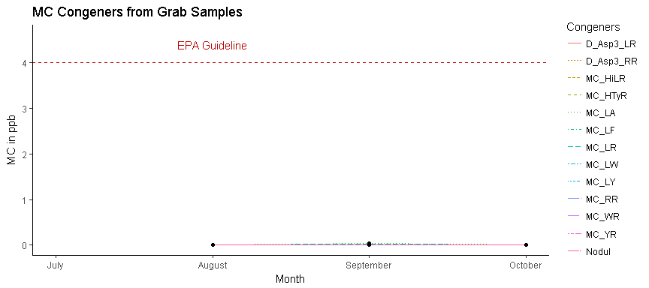

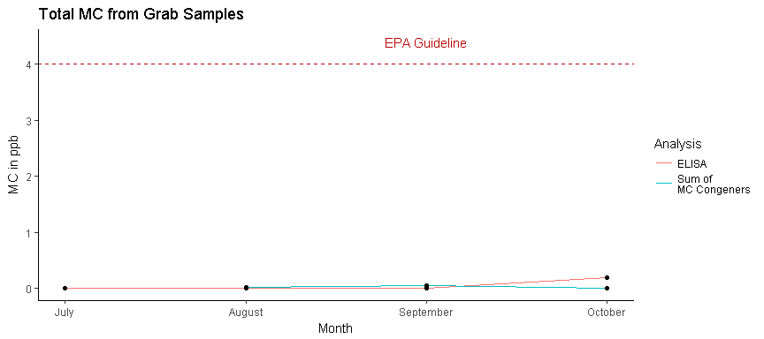

|  |  |  |
| --- | --- | --- |
| Month | ELISA (ppb) | Sum of MC Congeners(ppb) |
| July | 0 | NA |
| August | 0 | 0 |
| September | 0 | 0 |
| October | 0 | 0 |

## SPATTS

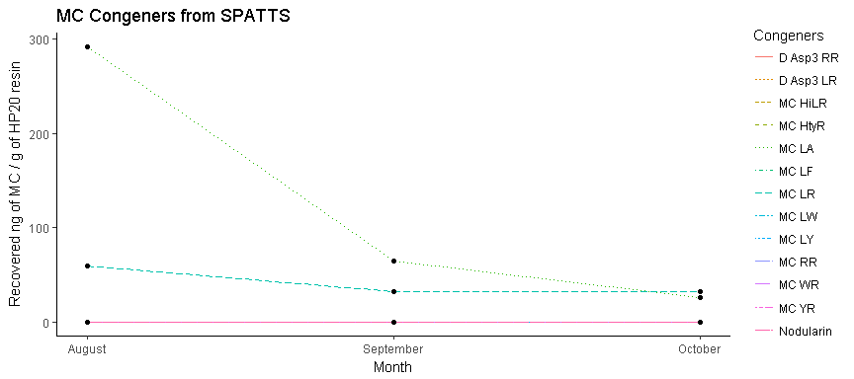

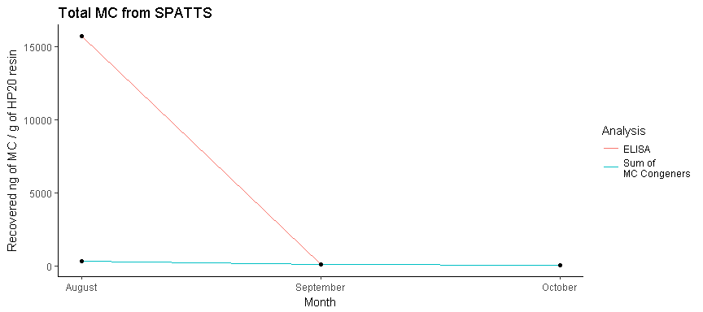

# qPCR

PhytoxigeneTM CyanoDtec test was performed with Applied Biosystem StepOnePlus PCR. Total Cyanobacteria 16s rRNA and toxin gene assay were analyzed in parallel for each month of grab samples. Data for each month is listed in table below. CyrA and SxtA were not detected for this year. The calculated values are expressed as “GeneCopies/mL”.

|  |  |  |
| --- | --- | --- |
| Month | 16s rRNA | mcyE |
| July | 14706 | NA |
| August | 14569 | 5 |
| September | 13590 | 38 |
| October | 18003 | 12 |

# Nutrient Summary

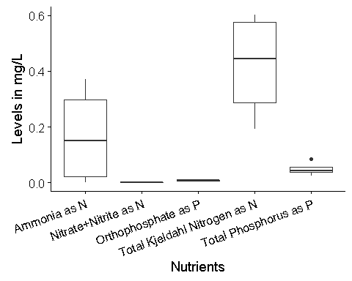

|  |  |  |  |  |  |
| --- | --- | --- | --- | --- | --- |
| Month | Orthophosphate (mg P/L) | Nitrate + Nitrite (mg N/L) | Ammonia (mg N/L) | Total Phosphorus (mg P/L) | Total Kjeldahl Nitrogen (mg N/L) |
| July | 0.0083 | 0 | 0.3714 | 0.025 | 0.601 |
| August | 0.0052 | 0 | 0.2719 | 0.042 | 0.568 |
| September | 0.0073 | 0 | 0.0275 | 0.045 | 0.319 |
| October | 0.0096 | 0 | 0.0000 | 0.085 | 0.192 |

# Water Parameters

|  |  |  |  |  |  |  |  |
| --- | --- | --- | --- | --- | --- | --- | --- |
| Month | Temprature (°C) | Turbidity (NTU) | pH | Dissolve Oxygen (mg/L) | Conductivity (µS) | Chlorophyll-a (RFU) | Phycocyanin (RFU) |
| July | 23.52 | 2.41 | 8.52 | 8.57 | 165 | NA | NA |
| August | 27.23 | 29.60 | 8.40 | 12.35 | 317 | 3.65 | 0.78 |
| September | 20.01 | 4.97 | 8.11 | 10.74 | 330 | 3.29 | 0.07 |
| October | 16.32 | 1.56 | 8.82 | 8.41 | 163 | 0.27 | 0.02 |