**Lake Paradise – 2017 Synopsis**

We measure microcystins by two methods: Adda ELISA and Liquid Chromatography Mass spectrometry (LC/MS/MS). The LC/MS/MS method is more sensitive and less likely to generate a false positive. It is much more time consuming to run. Grab samples were taken in July, August, September, and October. The microcystin levels in Lake Paradise were well below the Environmental Protection Agency’s draft guidance level of 4 ppb (parts per billion) using both methods. We also analyze samples for anatoxin-a and cylindospemopsin. There were no detections of cylindrospermopsin, or anatoxin-a. The phosphorus levels in the lake were indicative of a “Eutrophic” lake signifying a moderately high level of phosphorus throughout the sampling season. The lake’s watershed has a high percentage of wetlands. Potentially toxin producing cyanobacteria were present in the lake in 2017, but not at high levels. It is important to understand that these cyanobacteria are often present in Michigan Lakes.

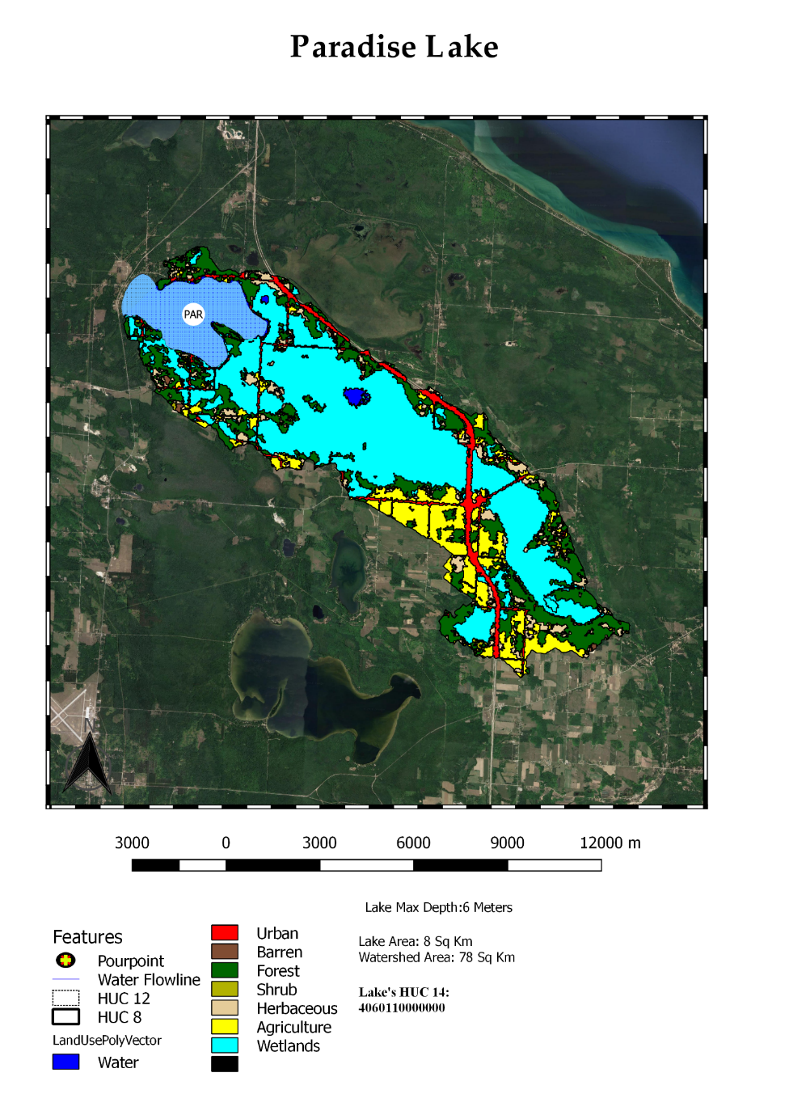

**Microcystin and Aquatic Toxin Summary**

**Grab Samples**

ELISA is a most commonly used analytical method for microcystin detection and gives a single value for “Total” microcystins. Twelve different microcystin congeners were measured by LC/MS/MS and added as a sum to be compared with ELISA. The figure shown below shows the results from the ELISA and LC/MS/MS. Further data will demonstrate the validity of the ELISA test across multiple aquatic environments. The ELISA and MS methods agreed in July, August, and September. The ELISA gave a high result in October.

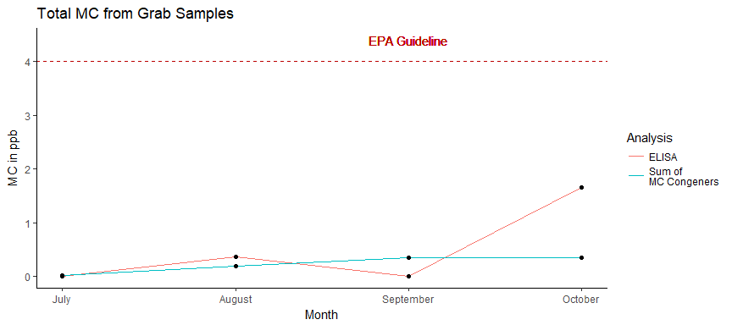

**SPATTs**

The information generated by the grab samples reflects the conditions at the time of sampling, but toxins recovered from the SPATT bags are indicative of toxin levels during the weeks between sampling. The wind and wave condition of the lake can dramatically affect the distribution of cyanbacteria and toxins over time. The SPATT bags were deployed for the month-long period between sampling events and then collected. SPATT data are represented by the total toxins collected during the period. The reported concentrations are from the analytical procedures used on the SPATT bags and are not directly indicative of average toxin levels. There is no USEPA guidance for this procedure yet and we will use the 2017 and 2018 data to provide interim guidance. At this time, we can say that the SPATs observed higher relative levels in August. This technique is highly experimental at this point andonly provide a relative MC value.

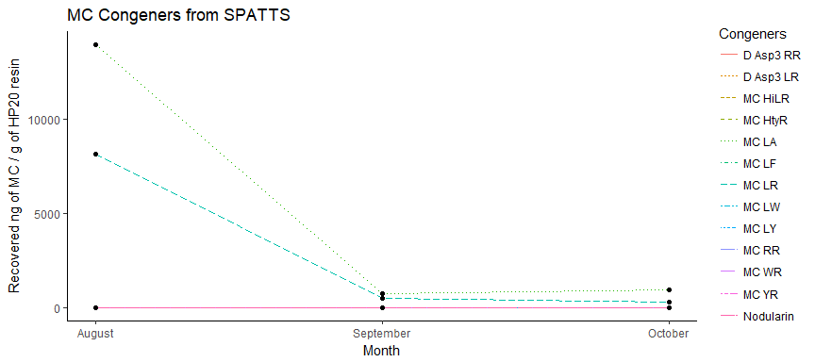

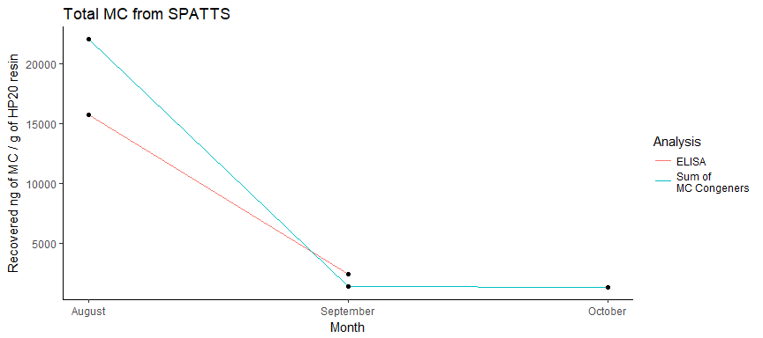

**QPCR**

QPCR is a DNA test to rapidly measure the amount of total cyanobacteria (16s rRNA ) and toxin genes (mcyE) present. PhytoxigeneTM CyanoDtec test was performed with Applied Biosystem StepOnePlus PCR. The observed values are relatively low; we do not become concerned until total cyanobacteria (16s rRNA) are above 200,000 and toxin genes (mcyE) are above 10,000. Samples were analyzed in parallel for each month of grab samples. Data for each month is listed in table below. CyrA and SxtA were not detected for this year. The calculated values are expressed as “GeneCopies/mL”.

|  |  |  |
| --- | --- | --- |
| Month | 16s rRNA | mcyE |
| July | 10618 | NA |
| August | 103474 | 274 |
| September | 23349 | 2278 |
| October | 59581 | 3452 |
|  |  |  |

**Nutrient Summary**

The chart and table show the nutrient levels below. The key nutrients we measure are the forms of nitrogen and phosphorous. Phosphorus has long been known to increase alagal and cyanobactria growth.

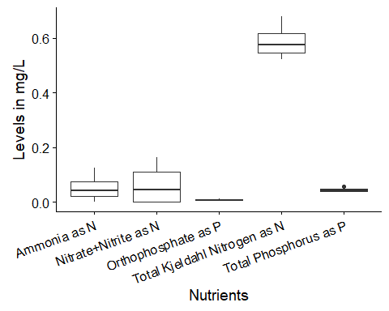

Total phosphorous may be expressed in different units; the average value for Paradise was 45 ppb or .045 mg/L.

|  |  |  |  |  |  |
| --- | --- | --- | --- | --- | --- |
| Month | Orthophosphate (mg P/L) | Nitrate + Nitrite (mg N/L) | Ammonia (mg N/L) | Total Phosphorus (mg P/L) | Total Kjeldahl Nitrogen (mg N/L) |
| July | 0.0092 | 0.000 | 0.0566 | 0.042 | 0.679 |
| August | 0.0069 | 0.093 | 0.1252 | 0.037 | 0.596 |
| September | 0.0067 | 0.000 | 0.0000 | 0.044 | 0.522 |
| October | 0.0118 | 0.163 | 0.0281 | 0.057 | 0.556 |
|  |  |  |  |  |  |

**Water Parameters**

The water parameters are listed below. The values are within normal ranges,

|  |  |  |  |  |  |  |  |
| --- | --- | --- | --- | --- | --- | --- | --- |
| Month | Temperature (°C) | Turbidity (NTU) | pH | Dissolve Oxygen (mg/L) | Conductivity (µS) | Chlorophyll-a (RFU) | Phycocyanin (RFU) |
| July | 25.30 | 2.13 | 8.22 | 9.51 | 232.0 | 1.085 | 0.203 |
| August | 22.40 | 1.91 | 9.07 | 9.03 | 232.8 | 0.735 | 0.083 |
| September | NA | NA | NA | NA | NA | NA | NA |
| October | 18.36 | 0.75 | 9.89 | 10.00 | 230.3 | 0.135 | 0.312 |