**Documentation for “GeoCliP-GER - A georeferenced local climate policy database for Germany”**

*Preliminary version 1.0 (2025) for first review stage*

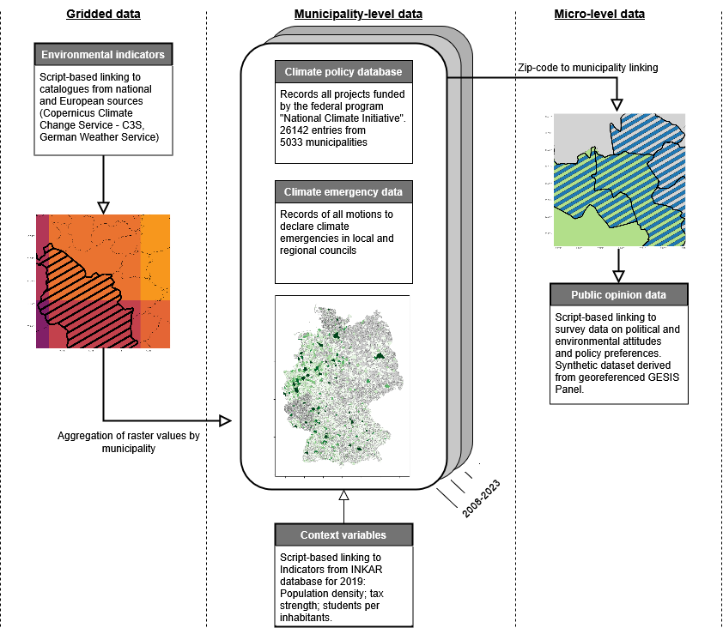

**Datasets**

**Local climate policy data for Germany**

*./data/NKI/NKI_full_list_21022024.xlsx*

The dataset currently covers 26,142 measures from 5,033 municipalities, including detailed descriptions of employed measures, funding sum, and duration between 2008 and 2023. The core of the dataset is composed of all projects funded by the federal funding scheme “National Climate Initiative” (NKI) between 2008 and 2023 (<https://www.klimaschutz.de/de/15-jahre-nki>).

The data was accessed via the funding portal of the federal government of Germany. The query to access all projects of the National Climate Initiative is:

* Thema (policy field): KSI:*
* Leistungsplansystematik (policy field code): FA19*
* Adjust „Nur lfd. Vorhaben“ (only current projects) to “nein” (no)

Variable list:

|  |  |
| --- | --- |
| **Variable name** | **Description** |
| FKZ | ID |
| Ressort | Responsible ministry |
| Referat | Unit |
| PT | Cooperating actor of funding body |
| Arb.-Einh. | Policy field |
| Zuwendungsempfänger | Recipient |
| Gemeindekennziffer | Municipality code of recipient |
| Stadt/Gemeinde | City or municipality name of recipient |
| Ort | Project site of recipient |
| Bundesland | Federal state of recipient of recipient |
| Staat | Country of recipient |
| Ausführende Stelle | Implementing entity |
| Gemeindekennziffer | Municipality code of implementing entity |
| Stadt/Gemeinde | City or municipality name of implementing entity |
| Ort | Project site of implementing entity |
| Bundesland | Federal state of implementing entity |
| Staat | Country of implementing entity |
| Thema | Policy field |
| Leistungsplansystematik | Policy field code |
| Klartext Leistungsplansystematik | Description policy field code |
| Laufzeit von | Start date |
| Laufzeit bis | End date |
| Fördersumme in EUR | Funding sum in EUR |
| Förderprofil | Overarching topic |
| Verbundprojekt | Collaborative project between municipalities |
| Förderart | Type of funding |

*Sources:* Funding portal of the federal government of Germany (2024). Accessed via: https://foerderportal.bund.de/foekat/jsp/SucheAction.do?actionMode=searchmask

**Climate emergency motions in local councils**

*./data/climate_emergency.xlsx*

Our dataset integrates comprehensive hand-coded data on climate emergency motions submitted to the local councils. These motions were submitted by civil society groups and parties in many German municipalities in 2019 and subsequent years to accelerate local climate action. Extensive desk research was conducted from June to August 2024 to identify all submitted motions. Several sources provided by activist groups and observers were cross-checked with municipal press releases to ensure the validity of the data. The finalized dataset records all incidents where motions to declare a climate emergency have been submitted to the local council, whether the municipality approved or declined the motion, and the date of the decision.

Variable list:

|  |  |
| --- | --- |
| **Variable name** | **Description** |
| ags | Municipality code |
| municipality_name | Municipality name |
| ce_jurisdiction | Name of jurisdiction to which the climate emergency motion was submitted |
| ce_level | Administrative level of the jurisdiction to which the climate emergency motion was submitted |
| date | Date of formal consideration of climate emergency motion |
| submission | Whether motion was submitted to local council |
| approved | Whether motion was approved by local council |
| notes | Further notes by coder detailing process or content of climate emergency motion |

*Sources*:

a. <https://www.klimabuendnis-hamm.de/klimanotstand-in-jedem-rathaus/>,

b. <https://kommunalwiki.boell.de/index.php/Klimanotstand>,

c.<https://de.wikipedia.org/wiki/Liste_deutscher_Orte_und_Gemeinden,_die_den_Klimanotstand_ausgerufen_haben>

**Synthetic public opinion data**

*./data/gesis_panel/gp_synth.rds*

The *.rds*-file stores the synthetic public opinion data generated based on the GESIS Panel survey data. For details on the construction of the data, please see the description below.

**Scripts**

**Public opinion data linking**

*./scripts/extract_inspire_coordinates.R*

*./scripts/gesis_panel_linking.R*

*./scripts/gxc_link_dwd.R*

*./scripts/link_dwd_modules.R*

We have developed linking workflows to the georeferenced survey programs German Longitudinal Election Study (GLES) Panel (GLES, 2023) and GESIS Panel (GESIS, 2024) based on synthetic datasets derived from these products. These survey programs, hosted by the “GESIS - Leibniz Institute for the Social Sciences” in Germany, offer access to crucial items on environmental and climate attitudes and behavior, political and institutional trust, policy preferences, and voting behavior. These panel programs have a fine-grained spatial and temporal resolution. Given that georeferenced survey data are highly sensitive, the data can only be accessed via GESIS’ secure data facilities. Our workflows for linking the policy database to these survey programs offer users easy and flexible data integration options that facilitate otherwise complex and burdensome data preparation endeavors preceding the analysis of sensitive data. The dataset contains a set of synthetic datasets which simulate the georeferenced survey data without revealing sensitive information.

All derived attributes of linking should nearly mirror the distribution, like conducting the linking with the original data. To reproduce the linking workflow presented in this paper, we provide a synthetic dataset of the GESIS Panel geocoordinates comprising 1 sq km grid centroids. We synthesized the original data in 4 steps: 1.) We segmented the dataset by the 16 German federal states and identified how many municipality types according to the regional statistical spatial typology (RegioStaR) are in each state; 2.) We counted how many respondents are located in each of these typologies; 3.) We created a sampling frame of potential municipalities from which we can draw a sample; 4.) We sampled as many 1 sqkm grid centroids as in the original data based on their population density. Several additional measures were taken to ensure the anonymity of the original survey respondents, such as re-using only municipalities of the original data with at least 100,000 inhabitants, making sure that at least 10 municipalities can be drawn from each spatial typology, and row-wise shuffling of all geocoordinates. We also deleted cases whose geographic distance between the synthetic and original data is less than 10 km.

The generation of the synthetic data has been implemented with the *geosynth* package in R (<https://github.com/StefanJuenger/geosynth>), which has been programmed for this project. This R package provides tools to create synthetic versions of geospatial survey data that mimic the spatial structure of the original dataset without exposing confidential coordinates. It is designed to support spatial linking workflows–such as joining survey data to contextual geographic information–by ensuring the synthetic data produces results that closely resemble the original data. This enables testing, prototyping, and methodological development without accessing restricted location data.

At the heart of the package are two functions: *geosynth::create_sample_frame()* constructs a sample frame based on municipalities and population thresholds while ensuring a minimum number of sampling points; *geosynth::draw_sample()* selects a sample of INSPIRE grid cells from a pre-defined sample frame, considering population data for weighting with built-in census data. Additionally, if one has access to the original geocoordinates and not only the municipality information, *geosynth::shuffle_min_distance()* ensures shuffling rows in the synthetic dataset so that each point is at least a pre-defined threshold of x kilometers away from its corresponding point in the original dataset.

**Earth observation data linking**

*./scripts/EO_linking.R*

*./scripts/p_validate_DWD.py*

*./scripts/p00_download_stationdata_dwd.py*

*./scripts/p01_impute_stationdata.py*

*./scripts/p02_aggregate_invdist_stationdata.py*

In order to capture climate mitigation and adaptation variables, we access data from national and European atmosphere and climate monitoring institutions. In particular, the German Weather Service (DWD), the Copernicus data services on Climate Change (C3S) and Atmosphere Monitoring (CAMS) are integrated. Given that researchers require custom-made indicators depending on their specific research question, we have created the R package [reference removed to ensure blinded review] for automated linkage between these data sources and GeoCliP-GER. It offers users high flexibility in terms of indicator choice as well as spatial and temporal coverage and resolution. To exemplify and validate these indicators, we have created and provided a sample version of monthly weather indicators for temperature, precipitation, and wind based on data from the German Weather Service (DWD).

**Replication of descriptive analysis in usage notes**

*./scripts/policy_data_descriptives.R*

*./scripts/p_plot_descriptive_figures_NKI.py*

*./scripts/p_plot_sequences_NKI.py*