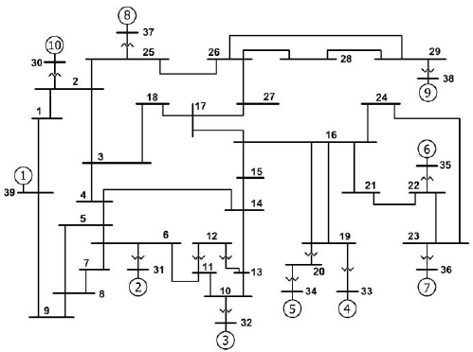

https://www.researchgate.net/figure/IEEE-New-England-39-Bus-test-system-single-line-diagram-13_fig1_259741047

https://al-roomi.org/power-flow/57-bus-system