#1 - Coal Prices Delivered to Power Sector Nationally 2005 through 2019

US coal prices delivered to the electricity sector rose sharply to a peak price in 2011, but have steadily dropped nearly 20%. Reductions in domestic coal consumption are mainly due to stiff competition from natural gas power plants and renewables, as well lower than expected demand in electricity[7]. Transportation fuel prices for coal deliveries to power plants have decreased during this period, even though the share of coal delivery costs coming from transportation has increased during this time period, showing that transportation has contributed to the decrease in coal prices, but not the only reason.

#2 - Historical Average Annual Henry Hub Natural Gas Prices from 2005 through 2020

Natural gas production in the US have seen a sharp increase since 2005 [4], which has coincided with a 77% reduction in the Henry Hub natural gas price during the same time period. Technological advances in hydraulic fracturing and horizontal drilling have allowed for production in previously inaccessible shale gas formations, resulting in a boom for natural gas production [5][7]. Despite a reduction in active natural gas rigs, which has been a traditional marker for natural gas production [5].

#3 – US Annual Coal and Natural Gas Electricity Generation from 2005 through 2019

Coal electricity generation in the US peaked in 2007 [13], but since then, the US coal industry has crippled due to several economic forces [7]. In 2019, 92% of US coal was consumed by the electricity sector [2], so any fluctuations in the coal industry are at the whims of the power sector. A 2017 study performed by T. Houser et al. concluded that from 2008 to 2016, 50% of the reduction in coal production was due to electricity generation from natural gas [7]. Between 2005 and 2019, coal generation has dropped by 52%, whereas natural gas generation has increased by 108%.

#4 - Projected Annual Henry Hub Natural Gas Prices from 2021 through 2040

The EIA’s AOE 2020 reference case projects the Henry Hub natural gas price to not exceed $3.50 per million Btu, and the high oil and gas supply projection hovers around $2.50 and $2.60 after the year 2027. The actual 2020 price of natural gas was much lower than any of the projections, coming out at $2.02, but this should not come as a surprise when considering the historical volatility in prices. COVID-19 had a significant impact on the natural gas price drop in the US, resulting in a drop in natural gas demand [18].

#5 - Natural Gas Electricity Generation as a Share of Coal Generation in 2040

#6 - Annual Coal Capacity Retirements from 2005 through 2020

Coal retirements managed to stay relatively low during the first decade of the 21st century, but competing sources of electricity and aging plants have led to a drastic increase in coal plant retirements in the past 10 years. Due to lower costs of energy for natural gas and renewables, coal power plants have been used less frequently, reducing profits and thus increasing the likelihood of retirement [15]. Other reasons include plants reaching the end of service life [17], low growth in electricity demand [17], and stricter emissions standards [16].

The main economic factors influencing coal retirements have consisted of increased competition from natural gas and renewables.

Sustained relatively low natural gas prices has allowed natural gas-fired generators to become [more competitive](https://www.eia.gov/todayinenergy/detail.php?id=24492) with coal-fired units, leading to a general decline in using coal-fired capacity. A decline in use leads to a decline in revenues at a plant, which generally translates to lower operating margins, less ability to cover costs, and in many cases, retiring that capacity. [15]

A direct relationship between a higher likelihood of a power plant retiring and higher operating and maintenance costs. [15]

as tighter air emission standards and decreased cost-competitiveness relative to other power resources make coal-fired power plants less economical [16]

As the coal-fired fleet is retired and remaining plants are utilized less, plant owners are evaluating new operating models, such as seasonal operation.[16]

Many plant owners have retired their coal-fired units because of relatively flat electricity demand growth and increased competition from natural gas and renewables [17]

The annual number of retired U.S. coal units has declined since 2015, and the configuration of retired coal capacity has changed. Coal-fired units that retired after 2015 in the United States have generally been larger and younger than the units that retired before 2015. The U.S. coal units that retired in 2018 had an average capacity of 350 megawatts (MW) and an [average age](http://www.eia.gov/electricity/data/eia860/) of 46 years, compared with an average capacity of 129 MW and average age of 56 years for the coal units that retired in 2015. [17]

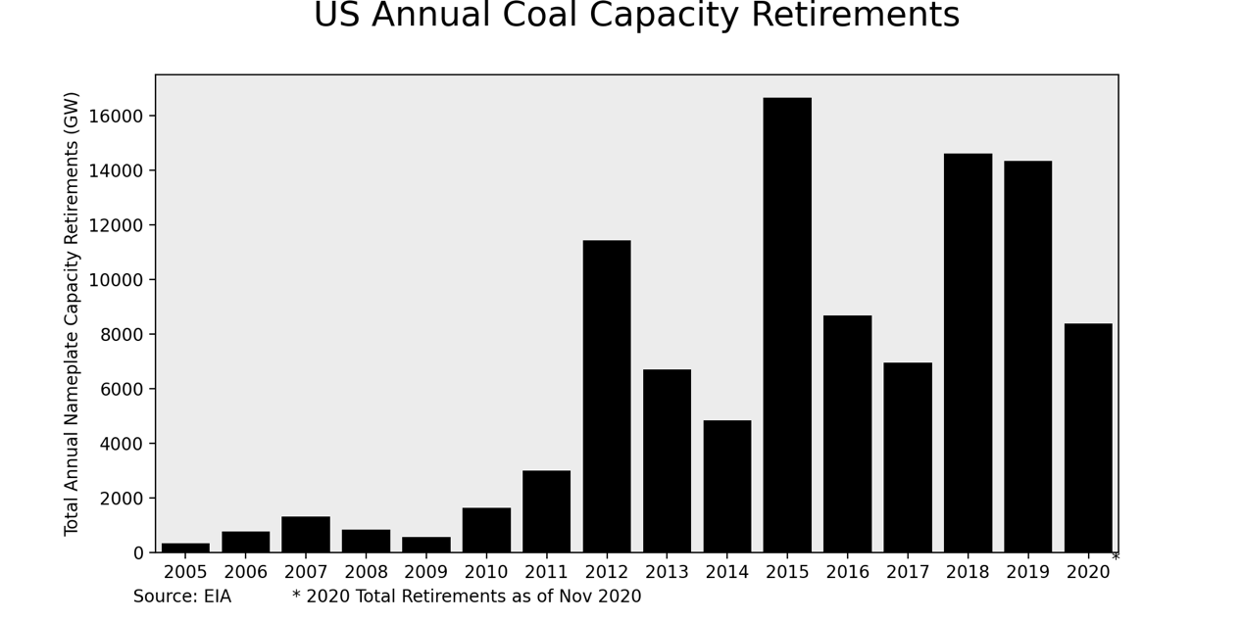

[16]

[1] https://www.eia.gov/outlooks/steo/report/coal.php

[2] https://www.eia.gov/energyexplained/coal/prices-and-outlook.php#:~:text=In%202019%2C%20the%20national%20average,was%20%2438.53%20per%20short%20ton

[3] https://www.eia.gov/coal/data.php#coalplants

[4] https://www.eia.gov/energyexplained/natural-gas/factors-affecting-natural-gas-prices.php

[5] https://www.eia.gov/todayinenergy/detail.php?id=13551

[6] https://www.brookings.edu/blog/planetpolicy/2019/01/16/why-theres-no-bringing-coal-back/

[7] https://www.energypolicy.columbia.edu/research/report/can-coal-make-comeback

[8] https://energy.stanford.edu/news/qa-stanford-expert-explains-why-we-continue-burning-coal-energy

[9] AEO2020 Electricity

[10] AEO2020 Natural Gas

[11] https://www.eia.gov/coal/annual/pdf/tableES1.pdf

[12] https://www.eia.gov/coal/annual/pdf/tableES4.pdf

[13] https://www.eia.gov/energyexplained/electricity/electricity-in-the-us-generation-capacity-and-sales.php

[14] https://www.eia.gov/todayinenergy/detail.php?id=37814

[15] https://www.eia.gov/todayinenergy/detail.php?id=42155

[16] https://www.eia.gov/todayinenergy/detail.php?id=44976

[17] https://www.eia.gov/todayinenergy/detail.php?id=40212

[18] https://www.eia.gov/todayinenergy/detail.php?id=46376

