why the broken development process makes housing more expensive in California
Overview

The median price for a home in California sits at $900,000, the highest in the country, and in the last decade, the state has failed to produce enough homes to keep up with job and population growth
California’s homebuyers have lost significant purchasing power. For example, a family that could afford a home for $900,000 before recent interest rate increases can now only afford a home price of $650,000—resulting in over 25 percent less purchasing power as of May 2022 and this trend will likely continue to worsen.
Factors contributing to high development costs in california
- Regulations and Licenses: California has strict regulations related to property development. The complex and lengthy permitting process can be time-consuming and costly for developers.

- Land Costs: Land prices in California can be very high, especially in densely populated or rapidly developing areas. High land costs can be one of the biggest factors in property development costs.

- Construction Costs: Construction in California can also be expensive, due to high labor costs, high material costs, and strict construction regulations.

- Environmental Costs: Due to the high concern for the environment in California, developers are often faced with additional costs to comply with strict environmental regulations.

- Lawsuits: Lawsuits against property developers, whether related to environmental, land or other issues, can also lead to significant costs.

- Infrastructure Costs: Sometimes, developers are also responsible for building or repairing local infrastructure such as roads, sidewalks, or drainage systems, which can also add to development costs.

- Community Challenges: Opposition from the local community or NIMBYism (Not In My Backyard) can slow down or even stop a development project, which can result in additional costs in terms of delays or changes to plans.

Source:https://ternercenter.berkeley.edu/research-and-policy/cost-to-build-housing-legislation-2022/
https://www.capradio.org/articles/2018/05/03/five-reasons-californias-housing-costs-are-so-high-with-charts-and-graphs/
https://www.cbsnews.com/sanfrancisco/news/state-report-slams-san-francisco-glacial-expensive-housing-permitting-process/

The idea in the visual is to make the factors that contribute to the high cost of construction in califoria in the form of a pie chart, above the damaged house in an illustration, and the explanation will be between the houses or in the pie chart but in the resume.

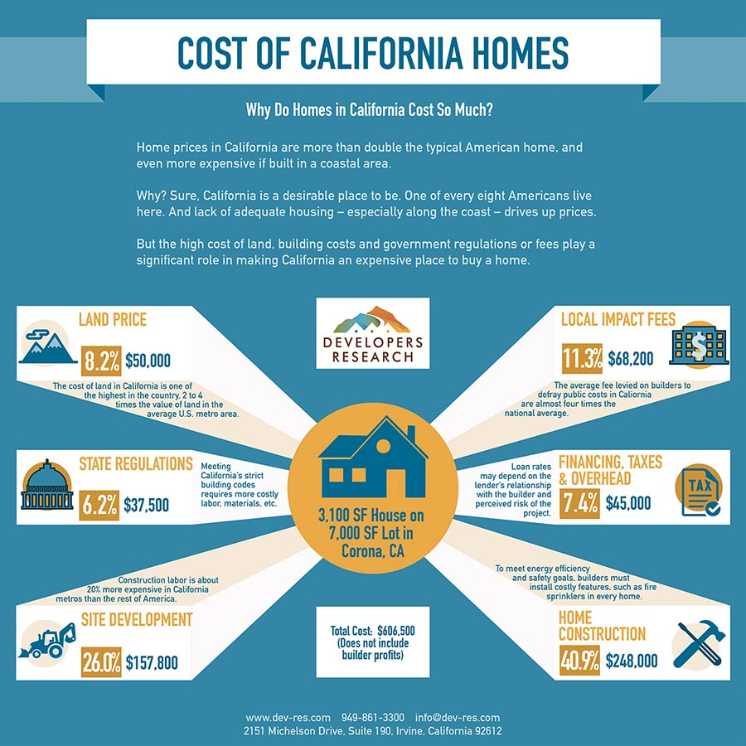
https://www.dev-res.com/press-and-news/why-do-homes-in-california-cost-so-much
Total 900.000 buat pie chart nya. Point nya yang di atas.
3100 SF 7000SF (ganti semua yang Tengah) jadi The median price for a home in California

