Task 1: Original Code
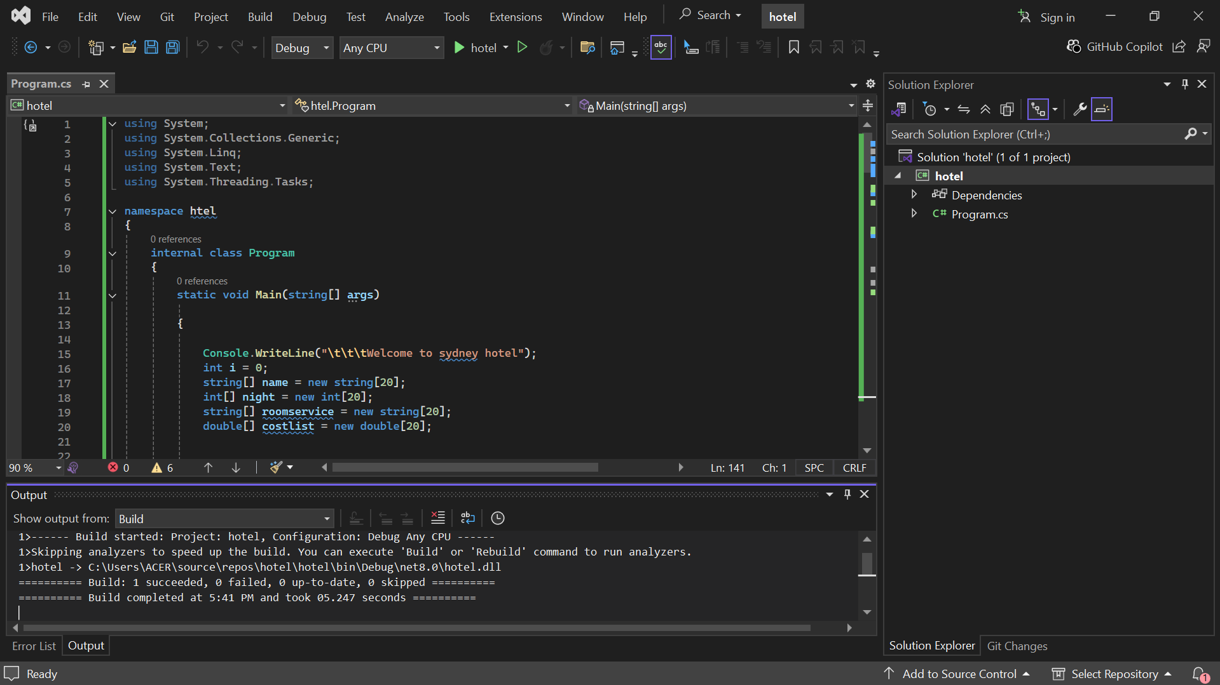

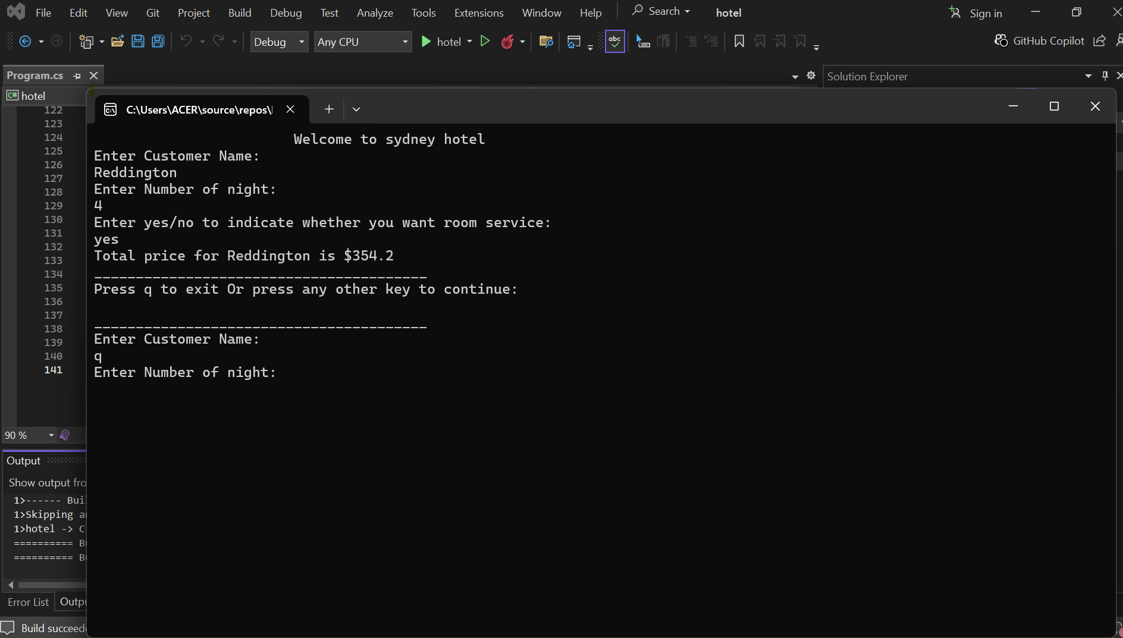

Task 2: Problem Description
This C# console program is designed to manage hotel reservations for a Sydney hotel. It allows the user to input multiple customers’ names, the number of nights they are staying, and whether they want room service. The program calculates the total cost based on the number of nights and an additional charge if room service is requested. Finally, it displays a summary of all reservations, including the total charges, the highest spending customer, and the lowest spending customer.
Task 3: Redesigning and Recoding the program
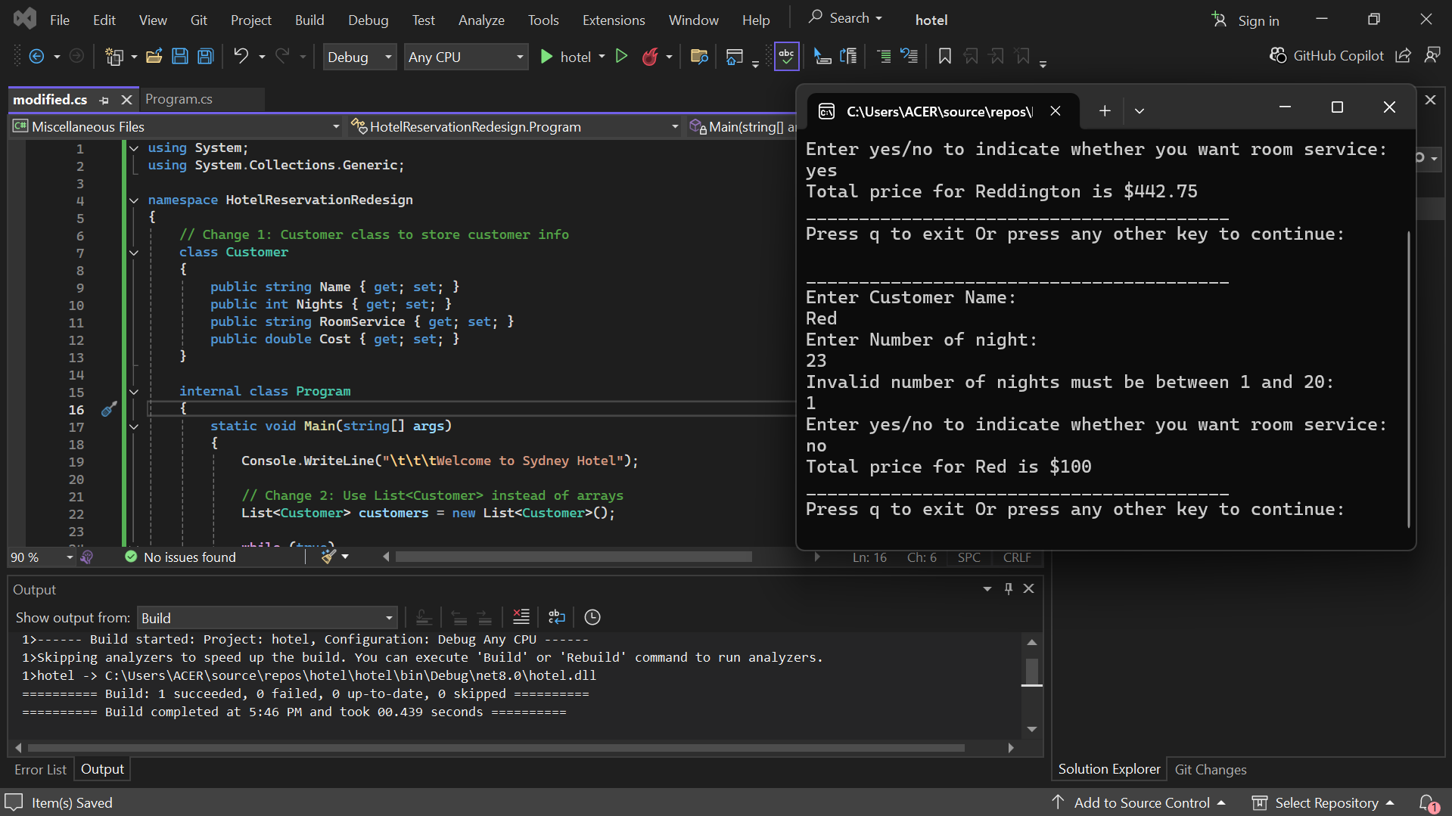

Change 1: Customer Class
Created a Customer class to store all customer information (name, number of nights, room service, and cost) in one object. This replaces multiple arrays and makes the code cleaner and easier to manage.
Before:

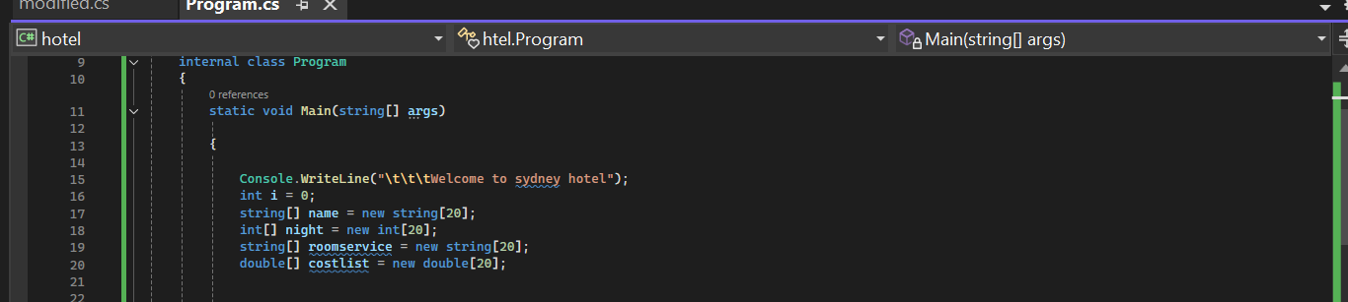
After:
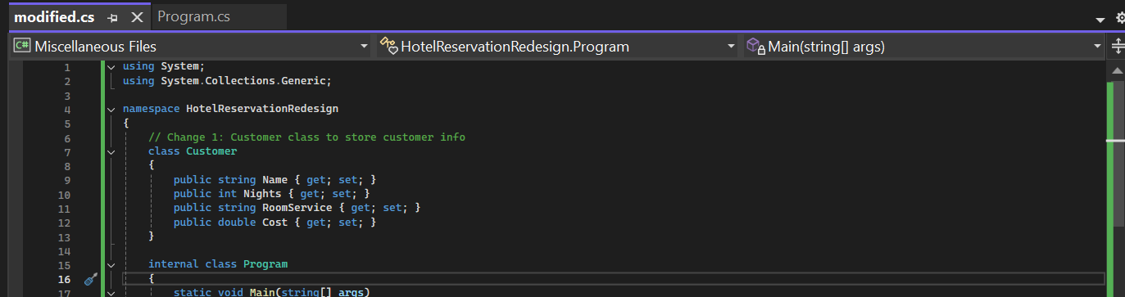

Change 2: List<Customer>
Description:
Replaced fixed-size arrays with a dynamic List<Customer> to store multiple customers. This allows adding any number of customers without worrying about array limits.
Before:
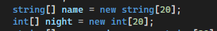
After:
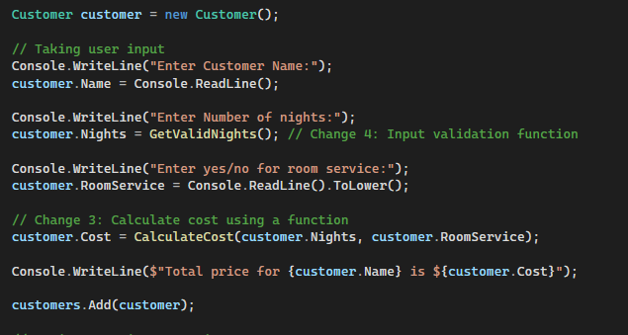

Change 3: CalculateCost Function
Moved the cost calculation logic into a separate function CalculateCost(). This improves code readability, makes it reusable, and separates logic from user input/output.
Before:
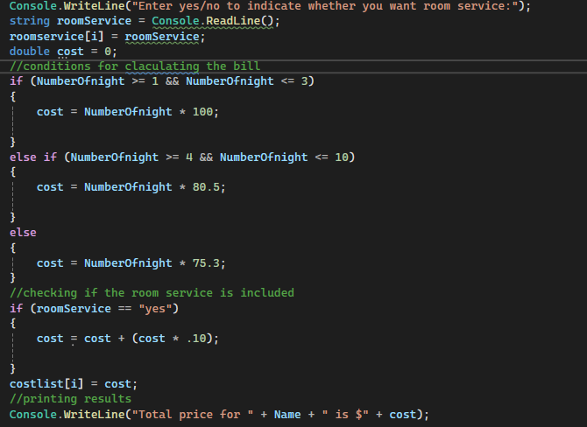
After:
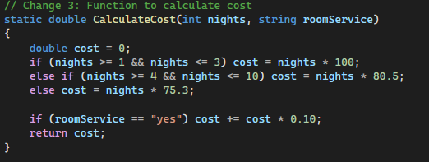

Change 4: GetValidNights Function (Input Validation)
Added a function GetValidNights() to validate user input for the number of nights. This prevents errors and ensures only numbers between 1 and 20 are accepted.
Before:
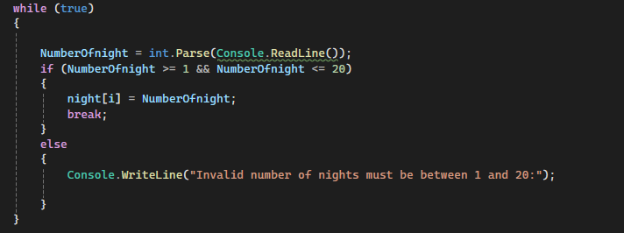
After:
