INSTALLATION INSTRUCTIONS AI AGENT AUTO LABEL

1. Install WSL (Windows Subsystem for Linux)
Requirements before installation: You need to be running Windows 10 version 2004 or later (Build 19041 or later) or Windows 11 to use the commands below. If you are using an older version, please see the manual installation guide page.
  - Install the Windows Subsystem Linux feature for Windows in the Control Panel.
- Search and Open:
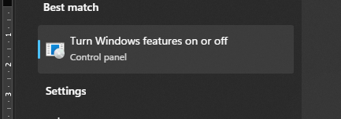
- Choose Windows Subsystem for Linux => OK
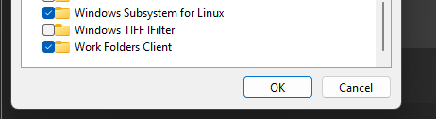
- Open microsoft powershell with admin privileges(run as administrator).
Run: wsl –install
If you want to change distro linux:
wsl.exe –install [Distro]
To see a list of available distros:
wsl.exe –list –online
  - Restart the computer
  - Setting up a Linux username and password on WSL
After installing WSL and your Linux distribution (Ubuntu by default), open the distro from the Start menu. You will be prompted to create a unique username and password for Linux.
- This username and password are separate from Windows and unique to each installed Linux distro.
- When entering the password, the screen will not display characters (blind typing), which is perfectly normal.
- This account will be the default user when opening the distro, automatically logging in upon opening the distro and having sudo privileges to run administrative commands.
- Each WSL distro has its own Linux account, which needs to be reset when installing, adding, or resetting a distro.
- Change or reset your Linux password on WSL
Open your Linux distro, type the command: passwd
The system will request to:
- Enter your current password.
- Enter your new password.
- Confirm your new password.
  - Using on visual code
- Install visual code (When installing and you see the "Select Additional Tasks" option, choose “Add to PATH”. This makes it easy to open a folder in WSL using the command: code
- Open Visual code, select extension section, install Extension WSL
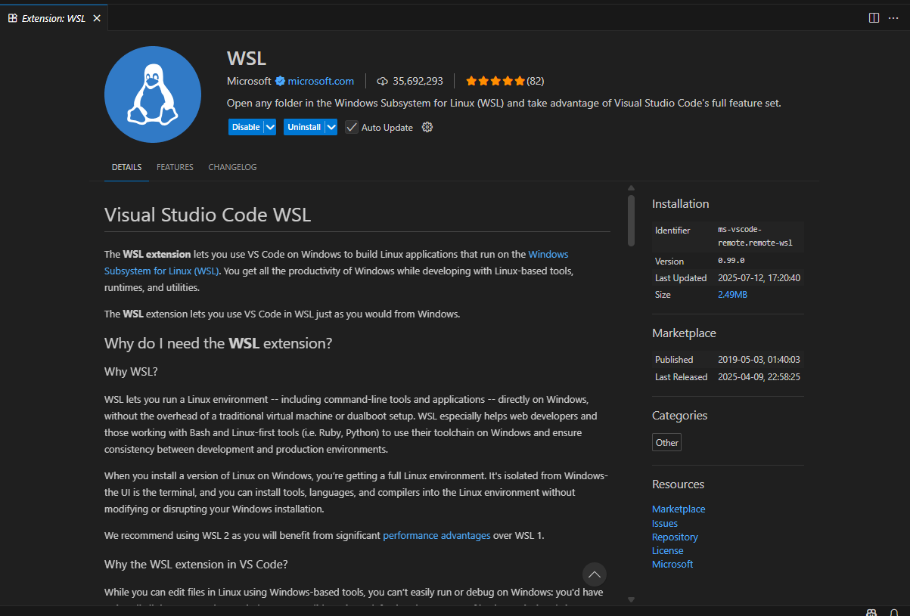

- Open wsl in visual code: From vs code, use shortcut ctrl+shift+P, and type wsl, and choose Connect to WSL using Distro
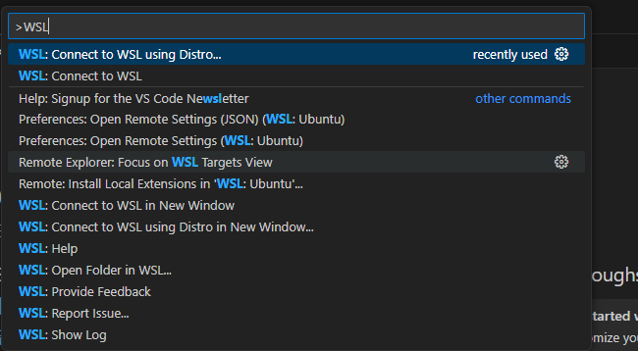
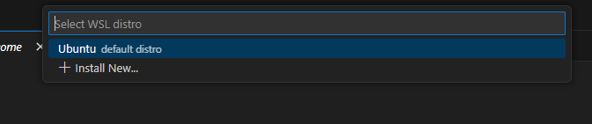
In which:
- WSL: Connect to WSL will connect to default distro
- Connect to WSL using Distro will allow you to select a distro to connect to
- Selections in New Window will open a new window

Or move to the Remote explorer section
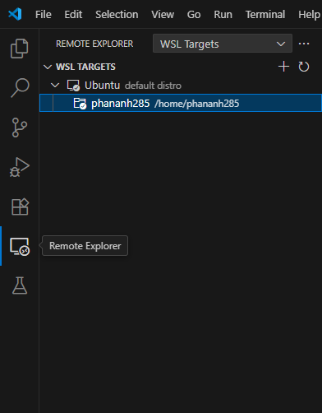
Choose Connect in current window to start
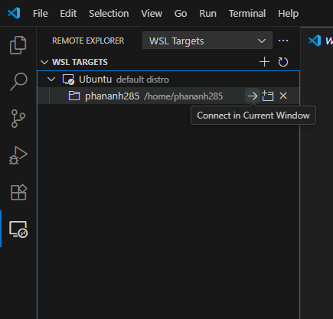

2. Install Miniconda
How to install: Installing Miniconda - Anaconda
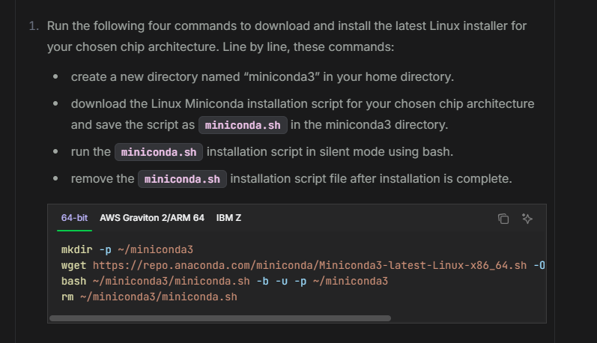
Or run the command:
mkdir -p ~/miniconda3
wget https://repo.anaconda.com/miniconda/Miniconda3-latest-Linux-x86_64.sh -O ~/miniconda3/miniconda.sh
bash ~/miniconda3/miniconda.sh -b -u -p ~/miniconda3
rm ~/miniconda3/miniconda.sh

3. Install AI-Agent Auto Label
- Copy file zip AI_AGENT in USB :
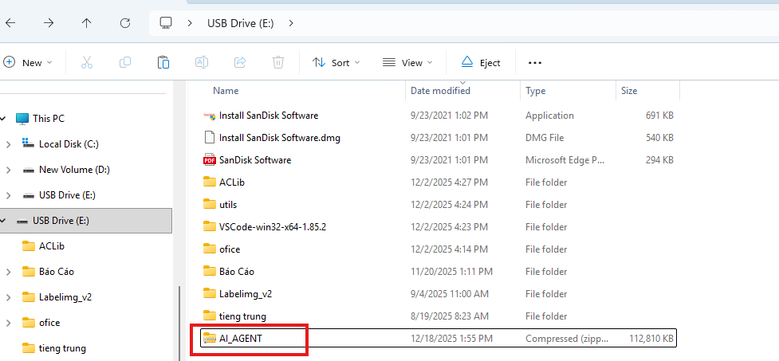
- Open visual code, move to the folder AI_AGENT and run:
pip install -r requirements.txt
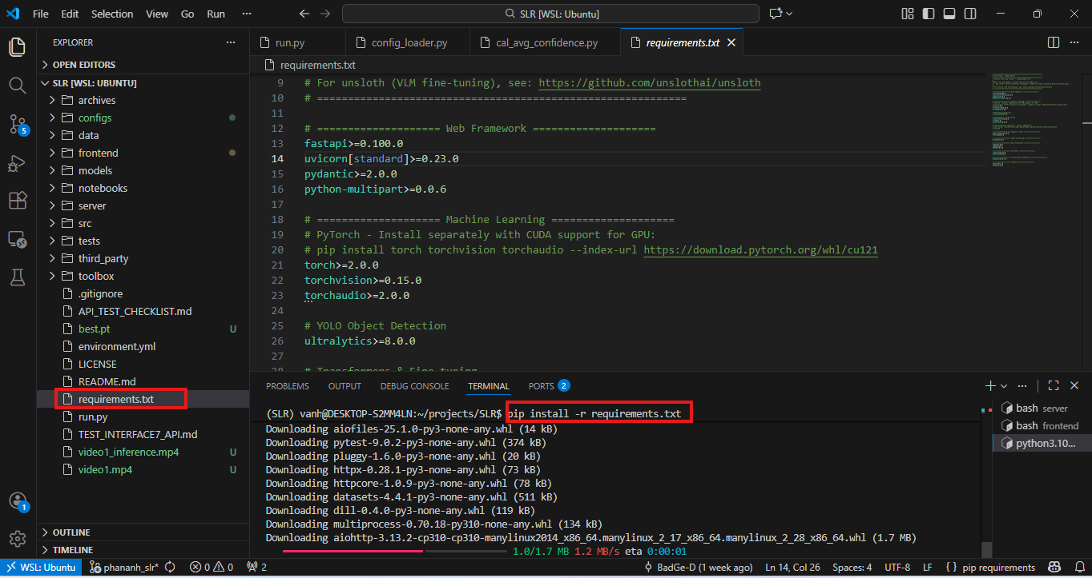

- Next, run: conda env create -f environment.yml
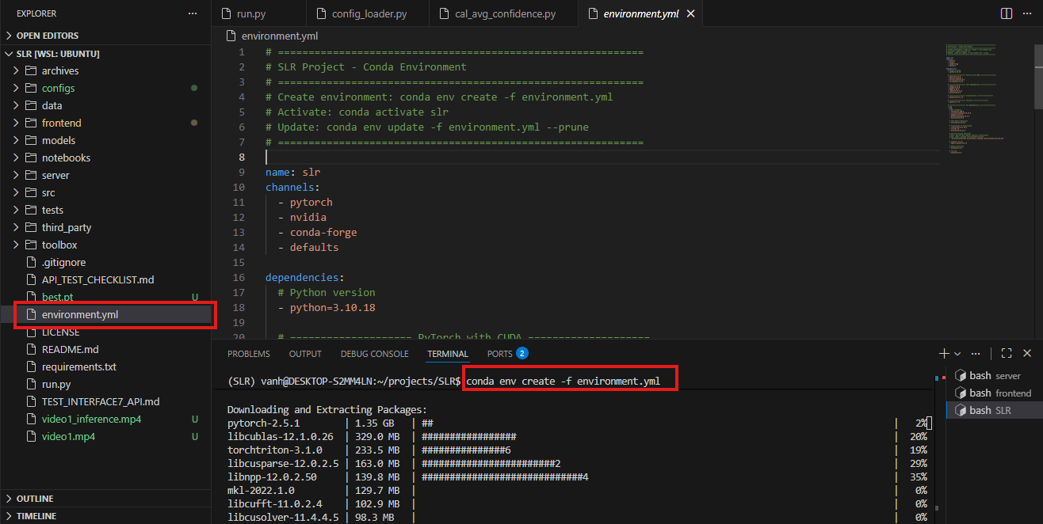
- Activate the environment: conda activate SLR
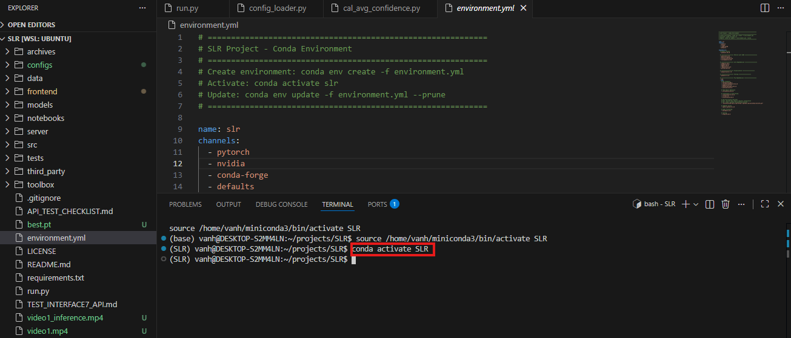

- Run the backend: cd server && bash start.sh -p 8000 (port 8000 can be changed)
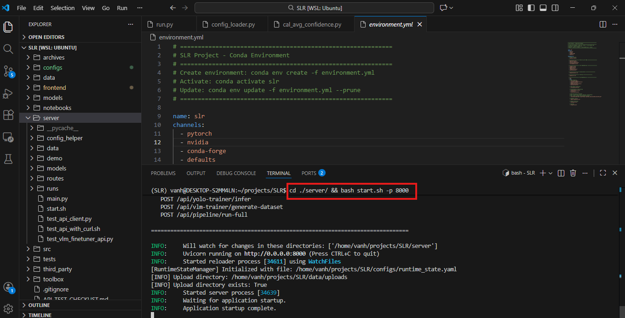
- Run the frontend: cd frontend && bash run_frontend.sh
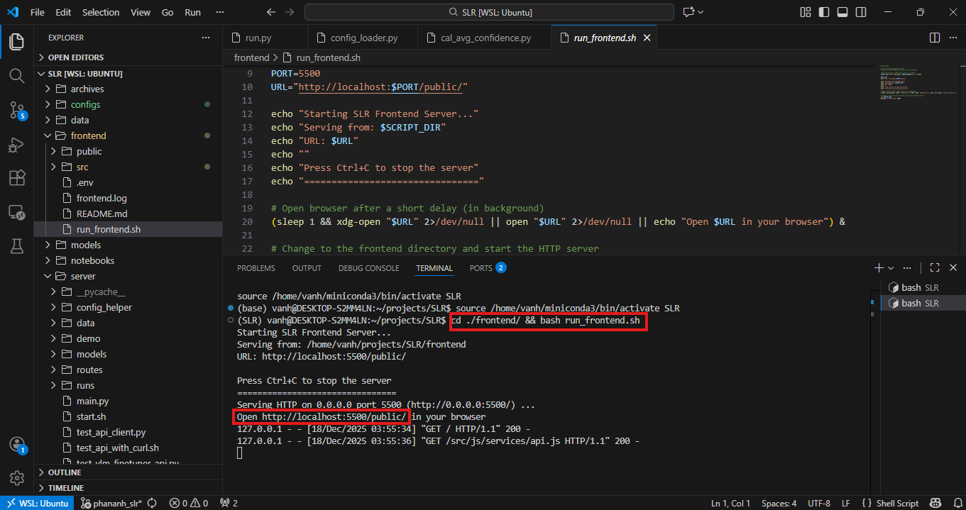

- Click http://localhost:5500/public/ . A user interface page will appear where you can start using AI AGENT AUTO LABEL.
