Functional Specification Document
Module: File Upload

1. Overview
This document describes the functional requirements for the File Upload module, used for attaching supporting documents to a customer support ticket. Section 2.3 covers virus scanning, which is a mandatory step before any file is made available for download.

2. Functional Requirements

2.1 File Selection and Validation
ID | Requirement | Details
FR-01 | Allowed File Types | See Table 2.1.1 for the list of accepted file types and size limits.
FR-02 | Upload Flow | See Figure 1 for the full validation and upload decision flow.
FR-03 | Multiple Files | A user may attach up to 5 files to a single support ticket.
Table 2.1.1: Accepted File Types
File Type | Extensions | Max Size
Images | .jpg, .jpeg, .png, .gif | 5 MB
Documents | .pdf, .docx, .txt | 10 MB
Spreadsheets | .xlsx, .csv | 10 MB

2.2 Upload Errors
ID | Requirement | Details
FR-04 | Type Rejection | If a file's extension is not in Table 2.1.1, the upload shall be rejected with an inline error, per Figure 1.
FR-05 | Size Rejection | If a file exceeds the size limit for its type, the upload shall be rejected with an inline error, per Figure 1.
FR-06 | Success Confirmation | On successful upload, a confirmation shall be shown and the file shall appear in the ticket's attachment list.

3. UI Reference
Figure 1 shows the upload decision flow referenced in FR-02, FR-04, and FR-05.
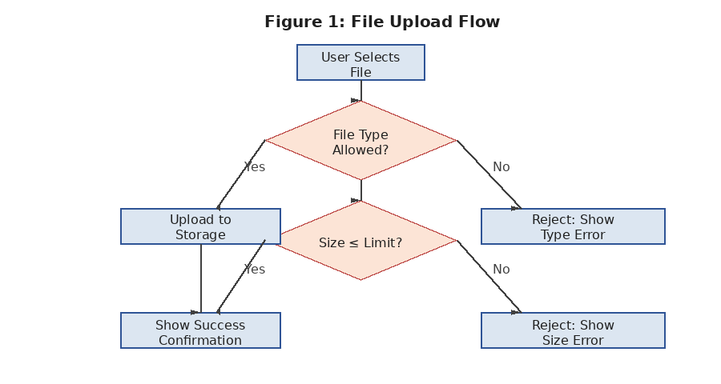

4. Open Items
- Section 2.3 (Virus Scanning) referenced in the Overview is missing from this document — needs to be written before this FSD is ready for test case generation.

