Functional Specification Document
Module: User Login

1. Overview
This document describes the functional requirements for the User Login module of the CustomerPortal application. It covers authentication, account lockout, and password reset initiation. It does not cover session management, which is specified separately.

2. Functional Requirements

2.1 Authentication
ID | Requirement | Details
FR-01 | User Login | A registered user shall be able to log in using their email address and password. See Figure 1 for the login screen layout.
FR-02 | Email Format Validation | The Email field shall accept only values in a valid email format (e.g. name@domain.com). An inline error shall be shown for invalid formats.
FR-03 | Password Rules | See Table 2.1.1 for password composition rules enforced at account creation and reset.
Table 2.1.1: Password Composition Rules
Rule | Value
Minimum length | 8 characters
Maximum length | 20 characters
Must contain | At least 1 uppercase letter, 1 number
Special characters | Allowed but not required

2.2 Account Lockout
ID | Requirement | Details
FR-04 | Failed Attempt Tracking | The system shall track consecutive failed login attempts per account. See Figure 2 for the full decision flow.
FR-05 | Account Lockout | After 5 consecutive failed attempts, the account shall be locked for 15 minutes. During lockout, login attempts shall be rejected even with correct credentials.
FR-06 | Lockout Notice
Note: FR-06 wording to be confirmed with the BA — see open item in Section 4.

2.3 Password Reset
ID | Requirement | Details
FR-07 | Forgot Password Link | The login screen shall provide a "Forgot password?" link, as shown in Figure 1.
FR-08 | Reset Link Delivery | On request, a reset link shall be emailed to the account's registered address. The link shall expire after 30 minutes.
FR-09 | System Performance | The login process should feel fast and responsive to the user.

3. UI Reference
Figure 1 shows the login screen layout referenced in FR-01, FR-02, and FR-07.
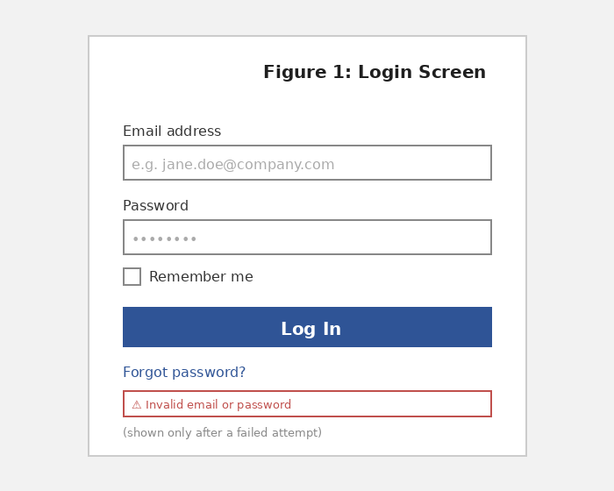

Figure 2 shows the decision flow referenced in FR-04 and FR-05.
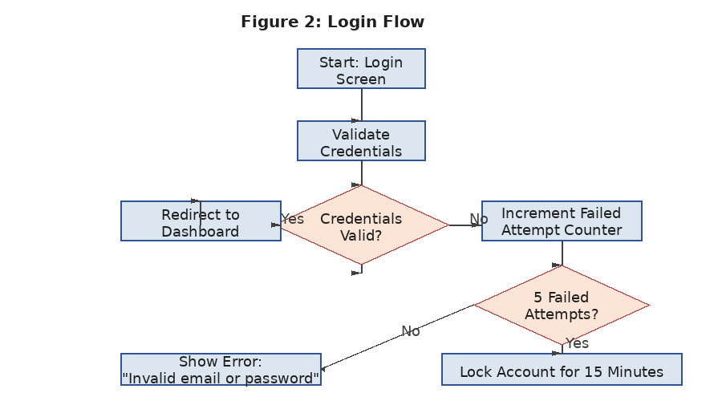

4. Open Items
- FR-06: exact wording of the lockout notice message is not yet defined — confirm with BA.
- FR-09: "fast and responsive" has no defined performance target — needs a measurable threshold.

