Functional Specification Document
Module: User Registration

1. Overview
This document describes the functional requirements for the User Registration module of the CustomerPortal application. See Figure 1 for the registration form layout.

2. Functional Requirements

2.1 Registration Form
ID | Requirement | Details
FR-01 | Registration Fields | The registration form shall collect Full Name, Email, Password, Confirm Password, and an optional Phone Number, as shown in Figure 1.
FR-02 | Field Validation | See Table 2.1.1 for per-field validation rules.
FR-03 | Terms Acceptance | The "I agree to the Terms of Service and Privacy Policy" checkbox must be checked before the Create Account button becomes enabled.
Table 2.1.1: Field Validation Rules
Field | Rule | Error Message
Full name | 2-50 characters, letters and spaces only | "Please enter a valid name"
Email | Must be a valid email format | "Please enter a valid email address"
Email | Must not already be registered | "An account with this email already exists"
Password | 8-20 characters, 1 uppercase, 1 number | "Password does not meet requirements"
Confirm password | Must match Password field exactly | "Passwords do not match"
Phone number | Optional. If provided, must be a valid phone format | "Please enter a valid phone number"

2.2 Email Verification
ID | Requirement | Details
FR-04 | Verification Email | After successful registration, a verification email containing a confirmation link shall be sent to the registered address.
FR-05 | Verification Speed | The verification email should arrive quickly so the user isn't kept waiting.
FR-06 | Unverified Account Access | An unverified account may log in but shall have read-only access until the email is verified.

3. UI Reference
Figure 1 shows the registration form layout referenced in FR-01 and FR-03.
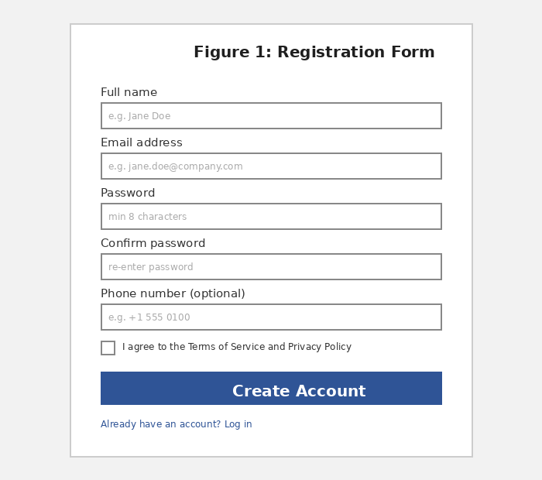

4. Open Items
- FR-05: "quickly" has no defined time target — needs a measurable threshold (e.g. within 60 seconds).

