Dendi Nurmahmudi

Progres minggu pertama :

* Imperative Leanguage

1. If/then/else
2. Loop ( for loop, bare loop, while loop
3. Case statement
4. Declarative regions
5. Conditional expression ( if expression, case expression )

* Subprogram
* Record
* Array
* Exceptions
* Tasking

Latihan :

* Membuat kalkulator memakai record dan subprogram.

**Main.adb**

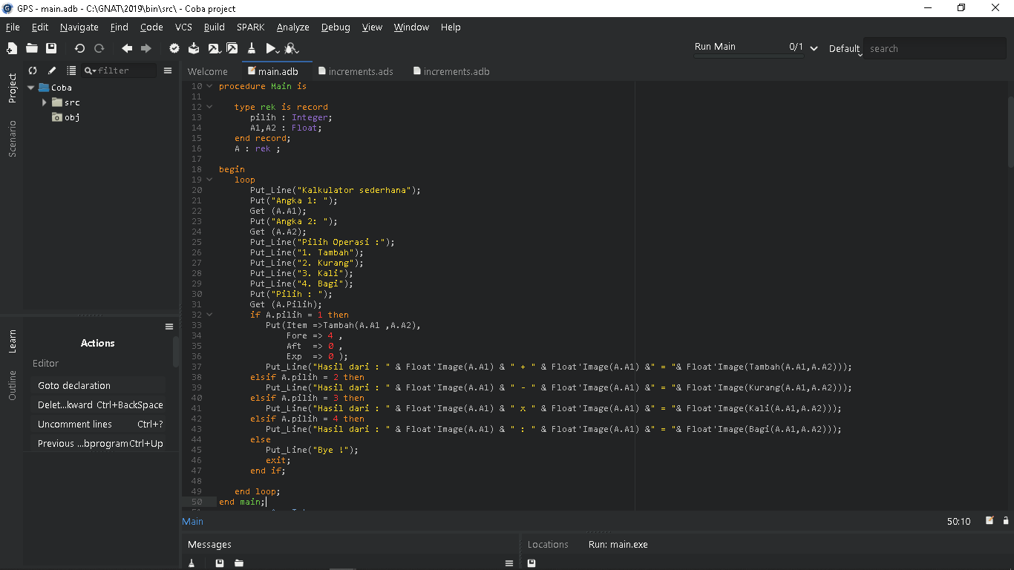

**Increments.ads**

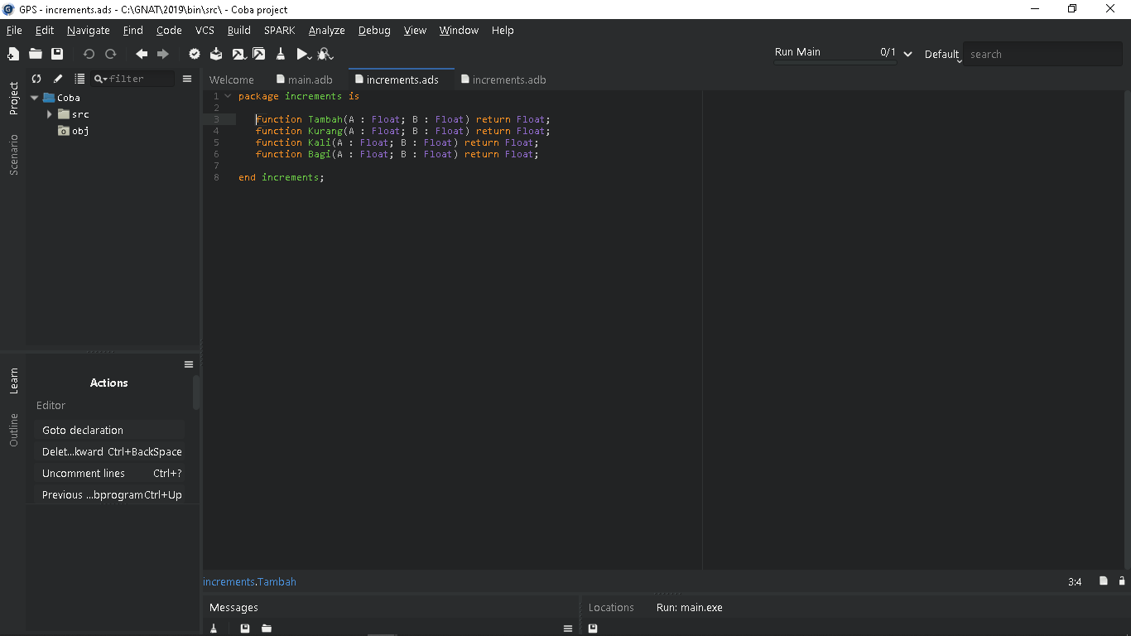

**Increments.adb**

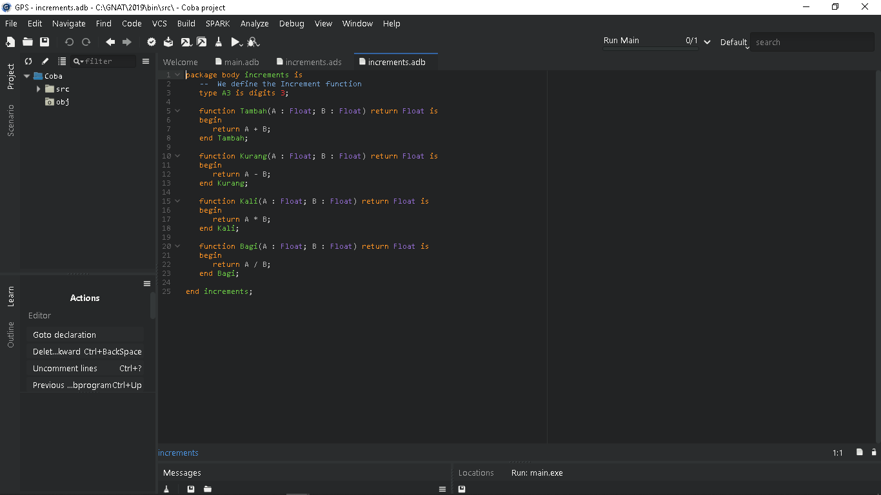

* Flowchart

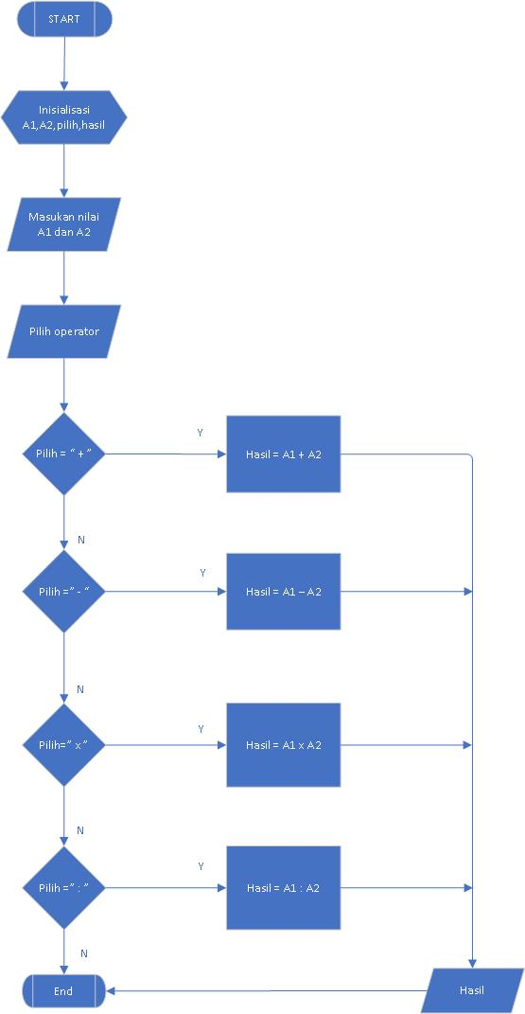

* Membuat perhitungan nilai pelajaran, rata- rata nilai, dan index nilai.
* Flowchart

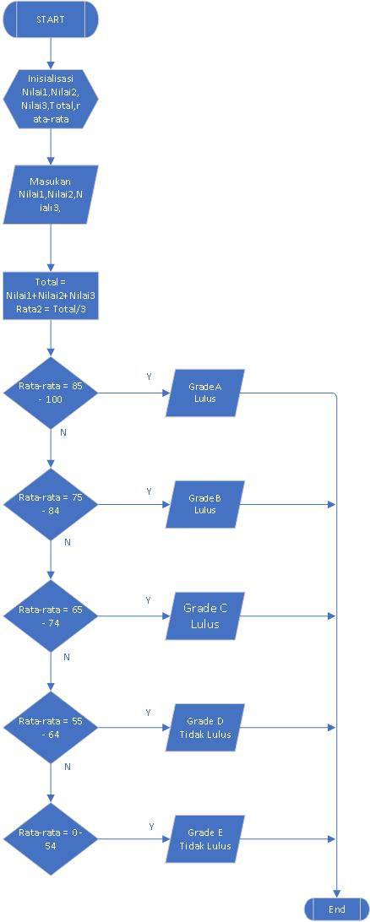

**Main.adb**

