PRACTICAL 1 :

A] Create an application to print on screen the output of adding , subtracting , multiplying and dividing two numbers entered by the user in C#.

using System;
public class practical1A
{
public static void Main(string[] args)
{
Console.Write("Enter the first number: ");
double num1 = Convert.ToDouble(Console.ReadLine());
Console.Write("Enter the second number: ");
double num2 = Convert.ToDouble(Console.ReadLine());
Console.WriteLine("\nResults:");
Console.WriteLine($"{num1} + {num2} = {num1+num2}");
Console.WriteLine($"{num1} - {num2} = {num1-num2}");
Console.WriteLine($"{num1} * {num2} = {num1*num2}");
Console.WriteLine($"{num1} / {num2} = {num1/num2}");
}
}

OUTPUT :

Enter the first number: 10
Enter the second number: 2
Results:
10 + 2 = 12
10 - 2 = 8
10 * 2 = 20
10 / 2 = 5

B] Create an application to print Floyd’s triangle till n rows in C#.

using System;
public class practical1A
{
public static void Main(string[] args)
{
Console.Write("Enter the number of rows for Floyd's triangle: ");
int count = 0;
int n = Convert.ToInt32(Console.ReadLine());
for(int i=0;i<n;i++)
{
for(int j=0;j<=i;j++)
{
Console.Write(count++);
}
Console.WriteLine();
} }
}

OUTPUT :

Enter the number of rows for Floyd's triangle: 5
0
1 2
3 4 5
6 7 8 9
10 11 12 13 14

C] Create an application to demonstrate following operations i. Generate Fibonacci series. ii. Test for prime numbers.

using System;
public class practical1A
{
public static void Main(string[] args)
{
Console.Write("Enter the number of terms for Fibonacci series: ");
int n = Convert.ToInt32(Console.ReadLine());
int f = 0;
int s = 1;
Console.Write(f);
Console.Write(" "+s);
for(int i =2;i<n;i++)
{
int sum = f + s;
Console.Write(" "+sum);
f=s;
s =sum;
}

}
}

OUTPUT :
Enter the number of terms for Fibonacci series: 6
0 1 1 2 3 5
PRACTICAL 2 :

A] Create a simple application to demonstrate the concepts boxing and unboxing.

using System;
public class HelloWorld
{
public static void Main(string[] args)
{
int value1 = 10;
double value2 = 10.40;

object boxing1 = value1;
object boxing2 = value2;

int unboxing1 = (int)boxing1;
double unboxing2 = (double)boxing2;

Console.WriteLine("Boxing Value 1: " + boxing1);
Console.WriteLine("Boxing Value 2: " + boxing2);
Console.WriteLine("Unboxing Value 1: " + unboxing1);
Console.WriteLine("Unboxing Value 2: " + unboxing2);
}
}

OUTPUT :

Boxing Value 1: 10
Boxing Value 2: 10.4
Unboxing Value 1: 10
Unboxing Value 2: 10.4

B] Create a simple application to perform addition and subtraction using delegate.

using System;

public class HelloWorld
{
public delegate void Operation(int a, int b);
public static void Main(string[] args)
{
Console.Write("Enter the first number: ");
int num1 = Convert.ToInt32(Console.ReadLine());

Console.Write("Enter the second number: ");
int num2 = Convert.ToInt32(Console.ReadLine());

Operation obj1 = add;
Operation obj2 = sub;
obj1(num1,num2);
obj2(num1,num2);

}
public static void add(int a,int b)
{
Console.WriteLine("Addition : "+(a+b));
}
public static void sub(int a,int b)
{
Console.WriteLine("Substraction : "+(a-b));
}
}

OUTPUT :

Enter the first number: 5
Enter the second number: 3
Addition : 8
Substraction : 2

C] Create a simple application to demonstrate use of the concepts of interfaces.

using System;
interface I1
{
void addition(int a,int b);
}
interface I2
{
void subtraction(int a, int b);
}
public class Cal:I1,I2
{
public void addition(int a,int b)
{
Console.WriteLine("Addition : "+(a+b));
}
public void subtraction(int a, int b)
{
Console.WriteLine("Subtraction : "+(a-b));
}
}

public class Program
{
public static void Main(string[] args)
{
Cal obj = new Cal();
obj.addition(10,20);
obj.subtraction(20,10);
}
}

OUTPUT :

Addition : 30
Subtraction : 10

PRACTICAL 3 :

A] Create a simple web page with various server controls to demonstrate setting and use of their properties. (Example : AutoPostBack).

practical3A.aspx:

<%@ Page Language="C#" AutoEventWireup="true" CodeBehind="WebForm1.aspx.cs" Inherits="AWP_practicals_1.WebForm1" %>

<!DOCTYPE html>

<html xmlns="http://www.w3.org/1999/xhtml">
<head runat="server">
<title></title>
</head>
<body>
<form id="form1" runat="server">
<div>
<asp:DropDownList ID="dropdownlist1" runat="server" AutoPostBack="true" OnSelectedIndexChanged="dropdownlist1_SelectedIndexChanged">
<asp:ListItem Value="400709">Koparkhairne</asp:ListItem>
<asp:ListItem Value="400701">Vashi</asp:ListItem>
<asp:ListItem Value="400710">Ghansoli</asp:ListItem>
</asp:DropDownList>
<asp:Label ID="Label1" runat="server" Text="Label"></asp:Label>
<asp:RadioButtonList ID="RadioButtonList1" runat="server" OnSelectedIndexChanged="RadioButtonList1_SelectedIndexChanged" AutoPostBack="true">
<asp:ListItem Text ="Red" Value="Red"></asp:ListItem>
<asp:ListItem Text ="Pink" Value="Pink"></asp:ListItem>
<asp:ListItem Text ="Yellow" Value="Yellow"></asp:ListItem>
<asp:ListItem Text ="Blue" Value="Blue"></asp:ListItem>
</asp:RadioButtonList>
<asp:RadioButtonList ID="RadioButtonList2" runat="server" OnSelectedIndexChanged="RadioButtonList2_SelectedIndexChanged" AutoPostBack="true">
<asp:ListItem > Times New Roman</asp:ListItem>
<asp:ListItem >Jokerman</asp:ListItem>
<asp:ListItem >Arial</asp:ListItem>
</asp:RadioButtonList>
<asp:RadioButtonList ID="RadioButtonList3" AutoPostBack="true" runat="server" OnSelectedIndexChanged="RadioButtonList3_SelectedIndexChanged">
<asp:ListItem > Small</asp:ListItem>
<asp:ListItem >Medium</asp:ListItem>
<asp:ListItem >Large</asp:ListItem>
<asp:ListItem >XLarge</asp:ListItem>
</asp:RadioButtonList>

<asp:CheckBox ID="CheckBox1" AutoPostBack="true" Text="Bold" runat="server" OnCheckedChanged="CheckBox1_CheckedChanged" />
<asp:CheckBox ID="CheckBox2" AutoPostBack="true" Text="Underline" runat="server" OnCheckedChanged="CheckBox2_CheckedChanged" />
<asp:CheckBox ID="CheckBox3" AutoPostBack="true" Text="Italic" runat="server" OnCheckedChanged="CheckBox3_CheckedChanged" />

</div>
</form>
</body>
</html>

practical3A.aspx.cs:

using System;
using System.Collections.Generic;
using System.Linq;
using System.Web;
using System.Web.UI;
using System.Web.UI.WebControls;

namespace AWP_practicals_1
{
public partial class WebForm1 : System.Web.UI.Page
{
protected void Page_Load(object sender, EventArgs e)
{

}

protected void dropdownlist1_SelectedIndexChanged(object sender, EventArgs e)
{
Label1.Text = dropdownlist1.SelectedValue;
}

protected void RadioButtonList1_SelectedIndexChanged(object sender, EventArgs e)
{
if (RadioButtonList1.SelectedIndex == 0)
{
Label1.ForeColor = System.Drawing.Color.Red;
}
if (RadioButtonList1.SelectedIndex == 1)
{
Label1.ForeColor = System.Drawing.Color.Pink;

}
if (RadioButtonList1.SelectedIndex == 2)
{
Label1.ForeColor = System.Drawing.Color.Yellow;

}
if (RadioButtonList1.SelectedIndex == 3)
{
Label1.ForeColor = System.Drawing.Color.Blue;

}

}

protected void RadioButtonList2_SelectedIndexChanged(object sender, EventArgs e)
{
Label1.Font.Name = RadioButtonList2.SelectedValue;
}

protected void RadioButtonList3_SelectedIndexChanged(object sender, EventArgs e)
{
if (RadioButtonList3.SelectedIndex == 0)
{
Label1.Font.Size = FontUnit.Small;
}
if (RadioButtonList3.SelectedIndex == 1)
{
Label1.Font.Size = FontUnit.Medium;
}
if (RadioButtonList3.SelectedIndex == 2)
{
Label1.Font.Size = FontUnit.Large;
}
if (RadioButtonList3.SelectedIndex == 3)
{
Label1.Font.Size = FontUnit.XLarge;
}

}

protected void CheckBox1_CheckedChanged(object sender, EventArgs e)
{
if (CheckBox1.Checked)
{
Label1.Font.Bold = true;
}
else
{
Label1.Font.Bold = false;
}

}

protected void CheckBox2_CheckedChanged(object sender, EventArgs e)
{
if (CheckBox2.Checked)
{
Label1.Font.Underline = true;
}
else
{
Label1.Font.Underline = false;
}

}

protected void CheckBox3_CheckedChanged(object sender, EventArgs e)
{
if (CheckBox3.Checked)
{
Label1.Font.Italic = true;
}
else
{
Label1.Font.Italic = false;
}

}
}
}
OUTPUT :

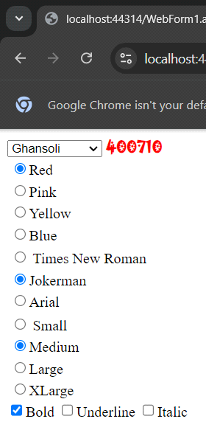

B] Create a simple application to demonstrate your vacation using calendar control.

practical3B.aspx:

<%@ Page Language="C#" AutoEventWireup="true" CodeBehind="Practical3B.aspx.cs" Inherits="AWP_project.Practical3B" %>

<!DOCTYPE html>

<html xmlns="http://www.w3.org/1999/xhtml">
<head runat="server">
<title></title>
</head>
<body>
<form id="form1" runat="server">
<div>
<asp:Calendar ID="Calendar1" runat="server" OnDayRender="Calendar1_DayRender" OnSelectionChanged="Calendar1_SelectionChanged"></asp:Calendar>
<asp:Label ID="Label1" runat="server" Text="Label"></asp:Label>

</div>
</form>
</body>
</html>

practical3B.aspx.cs:

using System;
using System.Collections.Generic;
using System.Linq;
using System.Web;
using System.Web.UI;
using System.Web.UI.WebControls;

namespace AWP_project
{
public partial class Practical3B : System.Web.UI.Page
{
protected void Page_Load(object sender, EventArgs e)
{
}
protected void Calendar1_SelectionChanged(object sender, EventArgs e)
{
Response.Write(Calendar1.SelectedDate.ToLongDateString());

}
protected void Calendar1_DayRender(object sender, DayRenderEventArgs e)
{
if (e.Day.Date.Day == 19 && e.Day.Date.Month == 9)
{
Label obj = new Label();
obj.Text = "BON DAY";
e.Cell.Controls.Add(obj);
}
DateTime t1 = new DateTime(2024, 09, 01);
DateTime t2 = t1.AddDays(5);
Calendar1.SelectedDates.SelectRange(t1, t2);

TimeSpan t = new DateTime(2024, 08, 07) - DateTime.Now;
Label1.Text = ("no of days left:" + t.Days);
} }}

OUTPUT :

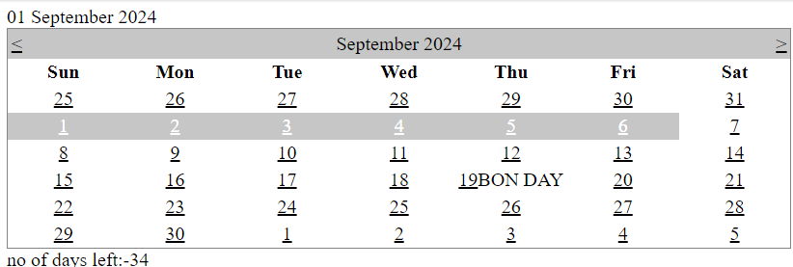

C] Demonstrate the use of Treeview operations on the web form.

Master page:
<%@ Master Language="C#" AutoEventWireup="true" CodeBehind="Site1.master.cs" Inherits="WebApplication5.Site1" %>
<!DOCTYPE html>
<html>
<head runat="server">
<title></title>
<asp:ContentPlaceHolder ID="head" runat="server">
</asp:ContentPlaceHolder>
</head>
<body>
<form id="form1" runat="server">
<div>
<asp:Table ID="Table1" runat="server" Height="166px" Width="312px">
<asp:TableRow>
<asp:TableCell>
<asp:TreeView ID="TreeView1" runat="server">
<Nodes>
<asp:TreeNode Text="TYIT SEM 5">
<asp:TreeNode Text="NGT" NavigateUrl="~/WebForm1.aspx"></asp:TreeNode>
<asp:TreeNode Text="AWP" NavigateUrl="~/WebForm2.aspx"></asp:TreeNode>
<asp:TreeNode Text="AI" NavigateUrl="~/WebForm3.aspx"></asp:TreeNode>
</asp:TreeNode>
</Nodes>
</asp:TreeView>
</asp:TableCell>
<asp:TableCell>
<asp:ContentPlaceHolder ID="ContentPlaceHolder1" runat="server"></asp:ContentPlaceHolder>
</asp:TableCell>
</asp:TableRow>
</asp:Table>
</div>
</form>
</body>
</html>
Webform1.aspx:
<%@ Page Title="" Language="C#" MasterPageFile="~/Site1.Master" AutoEventWireup="true" CodeBehind="WebForm1.aspx.cs" Inherits="WebApplication5.WebForm1" %>
<asp:Content ID="Content1" ContentPlaceHolderID="head" runat="server">
NGT
</asp:Content>
<asp:Content ID="Content2" ContentPlaceHolderID="ContentPlaceHolder1" runat="server">
Next Generation Technologies
</asp:Content>

Webform2.aspx
<%@ Page Title="" Language="C#" MasterPageFile="~/Site1.Master" AutoEventWireup="true" CodeBehind="WebForm2.aspx.cs" Inherits="WebApplication5.WebForm2" %>
<asp:Content ID="Content1" ContentPlaceHolderID="head" runat="server">
AWP
</asp:Content>
<asp:Content ID="Content2" ContentPlaceHolderID="ContentPlaceHolder1" runat="server">
Advanced Web Programming
</asp:Content>

Webform3.aspx
<%@ Page Title="" Language="C#" MasterPageFile="~/Site1.Master" AutoEventWireup="true" CodeBehind="WebForm3.aspx.cs" Inherits="WebApplication5.WebForm3" %>

<asp:Content ID="Content1" ContentPlaceHolderID="head" runat="server">
AI
</asp:Content>
<asp:Content ID="Content2" ContentPlaceHolderID="ContentPlaceHolder1" runat="server">
Artificial Intelligence
</asp:Content>

OUTPUT :

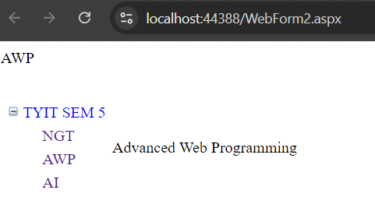

PRACTICAL 4 :

A] Create a Registration form to demonstrate use of various Validation controls.

WebForm4 .aspx:

<%@ Page Language="C#" AutoEventWireup="true" CodeBehind="WebForm4.aspx.cs" Inherits="AWP_practicals_1.WebForm4" %>

<!DOCTYPE html>

<html xmlns="http://www.w3.org/1999/xhtml">
<head runat="server">
<title></title>
</head>
<body>
<form id="form1" runat="server">
<div>
Enter Name : <asp:TextBox ID="TextBox1" runat="server"></asp:TextBox>
<asp:RequiredFieldValidator ID="RequiredFieldValidator1" runat="server" ErrorMessage="Enter valid name !!!" ControlToValidate="TextBox1" ValidationGroup="vg1">
</asp:RequiredFieldValidator>

<br />

Enter Age : <asp:TextBox ID="TextBox2" runat="server"></asp:TextBox>
<asp:RangeValidator ID="RangeValidator1" runat="server" ErrorMessage="Enter valid age !!!" MinimumValue="20" MaximumValue="50" ControlToValidate="TextBox2" Type="Integer" ValidationGroup="vg1">
</asp:RangeValidator>

<br />

Enter Email : <asp:TextBox ID="TextBox3" runat="server"></asp:TextBox>
<asp:RegularExpressionValidator ID="RegularExpressionValidator1" runat="server" ErrorMessage="Enter valid email !!!" ValidationExpression="^[^@\s]+@[^@\s]+\.[^@\s]+$" ControlToValidate="TextBox3" ValidationGroup="vg1">
</asp:RegularExpressionValidator>

<br />

Enter Password: <asp:TextBox ID="TextBox4" runat="server"></asp:TextBox>
<asp:RequiredFieldValidator ID="RequiredFieldValidator2" runat="server" ErrorMessage="enter valid password" ControlToValidate="TextBox4" ValidationGroup="vg1">
</asp:RequiredFieldValidator>

<br />

Re-Enter password : <asp:TextBox ID="TextBox5" runat="server"></asp:TextBox>
<asp:CompareValidator ID="CompareValidator1" runat="server" ErrorMessage="Passwords do not match !!!" ControlToCompare="TextBox4" ControlToValidate="TextBox5" Operator="Equal" ForeColor="Red" ValidationGroup="vg1">
</asp:CompareValidator>
<br />
<asp:Button ID="Button1" runat="server" Text="Button

" OnClick="Button1_Click" ValidationGroup="vg1" />
</div>
</form>
</body>
</html>

WebForm4.aspx.cs:

using System;
using System.Collections.Generic;
using System.Linq;
using System.Web;
using System.Web.UI;
using System.Web.UI.WebControls;
namespace pract4a
{
public partial class WebForm4 : System.Web.UI.Page
{
protected void Page_Load(object sender, EventArgs e)
{
}
protected void Button1_Click(object sender, EventArgs e)
{
if (Page.IsValid)
{
Response.Write("Success");
}
}
}
}

OUTPUT :

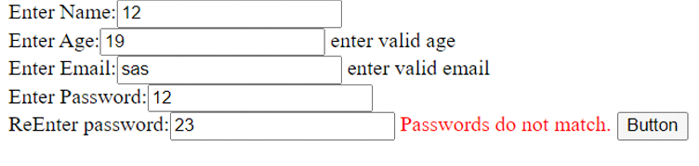

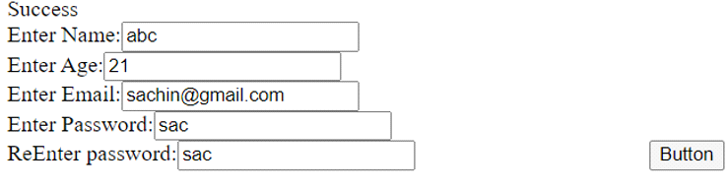

B] Create Web Form to demonstrate use of Adrotator Control.

WebForm5.aspx:

<%@ Page Language="C#" AutoEventWireup="true" CodeBehind="WebForm5.aspx.cs" Inherits="AWP_practicals_1.WebForm5" %>
<!DOCTYPE html>
<html xmlns="http://www.w3.org/1999/xhtml">
<head runat="server">
<title></title>
</head>
<body>
<form id="form1" runat="server">
<div>
<asp:AdRotator ID="AdRotator1" runat="server" AdvertisementFile="~/FileName.xml"/>
</div>
</form>
</body>
</html>

FileName.xml:

<?xml version="1.0" encoding="utf-8" ?>

<Advertisements>
<Ad>
<NavigateUrl> https://github.com/logos</NavigateUrl>
<ImageUrl>https://encrypted-tbn0.gstatic.com/images?q=tbn:ANd9GcSbqj9Ii13d6hx5a9kyLnC5A8A96LDSaSZv_w&s</ImageUrl>
<AlternateText>gitub</AlternateText>
<Impressions>20</Impressions>
<Keywords>google</Keywords>
</Ad>
<Ad>
<NavigateUrl>https://in.linkedin.com/</NavigateUrl>
<ImageUrl>https://encrypted-tbn0.gstatic.com/images?q=tbn:ANd9GcS4fcdsIUPUgmbvGaP-RC4RbHYdVtoN_fM8aya_8gOXI2BRtClESO-0_jgWTtKtIVmOQKs&usqp=CAU</ImageUrl>
<AlternateText>linkedin</AlternateText>
<Impressions>10</Impressions>
<Keywords>google</Keywords>
</Ad>
<Ad>
<NavigateUrl> https://x.com/</NavigateUrl>
<ImageUrl>https://img.freepik.com/free-vector/new-2023-twitter-logo-x-icon-design_1017-45418.jpg?size=338&ext=jpg&ga=GA1.1.2008272138.1726012800&semt=ais_hybrid</ImageUrl>
<AlternateText>X</AlternateText>
<Impressions>5</Impressions>
<Keywords>google</Keywords>
</Ad>
</Advertisements>

OUTPUT :

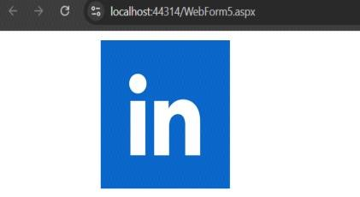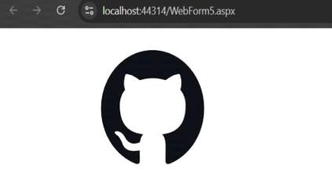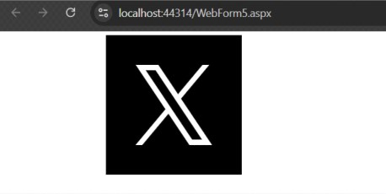
OUTPUT :

C] Create Web Form to demonstrate use User Controls

practical4C.aspx:

<%@ Control Language="C#" AutoEventWireup="true" CodeBehind="practical4C.ascx.cs" Inherits="AWP_project.practical4C" %>
<asp:Calendar ID="Calendar1" runat="server" OnSelectionChanged="Calendar1_SelectionChanged"></asp:Calendar>
<asp:Label ID="Label1" runat="server" Text="Label"></asp:Label>

practical4C.aspx.cs:

using System;
using System.Collections.Generic;
using System.Linq;
using System.Web;
using System.Web.UI;
using System.Web.UI.WebControls;

namespace AWP_project
{
public partial class practical4C : System.Web.UI.Page
{
protected void Page_Load(object sender, EventArgs e)
{
Label1.Text = Calendar1.SelectedDate.ToLongDateString();
}
}
}

webform1.axpx:

<%@ Page Language="C#" AutoEventWireup="true" CodeBehind="WebForm1.aspx.cs" Inherits="AWP_project.WebForm1" %>
<!DOCTYPE html>
<html xmlns="http://www.w3.org/1999/xhtml">
<head runat="server">
<title></title>
</head>
<body>
<form id="form1" runat="server">
<div>
DOB <uc1:tyit runat="server" id="tyit" />
</div>
</form>
</body>
</html>

webform2.axpx:

<%@ Page Language="C#" AutoEventWireup="true" CodeBehind="WebForm2.aspx.cs" Inherits="AWP_project.WebForm2" %>
<!DOCTYPE html>
<html xmlns="http://www.w3.org/1999/xhtml">
<head runat="server">
<title></title>
</head>
<body>
<form id="form1" runat="server">
<div>
DOJ<uc1:tyit runat="server" id="tyit" />
</div>
</form>
</body>
</html>

webform3.axpx:

<%@ Page Language="C#" AutoEventWireup="true" CodeBehind="WebForm3.aspx.cs" Inherits="AWP_project.WebForm3" %>
<!DOCTYPE html>
<html xmlns="http://www.w3.org/1999/xhtml">
<head runat="server">
<title></title>
</head>
<body>
<form id="form1" runat="server">
<div>
DOP<uc1:tyit runat="server" id="tyit" />
</div>
</form>
</body>
</html>

OUTPUT :

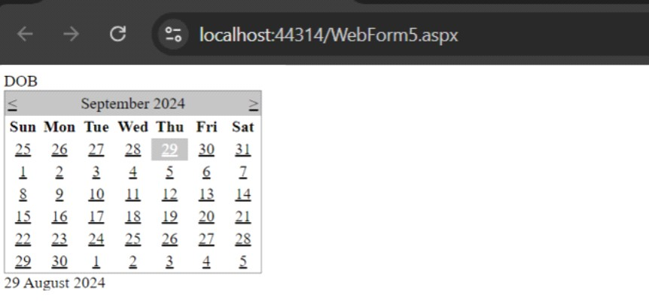

PRACTICAL 5 :

A] Create Web Form to demonstrate use of Website Navigation controls.
Create a web application to demonstrate use of Master Page and content page.

Master page:
<%@ Master Language="C#" AutoEventWireup="true" CodeBehind="Site2.master.cs" Inherits="WebApplication5.Site2" %>
<!DOCTYPE html>
<html>
<head runat="server">
<title></title>
<asp:ContentPlaceHolder ID="head" runat="server">
</asp:ContentPlaceHolder>
</head>
<body>
<form id="form1" runat="server">
<div>
<asp:Table ID="Table1" runat="server" Height="391px" GridLines="Both" Width="589px">
<asp:TableRow>
<asp:TableCell ColumnSpan="2">TYIT MASTER PAGE</asp:TableCell>
</asp:TableRow>
<asp:TableRow>
<asp:TableCell>
<asp:Menu ID="Menu1" runat="server">
<Items>
<asp:MenuItem Text="SEM V">
<asp:MenuItem Text="AWP" NavigateUrl="~/WebForm5.aspx"></asp:MenuItem>
<asp:MenuItem Text="NGT" NavigateUrl="~/WebForm6.aspx"></asp:MenuItem>
<asp:MenuItem Text="AI" NavigateUrl="~/WebForm7.aspx"></asp:MenuItem>
<asp:MenuItem Text="IOT" NavigateUrl="~/WebForm8.aspx"></asp:MenuItem>
</asp:MenuItem>
</Items>
</asp:Menu>
</asp:TableCell>
<asp:TableCell>
<asp:ContentPlaceHolder ID="ContentPlaceHolder1" runat="server">
</asp:ContentPlaceHolder>
</asp:TableCell>
</asp:TableRow>
<asp:TableRow>
<asp:TableCell ColumnSpan="2">
Copyright@2003
</asp:TableCell>
</asp:TableRow>
</asp:Table>
</div>
</form>
</body>
</html>
Webform5.aspx:
<%@ Page Title="" Language="C#" MasterPageFile="~/Site2.Master" AutoEventWireup="true" CodeBehind="WebForm5.aspx.cs" Inherits="WebApplication5.WebForm5" %>
<asp:Content ID="Content1" ContentPlaceHolderID="head" runat="server">
AWP
</asp:Content>
<asp:Content ID="Content2" ContentPlaceHolderID="ContentPlaceHolder1" runat="server">
Advanced Web Programming
</asp:Content>
Webform6.aspx:
<%@ Page Title="" Language="C#" MasterPageFile="~/Site2.Master" AutoEventWireup="true" CodeBehind="WebForm6.aspx.cs" Inherits="WebApplication5.WebForm6" %>
<asp:Content ID="Content1" ContentPlaceHolderID="head" runat="server">
NGT
</asp:Content>
<asp:Content ID="Content2" ContentPlaceHolderID="ContentPlaceHolder1" runat="server">
Next Generation Technologies
</asp:Content>

Webform7.aspx:
<%@ Page Title="" Language="C#" MasterPageFile="~/Site2.Master" AutoEventWireup="true" CodeBehind="WebForm7.aspx.cs" Inherits="WebApplication5.WebForm7" %>
<asp:Content ID="Content1" ContentPlaceHolderID="head" runat="server">
AI
</asp:Content>
<asp:Content ID="Content2" ContentPlaceHolderID="ContentPlaceHolder1" runat="server">
Artificial Intelligence
</asp:Content>

Webform8.aspx:
<%@ Page Title="" Language="C#" MasterPageFile="~/Site2.Master" AutoEventWireup="true" CodeBehind="WebForm8.aspx.cs" Inherits="WebApplication5.WebForm8" %>
<asp:Content ID="Content1" ContentPlaceHolderID="head" runat="server">
IOT
</asp:Content>
<asp:Content ID="Content2" ContentPlaceHolderID="ContentPlaceHolder1" runat="server">
Internet of Things
</asp:Content>

OUTPUT :

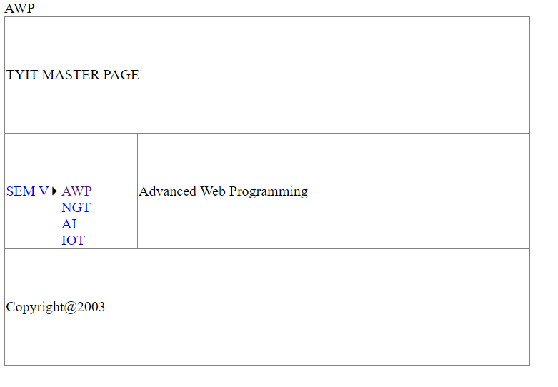
B] Create a simple application to demonstrate your vacation using calendar control.

WebForm9.aspx:
<%@ Page Language="C#" AutoEventWireup="true" CodeBehind="WebForm9.aspx.cs" Inherits="WebApplication5.WebForm9" %>

<!DOCTYPE html>

<html xmlns="http://www.w3.org/1999/xhtml">
<head runat="server">
<title></title>
</head>
<body>
<form id="form1" runat="server">
<div>
<asp:TextBox ID="TextBox1" runat="server"></asp:TextBox>
<asp:Button ID="Button1" runat="server" Text="Reload" OnClick="Button_click1"/>
</div>
</form>
</body>
</html>
WebForm9.aspx.cs(ViewState):
using System;
using System.Collections.Generic;
using System.Linq;
using System.Web;
using System.Web.UI;
using System.Web.UI.WebControls;

namespace WebApplication5
{
public partial class WebForm9 : System.Web.UI.Page
{
int x = 1;
protected void Page_Load(object sender, EventArgs e)
{
if(!IsPostBack)
{
TextBox1.Text = "0";
}
}

protected void Button_click1(object sender, EventArgs e)
{
if (ViewState["a"] != null)
{
x = Convert.ToInt32(ViewState["a"]) + 1;
}
TextBox1.Text = x.ToString();
ViewState["a"] = x;

}
}
}

OUTPUT :
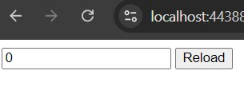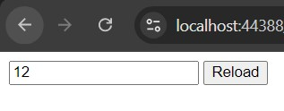

WebForm9.aspx.cs(Application):
using System;
using System.Collections.Generic;
using System.Linq;
using System.Web;
using System.Web.UI;
using System.Web.UI.WebControls;

namespace WebApplication5
{
public partial class WebForm9 : System.Web.UI.Page
{
int x = 1;
protected void Page_Load(object sender, EventArgs e)
{
if(!IsPostBack)
{
TextBox1.Text = "";
}
}

protected void Button_click1(object sender, EventArgs e)
{
if (Application["a"] != null)
{
x = Convert.ToInt32(Application["a"]) + 1;
}
TextBox1.Text = x.ToString();
Application["a"] = x;

}
}
}

OUTPUT :

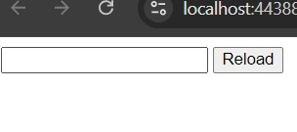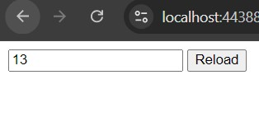
WebForm9.aspx.cs(Session):

using System;
using System.Collections.Generic;
using System.Linq;
using System.Web;
using System.Web.UI;
using System.Web.UI.WebControls;

namespace WebApplication5
{
public partial class WebForm9 : System.Web.UI.Page
{
int x = 1;
protected void Page_Load(object sender, EventArgs e)
{
if(!IsPostBack)
{
TextBox1.Text = "0";
}
}

protected void Button_click1(object sender, EventArgs e)
{
if (Session["a"] != null)
{
x = Convert.ToInt32(Session["a"]) + 1;
}
TextBox1.Text = x.ToString();
Session["a"] = x;
}
}
}

OUTPUT :

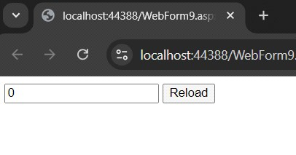

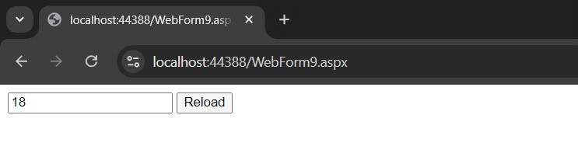

PRACTICAL 6:

A] Create a web application for inserting and deleting records from a database.
WebForm1.aspx:

<%@ Page Language="C#" AutoEventWireup="true" CodeBehind="WebForm1.aspx.cs" Inherits="WebApplication6.WebForm1" %>
<!DOCTYPE html>
<html xmlns="http://www.w3.org/1999/xhtml">
<head runat="server">
<title></title>
</head>
<body>
<form id="form1" runat="server">
<div>
data inserted
<br />
emp id<asp:TextBox ID="TextBox1" runat="server"></asp:TextBox>
name<asp:TextBox ID="TextBox2" runat="server"></asp:TextBox>
salary<asp:TextBox ID="TextBox3" runat="server"></asp:TextBox>
age<asp:TextBox ID="TextBox4" runat="server"></asp:TextBox>
<asp:Button ID="Button1" runat="server" Text="insert" OnClick="Button1_Click"/>
<asp:Button ID="Button2" runat="server" Text="delete" OnClick="Button2_Click"/>
</div>
</form>
</body>
</html>

WebForm1.aspx.cs:

using System;
using System.Collections.Generic;
using System.Data.SqlClient;
using System.Linq;
using System.Web;
using System.Web.UI;
using System.Web.UI.WebControls;
using System.Data;
using System.Data.SqlClient;

namespace WebApplication6
{
public partial class WebForm1 : System.Web.UI.Page
{
protected void Page_Load(object sender, EventArgs e)
{

}
}
protected void Button1_Click(object sender, EventArgs e)
{
SqlConnection con = new SqlConnection("Data Source=SQL;Initial Catalog=tybscit;User ID=user1;Password=user1");
SqlCommand cmd = new SqlCommand("insert into emp values(@Id,@ename,@salary,@age)", con);
cmd.Parameters.AddWithValue("@Id", TextBox1.Text);
cmd.Parameters.AddWithValue("@ename", TextBox2.Text);
cmd.Parameters.AddWithValue("@salary", TextBox3.Text);
cmd.Parameters.AddWithValue("@age", TextBox4.Text);
con.Open();
cmd.ExecuteNonQuery();
Response.Write("data inserted");
con.Close();
}

protected void Button2_Click(object sender, EventArgs e)
{
SqlConnection con = new SqlConnection("Data Source=SQL;Initial Catalog=tybsc123;User ID=user1;Password=user1");
SqlCommand cmd = new SqlCommand("delete from emp where Id=@Id", con);
cmd.Parameters.AddWithValue("@Id", TextBox1.Text);
con.Open();
cmd.ExecuteNonQuery();
Response.Write("data deleted");
con.Close();
}

}

OUTPUT :

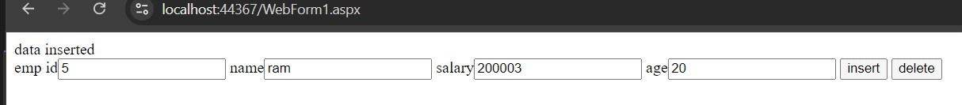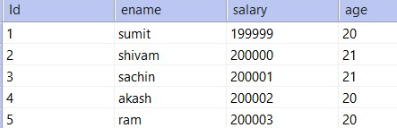

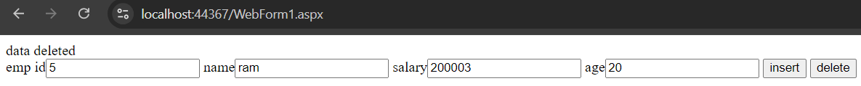

B] Create a web application to display Using Disconnected Data Access and Databinding using GridView

WebForm2.aspx:

<%@ Page Language="C#" AutoEventWireup="true" CodeBehind="WebForm2.aspx.cs" Inherits="WebApplication6.WebForm2" %>

<!DOCTYPE html>

<html xmlns="http://www.w3.org/1999/xhtml">
<head runat="server">
<title></title>
</head>
<body>
<form id="form1" runat="server">
<div>
<asp:GridView ID="GridView1" runat="server"></asp:GridView>
</div>
</form>
</body>
</html>

WebForm2.aspx.cs:

using System;using System;
using System.Collections.Generic;
using System.Linq;
using System.Web;
using System.Web.UI;
using System.Web.UI.WebControls;
using System.Data;
using System.Data.SqlClient;
namespace WebApplication6
{
public partial class WebForm2 : System.Web.UI.Page
{
protected void Page_Load(object sender, EventArgs e)
{
SqlConnection con = new SqlConnection("Data Source=SQL;Initial Catalog=tybsc123;User ID=user1;Password=user1");
SqlDataAdapter ad = new SqlDataAdapter("select * from emp", con);
DataSet ds = new DataSet();
ad.Fill(ds);
GridView1.DataSource = ds;
GridView1.DataBind();
}
}
}

OUTPUT :

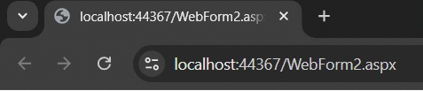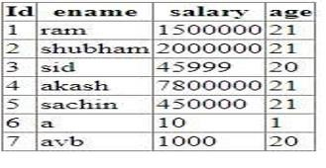

PRACTICAL 7:

A] Create a web application to demonstrate the use of different types of Cookies.
practical7A1.aspx:

<%@ Page Language="C#" AutoEventWireup="true" CodeBehind="Practical7A1.aspx.cs" Inherits="AWP_project.Practical7A1" %>

<!DOCTYPE html>

<html xmlns="http://www.w3.org/1999/xhtml">
<head runat="server">
<title></title>
</head>
<body>
<form id="form1" runat="server">
<div>
Name : <asp:TextBox ID="TextBox1" runat="server"></asp:TextBox>
class : <asp:TextBox ID="TextBox2" runat="server"></asp:TextBox>
<asp:Button ID="Button1" runat="server" Text="submit" OnClick="Button1_Click" />
</div>
</form>
</body>
</html>

practical7A2.aspx.cs:

using System;
using System.Web;
using System.Web.UI;

namespace AWP_project
{
public partial class Practical7A1 : System.Web.UI.Page
{
protected void Button1_Click(object sender, EventArgs e)
{
HttpCookie cook = new HttpCookie("Info");
cook["name"] = TextBox1.Text;
cook["class"] = TextBox2.Text;
Response.Cookies.Add(cook);
cook.Expires = DateTime.Now.AddDays(10);
Response.Redirect("Practical7A2.aspx");
}
}
}

practical7A1.aspx:

<%@ Page Language="C#" AutoEventWireup="true" CodeBehind="Practical7A2.aspx.cs" Inherits="AWP_project.Practical7A2" %>

<!DOCTYPE html>

<html xmlns="http://www.w3.org/1999/xhtml">
<head runat="server">
<title></title>
</head>
<body>
<form id="form1" runat="server">
<div>
<asp:Label ID="Label1" runat="server" Text="Label"></asp:Label>
<asp:Label ID="Label2" runat="server" Text="Label"></asp:Label>

</div>
</form>
</body>
</html>

practical7A2.aspx.cs:

using System;
using System.Collections.Generic;
using System.Linq;
using System.Web;
using System.Web.UI;
using System.Web.UI.WebControls;
namespace AWP_project
{
public partial class Practical7A2 : System.Web.UI.Page
{
protected void Page_Load(object sender, EventArgs e)
{
HttpCookie cook = Request.Cookies["Info"];
if (cook != null)
{
Label1.Text = cook["name"];
Label2.Text = cook["age"];
}
}
}
}

}

OUTPUT :

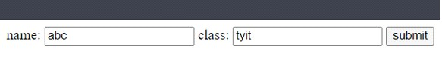

B] Create a web application to demonstrate Form Security and Windows Security with proper Authentication and Authorization properties.

practical7B.aspx:

<%@ Page Language="C#" AutoEventWireup="true" CodeBehind="Practical7B1.aspx.cs" Inherits="AWP_project.Practical7B1" %>

<!DOCTYPE html>

<html xmlns="http://www.w3.org/1999/xhtml">
<head runat="server">
<title></title>
</head>
<body>
<form id="form1" runat="server">
<div>
userID: <asp:TextBox ID="TextBox1" runat="server"></asp:TextBox>
password: <asp:TextBox ID="TextBox2" runat="server"></asp:TextBox>
<asp:Button ID="Button1" runat="server" Text="submit" OnClick="Button1_Click" />

</div>
</form>
</body>
</html>

practical7B.aspx.cs:

using System;
using System.Collections.Generic;
using System.Linq;
using System.Web;
using System.Web.Security;
using System.Web.UI;
using System.Web.UI.WebControls;
using System.Web.Security;
namespace prac7b
{
public partial class Practical7B1 : System.Web.UI.Page
{
protected void Page_Load(object sender, EventArgs e)
{

}

protected void Button1_Click(object sender, EventArgs e)
{
if (FormsAuthentication.Authenticate(TextBox1.Text, TextBox2.Text))
{
FormsAuthentication.RedirectFromLoginPage(TextBox1.Text, false);
}
else
{
Response.Write("invalid credential");
TextBox1.Text = "";
TextBox2.Text = "";
}
}
}
}

practical7B1.aspx:

<%@ Page Language="C#" AutoEventWireup="true" CodeBehind="Practical7B1.aspx.cs" Inherits="AWP_project.Practical7A1" %>

<!DOCTYPE html>

<html xmlns="http://www.w3.org/1999/xhtml">
<head runat="server">
<title></title>
</head>
<body>
<form id="form1" runat="server">
<div>
welcome
</div>
</form>
</body>
</html>

practical7B1.config

<system.web>
<authentication mode="Forms">
<forms loginUrl="Practical7B1.aspx" defaultUrl="Practical7B1
.aspx" timeout="20" protection="None">
<credentials passwordFormat="Clear">
<user name="tyit" password="tyit"/>
</credentials>
</forms>
</authentication>
<authorization>
<deny users="?"/>
</authorization>
<compilation debug="true" targetFramework="4.7.2" />
<httpRuntime targetFramework="4.7.2" />
</system.web>

OUTPUT :

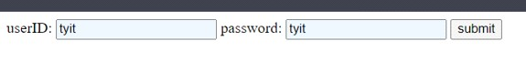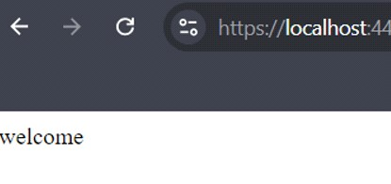

PRACTICAL 8 :

A. create application for inserting and deleting records from a database. (Using Execute-Non Query).
webform3aspx :
<%@ Page Language="C#" AutoEventWireup="true" CodeBehind="WebForm3.aspx.cs" Inherits="WebApplication21.WebForm3" %>

<!DOCTYPE html>

<html xmlns="http://www.w3.org/1999/xhtml">
<head runat="server">
<title></title>
</head>
<body>
<form id="form1" runat="server">
<div>
<asp:TextBox ID="TextBox1" runat="server"></asp:TextBox>
<asp:TextBox ID="TextBox2" runat="server"></asp:TextBox>
<asp:TextBox ID="TextBox3" runat="server"></asp:TextBox>
<asp:TextBox ID="TextBox4" runat="server"></asp:TextBox>
<asp:Button ID="Button1" runat="server" Text="Button" OnClick="Button1_Click" />
<asp:Button ID="Button2" runat="server" Text="Button" OnClick="Button2_Click" />
</div>
</form>
</body>
</html>
webform3.aspx.cs :
using System;
using System.Collections.Generic;
using System.Data.SqlClient;
using System.Linq;
using System.Web;
using System.Web.UI;
using System.Web.UI.WebControls;

namespace WebApplication21
{
public partial class WebForm3 : System.Web.UI.Page
{
protected void Page_Load(object sender, EventArgs e)
{

}
protected void Button1_Click(object sender, EventArgs e)
{
SqlConnection con = new SqlConnection("data Source= LAPTOP-5O781FEJ\\SQLEXPRESS01; Initial catalog= tyit23; User ID=user1;Password=user1");
SqlCommand cmd = new SqlCommand("insert into emp values(@Id,@name,@age,@sal)", con);
cmd.Parameters.AddWithValue("@Id",TextBox1.Text);
cmd.Parameters.AddWithValue("@name", TextBox2.Text);
cmd.Parameters.AddWithValue("@age", TextBox3.Text);
cmd.Parameters.AddWithValue("@sal", TextBox4.Text);
con.Open();
cmd.ExecuteNonQuery();
Response.Write("data inserted");
con.Close();
}

protected void Button2_Click(object sender, EventArgs e)
{
SqlConnection con = new SqlConnection("data Source= LAPTOP-5O781FEJ\\SQLEXPRESS01; Initial catalog= tyit23; User ID=user1;Password=user1");
SqlCommand cmd = new SqlCommand("delete from emp where Id=@Id", con);
cmd.Parameters.AddWithValue("@Id", TextBox1.Text);
con.Open();
cmd.ExecuteNonQuery();
Response.Write("data deleted");
con.Close();
}
}
}
OUTPUT :
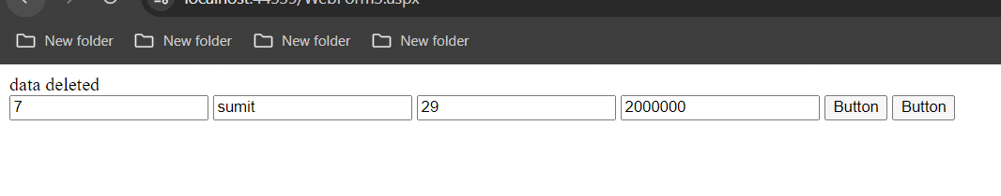

B. Create a web application for user defined exception handling.
webForm1.aspx:

<%@ Page Language="C#" AutoEventWireup="true" CodeBehind="WebForm1.aspx.cs" Inherits="WebApplication8.WebForm1" %>

<!DOCTYPE html>

<html xmlns="http://www.w3.org/1999/xhtml">
<head runat="server">
<title></title>
</head>
<body>
<form id="form1" runat="server">
<div>
Enter your age :
<asp:TextBox ID="TextBox1" runat="server"></asp:TextBox>
<asp:Button ID="Button1" runat="server" Text="Button" OnClick="Button1_Click" />
</div>
</form>
</body>
</html>

webForm1.aspx.cs :
using System;
using System.Collections.Generic;
using System.Linq;
using System.Web;
using System.Web.UI;
using System.Web.UI.WebControls;

namespace WebApplication8
{
public partial class WebForm1 : System.Web.UI.Page
{
class ageException : Exception
{
public ageException(string s) : base(s)
{ }
}

protected void Page_Load(object sender, EventArgs e)
{

}

protected void Button1_Click(object sender, EventArgs e)
{
int age1 = Convert.ToInt32(TextBox1.Text);
try
{
if(age1>80)
{
throw new ageException("Invalid Age !!!");
}

}
catch(ageException obj)
{
Response.Write(obj.Message);
}
}
}
}
Output :
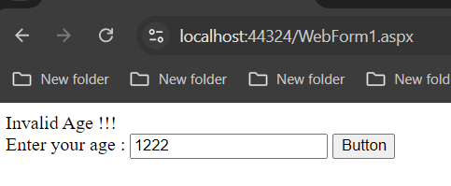

PRACTICAL 9 :

B. Create a web application to demonstrate data binding using DetailsView and FormView Control.
webForm1.aspx:

<%@ Page Language="C#" AutoEventWireup="true" CodeBehind="WebForm1.aspx.cs" Inherits="WebApplication8.WebForm1" %>

<!DOCTYPE html>

<html xmlns="http://www.w3.org/1999/xhtml">
<head runat="server">
<title></title>
</head>
<body>
<form id="form1" runat="server">
<div>
<asp:GridView ID="GridView1" runat="server" DataSourceID="SqlDataSource1" AutoGenerateColumns="False" DataKeyNames="Id">
<Columns>
<asp:CommandField ShowSelectButton="True"></asp:CommandField>
</Columns>
</asp:GridView>

<asp:SqlDataSource ID="SqlDataSource1" runat="server" ConnectionString="<%$ ConnectionStrings:ConnectionString %>" SelectCommand="SELECT [Id] FROM [Table]"></asp:SqlDataSource>
<asp:SqlDataSource ID="SqlDataSource2" runat="server" ConnectionString="<%$ ConnectionStrings:ConnectionString %>" SelectCommand="SELECT * FROM [Table] WHERE ([Id] = @Id)">
<SelectParameters>
<asp:ControlParameter ControlID="GridView1" PropertyName="SelectedValue" Name="Id" Type="Int32"></asp:ControlParameter>
</SelectParameters>
</asp:SqlDataSource>
<asp:DetailsView ID="DetailsView1" runat="server" Height="50px" Width="125px" DataSourceID="SqlDataSource2" AutoGenerateRows="False" DataKeyNames="Id">
<Fields>
<asp:BoundField DataField="Id" HeaderText="Id" ReadOnly="True" SortExpression="Id"></asp:BoundField>
<asp:BoundField DataField="name" HeaderText="name" SortExpression="name"></asp:BoundField>
<asp:BoundField DataField="sal" HeaderText="sal" SortExpression="sal"></asp:BoundField>
<asp:BoundField DataField="job" HeaderText="job" SortExpression="job"></asp:BoundField>
</Fields>
</asp:DetailsView>

<asp:FormView ID="FormView1" runat="server" DataKeyNames="Id" DataSourceID="SqlDataSource2">
<EditItemTemplate>
Id:
<asp:Label Text='<%# Eval("Id") %>' runat="server" ID="IdLabel1" /><br />
name:
<asp:TextBox Text='<%# Bind("name") %>' runat="server" ID="nameTextBox" /><br />
sal:
<asp:TextBox Text='<%# Bind("sal") %>' runat="server" ID="salTextBox" /><br />
job:
<asp:TextBox Text='<%# Bind("job") %>' runat="server" ID="jobTextBox" /><br />
<asp:LinkButton runat="server" Text="Update" CommandName="Update" ID="UpdateButton" CausesValidation="True" />&nbsp;<asp:LinkButton runat="server" Text="Cancel" CommandName="Cancel" ID="UpdateCancelButton" CausesValidation="False" />
</EditItemTemplate>
<InsertItemTemplate>
Id:
<asp:TextBox Text='<%# Bind("Id") %>' runat="server" ID="IdTextBox" /><br />
name:
<asp:TextBox Text='<%# Bind("name") %>' runat="server" ID="nameTextBox" /><br />
sal:
<asp:TextBox Text='<%# Bind("sal") %>' runat="server" ID="salTextBox" /><br />
job:
<asp:TextBox Text='<%# Bind("job") %>' runat="server" ID="jobTextBox" /><br />
<asp:LinkButton runat="server" Text="Insert" CommandName="Insert" ID="InsertButton" CausesValidation="True" />&nbsp;<asp:LinkButton runat="server" Text="Cancel" CommandName="Cancel" ID="InsertCancelButton" CausesValidation="False" />
</InsertItemTemplate>
<ItemTemplate>
Id:
<asp:Label Text='<%# Eval("Id") %>' runat="server" ID="IdLabel" /><br />
name:
<asp:Label Text='<%# Bind("name") %>' runat="server" ID="nameLabel" /><br />
sal:
<asp:Label Text='<%# Bind("sal") %>' runat="server" ID="salLabel" /><br />
job:
<asp:Label Text='<%# Bind("job") %>' runat="server" ID="jobLabel" /><br />

</ItemTemplate>
</asp:FormView>
</div>
</form>
</body>
</html>
Output:

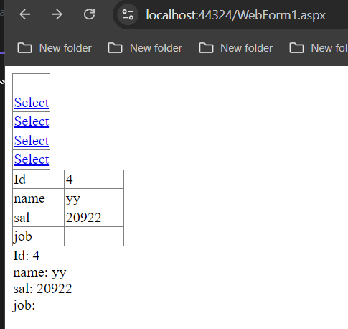

PRACTICAL 10 :

A. Create a web application to demonstrate JS Bootstrap Button.
webForm1.aspx:

<Window x:Class="WpfApp1.MainWindow"
xmlns="http://schemas.microsoft.com/winfx/2006/xaml/presentation"
xmlns:x="http://schemas.microsoft.com/winfx/2006/xaml"
xmlns:d="http://schemas.microsoft.com/expression/blend/2008"
xmlns:mc="http://schemas.openxmlformats.org/markup-compatibility/2006"
xmlns:local="clr-namespace:WpfApp1"
mc:Ignorable="d"
Title="MainWindow" Height="553" Width="1539">
<Grid Background="Orange">
<StackPanel VerticalAlignment="Center">
<Button Content="cleck here" Click="Button_Click"></Button>
<TextBlock x:Name="tb1" Height="98"></TextBlock>
</StackPanel>
</Grid>
</Window>

output :
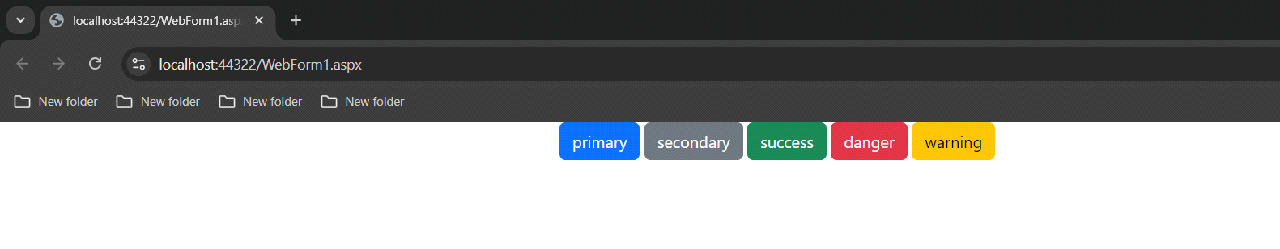
b. Create a web application to demonstrate use of various Ajax controls.
1) Timer :
webform5.aspx :
<%@ Page Language="C#" AutoEventWireup="true" CodeBehind="WebForm5.aspx.cs" Inherits="WebApplication21.WebForm5" %>

<!DOCTYPE html>

<html xmlns="http://www.w3.org/1999/xhtml">
<head runat="server">
<title></title>
</head>
<body>
<form id="form1" runat="server">
<div>
Outside : <asp:Label ID="Label1" runat="server" Text="Label"></asp:Label>
<asp:ScriptManager ID="ScriptManager1" runat="server"></asp:ScriptManager>
<asp:UpdatePanel ID="UpdatePanel1" runat="server">
<ContentTemplate>
<asp:Timer ID="Timer1" runat="server" Interval="4000" OnTick="Timer1_Tick"></asp:Timer>
inside : <asp:Label ID="Label2" runat="server" Text="Label"></asp:Label>
</ContentTemplate>
</asp:UpdatePanel>
<asp:UpdateProgress ID="UpdateProgress1" runat="server">
<ProgressTemplate>
pls wait for loading .........
</ProgressTemplate>
</asp:UpdateProgress>
</div>
</form>
</body>
</html>
webform5.aspx.cs :
using System;
using System.Collections.Generic;
using System.Linq;
using System.Web;
using System.Web.UI;
using System.Web.UI.WebControls;

namespace WebApplication21
{
public partial class WebForm5 : System.Web.UI.Page
{
protected void Page_Load(object sender, EventArgs e)
{
Label1.Text=DateTime.Now.ToLongTimeString();
}

protected void Timer1_Tick(object sender, EventArgs e)
{
System.Threading.Thread.Sleep(2000);
Label2.Text = DateTime.Now.ToLongTimeString();
}
}
}

C. Create a web application to demonstrate Installation and use of NuGet package.
MainWindow.xaml :
<Window x:Class="WpfApp1.MainWindow"
xmlns="http://schemas.microsoft.com/winfx/2006/xaml/presentation"
xmlns:x="http://schemas.microsoft.com/winfx/2006/xaml"
xmlns:d="http://schemas.microsoft.com/expression/blend/2008"
xmlns:mc="http://schemas.openxmlformats.org/markup-compatibility/2006"
xmlns:local="clr-namespace:WpfApp1"
mc:Ignorable="d"
Title="MainWindow" Height="553" Width="1539">
<Grid Background="Orange">
<StackPanel VerticalAlignment="Center">
<Button Content="cleck here" Click="Button_Click"></Button>
<TextBlock x:Name="tb1" Height="98"></TextBlock>
</StackPanel>
</Grid>
</Window>
MainWindow.xaml.cs :
using System;
using System.Collections.Generic;
using System.Linq;
using System.Text;
using System.Threading.Tasks;
using System.Windows;
using System.Windows.Controls;
using System.Windows.Data;
using System.Windows.Documents;
using System.Windows.Input;
using System.Windows.Media;
using System.Windows.Media.Imaging;
using System.Windows.Navigation;
using System.Windows.Shapes;
using Newtonsoft.Json;

namespace WpfApp1
{
/// <summary>
/// Interaction logic for MainWindow.xaml
/// </summary>
public class tyit
{
public string Name
{
get;
set;
}
public string Email
{ get; set; }

public DateTime DOB
{ get; set; }
}
public partial class MainWindow : Window
{
public MainWindow()
{
InitializeComponent();
}

private void Button_Click(object sender, RoutedEventArgs e)
{
tyit t = new tyit
{
Name = "sumit dige",
Email = "sumitdige@gmail.com",
DOB = new DateTime(2003,09,19)
};
string s = JsonConvert.SerializeObject(t,Newtonsoft.Json.Formatting.Indented);
tb1.Text = s;
}
}
}
OUTPUT :

