

|  |
| --- |
| Prototype1 |
| 15/10/17 19:01 |
| **Author:** John Doe  **File name:** Prototype1.vp  **Version** 1.0 |

|  |
| --- |
| Site Map |
|  |

|  |
| --- |
|  |

01. Site Map / Prototype1 

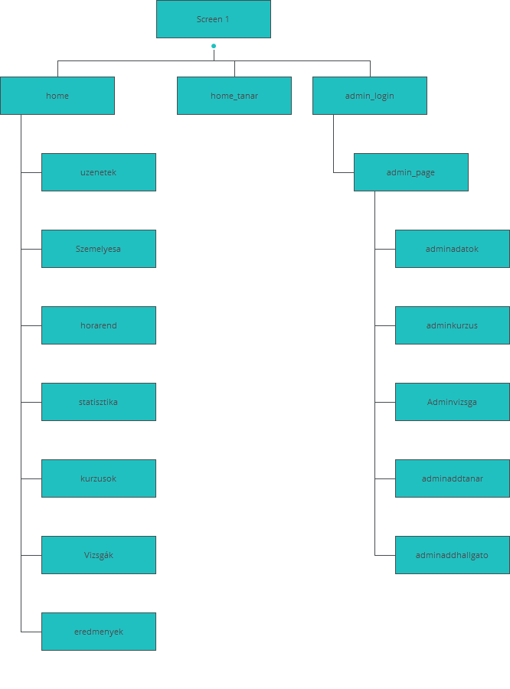

|  |
| --- |
| Screens |
|  |

|  |
| --- |
|  |

02. Screens / Prototype1 

Screen 1

|  |
| --- |
|  |

Interactions

|  |  |
| --- | --- |
| 1 | **on Click:** When Radio_button_1.value goes to 'home' with effect: flip horizontal 🡪 Else when Radio_button_2.value goes to 'home_tanar' 🡪 |
| 2 | **on Click:** goes to 'admin_login' 🡪 |

02. Screens / Prototype1 

home

|  |
| --- |
|  |

02. Screens / Prototype1 

home_tanar

|  |
| --- |
|  |

Interactions

|  |  |
| --- | --- |
| 3 | **on Click:** goes to 'Screen 1' with effect: flip horizontal 🡪 |

02. Screens / Prototype1 

admin_login

|  |
| --- |
|  |

Interactions

|  |  |
| --- | --- |
| 4 | **on Click:** When (Input_3.value = 'admin') goes to 'admin_page' 🡪 |

02. Screens / Prototype1 

admin_page

|  |
| --- |
|  |

Interactions

|  |  |
| --- | --- |
| 5 | **on Click:** goes to 'Screen 1' with effect: flip horizontal 🡪 |

02. Screens / Prototype1 

kurzusok

|  |
| --- |
|  |

02. Screens / Prototype1 

Vizsgák

|  |
| --- |
|  |

02. Screens / Prototype1 

orarend

|  |
| --- |
|  |

02. Screens / Prototype1 

uzenetek

|  |
| --- |
|  |

02. Screens / Prototype1 

eredmenyek

|  |
| --- |
|  |

02. Screens / Prototype1 

horarend

|  |
| --- |
|  |

02. Screens / Prototype1 

Szemelyesa

|  |
| --- |
|  |

02. Screens / Prototype1 

statisztika

|  |
| --- |
|  |

02. Screens / Prototype1 

adminadatok

|  |
| --- |
|  |

02. Screens / Prototype1 

adminaddhallgato

|  |
| --- |
|  |

02. Screens / Prototype1 

adminaddtanar

|  |
| --- |
|  |

02. Screens / Prototype1 

adminkurzus

|  |
| --- |
|  |

02. Screens / Prototype1 

Adminvizsga

|  |
| --- |
|  |

|  |
| --- |
| Templates |
|  |

|  |
| --- |
|  |

03. Templates / Prototype1 

admin template

|  |
| --- |
|  |

Interactions

|  |  |
| --- | --- |
| 11 | **on Click:** goes to 'Screen 1' with effect: flip horizontal 🡪 |

03. Templates / Prototype1 

felh_template

|  |
| --- |
|  |

Interactions

|  |  |
| --- | --- |
| 12 | **on Click:** goes to 'uzenetek' 🡪 |
| 19 | **on Click:** goes to 'Screen 1' with effect: flip horizontal 🡪 |

03. Templates / Prototype1 

tanartemplate

|  |
| --- |
|  |

Interactions

|  |  |
| --- | --- |
| 20 | **on Click:** goes to 'Screen 1' with effect: flip horizontal 🡪 |
| 21 | **on Click:** goes to 'Screen 1' with effect: flip horizontal 🡪 |

03. Templates / Prototype1 

Template 1

|  |
| --- |
|  |

Interactions

|  |  |
| --- | --- |
| 22 | **on Click:** goes to 'Screen 1' with effect: flip horizontal 🡪 |

|  |
| --- |
| Scenarios |
|  |

|  |
| --- |
|  |

04. Scenarios / Prototype1 

default

|  |
| --- |
|  |