Dear Sir or Madam:
Good morning!
Here I apply for the position about FAE in your company.
Firstly I will introduce myself briefly to U.
My name is Li Ronglei, I come from Henan Province and graduated from China Jiliang University. In the past I have worked as an electronic engineer in three companies. One is Hangzhou Greatstar technoloy co., LTD, the other is Shenzhen JT Automation Equipment Co., LTD, the third is Testo.
For almost 7 years experience in electronic engineering field, I’m proficient in digital and analogue circuit design,master in C and C++. as an electronic engineer, I am familiar with some kinds of MCU. In the project I like to do some works with lots of challenge. When I solve a problem or find a bug from HW or from FW, I will be very happy.Here I’m also master in solve some EMC problem for the products.
Recently, I work in a international company testo, I have the experience on how to get along with different people with different culture background!
I think I can take on this role! Thanks!
Best wishes
Li Ronglei
2018-05-16

CV

PERSONAL PROFILS

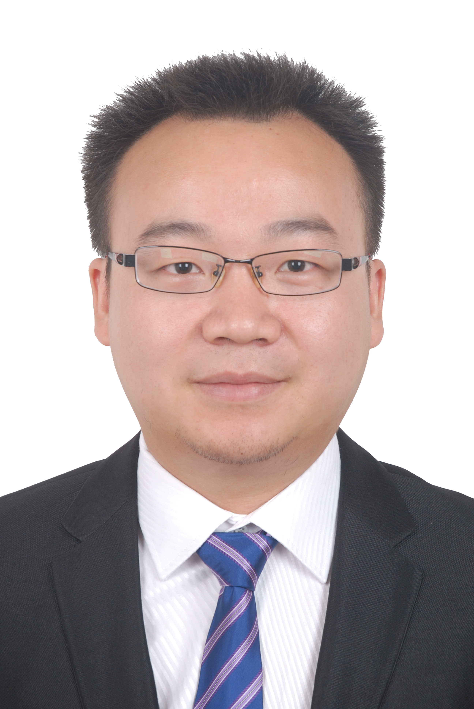
Name: Li Ronglei

Sex: Male

Birth date: 19870415

Age: 31

Ethnic: Han

Height: 162cm

Weight: 68kg

Birth address: Henan xinyang

Mob: 15999535956

E-Mail: lironglei4321@126.com
____________________________________________________________________

OBJECTIVE
ELectronic Engineer

EDUCATION
2007.9-2011.6
CHINA JILIANG UNIVERSITY
Mechanical and electrical department
Electrical engineering and its automation major
BE
Subjects include:
Digital Electronic Analog Electronic
Electric Circuit Power electronic technology
C Language Microcomputer principle
Automatic Control Theory Electric drive base
Power supply technology Detection technology

EMPLOYMENT

Relevant Experience: 2015.6~
Electronic engineer (Testo)
Responsibilities:
- Do some embedded development for the products base on Cortex M3/M4 and MSP 430.
- Estimation the new product base on the requirement from TKG.
- Define the document and communicate with internal and external implementation engineers.
Achievements:
- Do a small RTOS-Time_sharing embedded development base on the BLE for smart probes.
- Do embedded development about free RTOS base on the STM32F429 for Multi-functional portable instrument.
Relevant Experience: 2014.5~2015.6
Electronic engineer (JT)
Responsibilities:
- To declaration the project and arrange the project.
- Assist colleagues to complete the project.
- Do some embedded development for the products base on Cortex M3
Achievements:
- Develop the valve controller of Dispenser.
- Do embedded development about ucosII base on the STM32F103 for the controller of SPI.
- Do embedded development about Time-sharing base on the STM32F103 for the controller of Reflow.
Relevant Experience: 2011.6~2014.5
Electronic engineer (GreatStar)
Responsibilities:
- To improve the old product and reduce the cost.
- Develop the new products.
- Define the document and communicate with internal and external implementation engineers.
Achievements:
- Improve the old products, reduce the power consumption of the circuit board, and solve the problem of battery pack leakage.
- Develop 3 to 5 chain li-ion battery protective board.
- Develop 6v to 24v motor control board.

SKILLS
- Versed in C/C++ Language.
- Good working knowledge of MCU.
- Proficient in RTOS.
- Can use Qt develop some simple software.
- Versed in Protel99se, Altium, Multisim and Proteus.
- Proficient in digital and analogue circuit design.
- Master in EMC problem solved.
- Master AutoCAD and Solidworks.

Language: English, A certain communication skills.

Organizational: Time management skills, Follow the PEP procedure to finish the projects. A3 report when solving some problem.

Communication and Interpersonal: Excellent team working skills

Appointment Date
One month.

