# Web项目启动到一半停止

## 可能没加依赖

|  |
| --- |
| <dependency>  <groupId>org.springframework.boot</groupId>  <artifactId>spring-boot-starter-web</artifactId>  </dependency> |

## 可能maven生命周期test失败，需要跳过可加

|  |
| --- |
| <plugin><!--编译跳过测试文件检查的生命周期-->  <groupId>org.apache.maven.plugins</groupId>  <artifactId>maven-surefire-plugin</artifactId>  <configuration>  <skip>true</skip>  </configuration>  </plugin> |

# 存在两个一样方式的请求路径

java.lang.IllegalStateException: Ambiguous handler methods mapped for HTTP path 'xxxx'

# kafka与springboot版本不兼容

Caused by: java.lang.TypeNotPresentException: Type org.springframework.kafka.listener.RecordInterceptor not present

at sun.reflect.generics.factory.CoreReflectionFactory.makeNamedType(CoreReflectionFactory.java:117) ~[na:1.8.0_311]

org.springframework.core.MethodParameter.getGenericParameterType(MethodParameter.java:513) ~[spring-core-5.2.14.RELEASE.jar:5.2.14.RELEASE]

原因：kafka需要依赖这个spring-core-5.2.14.RELEASE.jar:5.2.14.RELEASE，所以要注spring-kafka，spring-boot-starter-parent，kafka-clients三者版本

比如：

|  |
| --- |
| <parent>  <groupId>org.springframework.boot</groupId>  <artifactId>spring-boot-starter-parent</artifactId>  <version>2.2.0.RELEASE</version>  <relativePath/> <!-- lookup parent from repository -->  </parent>  <dependency>  <groupId>org.springframework.kafka</groupId>  <artifactId>spring-kafka</artifactId>  <version>2.4.3.RELEASE</version>  </dependency>  <dependency>  <groupId>org.apache.kafka</groupId>  <artifactId>kafka-clients</artifactId>  <version>2.4.1</version>  </dependency> |

# Maven3.8.5版本过高

Error injecting constructor, java.lang.NoSuchMethodError: org.apache.maven.model.validation

解决：替换成maven3.6.3就好了

# 依赖导入失败

The POM for com.dzh:grpc-lib:jar:1.0-SNAPSHOT is missing, no dependency information available

Failed to execute goal on project grpc-server: Could not resolve dependencies for project com.dzh:grpc-server:jar:1.0-SNAPSHOT: Failure to find com.dzh:grpc-lib:jar:1.0-SNAPSHOT in https://maven.aliyun.com/nexus/content/groups/public was cached in the local repository, resolution will not be reattempted until the update interval of snapshots has elapsed or updates are forced

Could not find artifact com.dzh:grpc-lib:pom:1.0-SNAPSHOT in snapshots (<https://maven.aliyun.com/nexus/content/groups/public>)

意思很明显，就是依赖没找到。去仓库发现就这么几个玩意，并没有对应的jar包

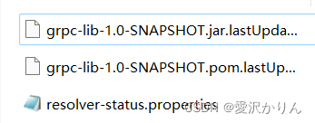

所以我们删除仓库的该包，重新对该module进行install一下

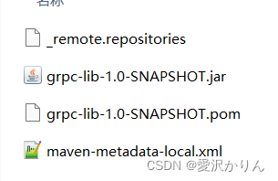

我建议就是，在maven仓库把该项目的依赖都删除，重新在父工程install

# Lombok的坑

问题：今天使用了一个实体类去映射数据库报这个错

Cannot determine value type from string "xxx"

数据库表字段类型与Java类里面都成员属性类型不一致，然后检查MyBatis中xml各自配置，感觉都没问题。

原因：是在Java类中使用了Lombok的注解@Builder和@Data，导致JavaBean中没有无参构造器。

解决：只需再添加两个Lombok注解@NoArgsConstructor和@AllArgsConstructor即可。

# 预期值与结果不一致

返回的是一个值，但如果数据库查出了多条数据就会报这个错误：

Expected one result (or null) to be returned by selectOne(), but found: 2

Mybatis-plus的this.getOne()方法也可能报这个错

解决：只需要保证数据库只查出一条数据即可。

# json反序列化错误

Caused by: com.fasterxml.jackson.databind.exc.UnrecognizedPropertyException: Unrecognized field "id"

原因是我的数据库里的json有id这个k-v，但我的实体没有这个id属性

Caused by: com.fasterxml.jackson.databind.exc.MismatchedInputException: Cannot deserialize value of type `com.hnxh.system.domain.vo.FileInfoVO` from Array value (token `JsonToken.START_ARRAY`)

at [Source: (PushbackInputStream); line: 1, column: 1504] (through reference chain: com.hnxh.business.domain.dto.employee.EmployeeDimissionDTO["relieveFile"])

原因是传递的json中 relieveFile:[]，而我后端实体中 private FileInfoVO relieveFile;

# mysql

## 获取公钥

java.sql.SQLNonTransientConnectionException: Public Key Retrieval is not allowed

url后加：`allowPublicKeyRetrieval=true`允许客户端从服务器获取公钥

## 数据库驱动版本

Could not create connection to database server. Attempted reconnect 3 times. Giving up.

原因是我的mysql是8.0的，而数据库驱动版本太低，所以改为

|  |
| --- |
| <!-- mysql驱动 -->  <dependency>  <groupId>mysql</groupId>  <artifactId>mysql-connector-java</artifactId>  <version>8.0.20</version>  </dependency> |

## 数据库时区

java.sql.SQLException: The server time zone value ‘�й���׼ʱ��’ is unrecognized or represents more than one time zone. You must configure either the server or JDBC driver (via the ‘serverTimezone’ configuration property) to use a more specifc time zone value if you want to utilize time zone support.

解决：url后加`serverTimezone=GMT%2B8`时区问题

## SSL

javax.net.ssl.SSLException

MESSAGE: closing inbound before receiving peer's close_notify

解决：useSSL=false

# nacos服务注册失败

Error processing condition on com.alibaba.cloud.nacos.discovery.reactive.NacosReactiveDiscoveryClientConfiguration.nacosReactiveDiscoveryClient

出现这种情况可能是依赖版本冲突

|  |
| --- |
| <dependency>  <groupId>com.alibaba.cloud</groupId>  <artifactId>spring-cloud-starter-alibaba-nacos-discovery</artifactId>  <version>2.2.1.RELEASE</version>  </dependency> |

# poi依赖重复

org.springframework.web.util.NestedServletException: Handler dispatch failed; nested exception is java.lang.NoClassDefFoundError: org/apache/poi/common/Duplicatable

很明显，poi依赖重复了，可能导入了两种底层是poi的依赖

# flyway不小心删除了中间的脚本数据

To allow executing this migration, set -outOfOrder=true.

不小心删除了中间脚本的数据，那么如果设置了有序迁移，就会报错

所以设置为无序迁移，out-of-order默认为false

|  |
| --- |
| flyway.out-of-order: true |

# SimpleGrantedAuthority

A granted authority textual representation is required

原因是SimpleGrantedAuthority的构造方法，有断言，role不能为空： Assert.hasText(role, "A granted authority textual representation is required");

# QueryDSL找不到Q开头的实体

需要导入依赖：

|  |
| --- |
| <!-- QueryDSL 依赖 -->  <dependency>  <groupId>com.querydsl</groupId>  <artifactId>querydsl-core</artifactId>  </dependency>  <dependency>  <groupId>com.querydsl</groupId>  <artifactId>querydsl-jpa</artifactId>  </dependency>  <dependency>  <groupId>com.querydsl</groupId>  <artifactId>querydsl-apt</artifactId>  </dependency> |

导入插件：

|  |
| --- |
| <build>  <plugins>  <!-- QueryDSL 编译插件 -->  <plugin>  <groupId>com.mysema.maven</groupId>  <artifactId>apt-maven-plugin</artifactId>  <version>1.1.3</version>  <executions>  <execution>  <goals>  <goal>process</goal>  </goals>  <configuration>  <outputDirectory>target/generated-sources/java</outputDirectory>  <processor>com.querydsl.apt.jpa.JPAAnnotationProcessor</processor>  </configuration>  </execution>  </executions>  </plugin>  </plugins>  </build> |

然后对实体模块重新package

# 代码中有这个包，而build时显示没有

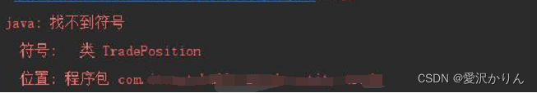

各种清缓存、重启都没用。

试试重新clean、package

# jdk版本问题

org.springframework.web.util.NestedServletException: Handler dispatch failed; nested exception is java.lang.NoClassDefFoundError: javax/xml/bind/DatatypeConverter

报错原因：JAXB API是java EE 的API，在java SE 9.0 中不再包含这个 Jar 包。 JDK 9 中引入了模块的概念，默认情况下，Java SE中将不再包含java EE 的Jar包,在 JDK 6/7 / 8 时关于这个API 都是捆绑在一起的

解决办法:

* 方法一：降低JDK版本至 JDK 8
* 在pom.xml文件的dependencies中引入以下部件:

|  |
| --- |
| <dependency>  <groupId>javax.xml.bind</groupId>  <artifactId>jaxb-api</artifactId>  <version>2.3.0</version>  </dependency>  <dependency>  <groupId>com.sun.xml.bind</groupId>  <artifactId>jaxb-impl</artifactId>  <version>2.3.0</version>  </dependency>  <dependency>  <groupId>com.sun.xml.bind</groupId>  <artifactId>jaxb-core</artifactId>  <version>2.3.0</version>  </dependency>  <dependency>  <groupId>javax.activation</groupId>  <artifactId>activation</artifactId>  <version>1.1.1</version>  </dependency> |

# 自定义工具Jar包到其他项目中使用但无法导入情况

场景：自己编写了项目，在生成jar，并且导入其他项目后，无法正确识别其中的类

原因：打包设置的参数不正确，导致导出的jar包出现问题。maven打包springboot工程时得到的jar包中有BOOT-INF目录，导致被其他工程依赖时找不到类。

|  |
| --- |
| <build>  <plugins>  <plugin>  <groupId>org.springframework.boot</groupId>  <artifactId>spring-boot-maven-plugin</artifactId>  <configuration>  <skip>true</skip>  </configuration>  </plugin>  </plugins>  </build> |

# Since Maven 3.8.1 http repositories are blocked.

## 低版本

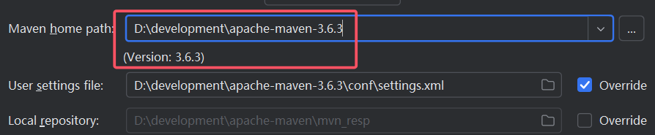

低版本maven设为这个即可

## 高版本

|  |
| --- |
| <mirrors>  <!--<mirror>  <id>maven-default-http-blocker</id>  <mirrorOf>external:http:*</mirrorOf>  <name>Pseudo repository to mirror external repositories initially using HTTP.</name>  <url>http://0.0.0.0/</url>  <blocked>true</blocked>  </mirror>-->  </mirrors> |

把这个注释掉就行了

# Command line is too long.

Command line is too long. Shorten the command line via JAR manifest or via a classpath file and rerun

解决：

1. 打开Run/Debug Configrations面板，打开Modify options下拉列表
2. 点击Shorten command line
3. 将none项改为"Jar manifest"

# 升级JDK21后idea2022终端乱码

## 解决方法一

setting->Editor->FIle Encodings

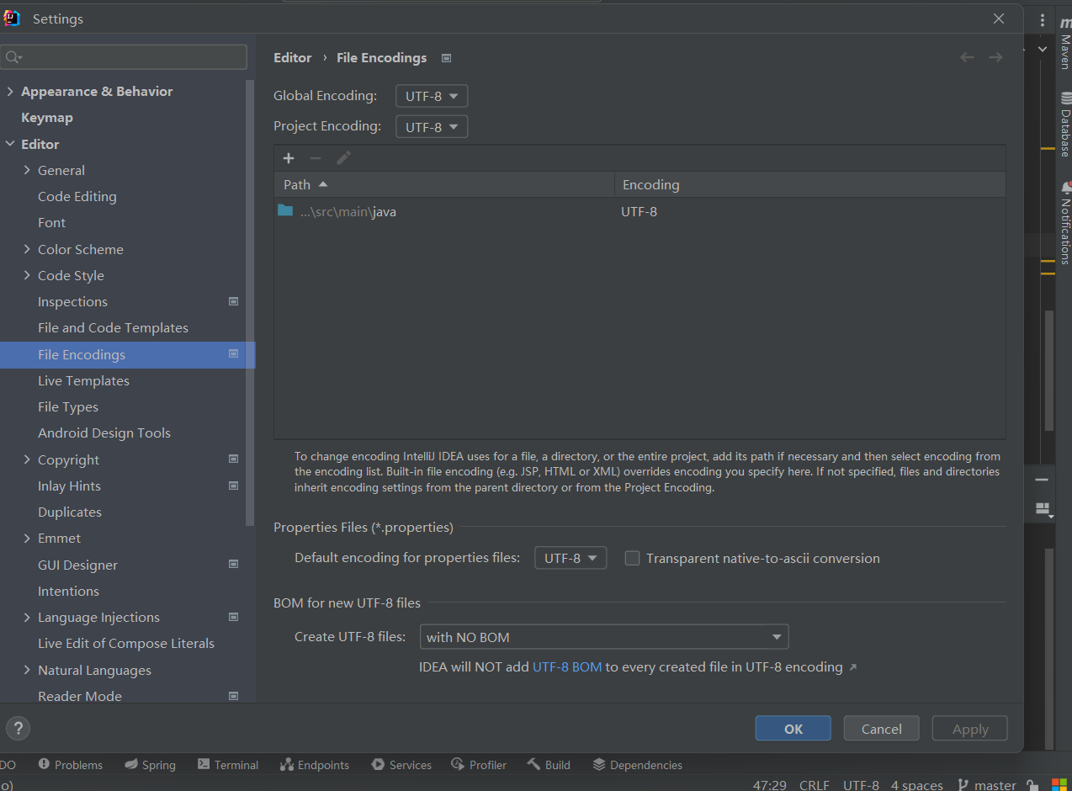

全部使用UTF-8

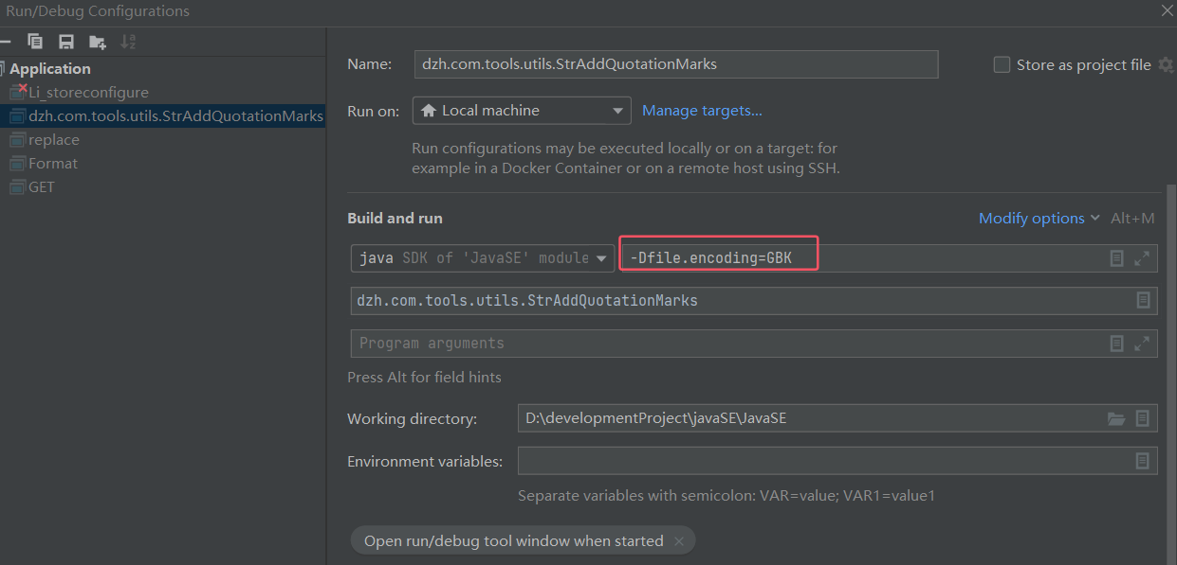

添加vm参数

|  |
| --- |
| -Dfile.encoding=GBK |

## 解决方法二

idea升级到2024

# 不支持发行版本 22解决方法

## 运行项目时

jdk21，idea2024

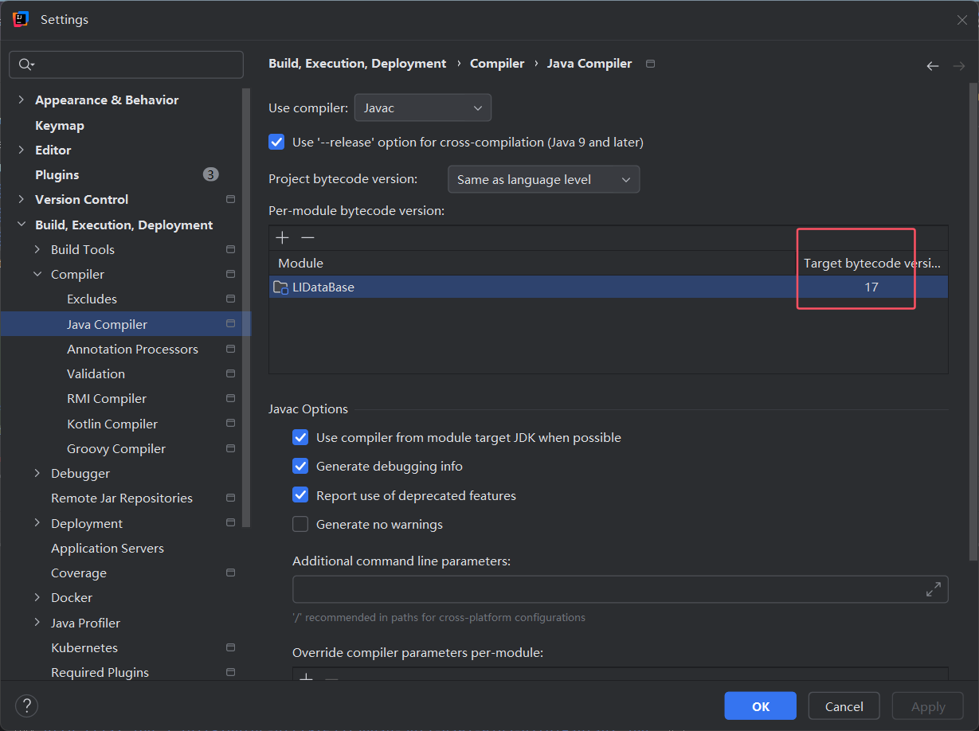

降低这个版本即可

## maven执行install时

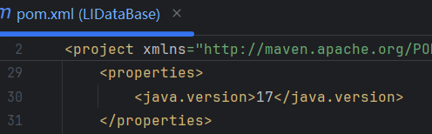

降低这个版本即可

# 多数据源开启事务导致找不到字段

Cause: java.sql.SQLSyntaxErrorException: Unknown column 'id' in 'field list'

我用了mybatisplus的多数据源

解决：不开启事务

