[Maven Repository: oracle » ojdbc6 » 11.2.0.3 (mvnrepository.com)](https://mvnrepository.com/artifact/oracle/ojdbc6/11.2.0.3)

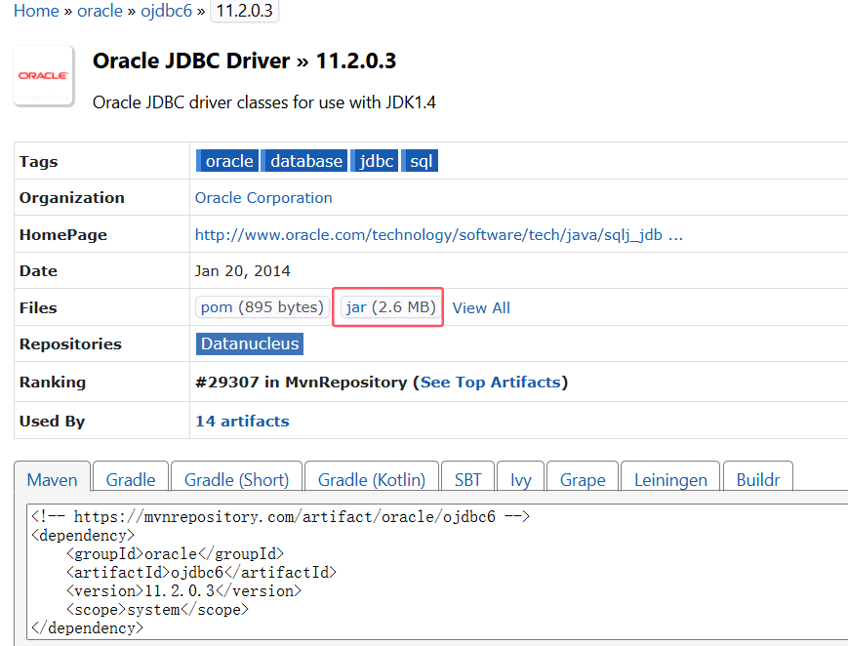

下载

确保maven配置了环境变量：

|  |
| --- |
| MAVEN_HOME ：D:\development\apache-maven-3.6.3  path：%MAVEN_HOME%\bin |

在jar目录下执行：

|  |
| --- |
| mvn install:install-file -DgroupId=com.oracle -DartifactId=ojdbc6 -Dversion=11.2.0.3 -Dpackaging=jar -Dfile=ojdbc6-11.2.0.3.jar |

再添加道pom文件：

|  |
| --- |
| <dependency>  <groupId>com.oracle</groupId>  <artifactId>ojdbc6</artifactId>  <version>11.2.0.3</version>  </dependency> |