# Tutorial on the use of D-Infinity Avalanche Runout.

David Tarboton, January 23, 2016.

Two input files are required

1. Digital elevation model (DEM)
2. Avalanche starting grid

The zip file [Avalanche.zip](http://hydrology.usu.edu/taudem/taudemdata/Avalanche.zip) contains the example data that will be used in this tutorial.

You should use common GIS tools to prepare the Avalanche source grid with values of 1 marking the avalanche starting locations and 0 everywhere else. The avalanche starting grid file is required to have the same dimensions (rows, columns and cell size) as the DEM.

Add each grid into ArcMap. Following is a screen shot with the example data.

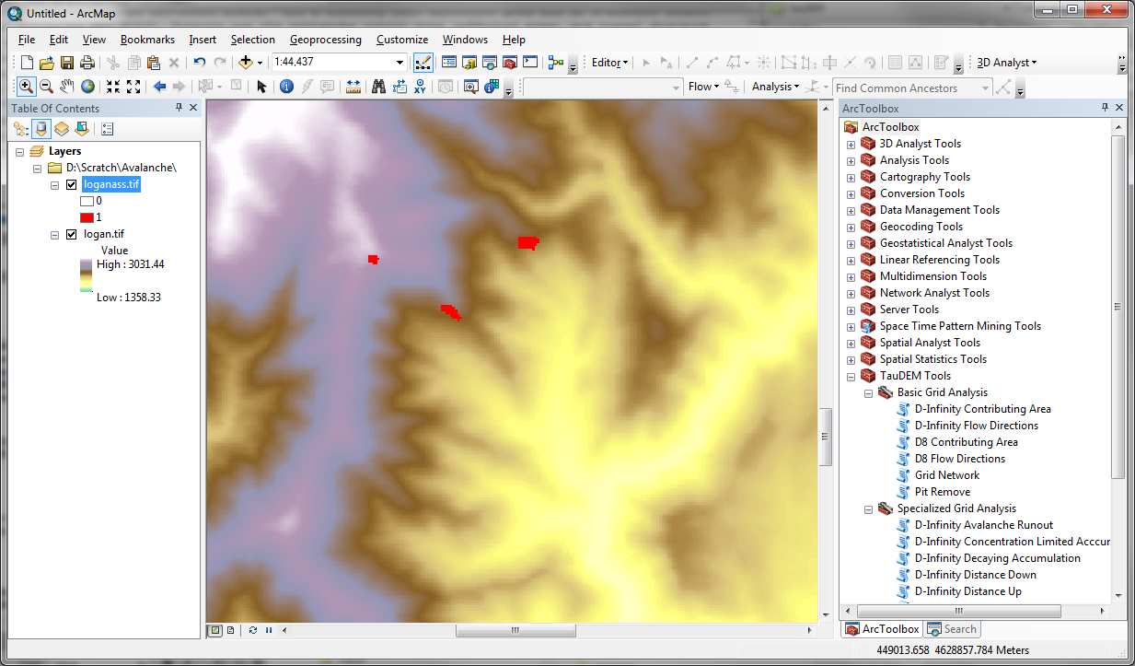

## Run preprocessing functions

Pit Remove

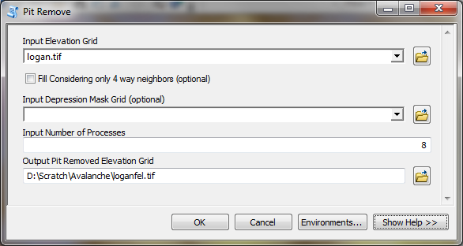

D-Infinity Flow Directions

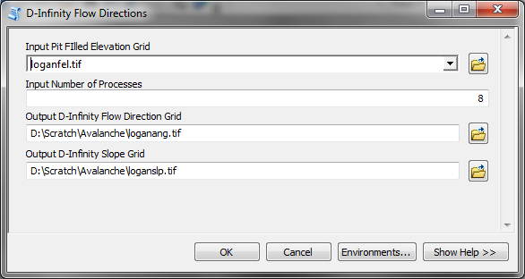

## Run D-Infinity Avalanche Runout

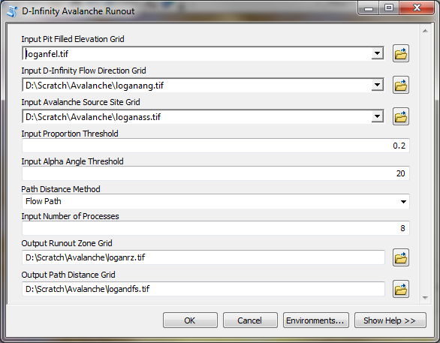

The screen shots below illustrate the results.

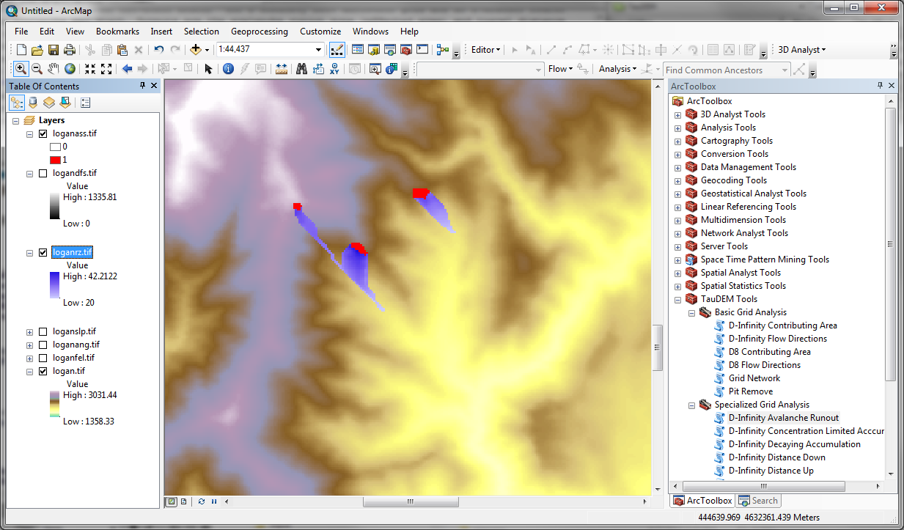

Here loganrz.tif gives the runout zone. Numerical values from 20 to 42 indicate the angle from each grid cell up along flow paths to a grid cell in the starting grid.

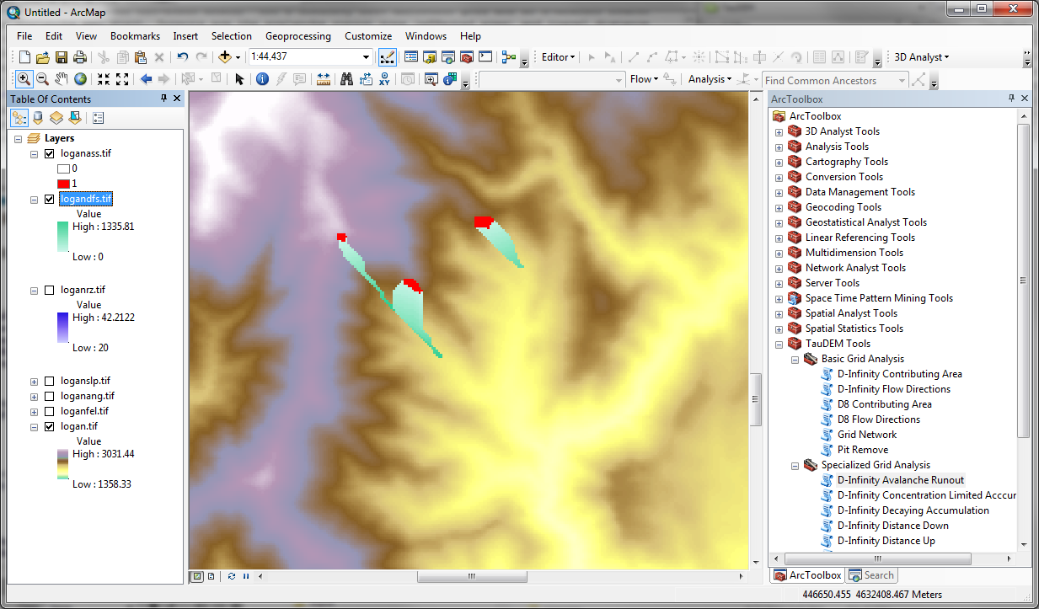

Here logandfs.tif gives the distance along the flow paths from cells in the starting grid to grid cells in the runout zone.