**TauDEM 5.1**

**QUICK START GUIDE TO USING THE TAUDEM ARCGIS TOOLBOX**

**August 2013**

**David G. Tarboton**

**Ibrahim N. Mohammed**

# QUICK START

## Purpose

The purpose of this document is to introduce Hydrologic Terrain Analysis in ArcGIS using the TauDEM toolbox. This guide is not intended to be comprehensive in documenting the use and functionality of TauDEM. Rather it is intended as a brief introduction to guide a reader through the initial steps of installing TauDEM obtaining data and running some of the more important functions required to delineate a stream network. Comprehensive documentation on the use of each TauDEM function is given in the online help that is part of the program (that will be introduced in this quick start guide).

TauDEM (Terrain Analysis Using Digital Elevation Models) is a set of Digital Elevation Model (DEM) tools for the extraction and analysis of hydrologic information from topography as represented by a DEM. This is software developed at Utah State University (USU) for hydrologic digital elevation model analysis and watershed delineation and may be obtained from <http://hydrology.usu.edu/taudem/taudem5.0/>.

In this guide, you will perform the following tasks:

* MPICH2 and TauDEM Installation
* Basic Grid Analysis using TauDEM functions, including.
  + Preparing data for use with TauDEM and using the TauDEM help
  + Pit Remove
  + D8 Flow Directions
  + D8 Contributing Area
  + Grid Network
  + D-Infinity flow direction
  + D-infinity Contributing Area
* Stream Network Analysis using TauDEM functions, including
  + Stream Definition by threshold
  + Move Outlets to Streams
  + Stream Reach and Watershed
  + Peuker Douglas
  + Peuker Douglas Stream Definition
* Specialized Grid Analysis using TauDEM functions, including
  + D-Infinity Ddistance Down
  + D-Infinity Distance Up

The Cub River watershed draining to USGS streamflow gauge #100096000 located just north of Preston, Idaho is used as an example.

## Computer and Data Requirements

To complete this guide, you will need to use ArcGIS 10.x, the TauDEM 5.1.1 or higher software as well as MPI software. Our current Windows PC precompiled executables have been compiled using the Microsoft HPC Pack 2012 MS-MPI libraries from <http://www.microsoft.com/en-us/download/details.aspx?id=36045>. Earlier versions used MPICH2 from <http://www.mcs.anl.gov/research/projects/mpich2/>. The ArcGIS software should be installed on your computer prior to starting this quick start guide, but we detail the steps involved in installing TauDEM and MPI libraries.

## MPI and TauDEM Installation

For this guide we assume that the installation is done to the default locations on the C: drive of a 64-bit Windows PC:

* Download TauDEM install file TauDEM511.exe or more recent equivalent. This is a Winzip self extracting file that installs the necessary MPI and runtime libraries and then installs TauDEM
* Run (double click) TauDEM511.exe. Respond Yes to the user account control dialog.
* Respond OK to the TauDEM install dialog

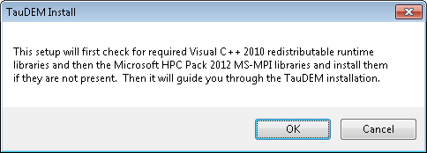

* Click Setup at the Install libraries required for TauDEM dialog

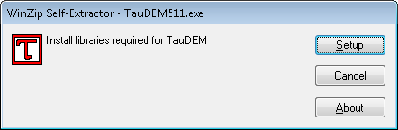

* Acknowledge read and accept license terms for the Microsoft software being installed and click install

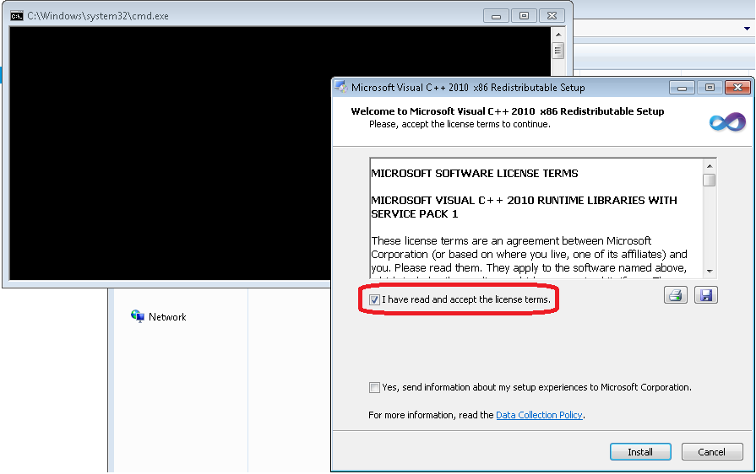

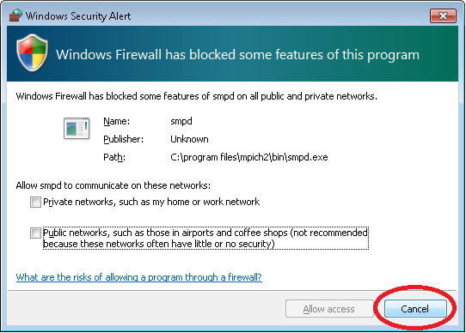

* Repeat for all the libraries to install
* Click Next multiple times at the TauDEM Setup WIzard

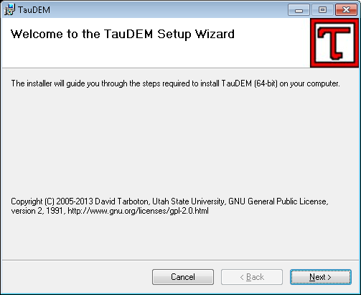

* That is it. TauDEM has been installed.

The installer did the following

* mpi_x86.msi
* Installed Visual Studio 2010 C++ runtime libraries vcredist_x86_2010.exe
* Installed Visual Studio 2010 C++ runtime libraries vcredist_x64_2010.exe if a 64 bit platform
* Installed Microsoft HPC Pack 2012 MS-MPI from mpi_x64.msi or mpi_x86.msi depending on your platform.
* Installed TauDEM from TaudemSetup_x86.msi or TaudemSetup_x64.msi depending on your platform
* Activate the TauDEM Toolbox in ArcGIS.
* Open ArcMap/ArcCatalog. If the ArcToolbox Window is not open, click on the "Show/Hide ArcToolbox Window" icon in the Standard Toolbar.
* Right click on ArcToolbox at the top of the window. Select Add Toolbox... .
* Browse to the TauDEM install directory (by default, this is: C:\Program Files\TauDEM\TauDEMArc).
* Click on the **TauDEM_Tools.tbx** file, and click Open.

The TauDEM Toolbox should now be visible in the list of toolboxes.

If you wish to save this configuration, right click on ArcToolbox, select Save to Default. This needs to be done for each user who wishes to use TauDEM. See below how we added TauDEM tools to Arc Toolbox when from ArcCatalog:

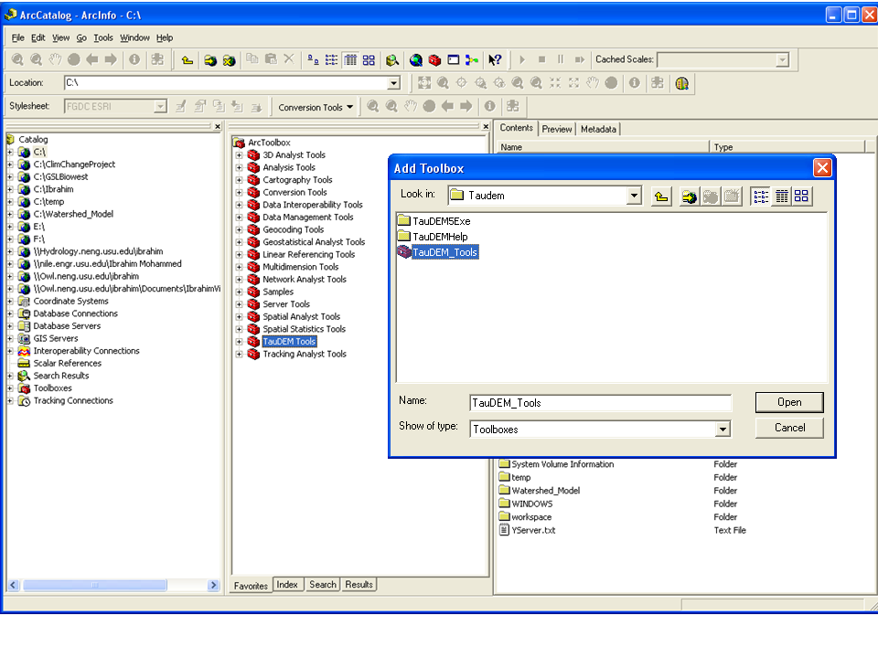

## Basic Grid Analysis using TauDEM functions

In this section we illustrate the TauDEM basic grid analysis functions. We start with a DEM in ESRI grid format and lead you through the steps of converting the data to the TIFF format needed for TauDEM, then running the necessary TauDEM commands.

1. Download the Cub River example data zip file from <http://hydrology.usu.edu/taudem/taudem5>. Extract all files from the zip file and load cubdem into ArcMAP.

This data was obtained from the National Elevation Dataset seamless data server. See appendix 1 for how to obtain US DEM data from the USGS seamless data server and project it to a spatial reference system for the area of interest. Projected data should be used when working with TauDEM because TauDEM uses grid dimensions (cell size) in its length and slope calculations and these will be incorrect if they are not consistent in E-W and N-S directions and in the same units as the vertical units of the DEM.

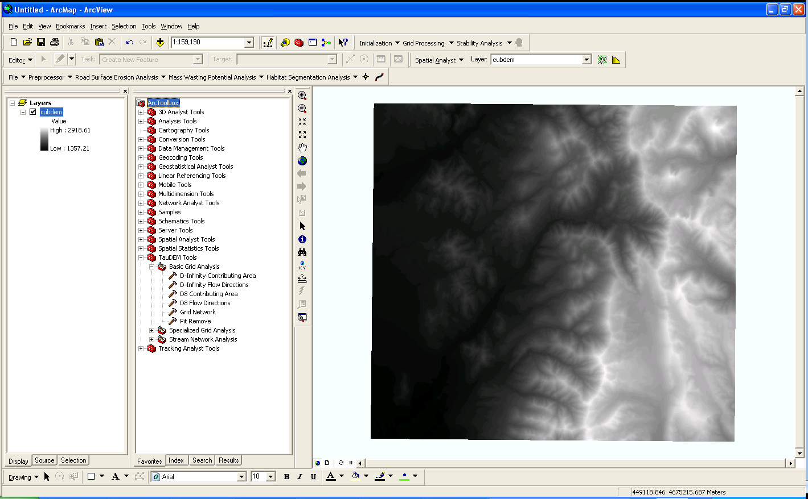

1. TauDEM 5 works with grids in TIFF format. Extract the grid cubdem to digital elevation model (DEM) "cubdem" to "cubdem.tif" by right clicking on cubdem and selecting Data->Export Data.

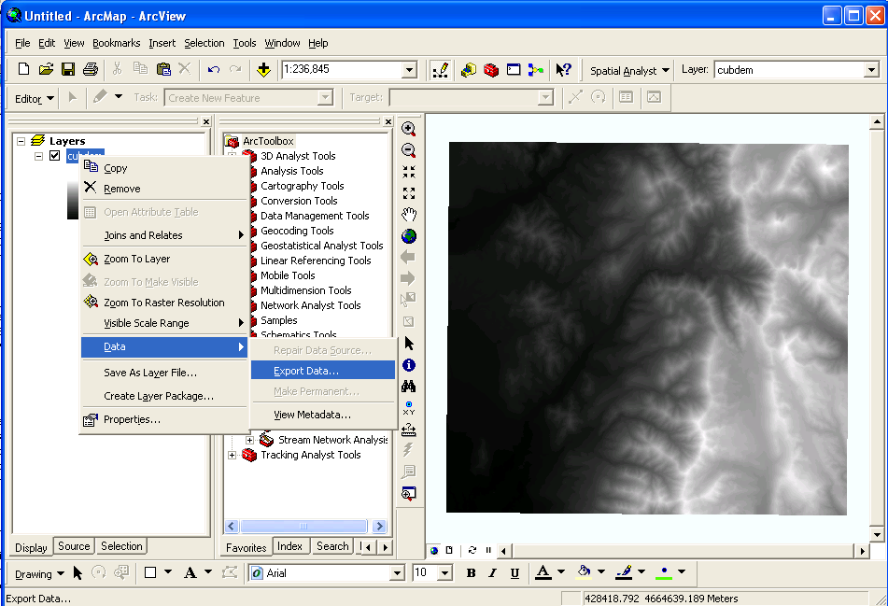

1. At the export Raster Data dialog set the folder location, name and TIFF format, and click Save.

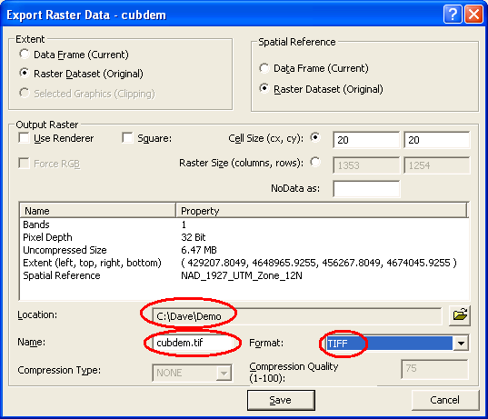

1. The first TauDEM function used is **Pit Remove**. Pits are grid cells surrounded by higher terrain that do not drain. Pit Remove creates a hydrologically correct DEM by raising the elevation of pits to the point where they overflow their confining pour point and can drain to the edge of the domain. Open (by double clicking on) the TauDEM Pit Remove Tool (in the Basic Grid Analysis) set

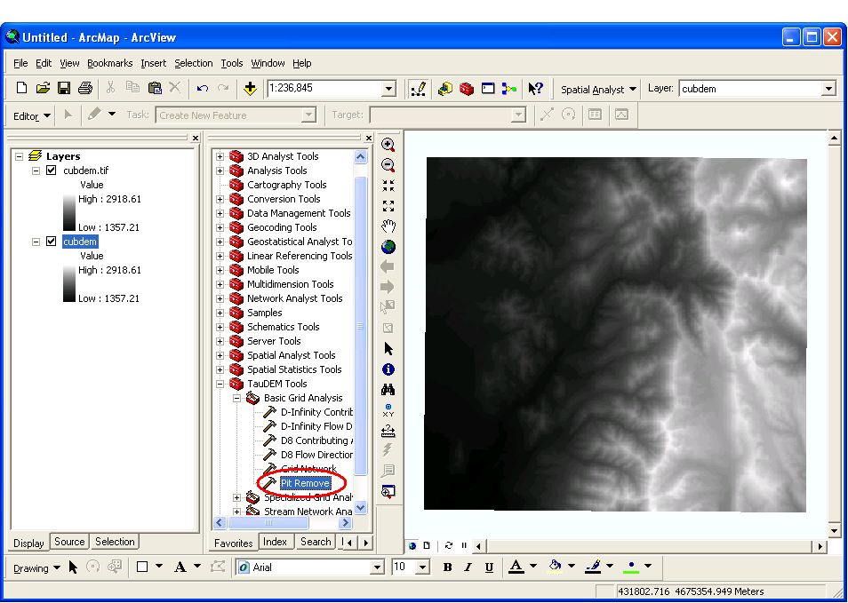

1. At the Pit Remove Tool dialog select Show Help to expand the embedded function help information.

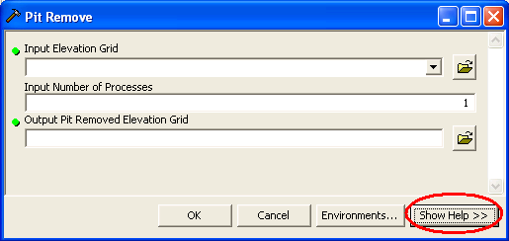

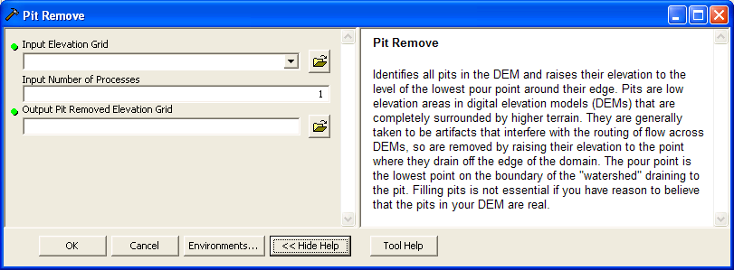

1. Click within each input field to obtain embedded context sensitive help for each input.

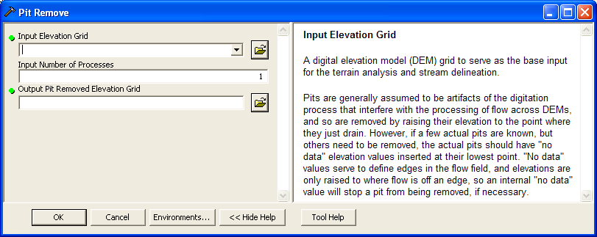

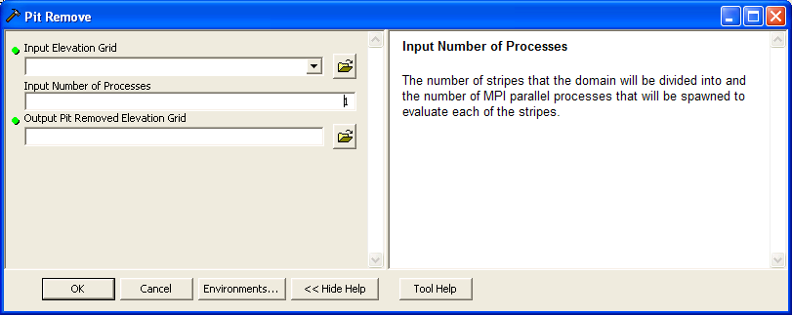

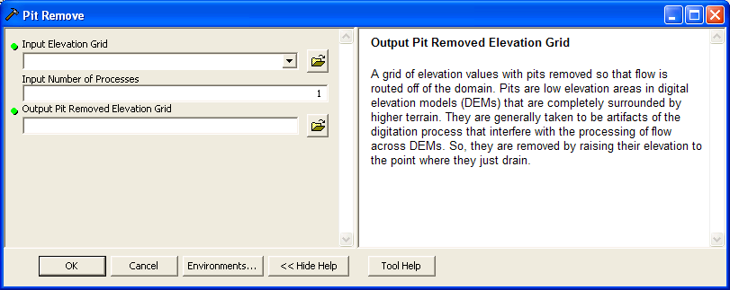

1. Click on Tool Help at the bottom to open the more detailed compiled help file included with the system

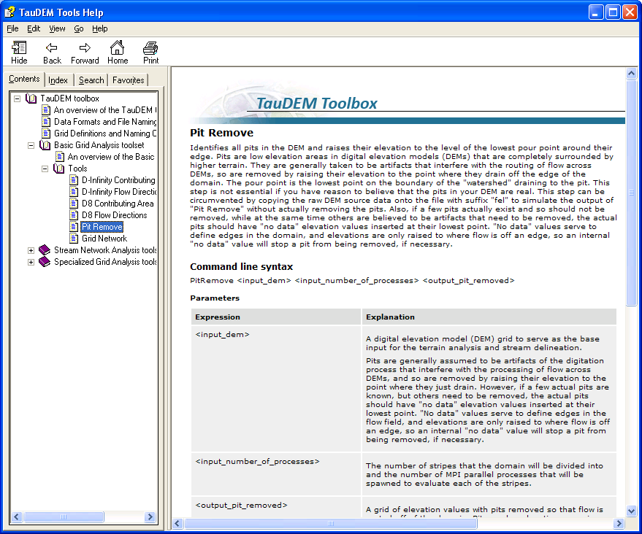

1. This TauDEM tools help contains an overview of the tools, data formats used and file naming conventions suggested for working with TauDEM. There is a detailed description of the functionality and parameters of each function. The tools are configured to, by default assign output file names following the naming convention given here. You do not have to use these names, but it is strongly recommended to aid in keeping track of the results.
2. Select **cubdem.tif** for the Input Elevation Grid. Note that the Output Pit Removed Elevation Grid is automatically filled with cubdemfel.tif following the file naming convention. Select the Input Number of Processes (I used 8 for a dual quad core PC).

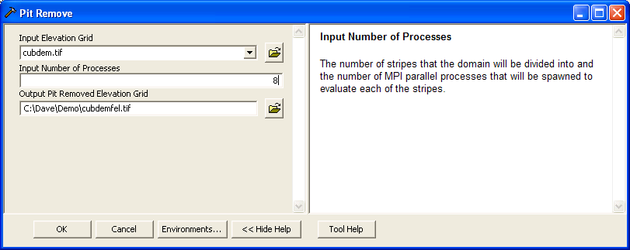

The parallel approach used by TauDEM is illustrated below. The domain is subdivided into row oriented partitions that are each processed independently by separate processes. When the algorithms reach a point where they can proceed no further within the partitions there is a swap step that exchanges information along the boundaries. The algorithms then proceed working within the partitions using new boundary information. This process is iterated until completion. The strategies for sharing information across boundaries and iterating are specific to each algorithm.

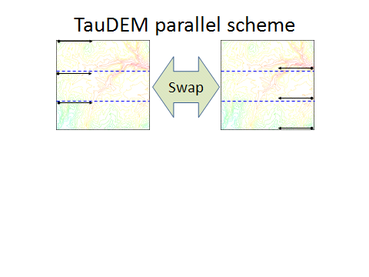

The number of processes does not have to be the same as the number of processors on your computer, although generally should be the same order of magnitude. The operating system (and MPICH2) takes care of time sharing between processes, so in cases where some processes are likely to be waiting for other processes to complete there may be a benefit in selecting more processes than physical processors on the computer. However then message passing across the borders is increased. For large datasets, some experimentation as to the number of processes that works best (fastest) is suggested.

1. Click OK on the Pit Remove tool to run the Pit Remove function for the cub river DEM. The output dialog reports run statistics that include timing, as well as any error or warning messages.

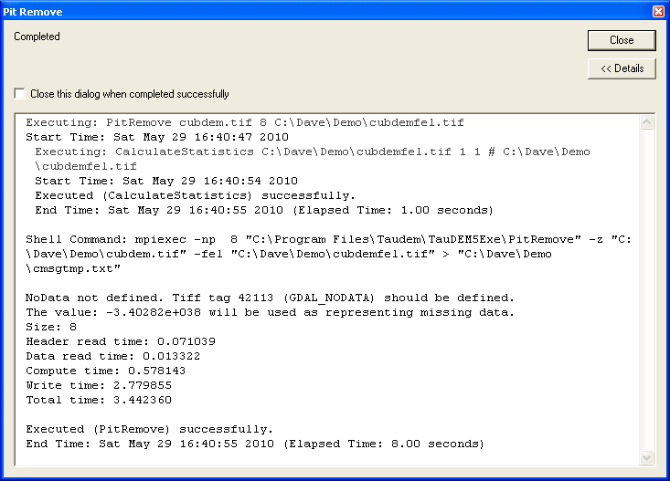

In this case there was a warning that the input TIFF file did not have a No Data value. TauDEM uses the GDAL TIFF tags to encode no data values as part of its TIFF files. The DEM exported from ArcGIS did not have this tag, so TauDEM defaulted to a large negative number. The defaults TauDEM uses have been chosen to be generally consistent with what is common for no data in ArcGIS, even if the GDAL TIFF tag is not present.

Note also in this output that timing information is reported for this run. In this case the largest amount of time was actually writing the output grid

1. The next function to run is **D8 Flow Direction**. This takes as input the hydrologically correct elevation grid and outputs D8 flow direction and slope for each grid cell.

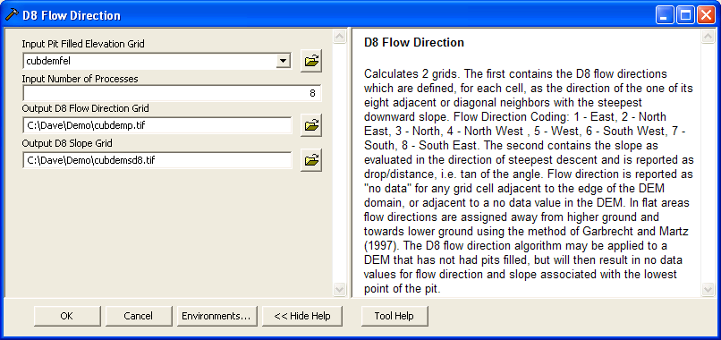

The resulting D8 flow direction grid (grid has suffix p) is illustrated. This is an encoding of the direction of steepest descent from each grid cell using the numbers 1 to 8 per the embedded help above. This is the simplest model of the direction water would flow over the terrain.

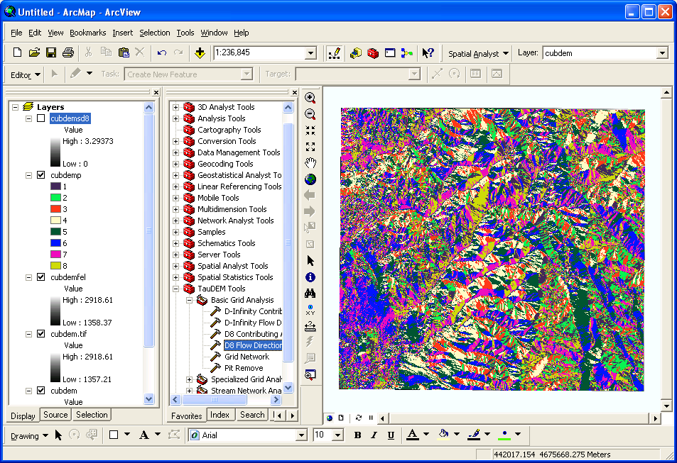

1. The next function to run is **D8 Contributing Area**. This counts the number of grid cells draining through (out of) each grid cell based on D8 flow directions.

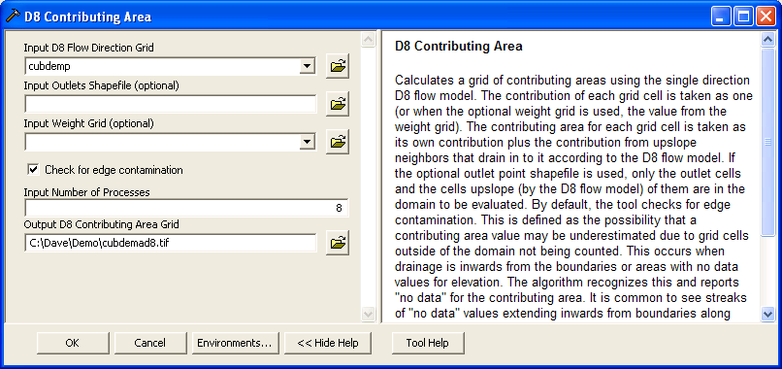

There are options to specify outlets and an input weight grid that were not used here. These are detailed in the tool help and allow calculations to be restricted to the area upstream of designated outlets (specified as a shapefile) and to accumulate an input weight field, rather than just counting contributing area as a number of grid cells. There is also an option to check for edge contamination. Edge contamination is a problem that can occur in the calculation of contributing area when flow is inwards from the boundary of the terrain. The computer does not know what the inflowing contributing area at the edge is, so evaluates the contributing area that may be impacted by this unknown area as no data. The result is streaks that enter the domain along flow paths. This is a desired result as it guards against missing parts of the watershed, but it can and should be turned off if the DEM has been clipped to a watershed boundary. A logarithmic scale is often best to render contributing area values as in the illustration below. Red has been used to display no data to illustrate edge contamination.

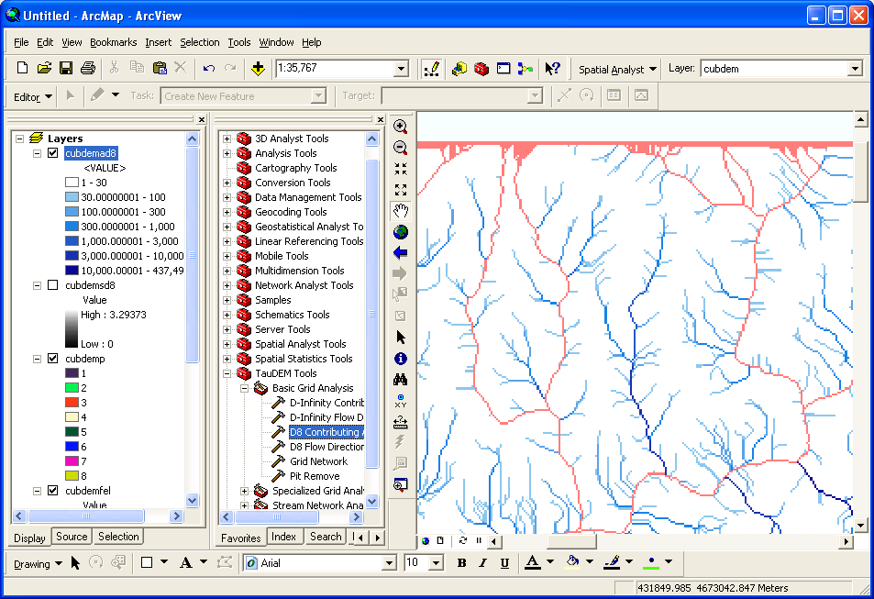

1. The **Grid Network** function outputs three grids: (1) the longest flow path along D8 flow directions to each grid cell, (2) the total length of all flow paths that end at each grid cell, and (3) the grid network order. This is obtained by applying the Strahler stream ordering system to the network defined starting at each grid cell.

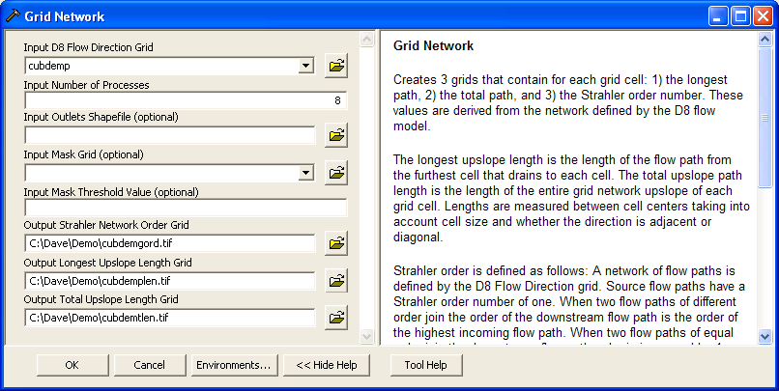

Grid Network Order (file name suffix gord) output from Grid Network is illustrated:

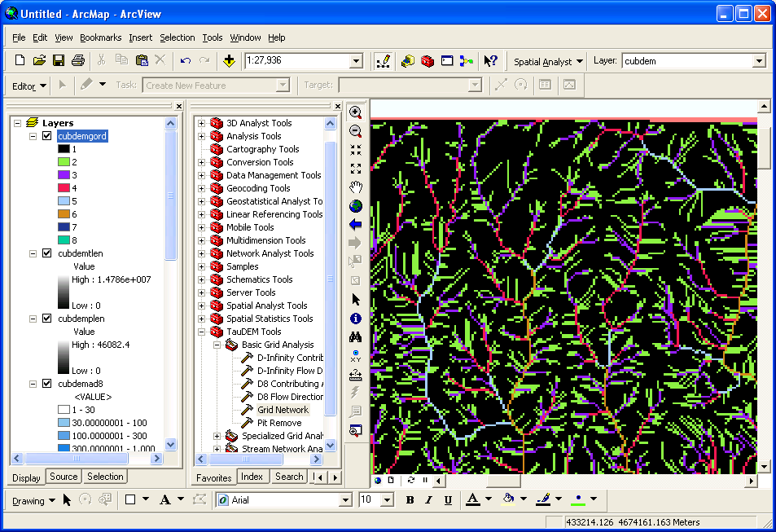

The functions above used the D8 flow model that represents flow from each grid cell to one neighbor. TauDEM also uses the D∞ (D-Infinity) flow model that calculates the steepest outwards flow direction using triangular facets centered on each grid cell and apportions flow between neighboring grid cells based on flow direction angles.

1. The **D-Infinity Flow Direction** function is starting point for all D-Infinity work. It calculates D-Infinity flow directions for use in other TauDEM functions requiring D-infinity flow direction input

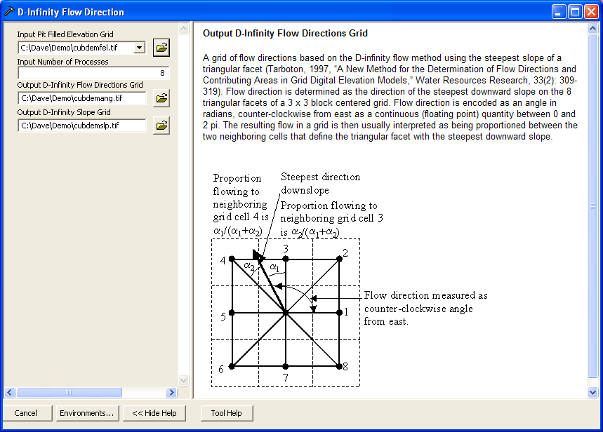

D-Infinity flow directions (encoded as angles counter clockwise from East in Radians as illustrated above) render similar to a hillshading

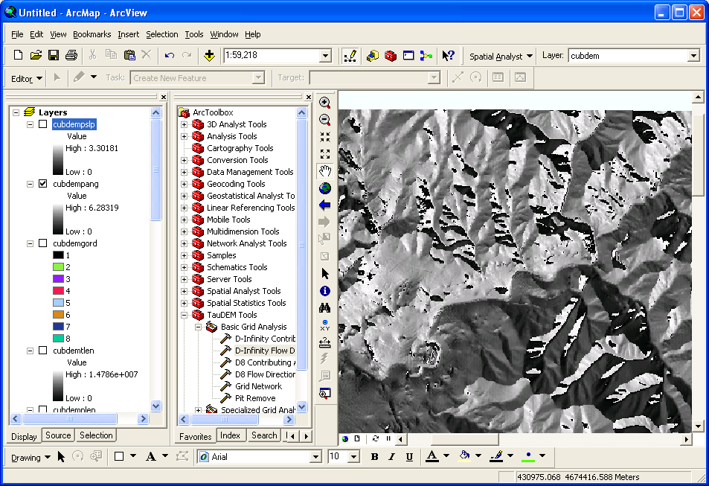

1. **The** **D-Infinity Contributing Area** function evaluates contributing area using the D-Infinity model based on flow being shared between grid cells proportional to the angle to the steepest downslope direction. This is designed to represent specific catchment area within dispersed flow over a smooth topographic surface.

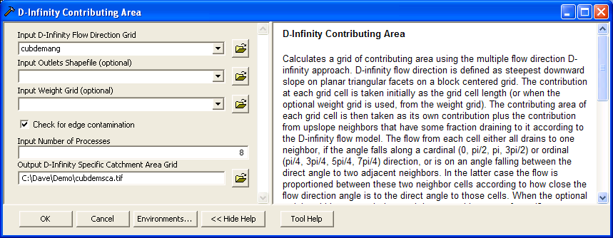

The result from running this is specific catchment area obtained from the D-Infinity contributing area function (with edge contamination) as illustrated below

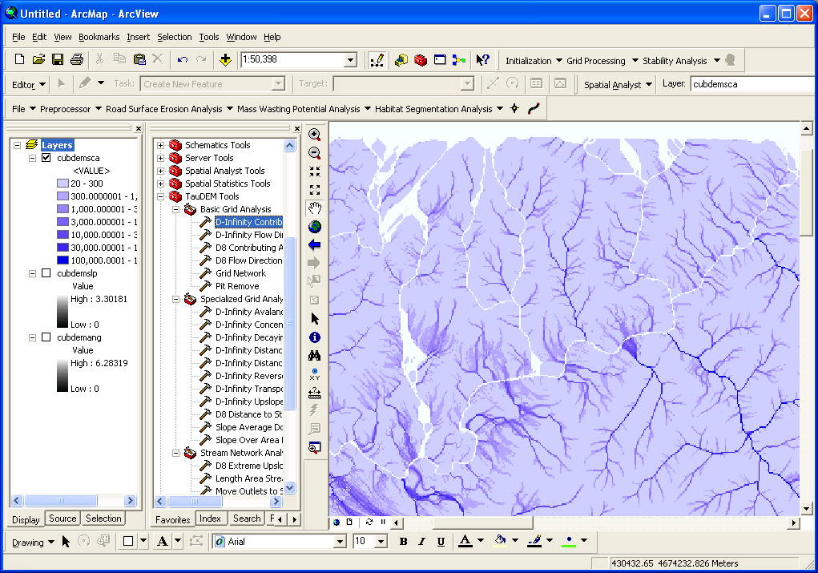

## Stream Network Analysis using TauDEM functions

TauDEM provides a number of methods for delineating and analyzing stream networks and watersheds. The simplest stream network delineation method uses a threshold on contributing area.

1. **Stream Definition by Threshold.** This function defines a stream raster grid (src suffix) by applying a threshold to the input. In this case the input is a D8 contributing area grid and a threshold of 100 grid cells has been used.

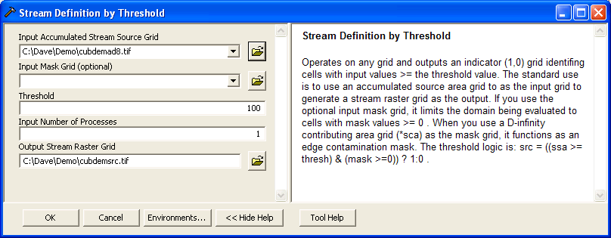

The result depicts the stream network (but is not logically connected as a network shapefile yet).

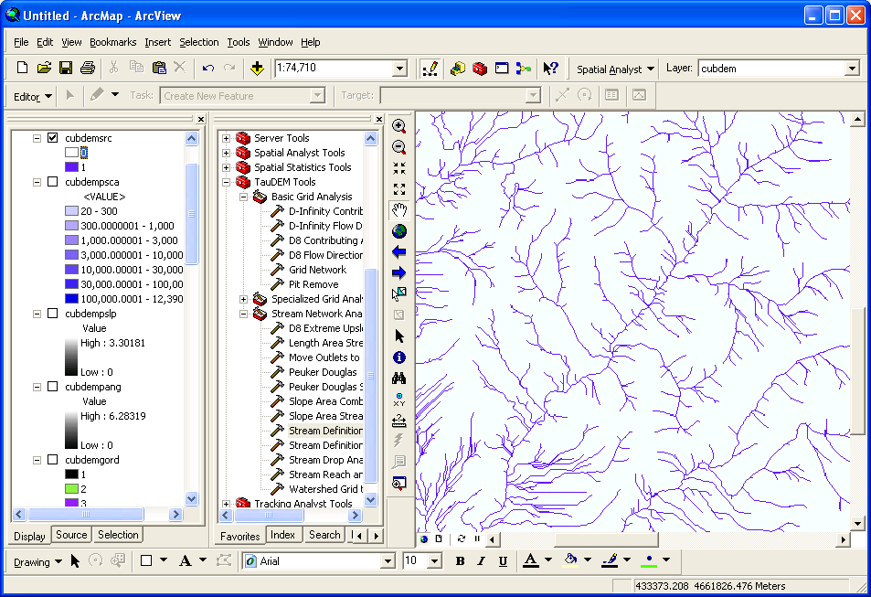

It is common to want to delineate watersheds upstream of an outlet, say a USGS stream gauge. This requires that gauge locations be precisely located on streams as rendered from the DEM. Due to inaccuracies in gauge locations and DEM stream delineation it is common for gauge locations not to be precisely on streams delineated from the DEM. The move Outlets to streams function slides gauge locations downslope following D8 flow directions until a stream (as defined by a stream raster grid) is encountered. The shapefile CubGauge in the example data is used to illustrate this.

1. Add the **CubGauge.shp** file to ArcMap and zoom in to the area around it.

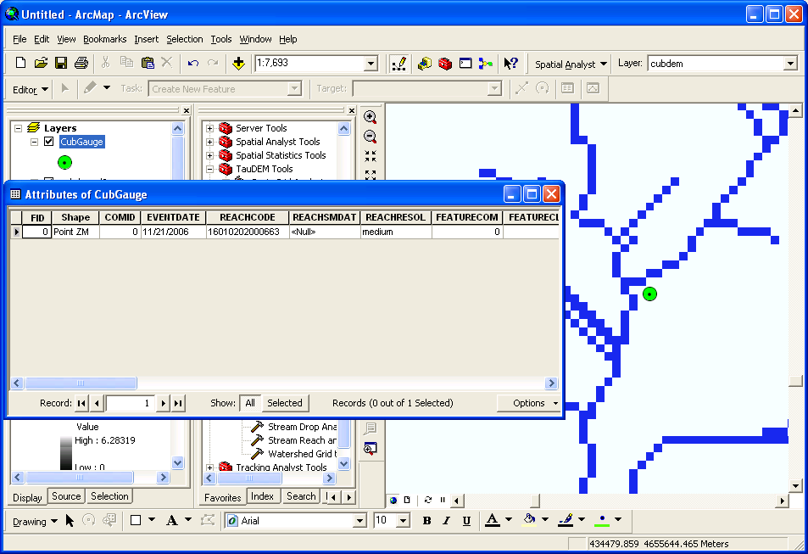

1. Open **Move Outlets to Streams** and select the following input and click OK

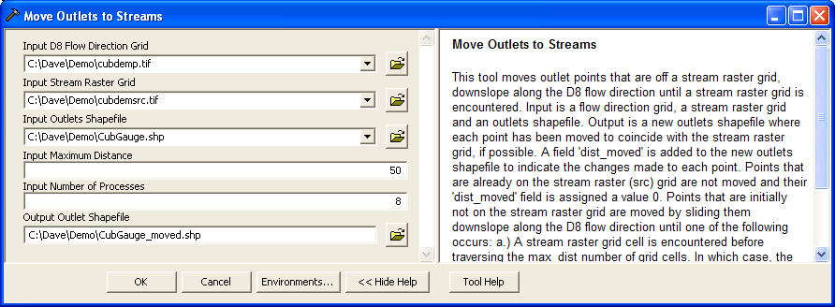

Notice (below) how the outlet has been moved to coincide with the stream.

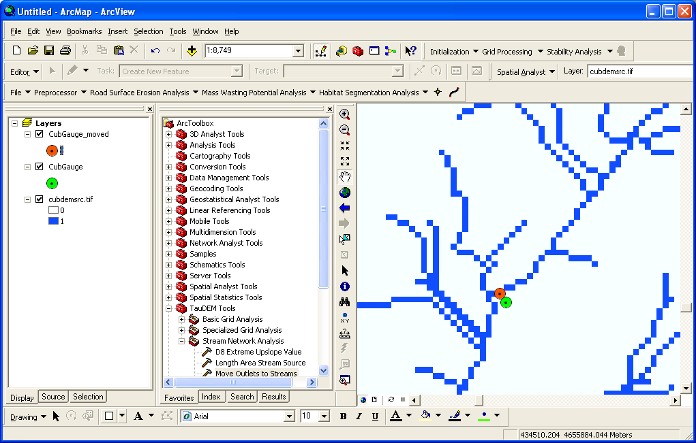

It is somewhat overkill to use 8 processors to move one outlet point, but this is illustrative of how this could be used for many more points. Upon adding the moved outlet you may have received an ArcMAP unknown spatial reference warning. Be aware in using TauDEM that TauDEM does not do any spatial reference (projection) conversions. Therefore all data needs to be in the same spatial reference system. TauDEM does copy the spatial reference information from input grids to output grids, but does not do this for shapefiles.

With the outlet positioned on the stream the stream network upstream of the outlet can be delineated.

1. Open **D8 Contributing Area** and select the following inputs and click OK

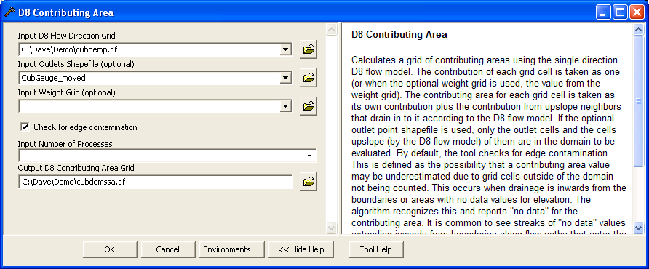

The result is contributing area only for the watershed upstream of the outlet.

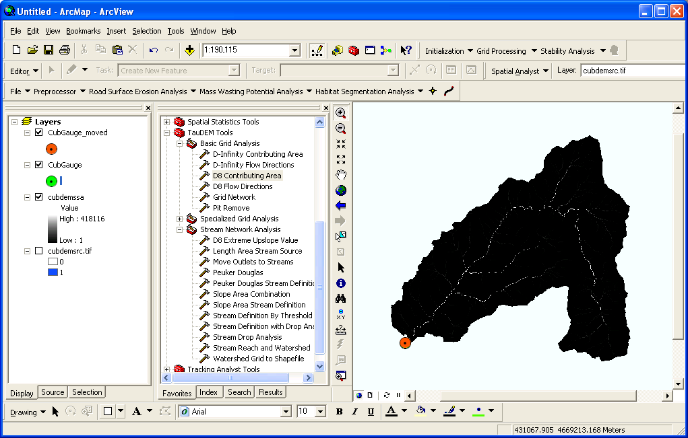

1. Open **Stream Definition By Threshold** and select the following inputs and click OK to define a stream raster for this area upstream of the outlet

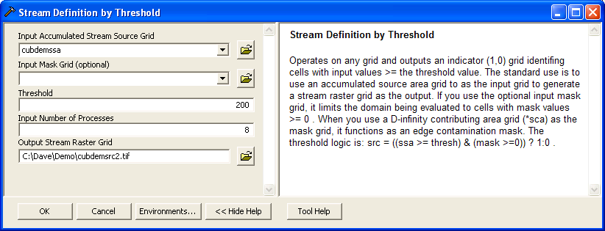

1. Open **Stream Reach and Watershed** and select the following inputs and click OK

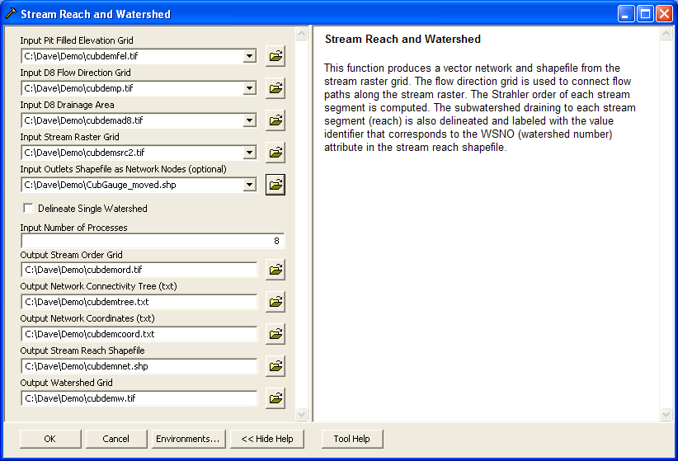

The result is a number of outputs illustrated below. These include a shapefile of the stream network and subwatersheds draining to each link of the stream network shapefile. This is one a key output from TauDEM. Each link in the stream network has a unique identifier that is linked to downstream and upstream links. Each subwatershed also has a unique identifier that is referenced in terms of the stream network that it drains to. This information enables construction of a subwatershed based distributed hydrologic model with flow from subwatersheds being connected to, accumulated in, and routed along the appropriate stream reaches.

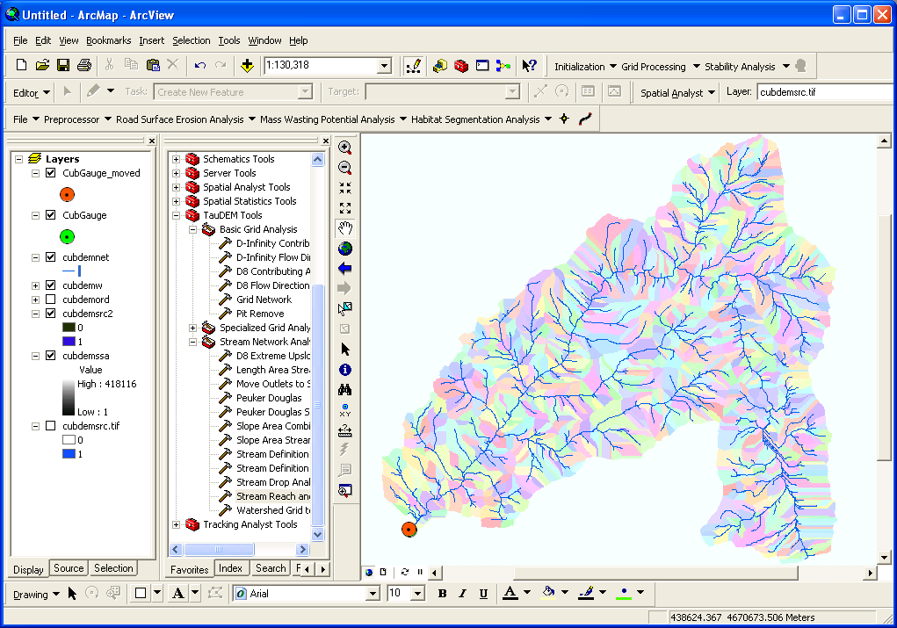

An important question in stream network delineation is, what stream delineation threshold to use. The above used arbitrary thresholds of 100 and 200 grid cells. TauDEM also provides ways to do select stream delineation threshold objectively using a stream drop test following theory described in Tarboton et al. (Tarboton et al., 1991; 1992) and Tarboton and Ames (2001). This may be combined with more geomorphologically based methods for channel definition that attempt to capture topographic texture and spatial variability in drainage density. These will be illustrated next.

1. Open the **Peuker Douglas** function and select the following inputs and click OK.

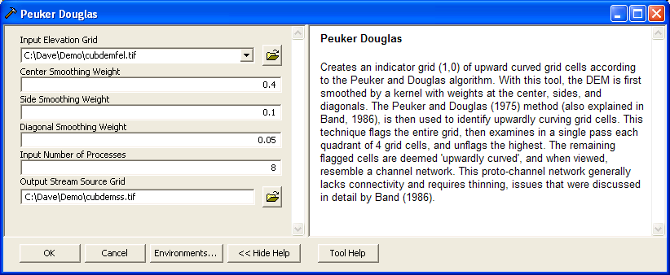

The result, derived entirely from a local filter applied to the topography is a skeleton of a stream network illustrated below

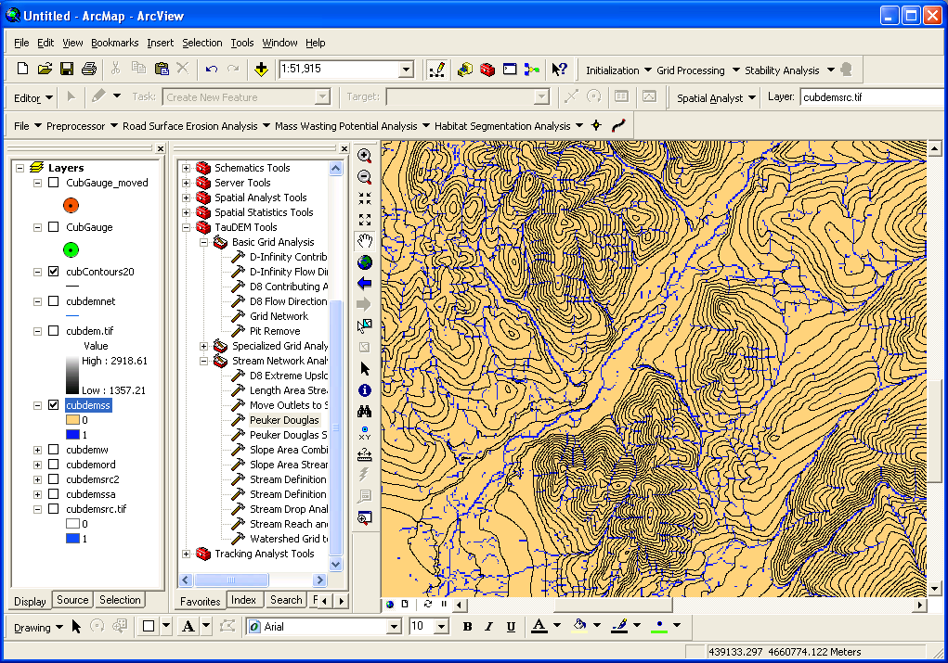

1. Open the **Peuker Douglas Stream Definition** function and select the following inputs and click OK.

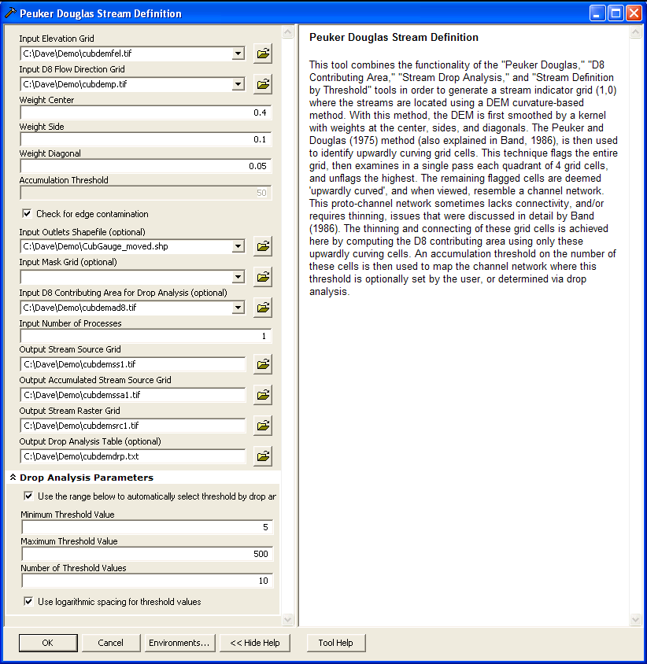

This rather extensive set of inputs configures TauDEM to run Peuker Douglas, then use the Peuker Douglas stream skeleton as a weighted input to a D8 contributing area calculation. The result is then thresholded using a range of thresholds (the drop analysis thresholds at the bottom of the input) to identify the smallest threshold for which the mean stream drop of first order streams is not significantly different from the mean stream drop of higher order streams. This is the constant drop law (Broscoe, 1959), and TauDEM uses it here to identify the highest resolution stream network that complies with this law as an objective way of identifying the stream delineation threshold. The output results include a table that reports the stream drop statistics for each threshold examined. This is included in the completion dialog below as well as written to the drop analysis table file. The last column of this gives T statistics for the differences of first and higher order streams. Using a threshold of |2| as indicating significance in this T test the threshold of 39 is chosen in this case as the objective stream delineation threshold.

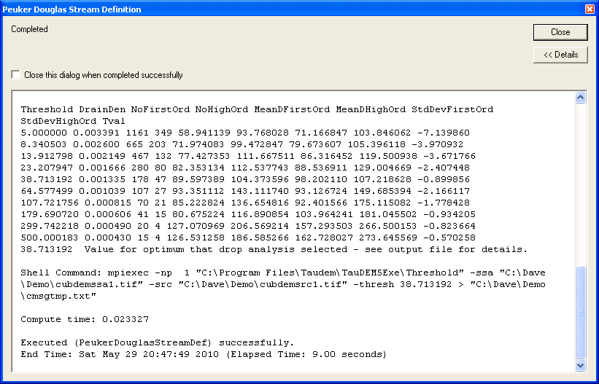

1. Open the **Stream Reach and Watershed** function and select the following inputs and click OK.

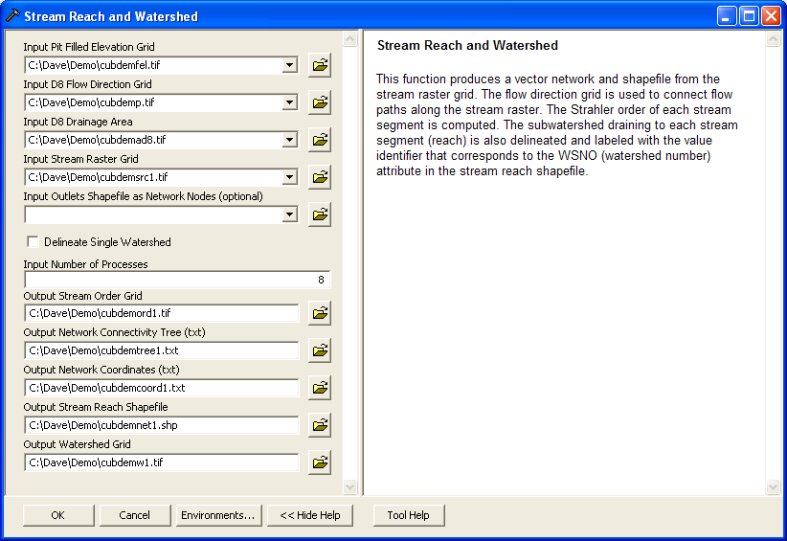

Following is an illustration of the result. Notice how the stream network has been delineated more or less consistently with the contour crenulations depicting the texture of the topography

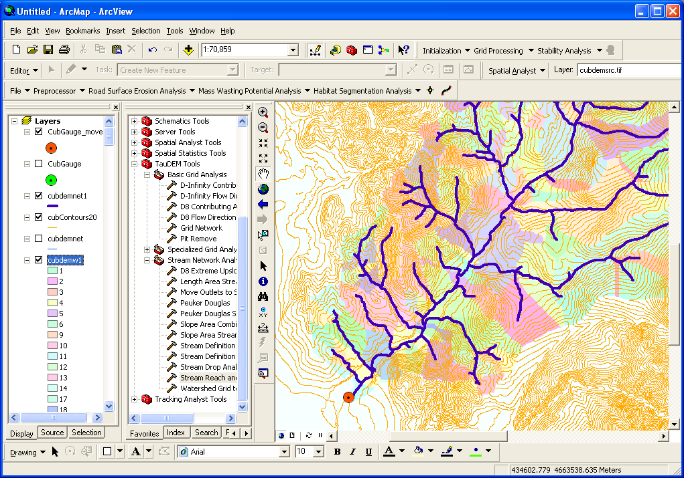

## Specialized Grid Analysis using TauDEM functions

TauDEM also includes a number of specialized grid analysis functions. Only a few are illustrated here as they are all detailed in the system help.

1. Open the **D-Infinity Distance Down** function and select the following inputs and click OK

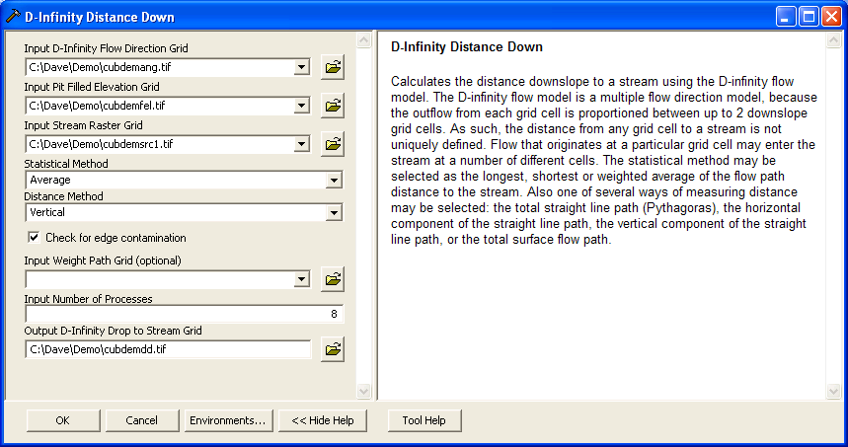

By selecting Vertical as the distance method the result is the vertical drop from each point, to a point on the stream as illustrated below

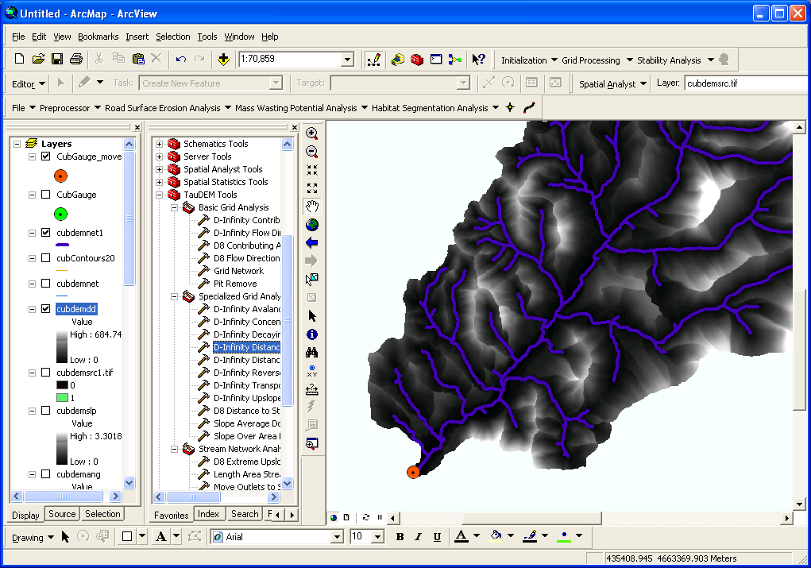

1. Open the **D-Infinity Distance Up** function and select the following inputs and click OK

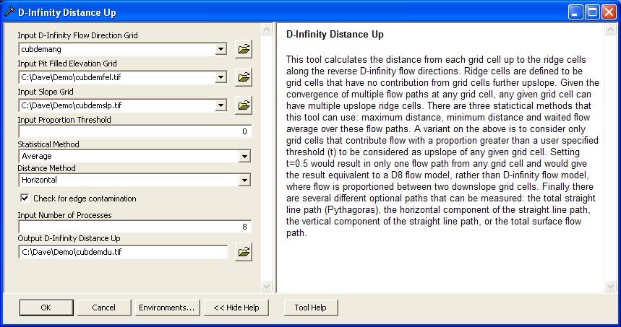

The result in this case is the average horizontal distance moving upslope along D-Infinity flow directions to a ridge, defined as a grid cell that has no other grid cells flowing in to it.

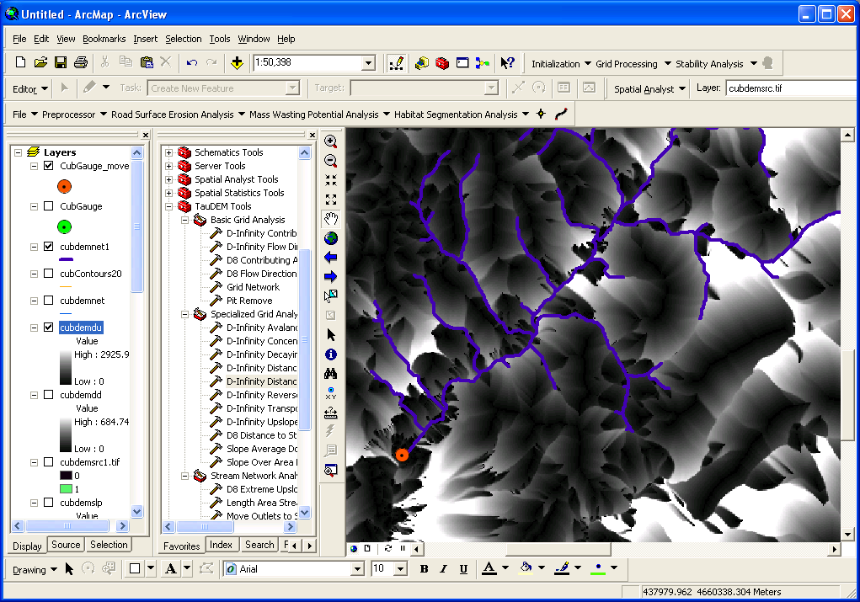

## Appendix. Projecting the Digital Elevation Model data

Projected data should be used when working with TauDEM because TauDEM uses grid dimensions (cell size) in its length and slope calculations and these will be incorrect if they are not consistent in E-W and N-S directions and in the same units as the vertical units of the DEM. The Digital Elevation Model data from sources such as Data.gov is often in Geographic Coordinates. This appendix outlines how to project a DEM grid. This assumes a DEM from the USGS National Elevation Dataset has been added to ArcMap. Then the ArcToolBox Project Raster tool is used to project this data. The ProjectRaster Tool is found within Data Management Tools / Projections and Transformations / Raster.

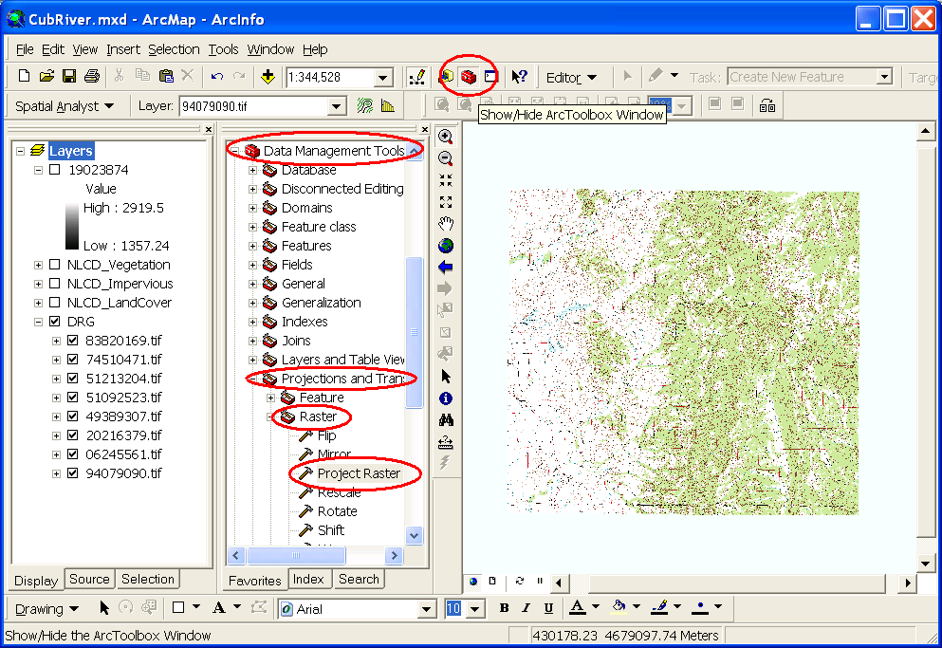

In the Project Raster dialog that opens specify the input raster as the National Elevation Dataset DEM that was unzipped from the download. Name the output raster something convenient. Here I used "cubdem". Click on the button next to Output coordinate system to open the Spatial Reference Properties dialog.

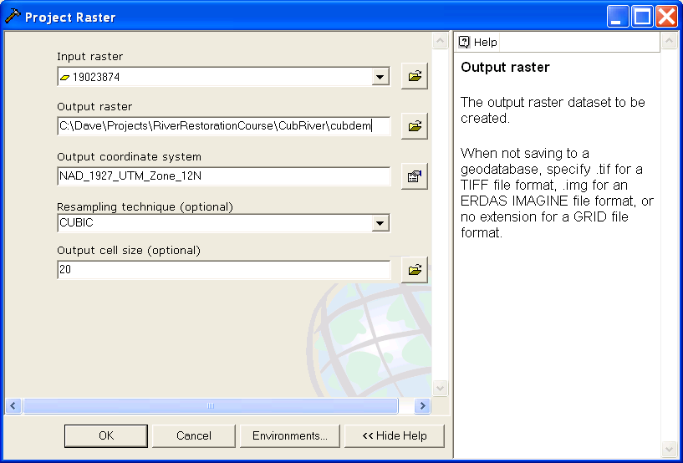

At this Spatial Reference Properties dialog click "Select" and navigate to the NAD_1927_UTM_Zone_12N projection being used as the standard spatial reference system for this exercise. Click OK.

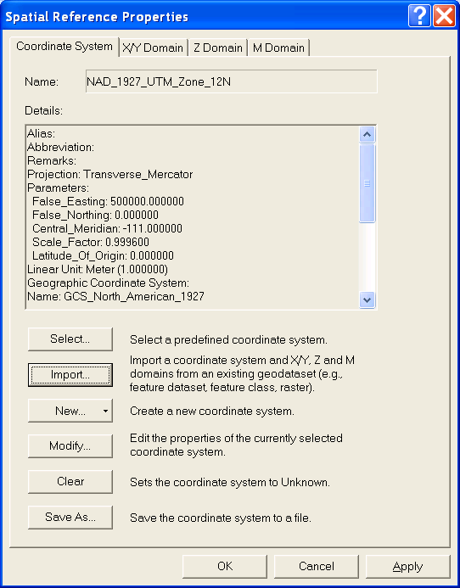

Back at the Project Raster dialog set the resampling technique to CUBIC (I have found by experience that this works best for DEMs) and set the output cell size to 20 m. The raw data in this case is at 1/3 arc second which is roughly 10 m. 20 m cell size is undersampling this a bit. Click OK. A processing dialog box should appear and after a few seconds indicate completion of the projection of the DEM. The DEM data has now been projected. The result is named 'cubdem'

## References

Broscoe, A. J., (1959), "Quantitative analysis of longitudinal stream profiles of small watersheds," Office of Naval Research, Project NR 389-042, Technical Report No. 18, Department of Geology, Columbia University, New York.

Tarboton, D. G. and D. P. Ames, (2001), "Advances in the mapping of flow networks from digital elevation data," World Water and Environmental Resources Congress, Orlando, Florida, May 20-24, ASCE, <http://www.engineering.usu.edu/dtarb/asce2001.pdf>.

Tarboton, D. G., R. L. Bras and I. Rodriguez-Iturbe, (1991), "On the Extraction of Channel Networks from Digital Elevation Data," Hydrologic Processes, 5(1): 81-100.

Tarboton, D. G., R. L. Bras and I. Rodriguez-Iturbe, (1992), "A Physical Basis for Drainage Density," Geomorphology, 5(1/2): 59-76.