**TauDEM 5.3**

**GUIDE TO USING THE TAUDEM COMMAND LINE FUNCTIONS**

**October 2015**

**David G. Tarboton**

**Pabitra Dash**

**Nazmus Sazib**

## Purpose

The purpose of this document is to introduce Hydrologic Terrain Analysis using the TauDEM command line functionality.

TauDEM (Terrain Analysis Using Digital Elevation Models) is a set of Digital Elevation Model (DEM) tools for the extraction and analysis of hydrologic information from topography as represented by a DEM. This is software developed at Utah State University (USU) for hydrologic digital elevation model analysis and watershed delineation and may be obtained from <http://hydrology.usu.edu/taudem/taudem5/>.

The architecture of TauDEM separates the system into a set of command line executable functions that comprise the engine that does the work, and a graphic user interface developed as a toolbox for ArcGIS. The ArcGIS toolbox is documented in a separate quick start guide and in comprehensive online documentation within the ArcGIS toolbox. This document focuses on the command line functions. These have been coded in C++ that is intended to be platform independent. The ArcGIS toolbox uses system calls to run these functions so running these functions from the command line produces exactly the same output as an equivalent ArcGIS toolbox function.

In this guide we assume that you are working on a Windows PC, although much of the functionality is generic and can be (with knowledge of the other system) be transferred to other systems. To use TauDEM command line functions you need the TauDEM 5.3 software as well as MPI software. Our current Windows PC precompiled executables have been compiled using the Microsoft HPC Pack 2012 MS-MPI libraries from <http://www.microsoft.com/en-us/download/details.aspx?id=36045>. Earlier versions used MPICH2 from <http://www.mcs.anl.gov/research/projects/mpich2/>. MPICH2 libraries are suggested for non-Windows installations.

**TauDEM 5.3 Installation**

TauDEM 5.3 needs to be installed using the TauDEM53_setup.exe program. This setup application can install TauDEM both on Windows 32-bit and 64-bit computers. Download this setup program from (**TODO**: provide the link here).

TauDEM setup program will install the following applications and libraries:

* TauDEM version 5.3
* GDAL 111 (MSVC 2010 Win64): *Only on x64 computers*
* GDAL 111 (MSVC 2010): *Only on x86 computers*
* Microsoft Visual C++ 2010 x64 Redistributable: *Only on x64 computers*
* Microsoft Visual C++ 2010 x86 Redistributable
* Microsoft HPC Pack 2012 MS-MPI Redistributable Pack

By default, TauDEM will be installed at C:\Program Files\TauDEM. GDAL related libraries will be installed at C:\GDAL. GDAL application will be installed at C:\Program Files\GDAL. MS HPC Pack will be installed at C:\Program Files\Microsoft HPC Pack 2012.

**NOTE**: If you have previously installed TauDEM 5.3, you need to first uninstall TauDEM and GDAL 111. You don’t need to uninstall other TauDEM dependencies.

**Requirements for TauDEM ArcGIS Tools:**

In order to be able to use TauDEM ArcGIS Tools, ArcGIS 10.2 or higher version must be installed.

**Procedure for Installing TauDEM:**

1. Run (double click) TauDEM53_setup.exe which should show the following installation startup window.

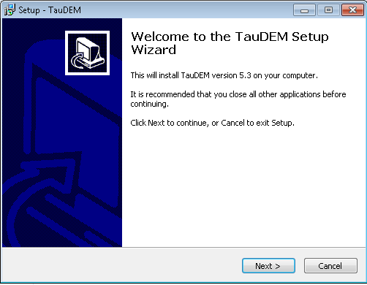

1. At the above window click on “Next” button which should show the following window.

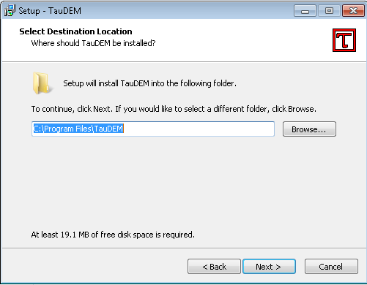

1. At the above window click on “Next” which should show the following window.

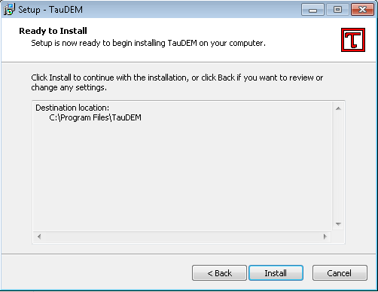

1. At the above window, click on the “Install” button to start the installation process. This will copy the TauDEM executables, TauDEM ArcGIS Tools related python files and all installer applications that TauDEM depends on. After TauDEM is installed, its dependencies will be installed. As shown below GDAL will be installed first.

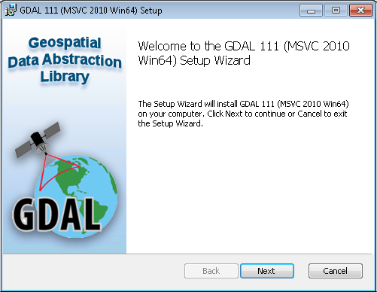

1. The above window shows that we are installing the 64bit of GDAL (which means we are running the TauDEM installer on a windows 64-bit machine). In case of 32-bit installation the above window title should show “GDAL 111 (MSVC 2010) Setup”. Click the “Next” button to see the following window.

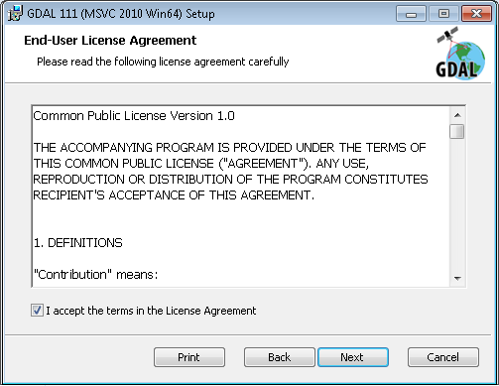

1. At the above window, select the checkbox to agree to the license agreement and then click on “Next”. Then you should see the following window.

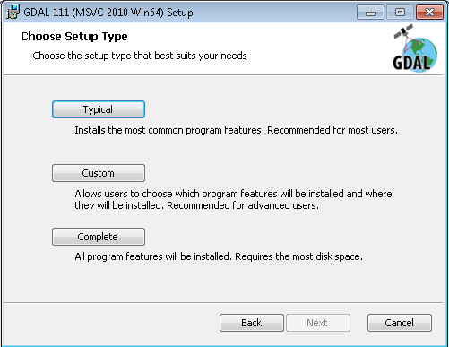

1. At the above window, click on the “Typical” button and you should see the following window.

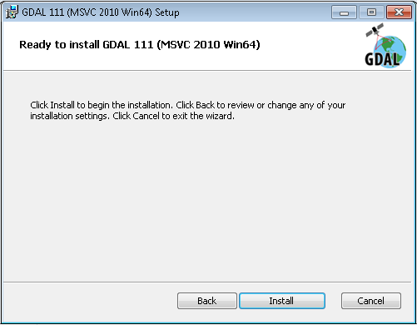

1. At the above window select the “Install” button to start installation of GDAL. When installation is done, you should see the following window.

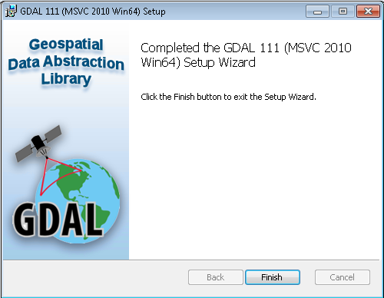

1. At the above window, click on the “Finish” button to finish installing GDAL. At this point the installation of MS C++ 2010 x86 Redistributable will start as shown below. The installation of this redistributable will occur only if your computer does not already have it installed.

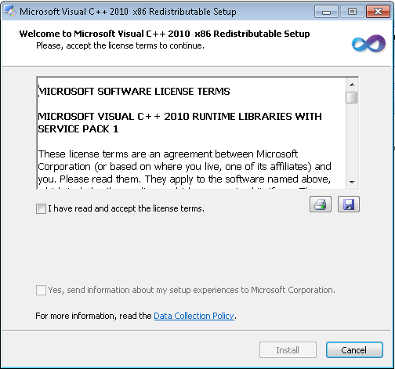

1. At the above window, select the checkbox to agree to the license agreement and then click on “Install” button to start the installation process. When installation of this redistributable finishes you should see the following window.

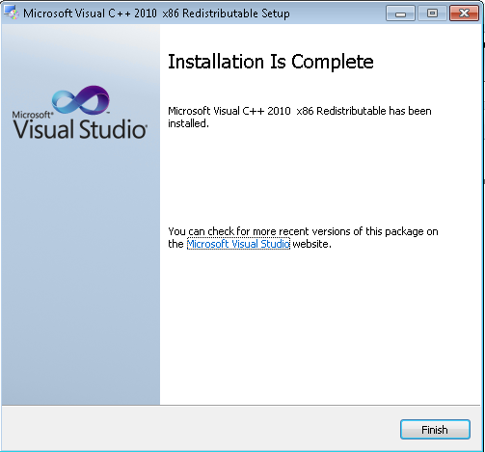

1. At the above window, click on “Finish” button. If you are running the TauDEM setup program on a 64-bit computer that does not already have the MS C++ 2010 x64 Redistributable installed, you should see the following window for installing MS C++ 2010 x64 Redistributable.

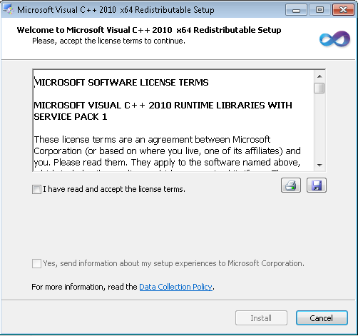

1. At the above window, select the checkbox to agree to the license agreement and then click on the “Install” button to start the installation process. When installation of this redistributable finishes you should see the following window.

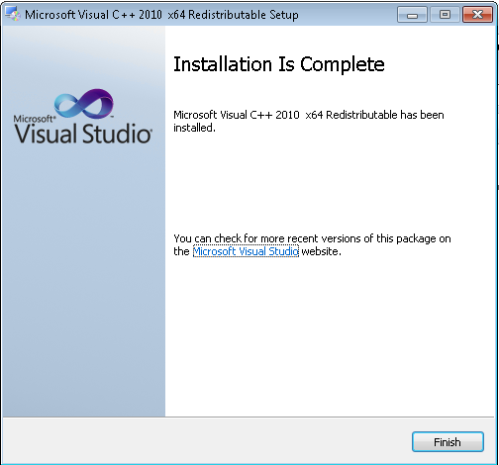

1. At the above window, click on the “Finish” button. If your computer doesn’t already have the MS HPC Pack 2012 MS-MPI Redistributable installed, you should see the following window to install that.

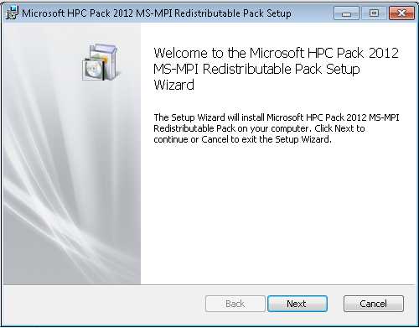

1. At the above window, click on the “Next” button. This should show you the following window.

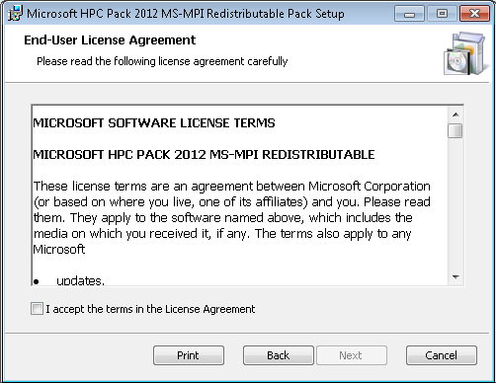

1. At the above window, select the checkbox to agree the license agreement and then click the “Next” button. Now you should see the following window.

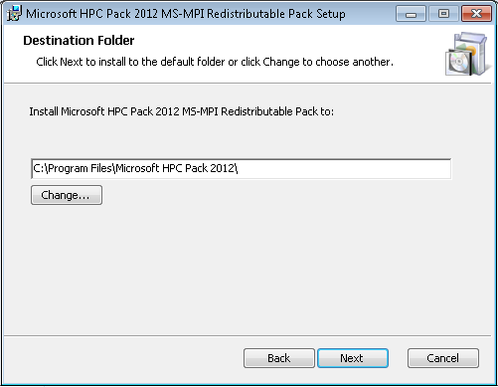

1. At the above window, click on the “Next” button to see the following window.

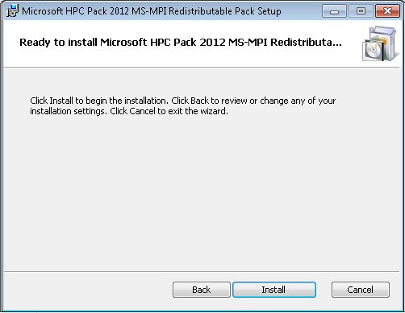

1. At the above window, click on the “Install” button to start the installation process. When installation finishes, you should see the following window.

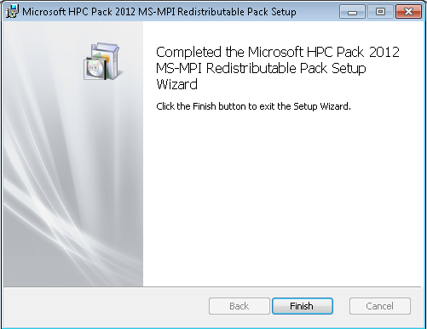

1. At the above window, click on the “Finish” button. At this point, TauDEM setup program will run a batch file to set the firewall settings for the TauDEM executables. You should see a console window for a short time as a result of running the batch file. When all install is complete, you should see the following window.

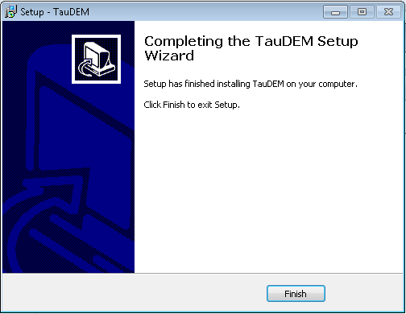

1. At the above window, click on the “Finish” to finish installation of TauDEM. At this point you have successfully installed TauDEM 5.3.

## Quick Start Examples

Download and unzip the Logan River example data from <http://hydrology.usu.edu/taudem/taudem5>. For these examples we assume these files have been unzipped into a folder C:\dave\logan.

Open a command prompt.

1. Execute the following command to change to the directory with the data

cd C:\dave\logan.

1. Remove Pits

mpiexec -n 8 PitRemove logan.tif

This produces the output file loganfel.tif that has pits removed. This output needs to be viewed in a GIS grid viewer, e.g. ArcGIS or MapWindow. The first time a TauDEM function is run, you may get a firewall warning.

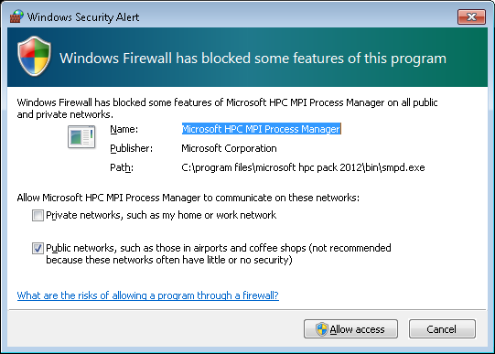

You may select Cancel as TauDEM does not require smpd to use the network. It is used to communicate between processes on the same computer.

1. Flow Directions

mpiexec -n 8 D8Flowdir -p loganp.tif -sd8 logansd8.tif -fel loganfel.tif

mpiexec -n 8 DinfFlowdir -ang loganang.tif -slp loganslp.tif -fel loganfel.tif

These produce the output files loganp.tif, logansd8.tif, loganang.tif and loganslp.tif that respectively contain D8 flow directions, D8 slopes, D-Infinity flow angles and D-Infinity slopes.

1. Contributing area

mpiexec -n 8 AreaD8 -p loganp.tif -ad8 loganad8.tif

mpiexec -n 8 AreaDinf -ang loganang.tif -sca logansca.tif

mpiexec -n 8 Aread8 -p loganp.tif -o loganoutlet.shp -ad8 loganad8o.tif

The first two of these produce the output files loganad8.tif and logansca.tif that respectively contain D8 and D-Infinity contributing area. The last command produces the file loganad8o.tif that is D8 contributing area evaluated upslope of outlets in the outlet.shp shapefile.

1. Gridnet

mpiexec -n 8 Gridnet -p loganp.tif -plen loganplen.tif -tlen logantlen.tif -gord logangord.tif

This produces the output files loganplen.tif, logantlen.tif and logangord.tif, containing respectively (1) the longest flow path along D8 flow directions to each grid cell, (2) the total length of all flow paths that end at each grid cell, and (3) the grid network order. This is obtained by applying the Strahler stream ordering system to the network defined starting at each grid cell.

1. PeukerDouglas

mpiexec -n 8 PeukerDouglas -fel loganfel.tif -ss loganss.tif

This produces a skeleton of a stream network derived entirely from a local filter applied to the topography.

1. PeukerDouglas stream delineation

mpiexec -n 8 Aread8 -p loganp.tif -o loganoutlet.shp -ad8 loganssa.tif -wg loganss.tif

mpiexec -n 8 Dropanalysis -p loganp.tif -fel loganfel.tif -ad8 loganad8.tif -ssa loganssa.tif -drp logandrp.txt -o loganoutlet.shp -par 5 500 10 0

mpiexec -n 8 Threshold -ssa loganssa.tif -src logansrc.tif -thresh 300

These three commands evaluate the weighted contributing area of the PeukerDouglas stream network skeleton, then use stream drop analysis to apply a range of thresholds to this weighted contributing area grid to identify the smallest threshold for which the mean stream drop of first order streams is not significantly different from the mean stream drop of higher order streams. This is the constant drop law (Broscoe, 1959), and TauDEM uses it here to identify the highest resolution stream network that complies with this law as an objective way of identifying the stream delineation threshold. The output results include a table (logandrp.txt) that reports the stream drop statistics for each threshold examined.

|  |  |  |  |  |  |  |  |  |
| --- | --- | --- | --- | --- | --- | --- | --- | --- |
| Threshold | Drain Den | No First Ord | No High Ord | Mean D First Ord | Mean D High Ord | Std Dev First Ord | Std Dev High Ord | T |
| 5 | 2.46E-03 | 2256 | 688 | 66.5 | 125.0 | 76.2 | 131.9 | -14.56 |
| 8 | 1.85E-03 | 1165 | 351 | 85.6 | 145.4 | 97.8 | 142.4 | -8.94 |
| 14 | 1.54E-03 | 774 | 239 | 96.6 | 159.9 | 103.3 | 151.4 | -7.35 |
| 23 | 1.23E-03 | 452 | 141 | 115.0 | 182.0 | 109.7 | 158.8 | -5.64 |
| 39 | 9.99E-04 | 294 | 96 | 116.6 | 211.5 | 107.4 | 166.9 | -6.48 |
| 65 | 7.90E-04 | 188 | 70 | 116.7 | 209.4 | 123.8 | 156.1 | -4.97 |
| 108 | 6.35E-04 | 109 | 38 | 154.0 | 239.1 | 144.1 | 162.6 | -3.03 |
| 180 | 5.24E-04 | 75 | 19 | 187.2 | 269.4 | 158.2 | 157.0 | -2.03 |
| 300 | 4.12E-04 | 50 | 14 | 197.5 | 255.4 | 137.7 | 168.1 | -1.32 |
| 500 | 3.04E-04 | 30 | 4 | 214.5 | 289.5 | 153.1 | 136.0 | -0.93 |

The last column of this gives T statistics for the differences of first and higher order streams. Using a threshold of |2| as indicating significance in this T test the threshold of 300 is chosen in this case as the objective stream delineation threshold. This was used in the last command to output the logansrc.tif stream raster grid

1. Stream Network

mpiexec -n 8 Streamnet -fel loganfel.tif -p loganp.tif -ad8 loganad8.tif -src logansrc.tif -ord loganord3.tif -tree logantree.dat -coord logancoord.dat -net logannet.shp -w loganw.tif -o loganoutlet.shp

* This produces a number of outputs illustrated below. These include a shapefile of the stream network and subwatersheds draining to each link of the stream network shapefile. This is one a key output from TauDEM. Each link in the stream network has a unique identifier that is linked to downstream and upstream links. Each subwatershed also has a unique identifier that is referenced in terms of the stream network that it drains to. This information enables construction of a subwatershed based distributed hydrologic model with flow from subwatersheds being connected to, accumulated in, and routed along the appropriate stream reaches.

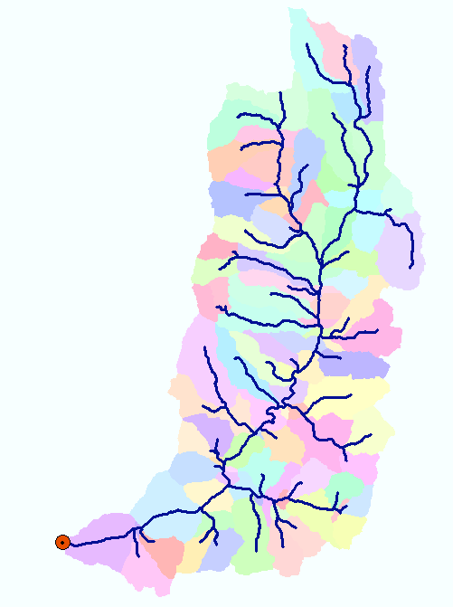

These examples have illustrated the use of key TauDEM command line functions to delineate watersheds. A summary of TauDEM command line functions with brief descriptions of their functionality is given below. Refer also to the TauDEM ArcGIS toolbox CHM help which provides more comprehensive information on what each function does and the full command line input specifications below.

|  |  |  |
| --- | --- | --- |
|  | Function | Description |
| 1. Basic Grid Analysis Functions | | |
|  | PitRemove | Pits are grid cells surrounded by higher terrain. A hydrologically correct DEM has no pits so that a drainage path can be defined from each grid cell to the edge of the domain. PitRemove takes as input an elevation data grid and outputs a hydrologically correct elevation grid with pits filled, using the flooding algorithm. |
|  | D8FlowDir | Takes as input the hydrologically correct elevation grid and outputs D8 flow direction and slope for each grid cell. In flat areas flow directions are assigned away from higher ground and towards lower ground. |
|  | DinfFlowDir | Assigns a flow direction based on steepest slope on a triangular facet following the D∞ model. This is recorded as an angle in radians anti-clockwise from east. |
|  | AreaD8 | Takes as input a D8 flow directions grid and outputs the contributing area as the number of grid cells draining through each grid cell. (Optionally accumulates an input weight grid) |
|  | AreaDinf | Takes as input a D∞ flow direction grid and outputs the specific catchment area. Specific catchment area is defined as contributing area per unit contour length. (Optionally accumulates an input weight grid) |
|  | GridNet | Takes as input a D8 flow directions file and outputs three grid files:  - plen contains the path length from the furthest cell that drains to each cell.  - tlen contains the total length of all paths draining to each cell.  - gord contains the Strahler order associated with that cell for a flow network defined using the D8 flow directions and including each grid cell. |
| 2. Stream Network Functions | | |
|  | PeukerDouglas | Takes as input an elevation grid and outputs an indicator (1,0) grid of candidate stream cells according to the Peuker and Douglas algorithm. |
|  | Threshold | Takes as any grid and outputs an indicator (1,0) grid of grid cells that have values >= the input threshold. This is used to delineate stream networks from contributing area and similar grids. |
|  | D8FlowPathExtremeUp | Evaluates the extreme (either maximum or minimum) upslope value from an input grid based on the D8 flow directions. Used in some stream delineation methods. |
|  | SlopeArea | Evaluates Sman based on slope and specific catchment area grid inputs, and parameters m and n. Uses with slope-area stream delineation. |
|  | LengthArea | Evaluates A >= M Ly and outputs an indicator (1,0) grid based on upslope path length and D8 contributing area grid inputs, and parameters M and y. Used with length-area stream delineation. |
|  | DropAnalysis | Applies a series of thresholds and outputs a table of stream statistics used in objectively selecting the stream delineation threshold. |
|  | StreamNet | Produces a vector network (shapefile) from a stream raster grid. Outputs a grid of subwatersheds draining to each stream network link |
|  | MoveOutletsToStreams | Adjusts the position of outlets by moving them downslope along D8 flow directions until they reach a stream. |
| 3. Specialized grid analysis functions | | |
|  | SlopeAreaRatio | Calculates ratio S/A where S is slope and A contributing area |
|  | D8HDistToStrm | Calculates horizontal distance to stream along D8 flow directions |
|  | DinfUpDependence | Calculates upslope dependence |
|  | DinfDecayAccum | Calculates decay limited accumulation |
|  | DinfConcLimAccum | Calculates concentration limited accumulation |
|  | DinfTransLimAccum | Calculates transport limited accumulation |
|  | DinfRevAccum | Calculates reverse accumulation |
|  | DinfDistDown | Calculates distance downslope to a target zone (typically stream) using Dinf flow directions. Options include vertical, horizontal, along slope and pythagorus distances , computed using minimum, maximum, or flow weighted averaging along multiple Dinf flow paths. |
|  | DinfDistUp | Calculates distance upslope to a ridge (grid cell with no inflow) using Dinf flow directions. Options include vertical, horizontal, along slope and pythagorus distances , computed using minimum, maximum, or flow weighted averaging along multiple Dinf flow paths. |
|  | DinfAvalanche | Calculates avalanche runout zone and distance to avalanche source in avalanche runout zone |
|  | SlopeAveDown | Calculates slope averaged over specified distance down D8 flow directions |

## Supported File Formats

TauDEM version 5.3 has been developed to read any raster supported by GDAL and write grid files in the GeoTiff (.tif) format only. TauDEM reads and writes ESRI shape files and text files generally identified using the .dat extension.

## TauDEM Codes

TauDEM works with numerous input and output file types, each of which contains data that needs to be interpreted differently. To manage this, a set of character TauDEM codes has been developed. The TauDEM codes are used both as suffixes in TauDEM’s default file names and as flags in the syntax of the command line functions.

## File Naming Convention

In TauDEM’s default file naming convention, the name of the base digital elevation model is used as the base file name for the default file names of all of the different files generated based on that DEM. Many of the TauDEM codes are used as suffixes, where they are combined with the base file name, followed by the extention, to identify each of the various file types used by TauDEM. For example, if “sss” is the TauDEM code for a particular type of file, and “dem.tif” is the base elevation grid name, then the default file name for a grid of that type would be “demsss.tif”, the default file name of a shapefile would be “demsss.shp”, and the default file name of a text file would be “demsss.dat”.

## Command Line Flags

TauDEM codes are also used as flags in the command line syntax to indicate the parameter being supplied to the function. When these codes are used as flags in the TauDEM command line syntax, they are preceded by a hyphen “-“followed by the parameter. For example, the suffix for the pit filled elevation file is ***fel*** while its corresponding command line flag is ***-fel***.

For the most part, the suffix codes and the flag codes are the same for each type of data file, but there are a few exceptions. **Table 1** lists the TauDEM codes used for grid data in TauDEM. The initial elevation file does not have a suffix, however the code “z” is used on the command line as flag. **Table 2** lists the TauDEM codes used for shapefile and text data. Table 3 lists the non-file related TauDEM code flags.

**Table 1 TauDEM codes for grids, their descriptions and input and output functions**

| **Suffix/Flag** | **Description** | **Function Input** | **Function Output** |
| --- | --- | --- | --- |
| **ad8/-ad8** | D8 contributing area grid (area measured as number of grid cells) | Threshold, DropAnalysis, LengthArea, StreamNet | AreaD8 |
| **ang/-ang** | D-infinity flow direction grid (flow direction grid measured in radians, counter clockwise from east) | AreaDinf, DinfUpDependence, DinfDecayAccum, DinfConcLimAccum, DinfTransLimAccum, DinfRevAccum, DinfDistDown, DinfDistUp, DinfAvalanche | DinfFlowDir |
| **ass/-ass** | avalanche source site grid, a required input for D-infinity avalanche runout | DinfAvalanche |  |
| **cs/-cs** | Concentration in supply grid, a grid giving the concentration of a compound of interest in the supply to the transport limited accumulation function | DinfTransLimAccum |  |
| **ctpt/-ctpt** | Concentration grid, a grid giving the concentration of a compound of interest |  | DinfConcLimAccum, DinfTransLimAccum |
| **dd/-dd** | D-infinity distance to stream which can be average, minimum or maximum of horizontal, vertical, surface or Pythagoras distances to the stream. |  | DinfDistDown |
| **dep/-dep** | Upslope dependence grid, a grid giving at each grid cell the fraction of flow that contributes to any part of the target disturbance grid |  | DinfUpDependence |
| **dfs/-dfs** | Distance from source grid |  | DinfAvalanche |
| **dg/-dg** | Disturbance indicator grid, an indicator grid that marks the target domain for various functions | DinfUpDependence, DinfConcLimAccum |  |
| **di** | Downslope influence grid that quantifies the influence of grid cells in the indicator grid on contributing area at each grid cell |  | AreaDinf |
| **dist/-dist** | D8 distance to stream grid |  | D8HDistDown |
| **dm/-dm** | Decay multiplier grid, a grid giving the factor by which flow leaving each grid cell is multiplied before accumulation on downslope grid cells. This may be used to simulate the movement of an attenuating substance. | DinfDecayAccum, DinfConcLimAccum |  |
| **dmax/ -dmax** | Maximum downslope grid, a grid giving the maximum of the weight loading grid downslope from each grid cell |  | DinfRevAccum |
| **dsca/-dsca** | Decayed specific catchment area grid (specific catchment area calculated by accumulating area but using the decay multipliers) |  | DinfDecayAccum |
| **du/-du** | D-infinity distance to ridge which can be average, minimum or maximum of horizontal, vertical, surface or Pythagoras distances to the ridge. |  | DinfDistUp |
| **fel/-fel** | Hydrologically correct elevation grid with pits removed either by filling or carving | D8FlowDir, DinfFlowDir, StreanRaster, DropAnalysis, StreamNet, DinfDistUp, DinfDistDown, PeukerDouglas, DinfAvalanche | PitRemove |
| **gord/-gord** | Stahler network order grid (Strahler order for grid network defined from D8 flow directions) | Threshold, DropAnalysis | Gridnet |
| **-mask** | Flag used to show mask file, with the name of the mask file as argument. | Threshold, Gridnet |  |
| **ord/-ord** | Network order grid, a grid giving the Strahler stream order for each delineated stream grid cell |  | StreamNet |
| **p/-p** | D8 flow direction grid obtained from the D8 flow direction function | AreaD8, D8HDistToStrm, D8FlowPathExtremeUp, PeukerDouglas, DropAnalysis, StreamNet,, Gridnet, SlopeAveDown | D8FlowDir |
| **plen/-plen** | Longest upslope length grid, a grid that gives the length of the longest upslope flow path terminating at each grid cell | Threshold, DropAnalysis, LengthArea | Gridnet |
| **q/-q** | Specific discharge of the flow carrying the constituent being loaded at the concentration threshold specified | DinfConcLimAccum |  |
| **racc/-racc** | Reverse accumulation grid, a grid giving the result of the "Reverse Accumulation" function |  | DinfRevAccum |
| **rz/-rz** | Runout zone grid, a runout zone indicator grid with value 0 to indicate that this grid cell is not in the runout zone and value > 0 to indicate that this grid cell is in the runout zone. |  | DinfAvalanche |
| **sa/-sa** | Slope-Area function output grid containing slope and area combined using SmAn | D8FlowPathExtremeUp | SlopeArea |
| **sar/-sar** | Slope/Area ratio grid used to evaluate wetness index |  | SlopeAreaRatio |
| **sca/-sca** | D-infinity contributing area grid (units in specific catchment area, i.e. area per unit contour width, using grid cell as the unit width and grid cell size squared as grid cell area) | SlopeAreaRatio, SlopeArea, Threshold, StreamNet | AreaDinf |
| **sd8/-sd8** | D8 slope grid (slope measured as drop/distance) |  | D8FlowDir |
| **slp/-slp** | D-infinity slope grid | SlopeAreaRatio, SlopeArea, DinfDistDown, DinfDistUp | DinfFlowDir |
| **slpd/-slpd** | D8 averaged slope distance grid, a grid of slope averaged over downslope distance |  | SlopeAveDown |
| **src/-src** | Computed stream raster grid, a grid indicating streams, grid cell value 1 on streams and 0 off streams | DinfDistDown, DropAnalysis, D8HDistDown, StreamNet | Threshold |
| **ss/-ss** | A stream source grid derived through application of a function to identify potential stream sources to a set of inputs. Values should be 0 on non potential stream sources and >0, with a value that has relevance to the method being used for potential stream sources. | AreaD8 | PeukerDouglas, LengthArea |
| **ssa/-ssa** | An accumulated stream source grid derived from a ss grid and is suitable for drop analysis. This needs to have the property that it is monotonically increasing downslope along D8 flow directions. This may be from an accumulation or maximum upslope function. | Threshold, DropAnalysis | D8FlowPathExtremeUp, AreaD8 |
| **tc/-tc** | Transport capacity grid, a grid giving the transport capacity at each grid cell for the transport limited accumulation function | DinfTransLimAccum |  |
| **tdep/-tdep** | Deposition grid, a grid giving the deposition resulting from the transport limited accumulation |  | DinfTransLimAccum |
| **tla/-tla** | Transport limited accumulation grid |  | DinfTransLimAccum |
| **tlen/-tlen** | Total upslope length grid, a grid that gives the total length of upslope flow paths terminating at each grid cell |  | Gridnet |
| **tsup/-tsup** | Transport supply grid, a grid giving the supply (loading) of material to a transport limited accumulation function | DinfTransLimAccum |  |
| **w/-w** | Watershed grid demarcating each reach watershed mapped using Streamnet function |  | Streamnet |
| **wg/-wg** | Flag used to show weight grid, with the name of the weight grid as argument. | AreaD8, AreaDinf, DinfDecayAccum, DinfConcLimAccum, DinfRevAccum, DinfDistDown, DinfDistUp |  |
| **-z** | Flag used to show elevation data before pit filling, with the name of the elevation file as argument | PitRemove |  |

**Table 2 TauDEM codes for shape and text files their descriptions and input and output functions**

| **Suffix/Flag** | **File Description** | **Input to** | **Output From** |
| --- | --- | --- | --- |
| **coord/-coord** | Network coordinates file |  | StreamNet |
| **drp/-drp** | Stream drop analysis table |  | DropAnalysis |
| **net/-net** | Stream network shapefile giving the links in a stream network |  | StreamNet |
| **-o** | Flag used to show outlets shapefile, with the name of name of the outlet shape file as argument. | AreaD8, AreaDinf, GridNet, StreamNet, DinfDecayAccum, DinfConcLimAccum, MoveOutletsToStreams |  |
| **-om** | Flag used to show moved outlets shapefile name as argument. |  | MoveOutletsToStreams |
| **tree/-tree** | Stream Network tree text file |  | StreamNet |

**Table 3 Non-file TauDEM codes and their descriptions**

|  |  |  |
| --- | --- | --- |
| **Flags** | **Description** | **Arguments** |
| **-alpha** | Flag for user selected input angle threshold used in avalanche runout function | Angle (degrees) |
| **-csol** | Solubility threshold in concentration limited accumulation function | Numeric value indicating substance solubility threshold |
| **-direct** | Flag to indicate direct rather than path distance to be used in avalanche runout function | No argument |
| **-dn** | Flag for user selected distance input in SlopeAveDown function | Downslope distance (in horizontal linear units of the DEM grid) |
| **-m** | Flag used as method indicator for computing horizontal, vertical, surface or Pythagoras distances to ridge and stream. | Two arguments are used with this flag: (1) The method type (horizontal as h, vertical as v, surface as s and Pythagoras as p); and (2) the method statistic (average as ave, minimum as min, and maximum as max). The default is h ave. (e.g. -m v ave) |
| **-md** | Flag used to indicate the maximum distance (in number of grid cells traversed) to move an outlet in the MoveOutletsToStreams function | Integer numeric value indicating the maximum number of grid cells to traverse when moving outlets |
| **-nc** | Flag for not checking edge contamination. The default is to check edge contamination. | No argument |
| **-par** | Flag to indicate that method parameters follow on the command line input. | Numerical method parameters, with method dependent interpretation and number |
| **-sw** | Flag used to indicate delineate single watershed only. Without the flag the default is to delineate multiple watersheds. | No argument |
| **-thresh** | Flag used to show threshold | Threshold value (number) |

## Command Line Interface Design Conventions

Command line interfaces may specify only the base name which is the name of the initial elevation file, for example dem.tif, in which case the program will add the necessary suffixes for the files it needs, or may specify the specific input and output files using the codes in tables 1 & 2 as command line flags. Specific command line interfaces conventions for each program are given in the following sections. The function names are in italics; the required parameters are in normal font; the optional parameters are in normal font but in brackets []; outputs are underlined, and the flags and suffixes are in bold italics.

## TauDEM Command Line Functions

### Basic Grid Analysis Functions

**PitRemove**

This function takes as input an elevation data grid and outputs a hydrologically correct elevation grid file with pits filled, using the flooding algorithm.

Command line interfaces

Simple:

*PitRemove* dem.tif (The output file name is taken as demfel.tif)

Specific file names used:

*PitRemove* ***-z*** dem.tif ***-fel*** demfel.tif

demfile 🡪 input elevation grid

felfile 🡪 output elevations with pits filled

**D8FlowDir**

This function takes as input the hydrologically correct elevation grid and outputs D8 flow direction and slope for each grid cell. In flat areas flow directions are assigned away from higher ground and towards lower ground using the method of Garbrecht and Martz (Garbrecht and Martz, 1997).

Command line interfaces

Simple:

*D8FlowDir* dem.tif (The flow direction and slope outputs are taken as demp.tif and demsd8.tif)

Specific file names used:

*D8FlowDir* ***-fel*** demfel.tif ***-p*** demp.tif ***-sd8*** demsd8.tif

demfile 🡪 Pit filled elevation input data

pointfile 🡪 D8 flow directions output

slopefile 🡪 D8 slopes output

**DinfFlowDir**

This function assigns a flow direction based on steepest slope on a triangular facet. This is recorded as an angle in radians anti-clockwise from east. In flat areas the D8 flow directions are converted to angles and used.

Command line interfaces

Simple:

*DinfFlowDir* dem.tif (The flow direction and slope outputs are taken as demang.tif and demslp.tif)

Specific file names used:

*DinfFlowDir* ***-fel*** demfel.tif ***-ang*** demang.tif ***-slp*** demslp.tif

demfile 🡪 Pit filled elevation input data

angfile 🡪 Dinf flow directions output

slopefile 🡪 Dinf slopes output

**AreaD8**

This function takes as input a D8 flow directions file and outputs the contributing area. The result is the number of grid cells draining through each grid cell. The optional command line argument for the outlet shapefile results in only the area contributing to outlet points in the shapefile being calculated. The optional weight grid input results in the output being the accumulation (sum) of the weights from upstream grid cells draining through each grid cell. By default the program checks for edge contamination. The edge contamination checking may be overridden with the optional command line argument -nc.

Command line interfaces

Simple:

*AreaD8* dem.tif (assume no outlets, no weight grid)

Specific file names used:

*AreaD8* ***-p*** demp.tif ***-ad8*** demad8.tif [***-o*** outletfile.shp] [***-wg*** demwg.tif] [***-nc***]

pfile 🡪 input flow directions grid

ad8file 🡪 output contributing area grid

wgfile 🡪 input weight grid file

Outletfile 🡪 input outlets shapefile

**AreaDinf**

This function takes as input a Dinf angle file and outputs the specific catchment area. Specific catchment area is defined as contributing area per unit contour length. Here the contour length is taken as the grid cell size. The result has length units the same as grid cell size. The optional command line argument for the outlet shapefile results in only the area contributing to outlet points in the shapefile being calculated. The optional weight grid input results in the output being the accumulation (sum) of the weights from upstream grid cells draining through each grid cell. By default the program checks for edge contamination. The edge contamination checking may be overridden with the optional command line argument -nc.

Command line interfaces

Simple:

*AreaDinf* dem.tif (assume no outlets, without weight grid)

Specific file names used:

*AreaDinf* ***-ang*** demang.tif ***-sca*** demsca.tif [***-o*** outletfile.shp] [***-wg*** demwg.tif] [***-nc***]

scafile 🡪 Dinf contributing areas output file

angfile 🡪 Dinf angles input file

outletfile 🡪 Shapefile with outlet coordinates

wgfile 🡪 an optional weight file for area computations

**Gridnet**

This function takes as input a D8 flow directions file and outputs three grid files:

* plen 🡪 Each grid cell contains the path length from the furthest cell that drains to each cell.
* tlen 🡪 Each grid cell contains the total length of all paths draining to each cell.
* gord 🡪 Each grid cell contains the Strahler order associated with that cell for a flow network defined using the D8 flow directions and including each grid cell.

Strahler order is defined as follows. Cells that don't have any other grid cells draining in to them are order 1. For grid cells that have other cells draining into them the order of inflowing cells is used to determine the order, according to Strahler ordering rules. Because more than two flow paths may join at any grid cell, these are extended as follows. The order of inflowing grid cells is ranked from largest to smallest. Where there is one highest rank inflowing grid cell, the order is taken as the order of that inflowing grid cell. Where there are two or more inflowing grid cells with order equal to the order of the highest rank inflowing grid cell, then the order is taken as one plus the order of the highest rank inflowing grid cell. The optional mask file and threshold input results in lengths and order being computed using only the domain defined by the mask grid greater than or equal to the threshold. The optional outlet shapefile input gives results only for the area contributing to the outlet points. [This function does not at present support edge contamination. This could be added in the future, but at present if edge contamination is needed a mask using output from a function like AreaD8 that does support edge contamination can be used.]

Command line interfaces

Simple:

*Gridnet* dem.tif (assume no outlets, default file suffixes used, no mask and threshold used)

Specific file names used:

*Gridnet* ***-p*** demp.tif ***-plen*** demplen.tif ***-tlen*** demtlen.tif ***-gord*** demgord.tif [***-o*** outletsfile.shp] [***-mask*** demmask.tif ***-thresh*** 100]

pfile 🡪 D8 flow directions input file

plenfile 🡪 grid of longest flow length upstream of each point output file

tlenfile 🡪 grid of total path length upstream of each point output file

gordfile 🡪 grid of strahler order output file

maskfile 🡪 mask file

outletsfile 🡪 Shapefile with outlet coordinates

thresh 🡪 the mask threshold used in >= test

### Stream Delineation Functions

**PeukerDouglas**

This function operates on an elevation grid and outputs an indicator (1,0) grid of upward curved grid cells according to the Peuker and Douglas algorithm. This is to be based on code in tardemlib.cpp/source.

Command line interfaces

Simple:

*PeukerDouglas* dem.tif (default file suffixes automatically appended and default parameters 0.4, 0.1, 0.05 used)

Specific file names used:

*PeukerDouglas* ***-fel*** demfel.tif ***-ss*** demss.tif ***-par*** 0.4 0.1 0.05

felfile 🡪 File name for float grid of elevations (input)

ssfile 🡪 File name for short indicator grid of upward curved grid cells, by Peuker and Douglas

par 🡪 float array of parameters used to smooth DEM, p[0] being center weight, p[1] side weight, p[2] being diagonal weight.

**Threshold**

This function operates on any grid and outputs an indicator (1,0) grid of grid cells that have values >= the input threshold. The standard use is to threshold an accumulated source area grid to determine a stream raster. There is an option to include a mask input to replicate the functionality for using the sca file as an edge contamination mask. The threshold logic should be

src = ((ssa >= thresh) & (mask >=0)) ? 1:0

Command line interfaces

Simple:

*Threshold* dem.tif (default file suffixes automatically appended and threshold 100.0 used)

Specific file names used:

*Threshold* ***-ssa*** demssa.tif ***-src*** demsrc.tif ***-thresh*** 100.0 [***-mask*** demmask.tif]

ssafile 🡪 File name for grid to be thresholded.

srcfile 🡪 File name for stream raster grid.

maskfile 🡪 File name for grid used to mask the output stream raster, or general thresholded grid.

thresh 🡪 Threshold parameter.

usemask 🡪 Flag to indicate whether maskfile has been input and is to be used (1 yes, 0 no)

**D8FlowPathExtremeUp**

This is a function that evaluates the extreme (either maximum or minimum) upslope value from an input grid based on the D8 flow directions. This is intended for use in stream raster generation to identify a threshold of slope x area product that results in an optimum (according to drop analysis) stream network. If an outlets shapefile is provided the function outputs results for the area upslope of the outlets.

Command line interfaces

Simple:

*D8FlowPathExtremeUp* dem.tif (default file suffixes automatically appended and maximum used, no outlets, edge contamination checking)

Specific file names used:

*D8FlowPathExtremeUp* ***-p*** demp.tif ***-sa*** demsa.tif ***-ssa*** demssa.tif [***-min***] [***-nc***] [***-o*** outlets.shp]

The default is maximum, that is switched to minimum if ***-min*** is specified.

pfile 🡪 File name for D8 flow direction grid (input)

safile 🡪 File name for slopearea file (input).

ssafile 🡪 File name for output grid with extreme upslope value

outletfile 🡪 File name for outlets shapefile (optional input)

**SlopeArea**

This is a function that evaluates Sman based on slope and specific catchment area grid inputs, and parameters m and n. This is intended for use with the slope-area stream raster delineation method.

Command line interfaces

Simple:

*SlopeArea* dem.tif (default file suffixes automatically appended and m=2, n=1 defaults used)

Specific file names used:

*SlopeArea* ***-slp*** demslp.tif ***-sca*** demsca.tif ***-sa*** demsa.tif [***-par*** 2 1]

The default parameter values of 2 and 1 are assumed unless ***-par*** is specified.

slopefile 🡪 File name for slope grid (generally from DinfFlowDir) (input)

scafile 🡪 File name for contributing area file (generally from AreaDinf) (input).

safile 🡪 File name for output grid with SmAn. Float. (output)

par 🡪 Array of input parameters with p[0] being the slope exponent and p[1] being the area exponent

**LengthArea**

This is a function that evaluates A >= M L^y ? 1:0 based on upslope path length and D8 contributing area grid inputs, and parameters M and y. This is intended for use with the length-area stream raster delineation method.

Command line interfaces

Simple:

*LengthArea* dem.tif (default file suffixes automatically appended and M=0.03, y=1.3 defaults used)

Specific file names used:

*LengthArea* ***-plen*** demplen.tif ***-ad8*** demad8.tif ***-ss*** demss.tif [***-par*** 0.03 1.3]

The default parameter values of 0.03 and 1.3 are assumed unless ***-par*** is specified.

plenfile 🡪 File name for longest upslope path grid (generally from Gridnet) (input)

ad8file 🡪 File name for contributing area file (generally from AreaD8) (input).

ssfile 🡪 File name for indicator (1,0) output grid with A >= M L^y. Short. (output)

par 🡪 Array of input parameters with p[0] being M coefficient and p[1] being the y exponent on length

**DropAnalysis**

This function to be based on code in tardemlib.cpp/dropan. Applies a series of thresholds (determined from the input parameters) to the input ssa grid and outputs in the drp.txt file the stream drop statistics table.

Command line interfaces.

No simple interface because we do not have a default outlets shapefile name, and an outlets shapefile is required.

Specific file names used:

*DropAnalysis* ***-ad8*** demad8.tif ***-p*** demp.tif ***-fel*** demfel.tif ***-ssa*** demssa.tif ***-o*** outlets.shp ***-drp*** demdrp.txt [***-par*** 5 500 10 0]

The default parameter values of min=5, max=500, nthresh=10, steptype=0 are assumed unless ***-par*** is specified.

ad8file 🡪 File name for D8 contributing area grid 'ad8'

pfile 🡪 File name for D8 flow direction grid 'p'

felfile 🡪 File name for hydrologically correct elevation grid 'fel'

ssafile 🡪 File name for an accumulated stream source grid suitable for drop analysis. This needs to have the property that it is monotonically increasing downslope along D8 flow directions.

dropfile 🡪 File name where stream drop analysis output is to be written as txt

outletfile 🡪 File name of outlets shape file (input). Note that unlike some other functions, for this function the outletfile is required.

par 🡪 Array of parameters consisting of:

* threshmin 🡪 Minimum value of threshold to be used in drop analysis
* threshmax 🡪 Maximum value of threshold to be used in drop analysis
* nthresh 🡪 Number of drop thresholds to be used in drop analysis
* steptype 🡪 Type of threshold step to be used in drop analysis (0 = log, 1=arithmetic)

**StreamNet**

This function produces a vector network from the Stream Raster grid by tracing down from each source grid cell. The network topological connectivity is stored in the output Stream Network Tree file, (suffix *tree.dat) and coordinates and attributes from each grid cell along the network are stored in the output Stream Network Coordinates file (suffix *coord.dat). A Strahler stream order grid is also produced as output. When an outlet shapefile is given, results are limited to the domain upslope of these outlets. Furthermore, internal “outlets”, defined as points that have other outlets downstream of them are used to segment stream links. This function is also used to write a stream network shapefile and define subwatersheds draining to each link (stream segment) in a channel network. Output is a stream network shapefile (suffix 'net') and subwatershed grid (suffix 'w') that has a separate value for each subwatershed. The optional flag ***-sw*** is used to indicate that a single watershed, rather than separate subwatershed draining to each stream segment is to be delineated.

Command line interfaces

Simple:

*StreamNet* dem.tif (assume no outlets)

Specific file names used:

*StreamNet* ***-fel*** demfel.tif ***-p*** demp.tif ***-ad8*** demad8.tif ***-src*** demsrc.tif ***-ord*** demord.tif ***-tree*** demtree.dat ***-coord*** demcoord.dat ***-net*** demnet.shp ***-w*** demw.tif [***-o*** outletfile.shp] [***-sw***]

pfile 🡪 Input D8 flow directions grid 'p'

srcfile 🡪 Input stream raster grid 'src'

ordfile 🡪 Output grid of channel network Strahler order 'ord'

ad8file 🡪 Input grid with D8 contributing area 'ad8'

felfile 🡪 Input pit filled elevation data grid 'fel'

treefile 🡪 Output textfile with list of links in channel network tree

coordfile 🡪 Output textfile with list of coordinates in channel network tree

outletshapefile 🡪 Input shapefile with outlet locations. This must contain a field named "id" that is used to identify the links upstream of outlet points

wfile 🡪 Output grid of watershed identifiers 'w'

demnetshp 🡪 Output shape file of resultant channel network '*.shp'

**MoveOutletsToStreams**

This function moves outlet point that are off a stream raster grid down D8 flow directions until a stream raster grid is encountered. Input is a flow direction grid, stream raster grid and outlets shapefile. Output is a new outlets shapefile where each point has been moved to coincide with the stream raster grid if possible. A field 'dist_moved' is added to the new outlets shapefile to indicate the changes made to each point. Points that are already on the stream raster (src) grid are not moved and their 'dist_moved' field is assigned a value 0. Points that are initially not on the stream raster grid are moved by sliding them along D8 flow directions until one of the following occurs:

1. A stream raster grid cell is encountered before traversing the max_dist number of grid cells. The point is moved and 'dist_moved' field is assigned a value indicating how many grid cells the point was moved.
2. More than the max_number of grid cells are traversed, or the traversal ends up going out of the domain (encountering a no data D8 flow direction value). The point is not moved and the 'dist_moved' field is assigned a value of -1.

Command line interfaces

No simple interface because we have no outlet shape file default suffixes.

Specific file names used:

*MoveOutletsToStreams* ***-p*** demp.tif ***-src*** demsrc.tif ***-o*** outlets.shp ***-om*** outletsmoved.shp [***-md*** 50]

Note that if the ***-md*** flag and max_dist parameter is not given, the default of 50 is used.

pfile 🡪 File name for D8 flow direction grid (input)

srcfile 🡪 File name for stream raster grid (input)

maxdist 🡪 maximum number of grid cells to traverse in moving outlet points (input)

outletshapefile 🡪 File name for outlets shapefile (input)

movedoutletshapefile 🡪 File name for new shapefile where outlets have been moved

### Specialized Grid Analysis Functions

**SlopeAreaRatio**

This function is used to calculate the ratio of slope to specific catchment area. Algebraically, it is related to the more common ln(a/tan beta) wetness index, but contributing area is in the denominator to avoid divide by 0 errors when slope is 0.

Command line interfaces

Simple:

*SlopeAreaRatio* dem.tif (default file suffixes used)

Specific file names used:

*SlopeAreaRatio* ***-slp*** demslp.tif ***-sca*** demsca.tif ***-sar*** demsar.tif

slopefile 🡪 input slope file

areafile 🡪 input specific catchment area file

sarfile 🡪 output slope area ratio file

**D8HDistToStrm**

This function computes the distance from each grid cell moving downstream until a stream grid cell as defined by the Stream Raster grid is encountered. The optional threshold input is to specify a threshold to be applied to the Stream Raster grid (src). Stream grid cells are defined as having src value >= the threshold, or >=1 if a threshold is not specified.

Command line interfaces

Simple:

*D8HDistToStrm* dem.tif (default file suffixes used, without threshold)

Specific file names used:

*D8HDistToStrm* ***-p*** demp.tif ***-src*** demsrc.tif ***-dist*** demdist.tif [***-thresh*** 50]

pfile 🡪 D8 flow direction input file

srcfile 🡪 stream channel definition input file

distfile 🡪 distance to stream channel output file

thresh 🡪 integer value used to define channels in srcfile (a greater or equal to test is used)

**DinfUpDependence**

This function calculates the amount of flow a cell contributes to a subset of cells using the Dinf flow model.

Command line interfaces

Simple:

*DinfUpDependence* dem.tif (default file suffixes used)

Specific file names used:

*DinfUpDependence* ***-ang*** demang.tif ***-dg*** demdg.tif ***-dep*** demdep.tif

angfile 🡪 Dinf flow direction input file

dgfile 🡪 disturbance grid input file

depfile 🡪 flow dependence output file

**DinfDecayAccum**

This function calculates the weighted Dinf flow accumulation at each grid cell, where the flow is subject to first order decay.

Command line interfaces

Simple:

*DinfDecayAccum* dem.tif (default file suffixes used; without outlet shapefile and weight grid)

Specific file names used:

*DinfDecayAccum* ***-ang*** demang.tif ***-dm*** demdm.tif [***-o*** outletfile.shp] [***-wg*** demwg.tif] ***-dsca*** demdsca.tif [***-nc***]

angfile 🡪 Dinf flow direction input file

adecfile 🡪 Output decayed specific catchment area grid

dmfile 🡪 Input decay multiplier grid (distance down grid)

wgfile 🡪 Input weight file

outletshapefile 🡪 Outlet shape file.

**DinfConcLimAccum**

This function applies to the situation where an unlimited supply of a substance is loaded into flow at a concentration or solubility threshold Csol over an area demarcated by the (0,1) indicator grid (***dg***) that identifies (value 1) the area of the substance supply. The specific discharge grid gives the overland flow calculated apriori (e.g. using the AreaDinf function) into which the substance is loaded at a solubility threshold over the area of the indicator grid. The concentration in the flow leaving the disturbance area is Csol. This is then attenuated due to decay and dilution downslope.

Command line interfaces

Simple:

*DinfConcLimAccum* dem.tif (assume no outlets, default file suffixes and solubility threshold of 1.0 used)

Specific file names used:

*DinfConcLimAccum* ***-ang*** demang.tif ***-dg*** demdg.tif ***-dm*** demdm.tif ***-ctpt*** demctpt.tif ***-q*** demq.tif [***-o*** outletfile.shp] [***-csol*** 1] [***-nc***]

angfile 🡪 Dinf flow direction input grid

ctptfile 🡪 Output concentration grid.

dmfile 🡪 decay multiplier grid

wgfile 🡪 Specific discharge grid

dgfile 🡪 Input disturbance indicator grid.

cSol 🡪 Concentration threshold

qfile 🡪 Specific discharge grid.

outletfile 🡪 Outlet shapefile.

**DinfTransLimAccum**

This function applies to the situation where there is a supply of substance (e.g. erosion) and capacity for transport of the substance (e.g. sediment transport capacity).   This function accumulates the substance flux subject to the rule that the transport out of any grid cell is the minimum of the transport in to that grid cell and the transport capacity.

Command line interfaces

Simple:

*DinfTransLimAccum* dem.tif (assume no outlets, no input concentration file, default file suffixes used)

Specific file names used:

*DinfTransLimAccum* ***-ang*** demang.tif ***-tsup*** demtsup.tif ***-tc*** demtc.tif [***-cs*** demcs.tif ***-ctpt*** demctpt.tiff] ***-tla*** demtla.tif ***-tdep*** demtdep.tif [***-o*** outletfile.shp] [***-nc***]

angfile 🡪 Dinf flow direction input grid

tsupfile 🡪 Input transport supply grid

tcfile 🡪 Input transport capacity grid

tlafile 🡪 Output transport limited accumulation grid

depfile 🡪 Output deposition grid

csfile 🡪 Input concentration grid (optional)

ctptfile 🡪 Output concentration grid (optional)

outletfile 🡪 Outlet shapefile.

**DinfRevAccum**

This works in a similar way to evaluation of weighted Contributing area (AreaDinf), except that the accumulation is by propagating the weight loadings upslope along the reverse of the flow directions to accumulate the quantity of weight loading downslope from each grid cell. The function also reports the maximum value of the weight loading downslope from each grid cell in the Maximum Downslope grid.

Command line interfaces

Simple:

*DinfRevAccum* dem.tif (default file suffixes used without threshold value)

Specific file names used:

*DinfRevAccum* ***-ang*** demang.tif ***-wg*** demwg.tif ***-racc*** demracc.tif ***-dmax*** demdmax.tif

angfile 🡪 Input Dinf flow direction grid

wgfile 🡪 Input weight grid

raccfile 🡪 Output reverse accumulation grid

dmaxfile 🡪 Output maximum downslope grid

**DinfDistDown**

This function was developed to calculate distance to stream using multiple methods: horizontal, vertical, Pythagoras and surface, each distance with average, maximum and minimum options, using the Dinf flow model. The distance between grid cells is defined as either:

* horizontal. The horizontal distance between grid cells, *h*.
* vertical. The difference in elevation between grid cells, *v*
* surface. The along the surface difference in elevation between grid cells defined as *s=h*sqrt(1+slope2)*

These are then accumulated downslope from each point to the stream as defined by the stream raster grid. Since the flow from each grid cell is proportioned between multiple downslope cells the following options are used in accumulating distance between a grid cell and the stream.

* Average (ave). Here the proportions of flow going from one grid cell to the next are used as weights for weighted averaging
* Minimum (min). Here the shortest distance over multiple flow paths is accumulated.
* Maximum (max). Here the longest distance over multiple flow paths is accumulated.

In addition, a Pythagoras distance from the point in question to the stream calculated as *p=sqrt(hs2+vs2)* where *hs* is the horizontal distance to the stream and *vs* is the vertical distance to the stream is defined. Further there is the option to specify a weight grid as input. If this is specified, the distance between grid cells indicated above is multiplied by *(w+wd)/2*, the average of the weight along the path from a grid cell to its downslope neighbor.

Command line interfaces

Simple:

*DinfDistDown* dem.tif (default file suffixes used, default method = ave h, and without weight grid)

Specific file names used:

*DinfDistDown* ***-ang*** demang.tif ***-fel*** demfel.tif ***-src*** demsrc.tif [***-wg*** demwg.tif] ***-dd*** demdd.tif [***-m*** ave h][***-nc***]

Note that two parameters need to follow -m, the first from ave, min, max to indicate the method statistic, and the second from h, v, s, p to indicate the method type. The default method 'ave' and 'h' are used if method is not specified.

angfile 🡪 Input Dinf flow direction grid

felfile 🡪 Input pit filled elevation grid

wgfile 🡪 Input weight path grid

srcfile 🡪 Input stream raster grid

ddfile 🡪 Output distance down grid

method 🡪 Method to be used (Encoding is h = horizontal, v = vertical, p = Pythagoras, s = surface, ave = average, min = minimum, and max = maximum)

**DinfDistUp**

This function was developed to calculate distance to ridge using four methods: horizontal, vertical, Pythagoras and surface, each distance with average, maximum and minimum variations, using the Dinf flow model. Distances between cells are defined the same as for the DinfDistDown function. Grid cells that have no flow contribution from upslope grid cells are defined to be ridge grid cell and this function reports the distance from ridge cells to each grid cell. There is no weighting option, unlike DinfDistUp. There is an option to input a threshold, which if specified considers only grid cells with proportion more than the specified threshold contributing to a grid cell as being upslope of a grid cell for the calculation of distances to the ridge.

Command line interfaces

Simple:

*DinfDistUp* dem.tif (default file suffixes used, default method = ave h, without threshold)

Specific file names used:

*DinfDistUp* ***-ang*** demang.tif ***-fel*** demfel.tif ***-du*** demdu.tif [***-m*** ave h] [***-thresh*** 0.5] [***-nc***]

Note that two parameters need to follow ***-m***, the first from ave, min, max to indicate the method statistic, and the second from h, v, s, p to indicate the method type. The default method 'ave' and 'h' are used if method is not specified.

angfile 🡪 Input Dinf flow direction grid

felfile 🡪 Input pit filled elevation grid

wgfile 🡪 Input weight path grid

dufile 🡪 Output Dinf rise to ridge grid

method 🡪 Method to be used (Encoding is h = horizontal, v = vertical, p = Pythagoras, s = surface, ave = average, min = minimum, and max = maximum)

thresh 🡪 Used to consider only grid cells that contribute flow with a proportion greater than a user specified threshold.

**DinfAvalanche**

In this function, avalanche runout zones are computed from input avalanche source zones. The rule for identifying runout zones is that all locations downslope from a source zone are potentially affected up until the energy from the avalanche is depleted. This depletion point is estimated when the slope between the source and the affected area is less than a threshold angle (alpha). The alpha angle is calculated using the distance from the highest point in the source zone to points within the potential runout zone. Distance may be measured either along a straight line or along a flow path. This alpha-angle model is a simple model for avalanche or debris flow runout that is used in practice to evaluate potential hazards (e.g. Schaerer, 1981; McClung and Schaerer, 1993; Iverson, 1997; Toyos et al., 2007).

Command line interfaces

Simple:

*DinfAvalanche* dem.tif (default file suffixes used, default path=1, default threshold=0.2, and default angle=18)

Specific file names used:

*DinfAvalanche* ***-ang*** demang.tif ***-fel*** demfel.tif ***-ass*** demass.tif ***-rz*** demrz.tif –dfs demdfs.tif [***-thresh*** 0.2] [***-alpha*** 20] [***-direct***]

angfile 🡪 Input Dinf flow direction grid

felfile 🡪 Input pit filled elevation grid

assfile 🡪 Input avalanche source site grid

rzfile 🡪 Output avalanche runout zone grid. The values output are actually the alpha angles from the source zone to each grid cell. All will be greater than the input alpha threshold angle.

dfsfile 🡪 Output distance down (path distance) grid

thresh 🡪 Input proportion threshold

alpha 🡪 Input angle threshold

directh 🡪 Flag to indicate whether distance is measured along flow path (default) or as a straight line from source to grid cell (if direct is given). Distances are horizontal distances in both cases.

**SlopeAveDown**

This function computes slope in a D8 downslope direction averaged over a user selected distance.

Command line interfaces

Simple:

*SlopeAveDown* dem.tif (default file suffixes used, default downslope distance taken as 50)

Specific file names used:

*SlopeAveDown* ***-p*** demp.tif ***-fel*** demfel.tif ***-slpd*** demslpd.tif [***-dn*** 50]

pfile 🡪 Input D8 flow direction grid

felfile 🡪 Input pit filled elevation grid

slpdfile 🡪 Output D8 slope distance averaged grid

dn 🡪 User selected downslope distance

## References

Broscoe, A. J., (1959), "Quantitative analysis of longitudinal stream profiles of small watersheds," Office of Naval Research, Project NR 389-042, Technical Report No. 18, Department of Geology, Columbia University, New York.

Garbrecht, J. and L. W. Martz, (1997), "The Assignment of Drainage Direction Over Flat Surfaces in Raster Digital Elevation Models," Journal of Hydrology, 193: 204-213.

Iverson, R. M., (1997), "The Physics of Debris Flows," Reviews of Geophysics, 35, No. 3(August 1997): 245-296.

McClung, D. and P. Schaerer, (1993), The Avalanche Handbook, 2nd Edition, Mountaineers Books, 271 p.

Schaerer, P. A., (1981), "Avalanches," in Handbook of Snow, Edited by D. M. Gray and D. H. Male, Pergamon press, Willowdale, Canada, p.776.

Toyos, G., D. Oramas Dorta, C. Oppenheimer, M. T. Pareschi, R. Sulpizio and G. Zanchetta, (2007), "GIS-assisted modelling for debris flow hazard assessment based on the events of May 1998 in the area of Sarno, Southern Italy: Part I. Maximum run-out," Earth Surface Processes and Landforms, 32(10): 1491-1502, <http://dx.doi.org/10.1002/esp.1472>