# DFS-Tools

This document describes the features of the three tools:

* Txt2Dfs0
* Dfs3PlotDfs0
* Dfs3PlotDfs2

The tools require that a Mike Zero version 2011 is installed. They do not require a license.

The tools are installed using dfstools.msi. This installer will also install the source code (c#). The users are encouraged to use the source code as this is easy to use and will provide much more flexibility than the executables. The tools are built on top of the open source HydroNumerics-framework.

# Txt2Dfs0

This tool reads a text file with time series data and output the data in .dfs0-format. The executable (txt2dfs0.exe) is in the bin-directory. In the examples-directory there is a txt-file that can be  
used as input. The source code is located in the txt2dfs0-directory.

The way to use txt2dfs0 is in a command prompt and write: “txt2dfs0.exe TxtFileName Dfs0Filename”. It will then read the entries in the text file and put them in the dfs0 file. The format should be like in the  
example text file (dd-mm-yyyy; 2.2).

The item is hardcoded to "concentration" and the unit is "mg/l" which is used the item used in a Mike She water quality simulation.

# Dfs3PlotDfs0

This tool extracts a time series from a .dfs3-file at the locations of extraction wells from a corresponding Mike She simulation. A well can be screened over several layers and the tool chooses the layer where most of the screen is situated. The data are exported to a dfs0-file, a txt-file and a jpg-file with a bitmap showing the graph (See figure below).

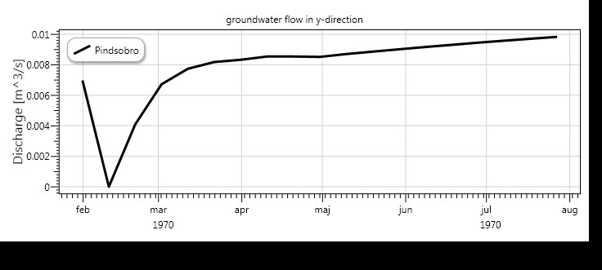

The tool is run from the command line and it is configured by providing an xml-file as argument, i.e. Dfs3plotdfs0.exe config.xml.

The xml-file has to have the elements shown below:

<?xml version="1.0" encoding="utf-8"?>

<Dfs3plotDfs0>

<SheFileName>..\..\Karup_Example_DemoMode.SHE</SheFileName>

<Dfs3FileName>..\..\Result Files\3DSZflow.dfs3</Dfs3FileName>

<ItemNumber>2</ItemNumber>

<TimeSteps></TimeSteps>

<WellNumbers></WellNumbers>

</Dfs3plotDfs0>

The SheFileName is the name and path of the she-file from which the wells should be written. The Dfs3FileName is the name and path of the dfs3-file from which the data should be extracted. This file has to have the same grid as Mike She simulation. The ItemNumber is the item that should be used. Note Item numbers counts from 1. In the TimeSteps element it is possible to provide specific time steps to extract data from. The following syntax can be used:

“0, 1, 5” = time steps 0, 1 and 5.

“” = all time steps.

“1-3, 7” = time steps 1, 2, 3 and 7.

In the WellNumbers-element specific wells can be selected for output using the same syntax as for the time steps. Note that Wells and Time steps count from 0.

# Dfs3PlotDfs2

This tool extracts two-dimensional data from Dfs3-files and outputs an ascii-grid and a contour plot in a jpg-file (see figure below). On the figure the extraction wells from a Mike She simulation is marked with circles.

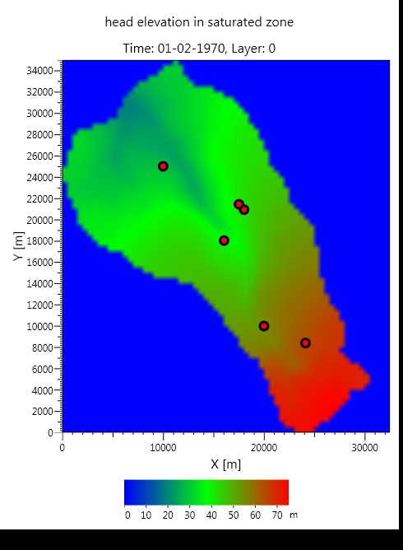

The tool is run from the command line and it is configured by providing an xml-file as argument, i.e. Dfs3plotdfs2.exe config.xml.

The xml-file has to have the elements shown below:

<?xml version="1.0" encoding="utf-8"?>

<Dfs3plotDfs2>

<SheFileName>..\Karup_Example_DemoMode.SHE</SheFileName>

<Dfs3FileName>..\Result Files\Karup_Example_DemoMode_3DSZ.dfs3</Dfs3FileName>

<ItemNumber>1</ItemNumber>

<TimeSteps>0</TimeSteps>

<Layers>0</Layers>

</Dfs3plotDfs2>

The syntax is the same as for the Dfs3plotdfs0 tool. Only in this tool the Layers should be provided. The bottom layer is number 0.