Framework for Distributed Semantic Web Crawler

 | Naresh Kumar |  |  | Manjeet Singh
AIIT, Amity University, Noida , India |  |  | YMCA University of Science & Technology,
naresh.dhull@gmail.com |  |  |  | Faridabad, India
 |  |  |  | mstomer2000@yahoo.com

Abstract: Relevant information retrieval from the www mainly depends on the technique and efficiency of a crawler. So crawlers must be capable enough to understand the text and context of a link which they are going to crawl. Anchor text contains a very useful information to know about the target web page. Because knowledge about the target web page content helps the crawlers to decide their preferences of crawling the particular page. In this paper we have presented a design of distributed semantic web crawler capable of crawling both HTML and semantic web pages written using owl/RDf. In our crawler a component called page analyser is used to understand the theme of content of page and context of anchor tag in the page. The output of the page analyser is used to make crawling decisions. Our approach have revealed the great improvement in extracting the information from the links and guide the crawler for more relevant domain specific crawling.

Keywords-Semantic Web, RDF, OWL, Semantic web Crawler, Distributed System

I. INTRODUCTION

With the advent of semantic web meaningful information extraction gained the popularity in the recent years. Semantic web which is a extension of current web enable the machines and human to work together [2].With the help of technologies like RDF and OWL information in the world wide web is represented in the form of ontologies. Moreover the semantic information is increasing at a fast pace on thetraditional web pages. To understand the meaning of anchor text in this paper we have used the Stanford Parser Based Approach for Extraction of Link- Context from Non-Descriptive Anchor-Text in our architecture. We have also used Jena framework to understand the semantic web pages, this framework create a model for the fetched OWL/RDF.The model created by jena is stored for later used to make advanced, quality related filtering, ranking and analysis of the collected semantic content contained in the OWL/RDF page, which is matched with the domain specific stored ontology to make the crawling decisions for semantic web pages. Rest of the paper is organized as follows: Related work is discussed in section 2.Section 3 described the proposed scheme in detail. In section 4 implementation is described with Conclusion and future work in section 5.

- But still most of the information is in the form of text in the traditional web. To navigate through the www links called as anchor text are also provided in natural language text in traditional web pages. So to make the search more relevant more efforts are required to understand the text data in the traditional web pages. Crawler is a program which extracts the web pages from the www web. If crawler is able to extract more relevant pages search engine is able to provide more relevant results to the user query. To crawl the relevant pages different architectures are developed for semantic web pages ontology based crawlers like [11, 10, 9, and 1] are developed. On the other hand to crawl relevant pages from traditional web, techniques of link context extraction has been used by many researchers [3, 4, and 5]. The context of link provides the semantic information related to target web page on that link so that decisions can be made based on that semantic information whether the target page is to be crawled or not. In this paper we have proposed and implemented the distributed semantic web crawler. Our crawler is able to crawl semantic as well as.

II. RELATED WORK

A continuous effort has been done by researchers to make the crawl more relevant pages. A Rule-Based Approach for Extraction of Link Context from Anchor-Text Structure has been used by authors in [3] they have used a rule based approach to extract the context of link using LR parser. In

- authors have used a finite state automata to recognize the named entities in a given text this system shows a great improvement for extracting named entities from the text of web page which can also be utilize for understanding the structure of anchor text. As major portion of the web pages on www contains the links on non-descriptive anchor text so authors in [5] have implemented an Stanford parser based approach for link context extraction of non-descriptive anchor text this approach provides a great help to crawlers who are making a blind search of links given on non-descriptive anchor text. Even this approach is appropriate for descriptive anchor text because it considers and analyse the text in the vicinity of anchor text to determine the context of the link. Various techniques of ontology based focussed crawlers were given by different authors [6,7,8,]. An ontology-focused crawler were proposed by [6] [7]. In their approach by using a domain specific ontology users can first define, crawling target to limit the crawling scope. Then focused crawler is used to retrieve the data from websites based on the ontology and crawling scope. Once the data is fetched relevancy is calculated between the ontological concepts and the crawled data by means of TF-IDF algorithm. In [8] the web pages are retrieved by linking them to topics by focused crawler. In this also terms of


978-1-5090-0076-0/15 $31.00 © 2015 IEEE | 1403
DOI 10.1109/CICN.2015.272

ontology is used to define each topic. Topical page rank algorithm [6] is used to compute relevance values between the terms and document texts for both global (the whole database) and local (the topic ontology) perspective. A pipeline architecture for crawling both traditional as well as semantic web pages is given by [9].The main goal of their pipelined architecture is to obtain large amounts of semi structured data from the web. Authors in [10] have proposed a methodology to extract Meta tags and metadata from web pages stored in knowledge base by using a web crawler.
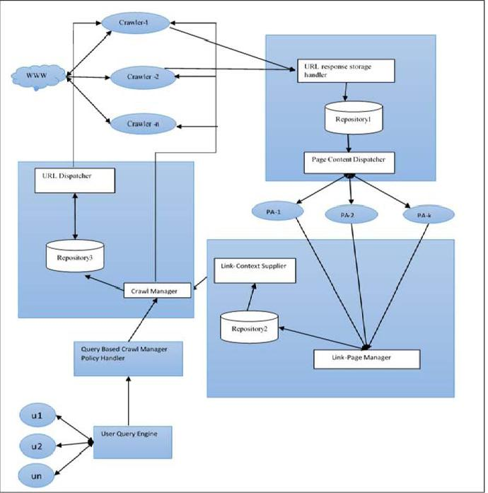

IIIIII FRAMEWORKFRAMEWORK OFOF DISTRIBUTEDDISTRIBUTED SEMANTICSEMANTI WEBWEB CRAWLERCRAWR..

Fig: 1

We have divided our system into six major components each component is implemented on a separate machine. This complete system works as client server architecture. All the different components can communicate with each other in a client server mode. When one component wants to communicate with other component a socket is created using ip address and port address of the machine running that component. Our proposed architecture consists of following components as shown in Fig: 1.

- Crawl Controller

- Crawler
- Page Manager
- Page Analyzer(PA)
- Analyzed page content supplier
- Query Based Crawl Manager Policy Handler

A. Crawl Controller

This component is responsible for maintaining all the crawl policies. It controls all the crawlers running and maintain
their states through message passing. Two main part of this component are:

1) Crawl Manager

The crawl manager is the main component for managing the policies for running the crawlers and page to be fetched. List of policies which are used by crawl manager are: (i) Where and when to start and stop a crawler.
Normally the crawler will start from the initial see pages. However, depending on the user queries sometimes it start with specific domain and from somewhere more central to the site.
(ii) Concurrent Pages
It is the number of pages crawler will crawl concurrently this number is also decided by crawl manager. (iii) Pause Between Pages
It is the waiting time a crawler must wait before moving to
next page.
(iv) Save Log
Maintain the state of all the crawlers. If any crawler stops in between start from the same point. (v) Context specific crawling

2) URL Dispatcher

This component is an interface between Repository 3 and various instances of crawlers. It provides a list of URLs as response to the request made by different crawlers.

B.Crawler

This is the second component of our distributed semantic web crawler. There are separate crawlers running on different machines they create a connection with crawl manager and page manager when they are started

1) World Wide Web

It is a global system of interconnected pages via hyperlinks based on Internet. It is a source of information for search engines. Search Engines download web pages from www which are then indexed.

2) Crawler

These components (each executing on separate machine) of our distributed search engine use input URLs to automatically download corresponding web pages from the Web. Individual instance of crawler starts with a set of seed URLs (for example, http: //www. yahoo. com). It makes a request to the server specified by a URL, and then downloads the corresponding page or receives an error. The downloaded pages or errors are then stored in a repository, a data structure shown in Repository 1 through an interface called URL Response Storage Handler (URSH) using client server architecture between crawler(as client) and URSH(as server). While designing the crawler instance, the scheduling policies are maintained by crawl manager. The crawler will crawl web pages as per the policy decided by Crawl Manager.

C. Page Manager

This component is responsible for responding the crawlers request to store the fetched page and then provide the stored content to page analyzer for further analysis. Two sub components of page manager are:

1) URL Response Storage Handler (URSH)

This sub component acts as interface between repository 1 (Table 1) and different instances of crawler. URSH receive request containing URL and corresponding page content form Crawlers and stores them in repository. The time of receiving page is also stored. If error are received then the status of errors are stored so that later the corresponding URL may be considered.

2) Page Content Dispatcher

This is the another sub component of page manager which is working as an interface between repository (Table 1) and instances of a component called Page Analyzer. It dispatch pages constituted at respective URLs to instances of Page analyzer.

D. Page Analyzer (Pa)

One instance of Page analyzer extracts links from the page content and their contexts using techniques based on statistical analysis and natural language processing. In our architecture of page analyzer for link context extraction we have used the technique of Stanford-Parser based approach for link context extraction of non-descriptive anchor text implemented by us in our previous research. The detail algorithm is given in next section. Page analyzer also extracts the theme of page. The separate instance of page Analyzer are executing on separate machine. This extracted information is stored in data structure shown in repository 2 through Link-Page Manager.

E. Analyzed Page Content Supplier

This component act as an interface between Page Analyzer and Crawl Manager. It receives the theme of the page and context of all the links in the page from Page Analyzer and provide the context to Crawl Manager through Link-Page Manager.

1) Link-page Manager

This component acts a interface between Page Analyzer and Repository 2 to store the extracted URLs from a page, their context, and the theme extracted from the page

2) Link-Context Supplier
It is an interface between repository 2 and Crawl Manager. This interface is passing URLs (Links) and context of URLs to Crawl Manager.

F.Query Based Crawl Manager Policy Handler
This component act as an interface between crawl manager and user queries so that crawl manager can decide the crawling policies based on user queries.
IV. PROPOSED SCHEME
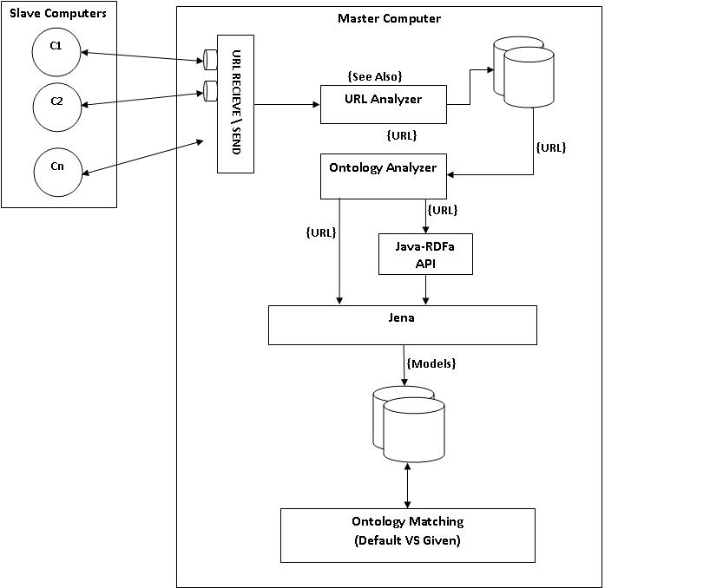

Fig:2

Crawler is the main component of any search engine because it is responsible for fetching the data from the World Wide Web and make it available for storing to indexer. If crawler is intelligent enough to make decisions whether the page it is going to crawl is relevant to its domain and can be used for indexing most of the problems of irrelevant search can be resolved and processing becomes faster. In our proposed scheme we try to implement a distributive semantic web crawler which makes its crawling decisions by understanding the concepts and context of links to be fetched so that it is able to avoid useless crawling of pages. In our scheme we have used an architecture of distributed web crawling, in which many independent machines are used to crawl, download, extract and index the semantic web via web crawling. We have developed a component called page analyser shown in fig 1.which is implemented on separate machine. It is responsible for analysing and extracting the links form the page sent by the crawler. It also verifies about the type of page if it is an OWL/RDF page the content is given to ontology analyser which using the Jena extracts the semantic information and creates a model to be stored in the database for further processing. If it is a html web page all the links will be extracted and stored in My Sql database to be used by link context extractor to extract the information from the all type of anchor text. The output of page analyser which is context and theme of all the links and text in the page is utilized by Link context manager. Link context manager works two folds it provide the links and context of links to Link
context supplier which is an interface between the crawl manager and Link context manager. Second Link context manager provide the theme of page to indexer for storing the semantic information. Mainly all the policies of our crawling framework is handled by crawl manager this component is responsible for managing all the crawler running on different machines. Our implemented architecture shows a great improvement for fetching the relevant pages. Also this due to distributed in nature it is robust kind of system which provides maximum reliability.

IV. IMPLEMENTATION

The system is implemented using Java as a front end and Oracle 11 I as backend. We also use Jena and Jsoup for model extraction of semantic web pages.Stanford parser based approach for link context extraction of Non-Descriptive anchor text is used for extraction of link context by page analyzer.

A. Crawl Controller
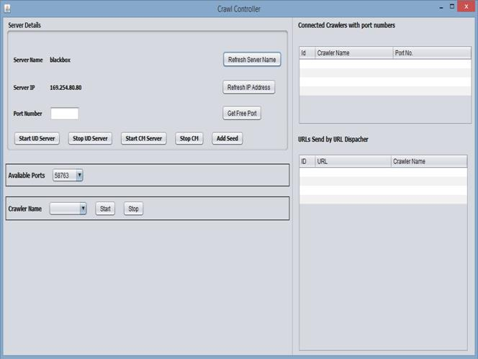
B. Crawler

Crawler Client connects to the server started by crawl manager and fetches the resources upon which model extraction is done.

C. Page Analyzer
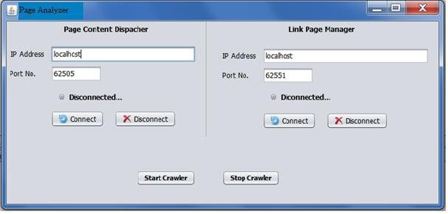

Fig: 3

1) Pseudo code for Crawl controller
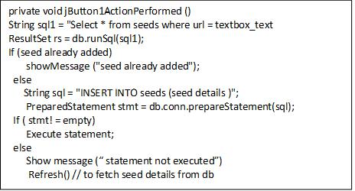

Fig: 4
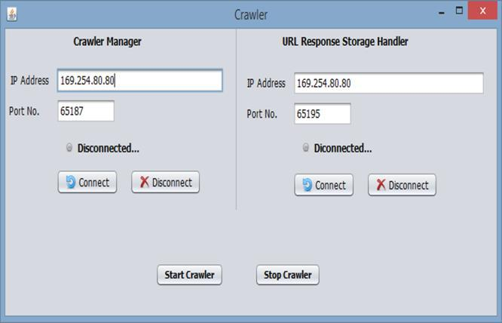

Fig: 7

The page analyzer acts as client for both page content dispatcher and link page manager. It extract hyperlinks from the RDF or HTML pages and extract models i.e. Subject Predicate and Object from the given page. To extract hyperlinks from the HTML PA use JSoup API in which it sees the HREF tag and extract the link. To extract hyperlink from the RDF and OWL PA uses JENA API.

1) Pseudo code for Model Extraction
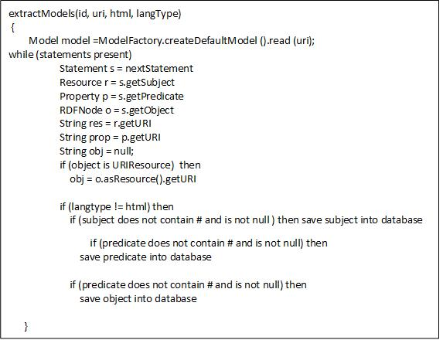

Fig: 8

2) Link Context Extraction Of The Anchor Text In The Page
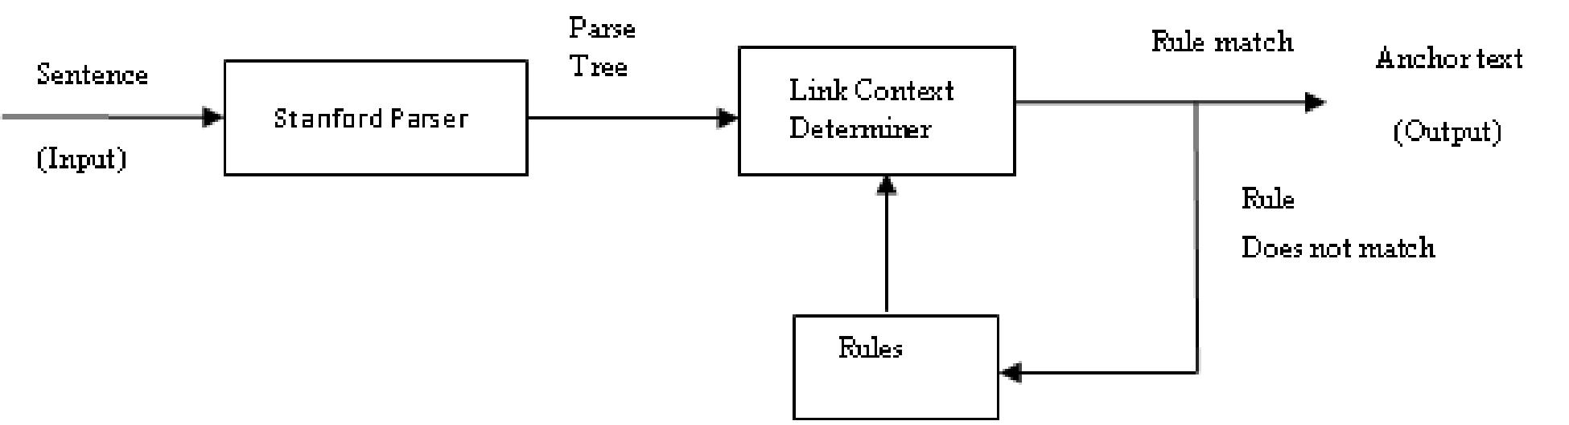

Fig: 10 [5]

For link context extraction we have used the technique given by us [5].All the links in the page and content of page is given to the SPLCA. The output of this SPLCA is given to the Link Page Manager.

D. Analyzed Page Content Supplier
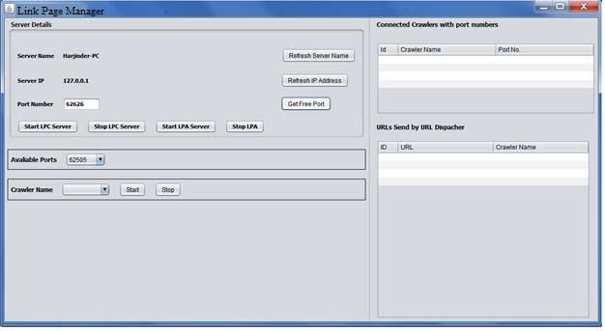

The Link page manager stores the URL or filter the URL which are ready to be fetched. The work of this controller is only to get data from multiple PAs and filters the URL and store them into database PA acts as client and LPM acts as server.

V. CONCLUSION AND FUTURE WORK.

In our distributed semantic web crawler we have designed and implemented a scheme of distributed semantic web crawling which is able to crawl pages from both traditional as well as semantic web. We try to make our architecture more robust and reliable by using a distributed computing architecture. We have used a scheme of SPLCA which help our crawlers to fetch more relevant information. Jena framework is also used so that pages written in RDF/OWL are easily handled by our system which can be later used to implement the ontology based crawling.
In this paper we have implemented distributed semantic web crawling using the link context of the anchor text in future work we further enhance this architecture for ontology based crawling also.

REFERENCES

- Slug: A Semantic Web Crawler Leigh Dodds, leigh@ldodds.com, February 2006

- T. Berners-Lee, J. Hendler, and O. Lassila. The Semantic Web. Scientific American, 284(5):34–43, 2001.

- ]. Suresh Kumar, Naresh Kumar, Manjeet Singh, Asok De “A Rule-Based Approach for Extraction of LinkContext from Anchor-Text

Structure” Intelligent Informatics Volume 182 of the series Advances in Intelligent Systems and Computing pp 261-271.

- Naresh Kumar, Manjeet Singh “Domain independent named entity recognition system based on finite state automata” ijacit Volume 2 Issue 4, 2013 - August Issue pp 77-87 .

- Naresh Kumar, Manjeet Singh “Stanford Parser Based Approach for Extraction of Link- Context from Non-Descriptive AnchorText” 978-1-4799-6896-1/14 ©2014 IEEE explore Reliability, Infocom Technologies and Optimization (ICRITO) (Trends and Future Directions), 2014.

  - M. Ehrig and A. Maedche, "Ontology-focused crawling of web documents," in ACM Symposium on Applied Computing (SAC 2003), Melbourne, 2003.

- M. Ehrig, A. Maedche, S. Handschuh, L. Stojanovic, and R. Volz, "Ontology-focused crawling of web documents and RDF-based metadata," in Intenational Semantic Web Conference 2002 (ISWC 2002), Sardinia, 2002.

- A. Ardö, "Focused crawling in the ALVIS semantic search engine," in 2nd European Semantic Web Conference (ESWC 2005), Heraklion, 2005.

- Anthoniraj Amalanathan, Senthilnathan Muthukumaravel “Semantic

Web Crawler Based on Lexical Database” IOSR Journal of Engineering Apr. 2012, Vol. 2(4) pp: 819-823

- Li Ding, Rong Pan, Tim Finin, Anupam Joshi, Yun Peng, and Pranam

Kolari “Finding and Ranking Knowledge on the Semantic Web” Proceedings of the 4th International Semantic Web Conference, Galway IE, November 2005, Springer-Verlag.

- MultiCrawler: A Pipelined Architecture for Crawling and Indexing Semantic Web Data

Andreas Harth, Ju¨rgen Umbrich, and Stefan Decker

- G.S. Tomar, S. Verma & Ashish Jha; “Web Page Classification using Modified naïve Baysian Approach”, IEEE TENCON-2006, pp 1-4, 14-17 Nov 2006

[13] Gautam Pant “Deriving Link-context from HTML Tag Tree” DMKD03: 8th ACM SIGMOD Workshop on Research Issues in Data Mining and Knowledge Discovery, 2003.

International Conference on Complex, Intelligent and Software Intensive Systems

PyThinSearch: A Simple Web Search Engine

Andri Mirzal

Graduate School of Information Science and Technology,
Hokkaido University, Kita 14 Nishi 9, Kita-Ku, Sapporo 060-0814, Japan

andri@complex.eng.hokudai.ac.jp

Abstract

We describe a simple, functioning web search engine for indexing and searching online documents using python programming language. Python was chosen because it is an elegant language with simple syntax, is easy to learn and debug, and supports main operating systems almost evenly. The remarkable characteristics of this program are an adjustable search function that allows users to rank documents with several combinations of score functions and the focus on anchor text analysis as we provide four additional schemes to calculate scores based on anchor text. We also provide an additional ranking algorithm based on link addition process in network motivated by PageRank and HITS as an experimental tool. This algorithm is the original contribution of this paper.

1. Introduction

Many papers written in the web information retrieval (IR) utilize their own web crawlers to crawl, index and analyze contents, hyperlink texts, and network structure of web pages, and sometimes also search functions to return the sorted relevant pages to users’ queries [1], [2]. Crawler and search function are considered to be the fundamental components of a search engine [3], and each has its own research challenges and problems.

Web crawler, also known as spider or robot, is the component that responsible to fetch pages, parse hyperlinks, manage crawl queue, and index pages’ contents. In a more sophisticated form, this component also implements politeness policies (for example obeying robot. txt instructions and not overloading servers with repetitive pages queries [3]—[5]), indexes anchor text [1], [6], decides in advanced which pages are spam [3], [7] or with different URLs but similar contents [7], [8] so that crawler can avoid downloading

these pages, and network bandwidth and processing resources can be saved.

The real working crawlers like Mercator [4], [9], Polybot [5], UbiCrawler [10], Googlebot [11], iRobot [7], and IRLbot [3] clearly are much more sophisticated than can be described here. Even though some of them provide good documentations on their designs and implementations [7], [11], the descriptions are still too general to make any reproduction efforts possible.
This is also true for second component, the search function. Starts with basic search facility, content-based scores which only index and search for Boolean matching between content of pages and queries, evolves to link analysis methods, like PageRank [11], HITS [12], and Salsa [13], and then also extends to more advanced methods like anchor text analysis [1], [14]—[18] and user-click behavior [6], [19]. Even though all of these methods are simply about how to find and rank the relevant pages according to the queries, the actual implementations of the algorithms, database designs, optimization issues, and memory management have already become too complex to deal with. This situation becomes even more difficult by the fact that web search engines are big businesses with very competitive nature, so that the designs and implementations of real web search engines remain closed.
978-0-7695-3575-3/09 $25.00 © 2009 IEEE | 1
DOI 10.1109/CISIS.2009.12

This is really a disappointing point in the open source era, where software should become tool to teach people and spread the knowledge without any restriction. Of course we can find chunk of codes that randomly shattered in web pages to construct our own system. And actually this effort can become easier because there are already good open source projects working on this field. Some notable projects are Lemur1 and Lucene2. But due to their complex designsand implementations, these projects are still not a good starting point.Here the importance of open source search engine project that the code and design are easy to understand is emphasized, because if learning is easy and fun the complex details can follow later. Also there are many occasions that we want to do something different than those already have done, like implementing new ranking algorithms, doing stemming on pages’ contents and hyperlinks texts, and using new methods in anchor texts analysis. All these require us to alter the existing codes and add new functions or modules to the source code.
To provide software that can satisfy the above mentioned conditions, we propose using search engine program written by Toby Segaran in his book, Programming Collective Intelligence [6]. This program is written in python, a free and open source script language that has been very popular recently due to its simple syntax and semantic, comprehensive libraries, and strong support for main operating systems. The program itself comprises of three classes, crawler, searcher and nn (neural network) class³. We will only use, improve and add new functionalities to crawler and searcher class because we are only interested in building search engine to crawl web pages and provide search function to the users, not in training the network with feedback from users (which requires user log dataset). Users who interested in implementing neural network are recommended to consult directly with the book [6] and a paper by Baeza-Yates et. al. [19] in which they used search log information to classify users’ queries.


Crawler Class
 |  | Users
 | Crawler | Queries | Results
Content, anchor text, | module | Porter
Content, anchor text, | Content and | Porter
and network structure | anchor text | stemmer | Ranking
information |  |  | Ranking
 | Porter | Query | module
 | stemmer | Query
 | stemmer | module
WWW |  | module
WWW |  |  | Searcher
 | Network | Database | Class
 | structure | Database
 |  | Content indexes
 |  | Anchor text indexes
 |  | Score indexes


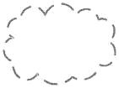

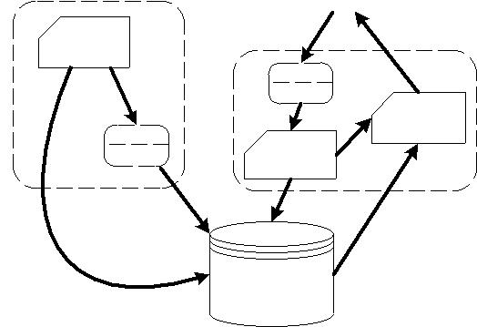
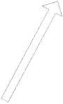

Figure. 1. The system design in top level view.

2. System overview

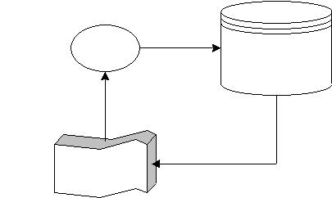
Figure 1 shows the overall design of the system which mostly inherits its structure from the original system, and figure 2 describes URLs queue management, where crawler downloads URLs from list in RAM, parses hyperlinks on pages, and sends it to disk. If the URLs are unique, they will be added to urllist table and then will be sent to the URLs queue in RAM. The following subsections describe the modifications to the original system.


 | Crawler | URLs | Disk
 |  |  | urllist
 |  |  | (rowid, url)
 | RAM | Unique URLs
 | URLs queue

Figure. 2. URLs queue management.

2.1. Improve the reliability of the crawling

In the original code, the crawler will attempt to open a URL in the URLs list (python set) provided by user. If it fails, the crawler will start with the next URL. The problem is even though the URL can be opened, it doesn’t mean that the content can be read. Further if the content can be read, sometimes the indexer functions in crawler class can fail to input the indexes into corresponding tables in database (see figure 3). In many cases, these errors can cause the program stops working, which is very inconvenient, because in web data mining the ability to continue crawling process by ignoring unreadable pages is an indispensable quality.

We overcome this shortcoming by simply introduce try-except statements for opening and reading URLs, and indexing processes which include content, anchor text, and network structure indexing (see figure 3). With this simply approach we were able to crawl web pages for three days without stopping and downloaded 74,243 pages (243 MB) from scholarpedia ⁴ in June 2008 using notebook with 1.86 GHz Intel processor, 2 GB RAM, and 100 Mbps (download speed: 53 Mbps and upload speed: 5.5 Mbps) Internet connection. Comparing to the original system, where the crawling will end immediately if there is an error in the process, this is a significant improvement.

We also add stop words according to English

- http://www.scholarpedia.org

standard stop words⁵ to reduce the size of database. But ‘computer’ term is eliminated from the list because we believe this term is meaningful in search purpose.

2.2. Add optional stemming function

We also add stemming function using porter stemmer algorithm⁶ [20] to both classes. Stemming is a process to reduce inflected or derived words into their stems. Stemming process frequently will improve the performance of an IR system, because words with the same stem usually have similar meaning. The stem itself need not to be the same with its morphological root, but a good stemming algorithm should return the same stem word for words that have the same morphological root. For example ‘navigational’, ‘navigation’, and ’navigate’ have morphological root ‘navigate’. If porter stemmer is used, ‘navig’ will be returned instead of ‘navigate’ for these words.

As shown in figure 1, the stemming function is located before contents and anchor texts enter the database in crawler class and before queries enter query module in searcher class. This procedure will ensure that all words in wordlist table (see figure 3 (a)) are saved in their stem forms, and all terms in queries will enter the query module also in their stem forms. One important thing to remember is, if crawling process is done with stemming function being activated, searching process must also be done with stemming function being activated.

2.3. Add new score functions

We incorporate some standard score functions that haven’t available in the original program. The first function is bm25score() that uses Okapi bm25 algorithm [21], an algorithm that calculates the frequency of appearance of query terms in the pages with assumption that each term is independent.

The second function is calculatelength() that creates pagelength table with urlid as the primary key and length of pages as the return values. This function scores pages based on their lengths where longer pages have higher scores than the shorter ones. Function that accesses pagelength table and returns length scores is lengthscore(). Note that this function not only returns pages that contain terms in query, but also pages that being linked by anchor texts which contain terms in

- http://www.dcs.gla.ac.uk/idom/ir_resources/linguistic_utils/stop_words
- http://tartarus.org/~martin/PorterStemmer/python.txt

query. We use this approach because anchor text is proven to be a good indicator about pages’ contents and behaves as a “consensus title” [18].

The third function is calculatehits() that calculates authority and hub scores of each page based on query-independent HITS [22 pp. 124—126], an algorithm that computes global authority and hub vector which slightly reduces the influence of link spamming. This function creates two tables, auth_hits and hub_hits for each urlid. Function authorityscore() accesses auth_hits table and return authority scores. Curious readers can also write a function similar to authorityscore() that returns hub scores by only change auth_hits with hub_hits statement (in real application hub scores are rarely being used to rank relevant pages).

The fourth function is calculatemyhits() that calculates authority and hub score of each page using proposed algorithm (see section 4). This function creates two tables, auth_myhits and hub_myhits for each urlid. Function myauthorityscore() accesses auth_myhits table and return authority scores.

And the last added score function is anchorscore(), a function with four optional schemes that returns relevant pages according to the frequency of appearance of query terms in the anchor texts linking to the pages. This is quite a new method and has been proved to be very effective in finding the relevant pages, especially if anchor model (scheme 4, the default scheme), proposed by Fujii, is used. The detail discussion and performance evaluation can be found in the author’s paper [17].

2.4. Organize the score functions into query-dependent and query-independent

Some scores are query-dependent, and some scores are query-independent so that can be calculated in advanced and stored in database. Generally, the former is content-based or anchor text-based scores, and the latter is link structure-based scores. However, lengthscore() is unique because it is actually a content-based score but its value is query-independent.The query-dependent functions can be changed into query-independent by passing string argument other than ‘qd’ into query() function in crawler class. The query() itself receives two arguments; the first is a query (string) and the second is type of scores, whether it is query-dependent or query-independent. The default value is ‘qd’ (query-dependent). See readme.txt

on the source code7 for more information.

2.5. Add additional indexes to linkword table

Because four additional schemes to calculate scores based on anchor texts [17] are implemented, it is inevitable to create new indexes for linkid and wordid column in linkword table to boost the performance of score functions that call entries on linkid and wordid. By using these indexes, the execution time for linkword related score functions, linktextscore() and anchorscore(), becomes 3-4 times faster.

3. Database design

There are 12 tables in the database which divided into three categories, content, anchor text, and score indexes tables. The shaded tables are the added tables. The content indexes tables are mainly used in content-based score functions, anchor text indexes tables are mainly used in anchor text based score functions, and score indexes tables are the tables that store query-independent scores.

The urllist table stores the crawled URLs in consecutive numbers based on the time they crawled. These numbers, rowids, are the identity numbers for corresponding urls. All other tables that utilize urls refer to rowids instead of directly using urls. The arrows from urllist to entries in others tables indicate that those entries are pointers to urls by using rowids of urllist table.

The same situation also goes to wordlist table, where its rowids are the identity numbers for corresponding words. And wordlocation table utilizes both urllist and wordlist to make a list of location of words in every page. The location itself is simply the order of word’s appearance on the page.

The link table stores network structure of crawled web pages. It is the table that link structure ranking algorithms use to calculate pages’ scores. The linkword table stores wordids of anchor texts of corresponding links. This table is used in the anchor text analysis and scoring, including linktextscore() and anchorscore() function.

All tables in score indexes store corresponding scores of every page in the collection. When a user inputs query, search function will call appropriate

- http://pythinsearch.googlepages.com/

score functions (based on predefined score functions combination) that utilize these tables. The third entries in auth_myhits, hub_myhits, and mypagerank, are constants that derived from our proposed algorithms.
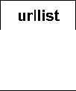
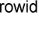
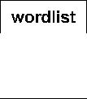
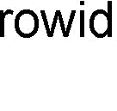
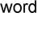
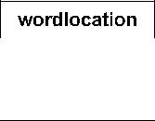
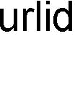
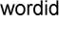
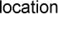
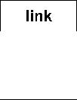
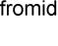
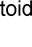
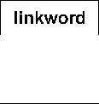
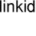
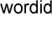
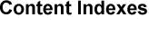
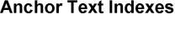
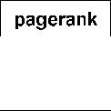
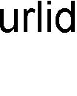
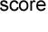
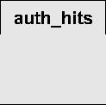
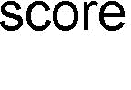
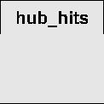
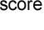
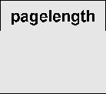
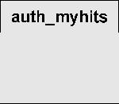
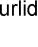
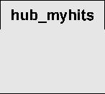
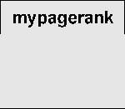
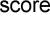
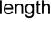
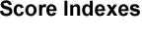
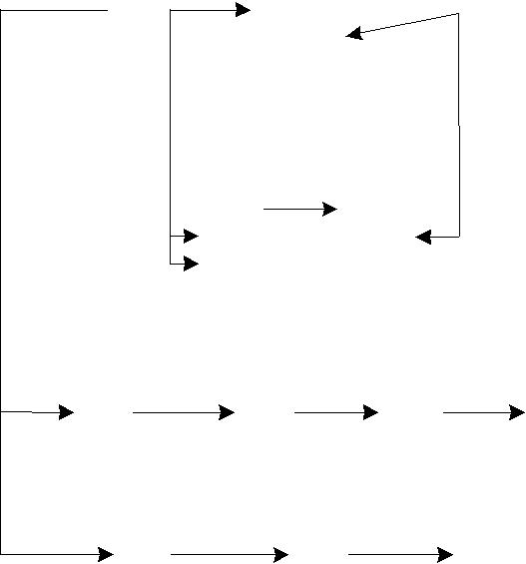

Figure. 3. Database structure.

4. Proposed algorithm

Proposed algorithm will be briefly discussed here. Further discussion can be found in [23], [24]. The development of the algorithm is motivated by the need to analyze trading network by using link structure ranking algorithm to cluster the most similar nodes. It is known that beside its function to determine degree of importance of the nodes, ranking algorithm can also be used to characterize the nodes and group them based on their similarity in characteristic vectors [25]. But before we point out the differences in the process of link addition between WWW network and trading networks, HITS, a ranking algorithm for WWW network, has been used to characterize users in e-commerce activities networks [25].

The process of link addition in network is the key to define ranking algorithms like PageRank [11], HITS [12], and SALSA [13]. By pointing out the differences between trading network and WWW network in this process, we are able to construct a new algorithm for trading network. The difference is: link addition in trading network is the exchange of two different resources between two nodes, on the other hand, in

4

r(n_{i} ) = β ∑(r(n _{j} ) × c_{a} (n _{j} )) + (1− β )∑(r(n _{j} ) × c_{h} (n _{j} ))

 |  |  | j→i |  |  |  |  |  |  |  |  |  | i→ j
where |  | ∑n _{j} inlinks
c_{a} (n _{j} ) = |  |  |  |  |  |  |  |  | ∑n _{j} inlinks − ∑n _{j} outlinks |  |  |  |  |  |  |  |  | p _{j}
 |  |  |  | × |  |  |  |  |  |  |  |  |  |  |  |  |  | ,
 |  | ∑n _{j} links
c_{h} (n _{j} ) = |  |  | ∑n _{j} outlinks |  |  | × |  |  |  |  |  | ∑ | n_{j} inlinks − | ∑ | n _{j} outlinks |  |  |  |  |  | − p _{j} | ,
 |  |  | ∑n _{j} links |  |  |  |  |  |  |  |  | ∑ |  | ∑
and

 | 1 | if ∑n _{j} inlinks > ∑n _{j} outlinks
 |  | if ∑ n _{j} inlinks < ∑n _{j} outlinks
p _{j} = -1
 | 0 | if | ∑ | n _{j} inlinks = | ∑ | n _{j} outlinks

r(n_{i}) denotes ranking score of node i, |*| denotes absolute value of *, i → j denotes node i links to node j, and ∑n_{j} inlinks / outlinks / links denotes number of inlinks / outlinks / links node j has. Parameter β (0.0 ≤ β = 0.5, if outlink is more important than inlink sets β < 0.5, and β > 0.5 otherwise.
As shown in eq. (1), r(n_{j}) is weighted with constant c_{a}(n_{j}) in the first term of right hand part, where the bigger the number of inlinks and the smaller the number of outlinks, the larger c_{a}(n_{j}) becomes. And in the second term, r(n_{j}) is weighted with constant c_{h}(n_{j}), where the bigger the number of outlinks and the smaller the number of inlinks, the larger c_{h}(n_{j}) becomes. Thus, the above equation agrees with proposed algorithm definition.
roposed algorithm for trading network can be stated with the following definition: a node becomes more important if being pointed to by others thaIn trading network, the resources are usually limited. Each node should be careful in creating and receiving new links. It is more preferable to create new outlinks to other nodes that are lack of resources and receive new inlinks from others that are plenty of resources, because creating outlinks means giving up resources and receiving inlinks means getting the resources.
t have many inlinks and points to others that have many outlinks. By comparing this statement with HITS definition, good authorities (nodes with many inlinks) are pointed to by good hubs (nodes with many outlinks) and good hubs point to good authorities, and its mathematical model [22 pp.115], proposed algorithm for trading network can be written as:β ≤ 1.0) is used to determine which type of link is more important. If outllink and inlink are equal sets

After ranking algorithm for trading network is defined, it can be translated to WWW network. Here we are only interested in creating algorithm based on the most famous one, HITS (actually algorithm based on PageRank is also constructed, but there is still convergence issue, so it hasn’t included in this paper yet although the code for it has already been included) and we call it modified HITS (in the code, function that implements it is calculatemyhits()).

Modified HITS algorithm is defined by restated HITS definition (shown above) in the style of proposed algorithm definition for trading network, a node becomes more important if being pointed to by others that have many outlinks (good hub) and points to others that have many inlinks (good authorities). This is our modified HITS definition for WWW network, and it can be shown that this statement is actually opposite to proposed algorithm definition for trading

- network, and can be written as:
r(n_{i} ) = α ∑(r(n _{j} ) × c_{h} (n _{j} )) + (1− α )∑(r(n _{j} ) × c_{a} (n _{j} )) |  | (2)
j→i | i→ j

Parameter α (0.0 ≤ α ≤ 1.0) is used to determine which type of link is more important. If outllink and inlink are equal sets α = 0.5, if outlink is more important than inlink sets α > 0.5, and α < 0.5 otherwise.

We will rewrite eq. (2) in matrix form for three reasons. First, it will allow us to see the network’s property from linear algebra perspective. Second, in

5

the very large network, the only visible method to compute r(n_{i}) is by using power method that applied to the adjacency matrix of the network [22 pp.40—41] (power method finds r(n_{i}) by calculating dominant left-hand eigenvector of network’s adjacency matrix). And third, in some programming languages that work on matrix like MATLAB, it is easier to write codes in matrix form.

In matrix form eq. (2) can be rewritten as:

r⁽ ^{k+1)T} = r^{(k} ^{)T} (αC_{h} L + (1− α )C_{a} L^{T} ) | (3)

where L is adjacency matrix of the network, C_{h} = K⁻¹D⁻¹D_{o}, C_{a} = KD⁻¹D_{i}, and k = 0, 1, 2, ... is iteration number. Diagonal matrices D_{i}, D_{o} and D are defined as:

D_{i} = diag(d_{i} ), D_{o} = diag(d_{o} ), and D = D_{i} + D_{o} | (4)

Table 1. Ranking algorithms summary.

Method | Authority |  | Hub
PageRank | _{pr}(k +1)T = _{pr}(k )T _{Do}−1_{L} |  | -
HITS | _{a}(k+1)T | ₌ _{h}(k )T _{L} | _{h}(k +1)T ₌ _{a}(k +1)T _{L}T
Proposed Algorithm | _{a}(k+1)T | = h^{(k} ^{)T} C_{h}L | _{h}(k+1)T ₌ _{a}(k+1)T _{CaL}T

Table 2. Needed costs per iteration.

Method | Multiplication | Addition
PageRank | N | nnz(L) + N
HITS | N | 2nnz(L) + N
Proposed Algorithm | 3N | 2nnz(L) + N

Table 3. Memory requirement.

Method | Memory
PageRank | nnz(L) + N integers
HITS | nnz(L) integers and N doubles
Proposed Algorithm | nnz(L) integers and 3N doubles

and K is a diagonal matrix with diagonal entries
defined as:
^{K}ii ⁼ |  | (^{D}i ⁻ ^{D}o )ii |  | p_{i} | (5)
given i_{i} = ∑_{j} L_{ji} is indegree of node i, o_{i} = ∑_{k} L_{ik} is
outdegree of node i, d_{i} = (i₁, i₂, …, i_{N})^{T} is inlink vector,
and d_{o} = (o₁, o₂, …, o_{N})^{T} is outlink vector of the
network.
Because in HITS authority and hub vector have
different role (authority scores are usually used to
describe the degree of importance of pages, and hub
scores are usually used to find portal pages, pages that
link to important pages), eq. (3) will be rewritten to
separate these vectors. The modified HITS can be
defined as:
_{a}(k +1)T = _{h}(k )T _{Ch} _{L} |  |  |  |  | (6)
for authority vector, and
_{h}(k +1)T = _{a}( k+1)T _{Ca} _{L}T |  |  |  |  | (7)
for hub vector.
Table 1 summarizes the algorithms, table 2 and 3
give the approximation of cost and memory
requirement respectively. Here nnz(L) is the number of
nonzeros in L.

5. Experiment results
Experiments are conducted to inspect the performance and characteristic of search function part,because this is where our main contributions to theoriginal system lie. First convergence rates ofPageRank, HITS (authority), and proposed algorithm(authority), are compared by using two datasets,wikipedia3 (number of pages: 10,431 and links:46,152) and scholarpedia (number of pages: 74,243and links: 1,077,781).As shown in figure 4, PageRank is the fastest toconverge followed by proposed algorithm and thenHITS. But in figure 5, PageRank is the slowest,followed by HITS and then proposed algorithm. Theseare actually twisted results because many HITS experiments have shown that HITS requires many fewer iterations than PageRank (less than quarter to reach the same error rate and about twice as long per iteration [22 pp. 126]). So only in the second dataset, our results agree with previous experiments. The most interesting fact is, for both datasets, proposed algorithm takes fewer iterations than HITS(about half) and faster (about 70%) to reach the same error rate. Unfortunately, these results are not conclusive yet, because we only tried it in the relatively small datasets. And second, by using the same datasets, similarities between ranking vectors are also calculated. Table 4, 5, and 6 show the results in cosine, Spearman correlation coefficient and Kendall’s Tau criterion (P is PageRank,H is HITS, M is modified HITS (proposed algorithm), and I is indegree of a page). Indegree is added because

this parameter is the simplest indicator in measuring popularity of a page.
In wikipedia dataset, proposed algorithm is most similar to HITS followed by indegree and then PageRank. And for Spearman and Kendall’s Tau criterion, proposed algorithm gives small negative correlations with PageRank. The situation is almost the same to the second dataset, scholarpedia, where proposed algorithm is least similar to PageRank and quite similar to HITS and indegree.

 | 10⁴ |  |  | http://en.wikipedia.org/
 | 10³ |  |  |  |  |  |  | PageRank
 |  |  |  |  |  |  |  | HITS
 | 10² |  |  |  |  |  |  | Proposed Algorithm
scale) | 10¹
scale) | 10⁰
(log | 10⁻¹
Error | ₁₀-2
Error | -3
 | 10
 |  |  |  |  |  | 108 s |  |  |  | 152 s
 | ₁₀-4 |  |  |  |  | 108 s
 | 10⁻⁵ |  |  | 42 s
 | ₁₀-6 | 2 | 4 | 6 | 8 | 10 | 12 | 14 | 16 | 18 | 20
 | 0
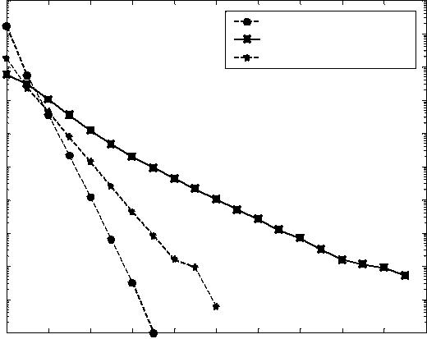
Iterations

Figure. 4. Convergence rate and time to reach error rate 10⁻⁴ for wikipedia dataset.

10⁶ | http://www.scholarpedia.org/
 |  | PageRank
10⁴ |  | HITS
10⁴ |  | Proposed Algorithm
scale)
10²
(log
10⁰
Error
10⁻²
10⁻⁴
 | 678 s | 917 s | 1517 s
10⁻⁶ | 678 s
10⁻⁶ | 5 | 10 | 15
0 | 5 | 10 | 15
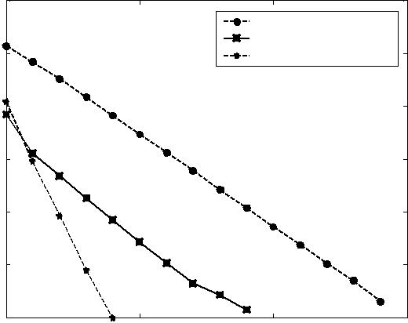
Iterations

Figure. 5. Convergence rate and time to reach error rate 10⁻⁵ for scholarpedia dataset.

Spearman and Kendall’s Tau criterion calculate similarity of two vectors based on ranking of vector’s entries, whereas cosine criterion is based on ranking scores. Thus, in the case of web pages ranking where the scores from link structure ranking algorithms will be combined with other scores (content scores and anchor text scores) to form final scores, the better measurement is cosine criterion because it calculates

the similarity of ranking scores, not the ranking itself.

Table 4. Cosine criterion.

Wikipedia dataset

 | P | H | M | I
P | 1 | 0.52 | 0.61 | 0.50
H | 0.52 | 1 | 0.84 | 0.95
M | 0.61 | 0.84 | 1 | 0.76
I | 0.50 | 0.95 | 0.76 | 1
 | Scholarpedia dataset
P | 1 | 0.98 | 0.86 | 0.98
H | 0.98 | 1 | 0.89 | ≈1
M | 0.86 | 0.89 | 1 | 0.88
I | 0.98 | ≈1 | 0.88 | 1

Table 5. Spearman criterion.

Wikipedia dataset

 | P |  | H | M | I
P | 1 | 0.28 |  | -0.31 | 0.68
H | 0.28 | 1 |  | 0.56 | 0.73
M | -0.31 | 0.56 |  | 1 | 0.55
I | 0.68 | 0.73 |  | 0.55 | 1
 | Scholarpedia dataset
P | 1 |  | 0.61 | -0.21 | 0.66
H | 0.61 |  | 1 | 0.41 | 0.90
M | -0.21 |  | 0.41 | 1 | 0.57
I | 0.66 |  | 0.90 | 0.57 | 1

Table 6. Kendall’s Tau criterion.

Wikipedia dataset

 | P |  | H | M | I
P | 1 | 0.19 |  | -0.32 | 0.52
H | 0.19 | 1 |  | 0.42 | 0.58
M | -0.32 | 0.42 |  | 1 | 0.37

I | 0.52 | 0.58 |  | 0.37 | 1
 | Scholarpedia dataset
P | 1 |  | 0.46 | -0.22 | 0.50
H | 0.46 |  | 1 | 0.30 | 0.83
M | -0.22 |  | 0.30 | 1 | 0.41
I | 0.50 |  | 0.83 | 0.41 | 1

6. Discussion and future researches
The main modifications we did in the original code are in the search function. The crawler part is almost unchanged (even though many additional functions are located in crawler class, they are unrelated to crawling process). As noted in the introduction, each of these has already become sophisticated research field which requires expertise in order to improve the system. Readers who have read the original documentation would notice that the crawling method used is breadth first search without politeness policies (for example, obeying robot.txt and controlling access to the servers), spam pages detection, priority URLs queue, and good memory management plan to divide disk and RAMload for list of next URLs to be downloaded. Without good memory management, all of URLs seen tasks are done by looking urllist table in the disk which is very time consuming. We will address the crawler design problem in the future researches.

As shown in figure 4 and 5, proposed algorithm seems to have interesting properties so that it can beat query-independent HITS in both required iteration number and needed time to reach the same error rates. At this time the explanation we have is, the introduction of constant c_{a} and c_{h} makes an authoritative node becomes more authoritative and a “hubby” node becomes more “hubby”. Consequently the iterations converge faster. Because these are interesting results, we will also address it in our future researches.

There is no single best way to choose the combination of score functions and their weights. Users are encouraged to experiment with their own databases. But perhaps some guidelines here can be considered. For example if database contains set of pages that linked by very descriptive anchor texts, like documents from online encyclopedia, linktextscore() and anchorscore() can be given relatively strong weights. And because authors can easily create pages with many occurrences of keywords, frequencyscore() and bm25score() will give misleading results in this situation, so their weights must be set smaller compare to more reliable content-based metric, locationscore().

7. References

- T.G. Kolda, B.W. Bader, and J.P. Kenny, “Higher-Order Web Link Analysis Using Multilinear Algebra,” in Proc. 5th IEEE International Conference on Data Mining, 2005, pp. 242—249.

- C. Ding, X. He, H. Zha, and H. Simon, “PageRank, HITS, and A Unified Framework for Link Analysis,” in Proc. 25th ACM SIGIR Conference, 2002, pp. 353—354.
- H.T. Lee, D. Leonard, X. Wang, and D. Logulnov, “IRLbot: Scaling to 6 Billion Pages and Beyond,” in Proc. 17th International WWW Conference, Beijing, 2008, pp. 427—436.
- A. Heydon and M. Najork, “Mercator: A Scalable, Extensible Web Crawler,” World Wide Web, vol. 2, no. 4, 1999, pp. 219—229.
- V. Shkapenyuk and T. Suel, “Design and Implementation of a High-Performance Distributed Web Crawler,” in Proc. IEEE ICDE, 2002, pp. 357—368.
- T. Segaran, Programming Collective Intelligence: Building Smart Web 2.0 Applications, O’Reilly Media Inc., 2007, pp. 49—52.
- R. Cai, J.M. Yang, W. Lai, Y. Wang, and L. Zhang, “IRobot: An Intelligent Crawler for Web Forums,” in Proc. 17th International WWW Conference, 2008, pp. 447—456.
- Z. Bar-Yossef, I. Keidar, and U. Schonfeld, “Do Not Crawl in the DUST: different URLs with similar text,” in Proc. 16th International WWW Conference, 2007, pp. 111—120.

- M. Najork and A. Heydon, “High-Performance Web Crawling,” Compaq Systems Research Center, Tech. Report 173, 2001.

- P. Boldi, M. Santini, and S. Vigna, “UbiCrawler: A Scalable Fully Distributed Web Crawler,” Software, Practices & Experience, vol. 34, no. 8, 2004, pp. 711—726.

- S. Brin and L. Page, “The Anatomy of a Large-scale Hypertextual Web Search Engine,” Computer Networks and ISDN Systems vol. 33, 1998, pp. 107—117.
- J. Kleinberg, “Authoritative Sources in A Hyperlink Environment,” Journal of the ACM vol. 46, 1999, pp. 604—632.
- R. Lempel and S. Moran, “SALSA: The Stochastic Approach for link-structure analysis,” ACM Trans. Inf. Syst., vol. 19, 2001, pp. 131—160.
- N. Craswell, D. Hawking, and S. Robertson, “Effective Site Finding using Link Anchor Information,” in Proc. 24th Annual International ACM SIGIR Conference on Research and Development in Information Retrieval, 2001, pp. 250—257.

- T. Westerveld, W. Kraaij, and D. Hiemstra, “Retrieving Web pages using Content, Links, URLs and Anchors,” in Proc. of the 10th Text Retrieval Conference, 2001, pp. 663—672.
- K. Yang, “Combining Text- and Link-based Retrieval Methods for Web IR,” in Proc. 10th Text Retrieval Conference, 2001, pp. 609—618.
- A. Fujii, “Modeling Anchor Text and Classifying Queries to Enhance Web Document Retrieval,” in Proc. 17th International World Wide Web Conference, 2008, pp. 337—346.

- N. Eiron and K.S. McKurley, “Analysis of Anchor Text for Web Search,” in Proc. ACM SIGIR, 2003, pp. 459—460.
- R. Baeza-Yates, L. Calderon-Benavides, and C. Gonzales-Caro, “The Intention Behind Web Queries,” in Proc. 13th International Conference on String Processing and Information Retrieval, 2006, pp. 98—109.

- C.J. van Rijsbergen, S.E. Robertson, and M.F. Porter, “New Models in Probabilistic Information Retrieval,” British Library Research and Development Report, No. 5587, 1980.
- K.S. Jones, S. Walker, and S.E. Robertson, “A Probabilistic Model of Information Retrieval: Development and Comparative Experiments,” Information Processing and Management vol. 36, 2000, pp. 779—840.

- A.N. Langville and C.D. Meyer, Google’s PageRank and Beyond: The Science of Search Engine Rankings, Princeton University Press, 2006.
- A. Mirzal, “Link Structure Ranking Algorithm for Trading Network,” in Proc. International Conference on Complex, Intelligent and Software Intensive Systems, 2009.

- A. Mirzal, “The Development of Link Structure Ranking Algorithms and Clustering Methods for Networks,” Master Thesis, Grad. School of Inf. Sci. and Tech., Hokkaido Univ., Japan, 2008, pp. 9—33.

- Y. Kawachi, S. Yoshii, and M. Furukawa, “Labeled Link Analysis for Extracting User Characteristics in E-commerce Activity Network,” in Proc. IEEE/WIC/ACM International Conference on Web Intelligence, 2006, pp. 73—80.

2015国际计算智能与通信网络会议
分布式网页爬虫框架
库马尔
AIIT，阿米提大学，诺伊达，印度
邮箱：naresh.dhull@gmail.com
辛格曼基
基督教青年会科技大学，
法里达巴德,印度
邮箱: mstomer2000@yahoo.com

摘要
从万维网中检索相关信息的快慢取主要决于爬行器的技术和效率。所以爬虫程序必须有足够的能力来理解文本和它们要抓取的链接的上下文。锚文本包含关于非常有用的网页信息，这种页面众所周知，叫作目标网页。由于了解目标网页内容有助于爬行器决定它们特定的首选爬行页面。所以在本文中，我们将会介绍了一种能够实现分布式语义网页爬虫的设计，这个设计使用超文本标记语言和语义网络页面进行爬取,这种语义web页面在书面上叫作“OWL/ RDf”。在我们的爬虫程序中有一个叫做页面分析器的组件，它用于了解网页内容的主题和上下文页面中的锚标记。更具页面分析器的输出来做出爬行决策。我们的方法在链接中提取信息方面有了很大的改进，并且你能够引导爬虫获取更多相关的特定领域信息。
关键词：语义web；RDF；OWL；语义网络爬虫；分布式系统；

一、简介
近年来， 随着网络中有价值的信息出现，萃取得到了广泛的应用。语义web是当前web enable机器和人一起工作的扩展。借助RDF和OWL信息等技术，万维网以本体的形式表示。此外语义信息正以较快的速度在万维网上增长。但大多数信息在传统网络中仍然是文本形式。浏览万维网链接（这种连接也叫锚文本）在自然语言中也提供了的传统的web页面文本。所以要做更多的搜索引擎需要作出更多的努力来理解在传统网页中的文本数据。爬虫是一个从万维网中提取信息的程序，如果爬行器可以的话，搜索引擎能够提取更多相关页面为用户查询提供更多相关的结果。为了爬取语义web页面本体，与之相关页面的不同体系结构的爬虫被开发了出来。 另一方面由于与爬取的相关网页来自传统网页，萃取上下文链接的技术也已经被许多研究人员使用[3,4,5]。链接的上下文提供与语义信息有关目标网页链接，这可以让我们从语义信息入手从而决定目标页是否被抓取。在这篇论文中提出并实现了分布式语义web爬虫。我们的爬虫程序能够抓取语义页面以及传统的web页面。在本文中为了理解锚的含义，我们使用了基于斯坦福语法分析器的文本非链接上下文的提取方法。我们也使用Jena框架来理解语义web页面，这个框架为获取的对象创建一个OWL/ RDF模型。jena创建的模型将存储到后面用于制作高级，质量相关的过滤，排名和所收集的语义内容的分析OWL/RDF页面。它与特定的域进行匹配，存储本体来语义并做出爬行web页面的决策。论文其余部分组织如下:相关工作将在第2节中讨论。第三节描述详细介绍了所提出的方案。在第4节实施中。第5节给出了结论和未来的工作。

二、工作叙述
相关工作研究人员已经做出了不懈的努力来抓取更多相关页面。基于规则从锚文本结构中提取链接上下文的方法在[3]中，作者使用的是基于规则LR解析器的方法提取链接上下文。在[4]中作者使用有限状态的自动机来识别在给定文本中的命名实体，本系统显示了一个很好的在文本中提取命名实体的改进网页，这样可以理解锚文本的结构。在[5]中万维网上的网页的主要部分包含非描述性锚文本上的链接。作者实现了一个基于Stanford的解析器，即非描述性链接上下文提取方法。这种方法为爬行器做一个盲目搜索的链接并给使用非描述性的锚文本的人提供了很大的帮助。甚至这种方法也是合适的，因为它对描述性锚文本进行了思考和分析。文本中是在在锚文本附近确定链接的上下文。在 [6][7]中提出了一种基于本体的各种技术，它是面向本体的爬虫。在他们的方法中，使用领域特定的本体用户可以先定义爬行目标，限制爬行范围。然后基于本体和爬行范围使用聚焦爬虫检索数据网站。每一次获取的数据之间的相关性是通过计算本体论的概念和用TF-方法抓取的数据IDF算法得到的。在[8]中，通过链接检索web页面以及通过有重点的爬行器将它们转换为主题。也可以把本体用于定义每个主题。局部网页排名算法[6]用于计算之间的术语和文档文本均为全局(整体)数据库)和本地(主题本体)透视图的相关值。一个管道架构的爬行，无论是传统的，以及语义web页面都由[9]给出。他们流水线结构的主要目标是为了获得大量来自web的结构化数据。[10]的作者提出使用web爬虫程序从web中提取元标记和元数据的方法，这种方法将提取的页面存储在知识库中。

三、分布式语义框架
图1如下：

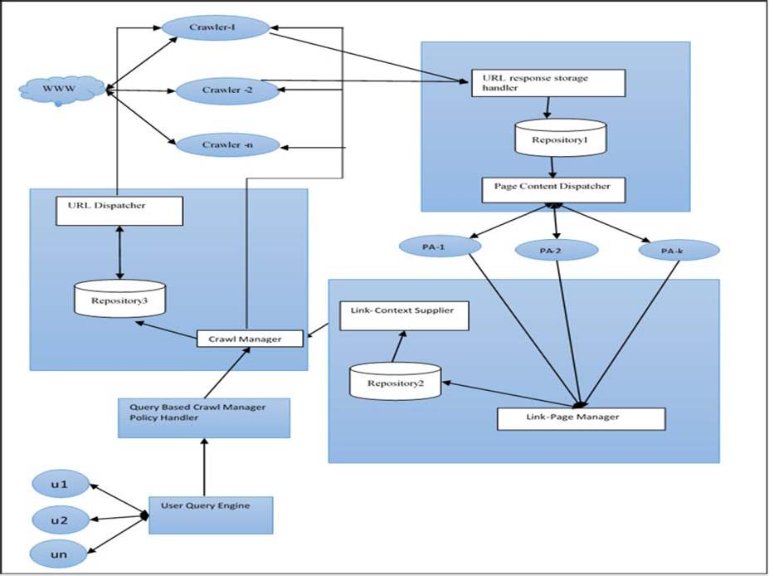

我们把系统分成六个主要组件，每一个部分组件在单独的机器上实现。这个完整的系统作为客户端服务器体系结构工作。所有的不同的组件可以在a中采用客户端服务器模式相互通信。当一个组件想要与其他组件通过创建套接字通信时，可以使用该组件中正在运行的机器的ip地址和端口地址。我们提出的体系结构由以下部分组成
如图1所示。

1. 爬控制器

2. 爬行者

3.页面管理

4. 页分析器(PA)

5. 分析页面内容供应商

6. 基于查询相关的爬虫管理器策略处理程序

A.爬控制器
此组件负责维护所有爬行策略。它是一个通过消息传递它们的状态来控制所有运行和维护的爬行器。其中有两个主要部分.
组件包括:
1)爬行管理器
爬行管理器管理运行的爬行器和获取爬行页面的策略。列表爬虫管理器使用的策略包括:
(i)何时何地启动和停止爬行器。
通常爬虫程序将从最初的可见页面开始。然而，根据用户的查询，有时它会启动特定的领域，从某个最中心的地方进入该网站。
(2)并发页面
它是爬行器将同时爬行的页面数，这个数字也是由爬行管理器决定的。

(三)页与页之间停顿
这是爬行器在移动之前必须等待下一个页面的时间。

(iv)保存日志
维护所有爬行器的状态。如果有爬虫进来从同一点开始就进行上下文特定的爬行。

2)URL调度员
这个组件是仓库，存储了接口爬虫程序的各种实例。它提供了一个url列表来响应不同爬虫程序的请求。

B.Crawler
这是分布式语义的第二个组成部分，网络爬虫。独立的爬行器在不同的机器上运行，并创建连接。
管理器和页面管理器

1)万维网
它是一个基于互联网的通过超链接连接页面的全球系统。它是搜索信息的来源引擎。搜索引擎从www下载网页，然后索引它们。

2)爬行者
我们分布式搜索引擎的这些组件(每个组件在单独的机器上执行，从输入url到自动下载相应的网页都能够实现。爬虫程序的单个实例从一组url(例如，http: //www)。雅虎。com)种子开始。它让一个服务器指定一个url请求，然后下载相应的页面或接收错误。下载的页面或错误随后存储在存储库中，然后通过接口显示在仓库 1中的数据结构中。
这个收藏库使用客户端调用URL响应存储处理程序(URSH)以及爬虫程序(作为客户机)和URSH(作为
服务器)。在设计爬虫程序实例时，调度策略由爬行管理器维护。爬虫程序将按照爬虫管理器所决定的策略抓取web页面。

C.页面管理
这个组件负责响应爬行器请求并存储获取的页面，然后将自已存储的页面内容放到页面分析器进行进一步分析。
两个页面管理器的组件包括:

1) URL响应存储处理程序(URSH)
这个子组件充当仓库1之间的接口(表1)和爬虫程序的不同实例。URSH接收包含的URL和相应页面内容相关的请求表单爬虫程序，并将它们存储在存储库中。在这段时间内接收的页也被存储。如果接收到错误，则
存储错误状态，以便以后处理这些错误的url。

2)页面内容调度器
这是页面管理器的另一个子组件,它是一个工作在存储库(表1)和被称为Page Analyzer的组件的实例之间的接口。它分派页面实例上相应的url便于构建页面分析。

D. Page Analyzer (Pa)
页面分析器的一个实例使用基于统计分析和自然语言处理从页面中提取链接内容及其上下文。我们介绍了一种用于链接上下文提取的页面分析器相关的体系结构，它使用了基于斯坦福解析器的方法用于非描述性锚文本的链接上下文提取，由我们在之前的研究中实现。细节算法在下一节给出。页分析器还
提取页面主题。页面的单独实例分析仪在单独的机器上执行。这个通过链接页面的管理器提取信息将存储在仓库2，repository 2显示的数据结构中。

E.分析页面内容供应商
该组件充当页面分析器之间的接口和爬行管理器。它接收页面的主题和页面中所有链接的上下文从而提供上下文来通过链接页抓取。

1)链接页面管理
该组件充当页面分析器和仓库2 Repository 2之间的接口实例，用于存储从页面中提取的url，上下文，以及从页面中提取的主题。

2)Link-Context供应商
它是仓库2 repository 2和爬行管理器之间的接口。这个接口传递url(链接)和url上下文爬的管理器。
F基于查询的爬网管理器策略处理程序
此组件基于用户查询的爬行策略充当爬行管理器之间的接口和用户查询实例，从而辅助爬行管理器做出决策。

四、方案提出
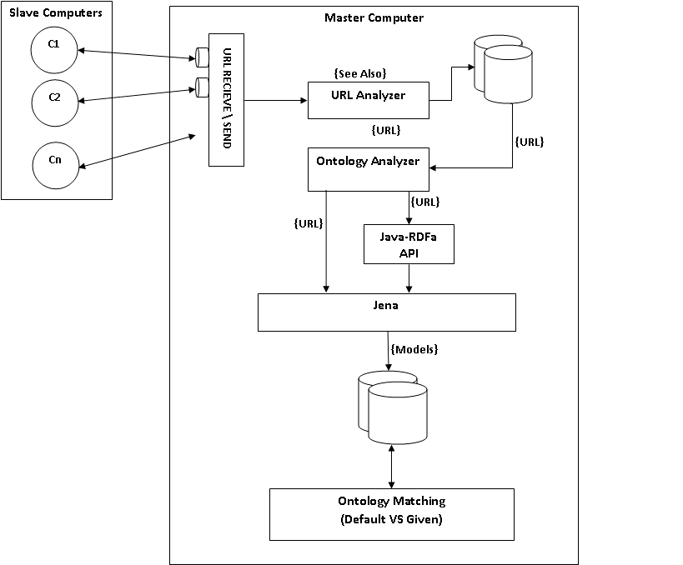
图二

爬虫是任何搜索引擎的主要组件，因为它负责从网络世界抓取数据并使其可存储到索引器。如果爬虫有足够的智慧来决定它要抓取的页面是否与其相关，那么它就可用于解决这种索引不相关的问题，因而处理的过程变得更快。在我们提出的方案中，我们试图实现分布式网络爬虫，通过理解链接的概念和上下文做出决策让这个爬虫实现其爬行，使它能够避免无用的爬行页面。在我们的方案中，我们使用了分布式网页爬虫，其中许多是独立的机器用于抓取、下载、提取和索引。
通过网页爬虫爬行实现理论上的爬行。我们开发了一个组件称为页面分析器，如图1所示。这是在多台独立的机器上实现的。它负责分析和提取网页链接并发送给爬行器。如果页面类型为OWL/RDF页面，内容将提供给本体分析器，这个分析器，使用Jena提取语义信息和创建要存储在数据库中的信息，以供进一步使用的模型处理。如果它是一个html网页，所有的链接将提取并存储在mysql数据库中，供链接文本提取器从所有锚文本类型中提取信息。页面分析器的输出，即在页面中上下文和主题的相关的所有链接和文本都将被使用来联系上下文管理器。链接上下文管理器工作有两个层次，它为链接供应商提供链接和上下文链接。链接供应是爬行管理器和链接上下文管理器之间的接口。第二个链接上下文管理器将网页的主题提供给索引器以存储语义信息。我们爬虫框架的主要策略是由爬行管理器处理。这个组件责管理所有运行在不同的机器上的爬虫程序。我们在获取相关页面方面实现了一个很好的体系结构，这是一个巨大的进步。这也是因为它在自然界的分布方面提供最大可靠性的，是一个鲁棒系统。

五、实现
该系统使用Java作为前端，Oracle11 I 作为后端。我们还使用Jena和Jsoup
模型提取理论上的网页。
我们使用斯坦福大学的非链接上下文提取的方法让解析器提取网页链接内容。

A:爬虫控制器
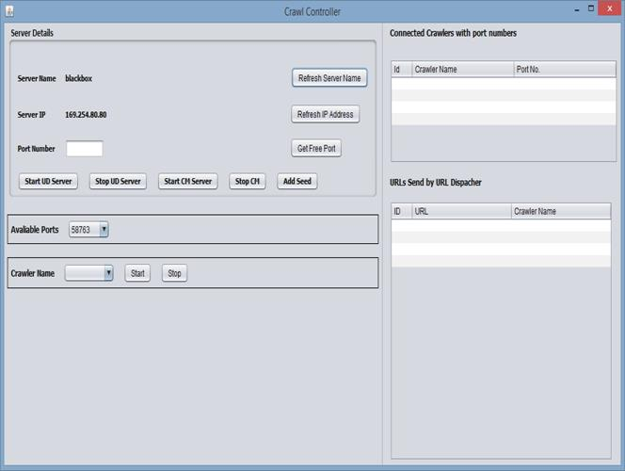
图三
抓取控制器伪代码
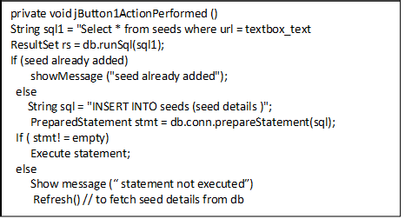
图四
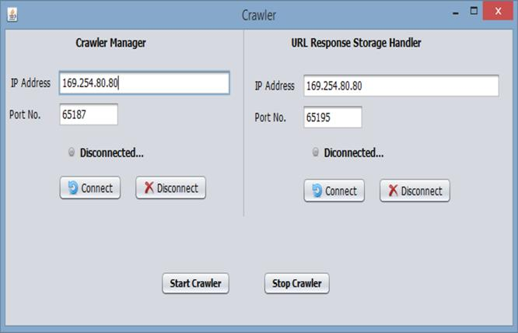

图五
B:爬虫
爬行器客户机连接到爬行启动的管理服务器并获取已经完成了的模型。
C:页面分析器
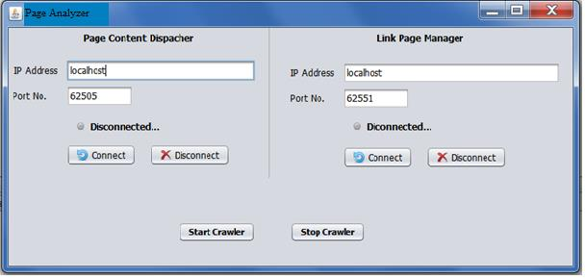

图七
页面分析器充当两个页面内容的客户机，它调度程序和链接页面管理器。它提取超链接RDF或HTML页面，并提取模型，即主题来自给定页面的谓词和对象。提取来自HTML PA的超链接使用JSoup API，查看HREF标记并提取链接。提取超链接RDF和OWL PA使用JENA API。
模型提取伪代码
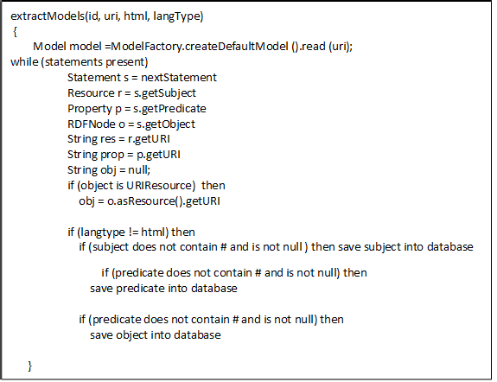
链接页面锚文本上下文提取
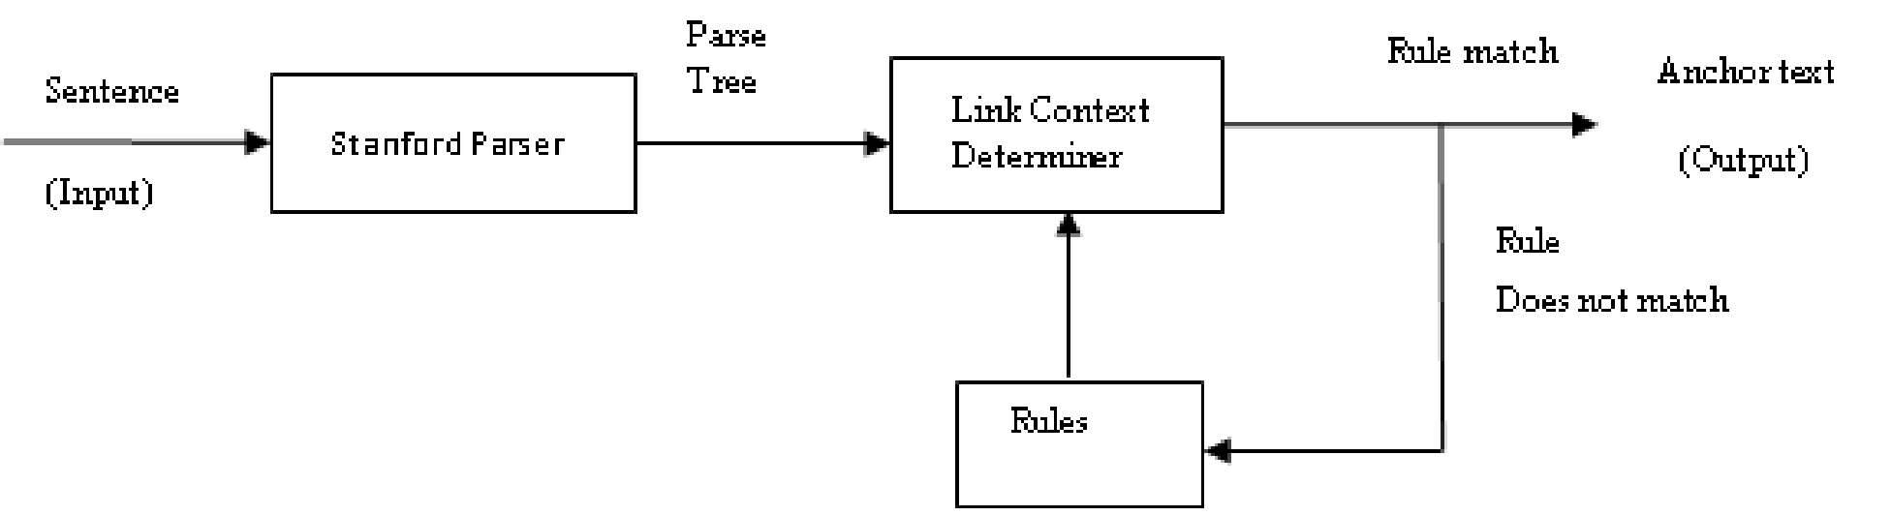
对于链接上下文提取，我们使用了给出的技术由美国[5]。页面中的所有链接和页面内容都是
给SPLCA。这个SPLCA的输出被赋给链接页面管理器。
D:分析页面内容供应器
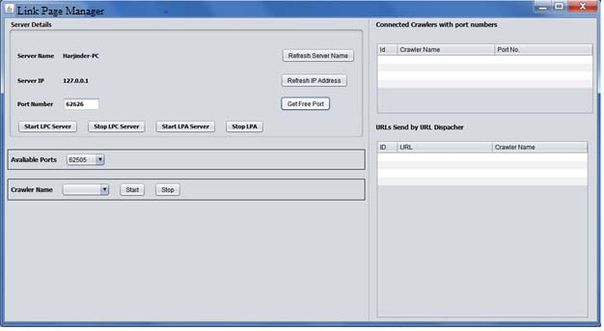

链接页面管理器存储URL或过滤URL都准备好了。这个控制器的工作是只从多个PAs获取数据并过滤URL并将它们存储到数据库中，PA充当客户机，LPM充当客户机服务器。

六、结论与未来展望
在我们分布式语义网页爬虫中，我们设计并实现了一种分布式网络爬行方案，这是能够从传统的爬行页面以及语义网页中爬行。我们尝试通过使用分布式计算架构来让我们的体系结构更加健壮和可靠。我们使用了一个SPLCA方案，这对我们的爬虫获取更多相关信息很有帮助。我们还是用了Jean框架以便RDF/OWL编写的页面能够很容易被我们的系统处理，这个系统可以稍后用于实现基于本体的爬行。在这篇论文中我们已经使用锚文本的链接上下文实现了分布式语义网页爬行。在未来的工作中，我们也将基于这个爬行原型进一步增强了该体系结构。

参考文献：
[1] Slug:语义网爬虫Leigh Dodds, leigh@ldodds.com，
2006年2月
[2] T. Berners-Lee, J. Hendler和O. Lassila。语义网。
《科学美国人》，284(5):34-43,2001。
[3]]。Suresh Kumar, Naresh Kumar, Manjeet Singh, Asok De De A Rule-
基于锚文本的链接上下文提取方法
《结构智能信息学》第182卷系列的研究进展
《智能系统与计算》第261-271页。
[4]。Naresh Kumar, Manjeet Singh“域名独立命名实体”
基于有限状态自动机的识别系统
2013 -8月刊第77-87页。
基于斯坦福解析器的方法
从非描述性锚文本“978-1-”中提取链接上下文
IEEE探索可靠性，Infocom技术
和优化(ICRITO)(趋势和未来方向)，2014年。
以本体论为中心的网路爬行
在ACM应用计算研讨会(SAC 2003)上，
墨尔本,2003。
[7] M. Ehrig, A. Maedche, S. Handschuh, L. Stojanovic, R. Volz，
“基于本体的web文档和基于rdf的元数据的爬行，”
在2002国际语义网会议(ISWC 2002)上，撒丁岛，
2002.
“专注于ALVIS语义搜索引擎的爬行”，in
第二届欧洲语义网会议(ESWC 2005)， Heraklion, 2005。
[9] Anthoniraj Amalanathan, Senthilnathan Muthukumaravel "语义
基于词法数据库的网络爬虫
2012年4月，第2卷第4期，第819-823页
[10]李丁，潘蓉，蒂姆·菲宁，阿努帕姆·乔希，云鹏，普拉纳姆
Kolari“在语义Web上查找和排序知识”

第四届国际语义网会议论文集，高威IE，
2005年11月,气象出版社。
[11] multirawler:用于爬行和索引的流水线架构
语义Web数据
Andreas Harth, Ju¨rgen Umbrich和Stefan Decker
[12] G.S. Tomar, S. Verma & Ashish Jha;“网页分类
"， IEEE TENCON-2006, pp 1-4，
2006年11月14日至17日
[13] Gautam Pant“从HTML标签树派生链接上下文”
DMKD03:第八届ACM SIGMOD数据研究研讨会
《挖掘与知识发现》，2003年。

关于复杂智能软件密集型系统国际会议

微搜索：一个简单的网页搜索引擎
Andri Mirzal：毕业于日本北海道大学信息科学技术研究生学院
北领地西北9号，札幌060-0814
andri@complex.eng.hokudai.ac.jp

摘要
我们描述了一种使用python语言来获取网页内容的搜索引擎。选择python的原因是因为它语法简单明了容易学习 和调试，并且它还有一个有特点是几乎支持所有的操作系统。这个程序的显著特点是它是可调式的，允许用户使用若干组合函数对文档进行排序，在锚文本分析的基础上我们提供了4种额外的计算比分。我们还提供了一个额外的基于链路添加过程的网络算法排名，我们提供合格这个算法的的动机是把页面排序和点击作为一个实验。这个算法是这个本文论述的核心。

许多论文都是作为网页信息展示在网上的便于利用检索和利用自己的网络爬虫来抓取内容，包括索引和分析内容，超链接文本，和网络结构的网页，有时也使用搜索函数来返回已经排好序的相关网页便于用户查询。爬虫和搜索功能都被认为是一个搜索引擎的基本组成部分，他们中的每一个都有自己研究挑战和问题。
网络爬虫，也被称为蜘蛛或机器人，是负责获取页面，解析链接，管理爬取队列和索引页面内容的组件。在更复杂的情况下，这个组件还实现了智能策略如：遵守robots.txt指令，不重新下载具有重复的页面以及使用锚点标识了的垃圾邮件内容或具有不同的url但相似的内容。这些策略可以让爬虫避免下载上面描述的不友好的内容，
因此网络宽带和访问资源的过程都能够得到妥善处理。真正运行的爬虫像Mercator,Poly,UbiCrawler,Goolebot,iRobot和IRLbot都显然比这里描述的更复杂。尽管他们中的一些人提供了很好的文件设计并实现了，但是这些信息对可重复生产而言太笼统了没有什么可能行。
对于第二个组件的搜索功能也是一样。从基本从基本得到的搜索功能开始，内容基于只索引和搜索布尔值的分数页面内容与查询内容之间的匹配。更进一步对链接方法进行分析比如PageRank,HITS 和SalSA,然后延伸到更高级的方法，比如锚文本分析和用户点击行为。尽管这些方法都只是关于如何去发现相关网页并根据查询，算法的实际实现，数据库设计，优化问题和内存管理已经变得过于复杂，难以处理。这种情况变得更加困难，事实上网络引擎在大型企业中很有竞争性，所以设计实现真正的web引擎任然存在问题。处在这个公开源代码的时代真的是一件令人失望的事情，软件应该成为教学人类的工具和无限制第传播知识。当然我们可以找到大量的可以在网页中自由构建我们自己系统的代码。实际上，这种努力可以变得更容易，因为在这个领域工作中，已经有很好的开源项目了。一些值得注意的项目是Lemur1和Lucene2.但是由于他们复杂的设计和实现，这些项目仍然不是很好的起点。
这就是开源搜索引擎中项目强调代码和设计需要易于理解的重要性。因为如果学习是简单和有趣的，这个复杂的细节可以稍后介绍。相比较于以前已经做了的，我们想取=去研究一些新的东西，比如实施新的排序算法，在页面上做词干分析内容和超文本链接，并使用新的方法来进行锚文本分析。所有这些都要求我没改变现有的代码并向其添加新函数或模块代码。为了能够提供满足上述条件的软件，我们建议使用Toby Segaren在书中提到过的搜索引擎即编程集体智慧。这个程序，是用Python编写的.
Python是一个免费的开源脚本，它是最近非常流行的语言，它的语法和语义简单，支持的库非常全面，对主要的操作系统都有强大爬虫的支持。这个程序本身包含三个类，爬虫搜索引擎和神经网络。我只会使用，改进和添加新的功能来爬取和搜索，因为我们只对建立搜索引擎抓取网页和提供搜索功能给用户，不训练这些来自用户返回的数据（这需要用户日志数据集）。对那些对神经网络感兴趣的用户而言，建议直接看参数书籍[6]或Bawza-Yates et等人的论文[19]，他们使用搜索日志信息对那些分类 用户进行调查。

系统概述
系统顶层设计图如下：
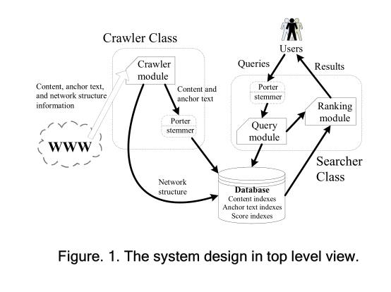

图1显示i了系统的总设计，该设计主要继承了它的原始结构，图2描述了url队列管理爬虫程序从RAM列表中下载url，解析页面上的超链接，并将其发送到磁盘。如果url是惟一的，那么它们将被添加到url列表然后被发送到url队列RAM中。下面的图描述了对原系统的修改。
URLs队列管理
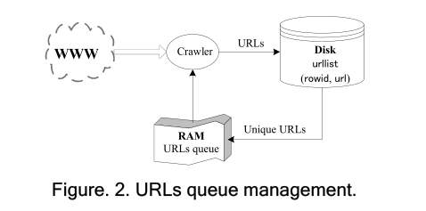

2.1提高爬虫的可靠性
在原始代码中，爬虫程序将尝试打开用户提供的URL列表(python集)中的url.
如果失败，爬虫程序将从下一个URL开始。但是问题是即使URL可以打开，但它并不意味着内容可以被阅读。进一步,如果内容可以被读取，有时是索引器爬虫类中的函可能无法输入索引进入数据库中相应的表中(参见图3)，很多情况下，这些错误会导致程序停止工作，这是非常不方便的，因为在网上数据挖掘的能力，继续爬行的过程忽略不可读的页面是一种不可或缺的品质。try-except语句用于打开和读取url，和索引过程，其中包括内容，锚文本和网络结构索引(参见图3)。有了这种简单的方法，我们就可以连续三天没有停止和下载爬取页面74,243页(243mb)，摘自6月份的《学术百科全书4》2008年采用英特尔1.86 GHz处理器笔记本，2GB内存，100 Mbps(下载度:53 Mbps)上传速度:5.5 Mbps)互联网连接。与原系统相比，在爬取的过程中在哪出错就会在哪停止，这是一个很大的进步。我们还根据英语标准停顿字5添加了停止词来减少数据库的存储大小。但是“计算机”一词被列表中删除了，因为我们相信这个词在搜索目的上是有意义的。

2.2添加词干分析功能
我们还通过使用porter为两个类的stemmer算法6[20]添加词干分析函数。抑制是一个将词形变化或派生的词还原为它们的过程茎。阻塞过程经常会改进一个红外系统的性能，因为文字具有同一茎通常有相似的意思。阀杆本身不需要与它的形态相同，但一个好的词干分析算法应该返回应该返回词干相同的词表示词干相同的词形态根。例如“navigational”,“navigation”和“navigate”都有词根“navigate”。如果使用porter stemer ,那么将返回navig这些词而不是navigate. 如图1所示，词干分析函数位于内容和锚文本输入数据库爬虫类和查询进入searcher类中的查询模块之前。这个过程将确保单词列表中的所有单词是否以stem形式保存，以及查询中的所有术语将以stem形式输入查询模块。有一件重要的事要记住，如果爬行进程是在阻塞函数存在的情况下完成的激活，搜索过程也必须用正在激活阻塞函数。

2.3添加新的score函数
我们加入了一些标准的原程序中没有的分数函数。第一个函数是使用Okapi bm25的bm25score()算法[21]，一个计算查询项在页面中出现的频率假设每一项都是独立的。第二个函数是calculatelength()以urlid为主键的pagelength表页的长度作为返回值。这个函数根据较长的且比矮的分数高的页面的页面长度进行评分。计算页面长度的表并返回长度分数的函数时lengthscore()函数。注意，这个函数不仅返回在查询中包术语的页面，但也包含那些由包含其中的术语的锚文本链接查询。我们使用这种方法是因为锚文本是被证明是一个很好的页面内容指示器并表现为一个“一致标题”[18]。第三个函数是calculatehits()权威和枢纽得分的每一页基于查询独立点击[22 pp. 124-126]，一种算法计算全局权限和中心向量轻微减少了垃圾链接的影响。

