Compare with nplcm using Kenya site data

WBPCR is not used.

TPR & FPR are not stratified.

No regression on FPR.

1. Multinomial non-regression model with 32 candidate pathogens.

|  |  |  |  |  |  |  |  |
| --- | --- | --- | --- | --- | --- | --- | --- |
| Eti.Name | pEti | Eti.Name | pEti | Eti.Name | pEti | Eti.Name | pEti |
| RSV | 0.3491 | PARA_3 | 0.0330 | ADENO | 0.0064 | ENTRB | 0.0017 |
| RHINO | 0.1528 | NoA | 0.0261 | PARA_2 | 0.0058 | CMV | 0.0015 |
| HMPV_A_B | 0.1016 | PARA_1 | 0.0261 | FUNGI | 0.0052 | COR | 0.0014 |
| PNEU | 0.0754 | FLU_A | 0.0220 | MCAT | 0.0040 | NMEN | 0.0013 |
| PV_EV | 0.0370 | PCP | 0.0211 | OTHSTR | 0.0039 | HBOV | 0.0011 |
| HINF | 0.0368 | PARA_4 | 0.0202 | M_PNEU | 0.0033 | FLU_C | 0.0007 |
| TB | 0.0331 | SAUR | 0.0140 | NFGNR | 0.0032 | C_PNEU | 0.0006 |
| PARA_3 | 0.0330 | FLU_B | 0.0087 | SASP | 0.0025 | BOPE | 0.0005 |

1. Top 5 singleton causes and NoA

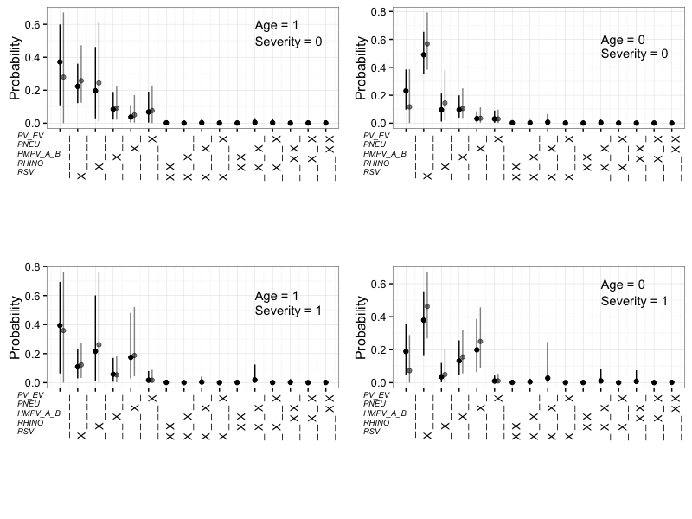

1. Top 5 singleton causes with pairs and NoA

