TOPO_fat_k8_100G_OS2_LOAD_40_FC_Lossless
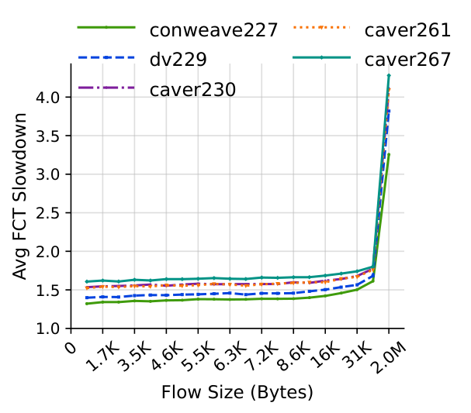 | 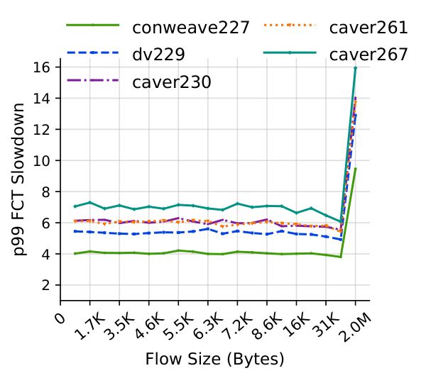

TOPO_fat_k8_100G_OS2_LOAD_60_FC_Lossless
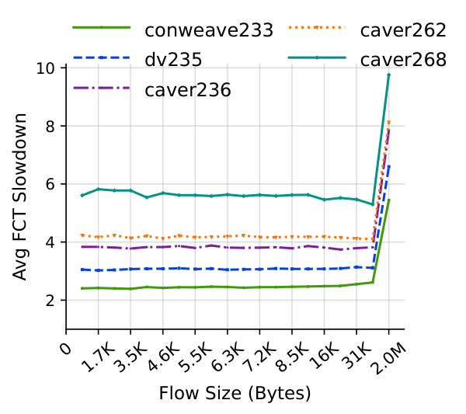 | 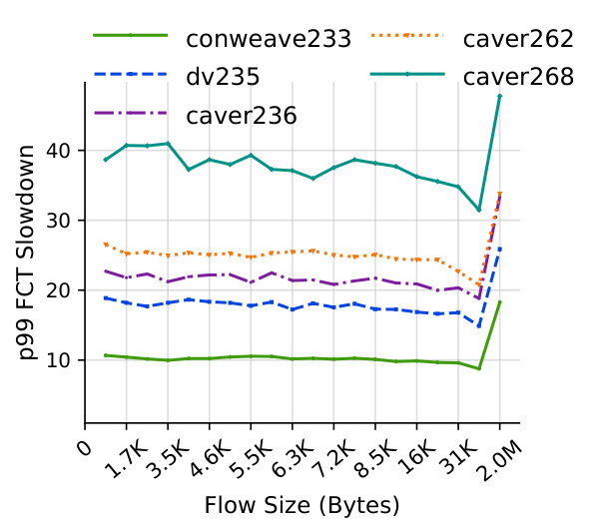

TOPO_fat_k8_100G_OS2_LOAD_80_FC_Lossless
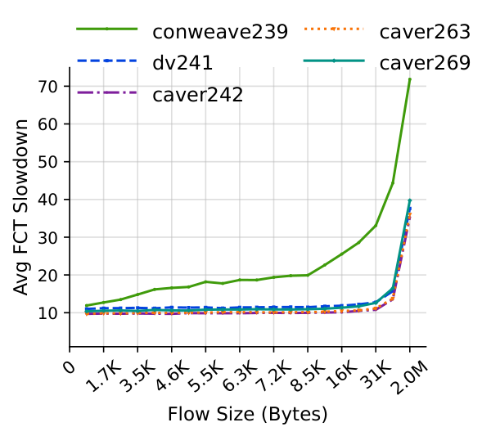 | 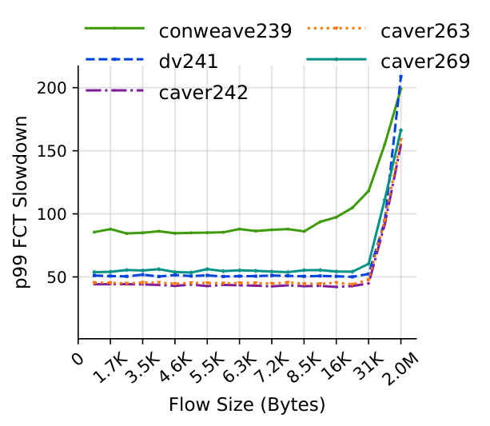

TOPO_leaf_spine_128_100G_OS2_LOAD_40_FC_Lossless
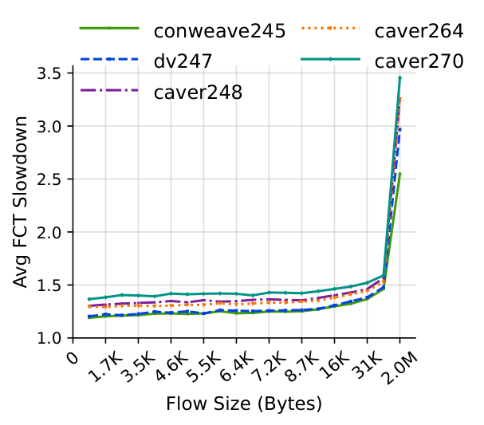 | 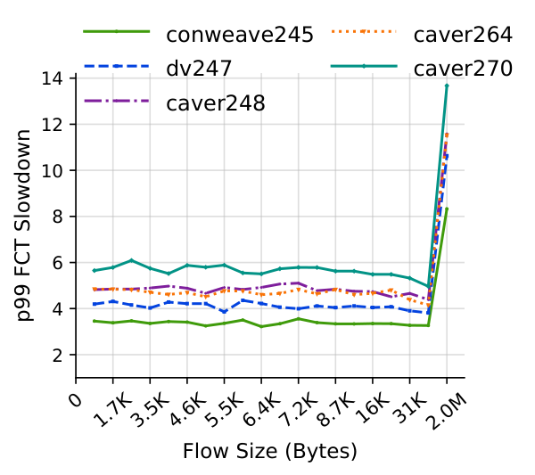

TOPO_leaf_spine_128_100G_OS2_LOAD_60_FC_Lossless
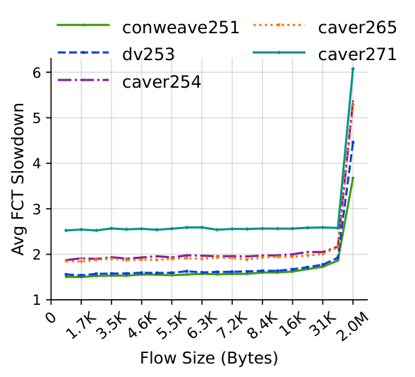 | 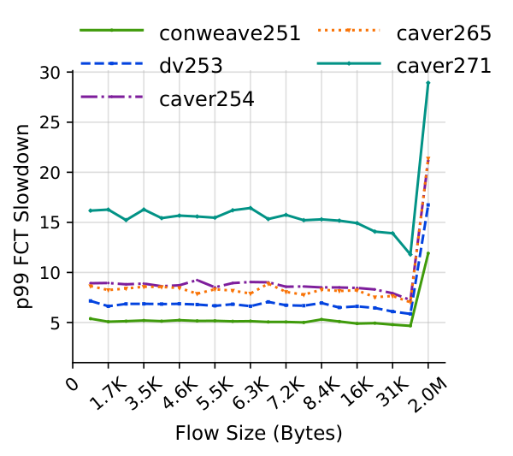

TOPO_leaf_spine_128_100G_OS2_LOAD_80_FC_Lossless
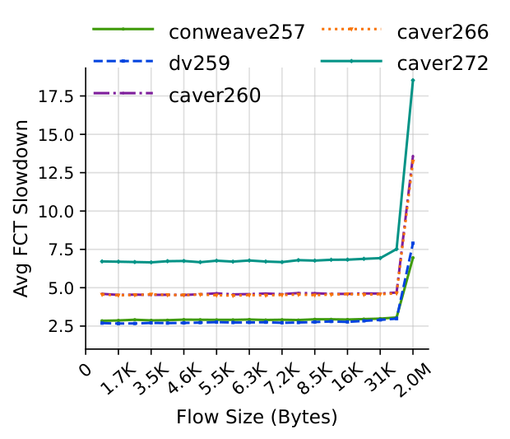 | 