/*
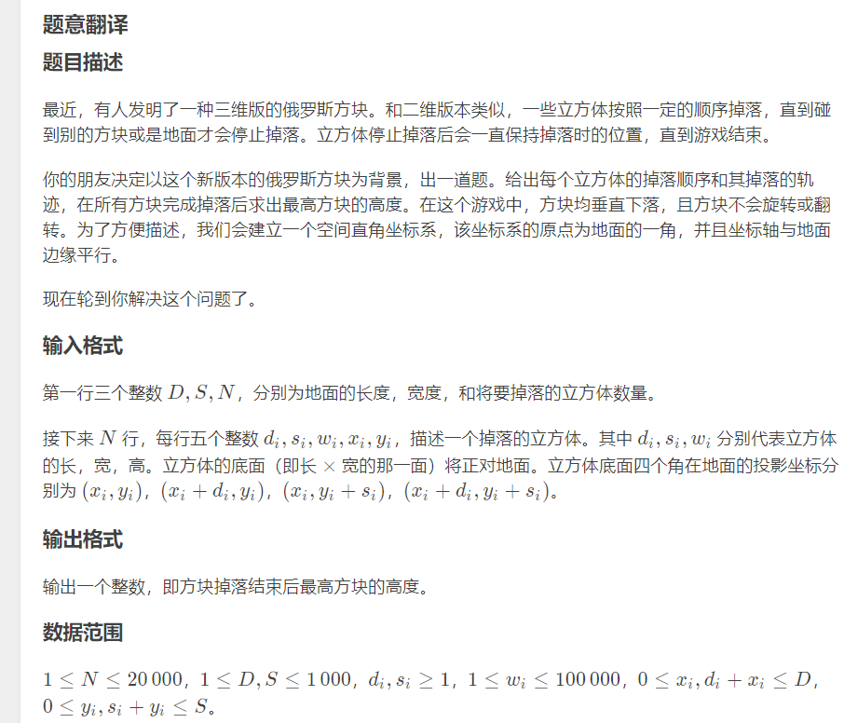
*/
#include <iostream>
#include <cmath>
#include <cstring>
#include <cstdio>
using namespace std;

#define getchar() (p1==p2&&(p2=(p1=buf)+fread(buf,1,1<<21,stdin),p1==p2)?EOF:*p1++)
char buf[1 << 21], *p1 = buf, *p2 = buf;

inline int qread() {
register char c = getchar();
register int x = 0, f = 1;
while (c < '0' || c > '9') {
if (c == '-') f = -1;
c = getchar();
}
while (c >= '0' && c <= '9') {
x = (x << 3) + (x << 1) + c - 48;
c = getchar();
}
return x * f;
}

inline int Abs(const int& x) {return (x > 0 ? x : -x);}
inline int Max(const int& x, const int& y) {return (x > y ? x : y);}
inline int Min(const int& x, const int& y) {return (x < y ? x : y);}

int d, s, n;

struct Segy {
int tag[3505], val[3505];
inline void Modify(int p, int pl, int pr, int l, int r, int v) {
val[p] = Max(val[p], v);
if (pl == l && pr == r) {
tag[p] = Max(tag[p], v);
return;
}
register int mid = pl + pr >> 1;
if (mid >= r) Modify(p << 1, pl, mid, l, r, v);
else if (mid + 1 <= l) Modify(p << 1 | 1, mid + 1, pr, l, r, v);
else {
Modify(p << 1, pl, mid, l, mid, v);
Modify(p << 1 | 1, mid + 1, pr, mid + 1, r, v);
}
}
inline int Query(int p, int pl, int pr, int l, int r) {
if (pl == l && pr == r) return val[p];
register int mid = pl + pr >> 1;
if (mid >= r) return Max(Query(p << 1, pl, mid, l, r), tag[p]);
else if (mid + 1 <= l) return Max(Query(p << 1 | 1, mid + 1, pr, l, r), tag[p]);
else return Max(Max(Query(p << 1, pl, mid, l, mid), Query(p << 1 | 1, mid + 1, pr, mid + 1, r)), tag[p]);
}
};
struct Segx {
Segy tag[3505], val[3505];
inline void Modify(int p, int pl, int pr, int l, int r, int _y0, int _y1, int v) {
val[p].Modify(1, 1, s, _y0, _y1, v);
if (pl == l && pr == r) {
tag[p].Modify(1, 1, s, _y0, _y1, v);
return;
}
register int mid = pl + pr >> 1;
if (mid >= r) Modify(p << 1, pl, mid, l, r, _y0, _y1, v);
else if (mid + 1 <= l) Modify(p << 1 | 1, mid + 1, pr, l, r, _y0, _y1, v);
else {
Modify(p << 1, pl, mid, l, mid, _y0, _y1, v);
Modify(p << 1 | 1, mid + 1, pr, mid + 1, r, _y0, _y1, v);
}
}
inline int Query(int p, int pl, int pr, int l, int r, int _y0, int _y1) {
if (pl == l && pr == r) return val[p].Query(1, 1, s, _y0, _y1);
register int mid = pl + pr >> 1, tmpv = tag[p].Query(1, 1, s, _y0, _y1);
if (mid >= r) return Max(tmpv, Query(p << 1, pl, mid, l, r, _y0, _y1));
else if (mid + 1 <= l) return Max(tmpv, Query(p << 1 | 1, mid + 1, pr, l, r, _y0, _y1));
else return Max(Max(Query(p << 1, pl, mid, l, mid, _y0, _y1), Query(p << 1 | 1, mid + 1, pr, mid + 1, r, _y0, _y1)), tmpv);
}
};

Segx sgt;

inline void Solve() {
d = qread(); s = qread(); n = qread();
while (n--) {
register int _d = qread(), _s = qread(), _w = qread(), _x = qread(), _y = qread();
register int val = sgt.Query(1, 1, d, _x + 1, _x + _d, _y + 1, _y + _s);
sgt.Modify(1, 1, d, _x + 1, _x + _d, _y + 1, _y + _s, val + _w);
}
printf("%d", sgt.Query(1, 1, d, 1, d, 1, s));
}

int main() {
Solve();
#ifndef ONLINE_JUDGE
while (1);
#endif
return 0;
}

