Data Modeling Report

ERD ViewDataModeling

Version 1.0 ● Proposed
 | Date/Time Generated: | 2015/4/13 22:58:39
 | Author: | Breeze

EA Repository : D:\Study\上师大研究生\研一\OOAD\homework\EA\XSAPP.eap
CREATED WITH | 

Table of Contents

1 ERD ViewDataModeling 4
1.1 ERD ViewDataModeling diagram 4
1.2 Browse 4
1.3 Collect 5
1.4 Delete 5
1.5 Evaluate 6
1.6 Publish 6
1.7 Table1 6
1.8 文章 7
1.9 期刊 7
1.10 编辑 8
1.11 读者 8

ERD ViewDataModeling
Package in package 'ERD View'

ERD ViewDataModeling
Version 1.0 Phase 1.0 Proposed
Breeze created on 2015/4/13. Last modified 2015/4/13
Alias

ERD ViewDataModeling diagram
Class diagram in package 'ERD ViewDataModeling'

ERD ViewDataModeling
Version 1.0
Breeze created on 2015/4/13. Last modified 2015/4/13

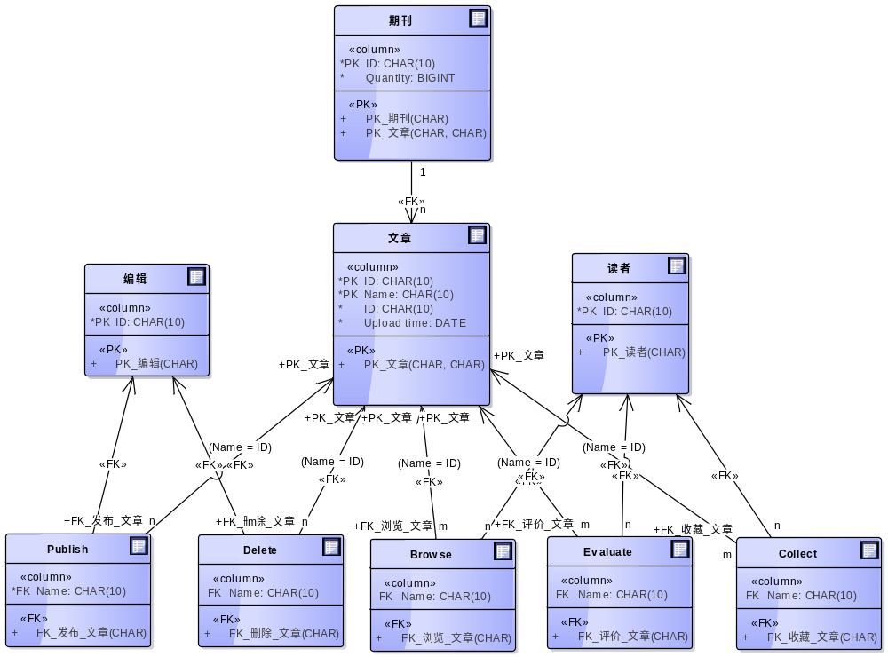

- ERD ViewDataModeling

Browse
Database table in package 'ERD ViewDataModeling'

Browse
Version 1.0 Phase 1.0 Proposed
Breeze created on 2015/4/13. Last modified 2015/4/13
DBMS MySql

COLUMN NAME | DATATYPE | NOT NULL | COMMENTS
Name | CHAR(10) | False

FOREIGN KEY NAME | COLUMNS | REFERENCES
FK_浏览_文章 | Name | 文章(ID)
 |  | 读者()

Collect
Database table in package 'ERD ViewDataModeling'

Collect
Version 1.0 Phase 1.0 Proposed
Breeze created on 2015/4/13. Last modified 2015/4/13
DBMS MySql

COLUMN NAME | DATATYPE | NOT NULL | COMMENTS
Name | CHAR(10) | False

FOREIGN KEY NAME | COLUMNS | REFERENCES
 |  | 读者()
FK_收藏_文章 | Name | 文章(ID)

Delete
Database table in package 'ERD ViewDataModeling'

Delete
Version 1.0 Phase 1.0 Proposed
Breeze created on 2015/4/13. Last modified 2015/4/13
DBMS MySql

COLUMN NAME | DATATYPE | NOT NULL | COMMENTS
Name | CHAR(10) | False

FOREIGN KEY NAME | COLUMNS | REFERENCES
 |  | 编辑()
FK_删除_文章 | Name | 文章(ID)

Evaluate
Database table in package 'ERD ViewDataModeling'

Evaluate
Version 1.0 Phase 1.0 Proposed
Breeze created on 2015/4/13. Last modified 2015/4/13
DBMS MySql

COLUMN NAME | DATATYPE | NOT NULL | COMMENTS
Name | CHAR(10) | False

FOREIGN KEY NAME | COLUMNS | REFERENCES
 |  | 读者()
FK_评价_文章 | Name | 文章(ID)

Publish
Database table in package 'ERD ViewDataModeling'

Publish
Version 1.0 Phase 1.0 Proposed
Breeze created on 2015/4/13. Last modified 2015/4/13
DBMS MySql

COLUMN NAME | DATATYPE | NOT NULL | COMMENTS
Name | CHAR(10) | True

FOREIGN KEY NAME | COLUMNS | REFERENCES
FK_发布_文章 | Name | 文章(ID)
 |  | 编辑()

Table1
Database table in package 'ERD ViewDataModeling'

Table1
Version 1.0 Phase 1.0 Proposed
Breeze created on 2015/4/13. Last modified 2015/4/13
DBMS MySql

文章
Database table in package 'ERD ViewDataModeling'

文章
Version 1.0 Phase 1.0 Proposed
Breeze created on 2015/4/13. Last modified 2015/4/13
DBMS MySql

COLUMN NAME | DATATYPE | NOT NULL | COMMENTS
ID | CHAR(10) | True
Name | CHAR(10) | True
ID | CHAR(10) | True
Upload time | DATE | True

PRIMARY KEY NAME | COLUMNS | COMMENTS
PK_文章 | ID, Name

期刊
Database table in package 'ERD ViewDataModeling'

期刊
Version 1.0 Phase 1.0 Proposed
Breeze created on 2015/4/13. Last modified 2015/4/13
DBMS MySql

COLUMN NAME | DATATYPE | NOT NULL | COMMENTS
ID | CHAR(10) | True
Quantity | BIGINT | True

PRIMARY KEY NAME | COLUMNS | COMMENTS
PK_期刊 | ID
PK_文章 | ID, Name

FOREIGN KEY NAME | COLUMNS | REFERENCES
 |  | Table1()
 |  | 文章()

编辑
Database table in package 'ERD ViewDataModeling'

编辑
Version 1.0 Phase 1.0 Proposed
Breeze created on 2015/4/13. Last modified 2015/4/13
DBMS MySql

COLUMN NAME | DATATYPE | NOT NULL | COMMENTS
ID | CHAR(10) | True

PRIMARY KEY NAME | COLUMNS | COMMENTS
PK_编辑 | ID

读者
Database table in package 'ERD ViewDataModeling'

读者
Version 1.0 Phase 1.0 Proposed
Breeze created on 2015/4/13. Last modified 2015/4/13
DBMS MySql

COLUMN NAME | DATATYPE | NOT NULL | COMMENTS
ID | CHAR(10) | True

PRIMARY KEY NAME | COLUMNS | COMMENTS
PK_读者 | ID

