**Logistic Regression Quiz:**

1. What is the *relationship* between linearand logistic regression?

Linear regression is a regression technique, while the logistic regression is a classification method. Both have input variables that have any measurement level.

1. In what sense is the term “logistic regression” *misleading*?

Because it is not a regression, but a classification method.

1. Consider the *sigmoid* (or *logistic function*) σ(z) = $\frac{1}{1+e^{-z}}$:
2. What is the domain of σ?

All real numbers. Increasing either from 0 to 1 or -1 to 1.

1. What is the range of σ?

Infinite

1. Show that $\frac{1}{1+e^{-z}}$ = $\frac{e^{z}}{1+e^{z}}$.

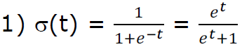

Voila!

1. Show that $1-(z)$ = $\frac{e^{-z}}{1+e^{-z}}$.

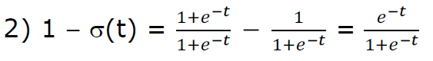

1. Compute $\frac{(z)}{1-(z)}$.

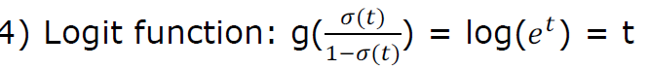

So, according to the Logit Function, then g(t).