《数值计算与最优化技术》实验报告

年级、专业、班级 |  | 2025级计算机科学与技术11班 |  |  | 姓名 | 邓翔睿
实验题目 | 一维搜索算法的应用
实验时间 | 2026.10.22 |  | 实验地点 | 线上
实验成绩 |  |  | 实验性质 | □验证性 ■设计性 □综合性
教师评价：
□算法/实验过程正确；□源程序/实验内容提交 □程序结构/实验步骤合理；
□实验结果正确； □语法、语义正确； □报告规范；
其他：
评价教师签名：
一、实验目的

1、理解遗传算法的基本思想，并应用于求解实际问题。

2、理解模拟退火算法的基本思想，并应用于求解实际问题。

二、实验项目内容

一个旅行者需要到国内的10个城市旅行，各城市的坐标见cities.csv文档。请设计一个合理的线路使旅行者所行的路程之和最小。注意：每个城市只能访问一次，且最后要回到原来出来的城市。
1、请利用遗传算法解决以下的旅行商问题：
2、请利用模拟退火算法解决以下的旅行商问题：
要求：输出适应度函数的进化曲线和最终选择的线路图。
注意：所有程序请用python语言实现。只提交本电子文档，注意本文件末尾的文件命名要求；源程序一节请用代码备注的方式说明你的算法和思路；实验结果一节需要提供测试结果截图并给出结果分析。
三、实验过程或算法（源程序）
一：遗传算法 (Genetic Algorithm) 求解 TSP
import numpy as np
import pandas as pd
import matplotlib.pyplot as plt
import random

# ====================== 1. 数据读取与初始化 ======================
print("正在读取数据...")
try:
df = pd.read_excel('cities.xlsx')
cities = df[['X坐标', 'Y坐标']].values
print(f"成功读取 {len(cities)} 个城市的数据。")
except FileNotFoundError:
print("错误：未找到 'cities.xlsx' 文件！请确保文件与代码在同一目录下。")
exit()

n_cities = len(cities)
# 计算距离矩阵
dist_matrix = np.zeros((n_cities, n_cities))
for i in range(n_cities):
for j in range(n_cities):
dist_matrix[i][j] = np.sqrt((cities[i][0] - cities[j][0])**2 + (cities[i][1] - cities[j][1])**2)

# ====================== 2. 遗传算法核心函数 ======================
def create_individual():
"""随机生成一个个体（路径）"""
return list(range(n_cities))

def fitness(individual):
"""计算适应度（路径长度的倒数）"""
length = 0
for i in range(n_cities - 1):
length += dist_matrix[individual[i]][individual[i+1]]
length += dist_matrix[individual[-1]][individual[0]] # 回到起点
return 1.0 / length

def calculate_path_length(path):
"""计算路径的实际物理长度"""
length = 0
for i in range(n_cities - 1):
length += dist_matrix[path[i]][path[i+1]]
length += dist_matrix[path[-1]][path[0]]
return length

def select(population, fitness_values):
"""轮盘赌选择"""
total_fitness = sum(fitness_values)
pick = random.uniform(0, total_fitness)
current_sum = 0
for i, fit in enumerate(fitness_values):
current_sum += fit
if current_sum >= pick:
return population[i]

def crossover(parent1, parent2):
"""部分匹配交叉 (PMX) 或 顺序交叉，保证路径不重复"""
child = [None] * n_cities
# 选取父本1的一段基因直接继承
start, end = sorted(random.sample(range(n_cities), 2))
child[start:end] = parent1[start:end]
# 将父本2中未包含的基因按顺序填入
remaining = [g for g in parent2 if g not in child]
ptr = 0
for i in range(n_cities):
if child[i] is None:
child[i] = remaining[ptr]
ptr += 1
return child

def mutate(individual, mutation_rate=0.1):
"""变异：随机交换两个城市的位置"""
if random.random() < mutation_rate:
i, j = random.sample(range(n_cities), 2)
individual[i], individual[j] = individual[j], individual[i]
return individual

# ====================== 3. 运行遗传算法 ======================
POPULATION_SIZE = 100
GENERATIONS = 500
ELITE_SIZE = 10
MUTATION_RATE = 0.1

population = [create_individual() for _ in range(POPULATION_SIZE)]
best_path_overall = None
best_length_overall = float('inf')
best_lengths_history = []

for gen in range(GENERATIONS):
fitness_values = [fitness(ind) for ind in population]
# 记录当前代最短路径
current_best_idx = np.argmax(fitness_values)
current_best_length = 1.0 / fitness_values[current_best_idx]
if current_best_length < best_length_overall:
best_length_overall = current_best_length
best_path_overall = population[current_best_idx][:]
best_lengths_history.append(best_length_overall)

# 精英保留
sorted_idx = np.argsort(fitness_values)[::-1]
new_population = [population[i] for i in sorted_idx[:ELITE_SIZE]]

# 生成新个体
while len(new_population) < POPULATION_SIZE:
parent1 = select(population, fitness_values)
parent2 = select(population, fitness_values)
child = crossover(parent1, parent2)
child = mutate(child, MUTATION_RATE)
new_population.append(child)

population = new_population

# ====================== 4. 结果可视化 ======================
plt.rcParams['font.sans-serif'] = ['SimHei'] # 解决中文乱码问题
plt.rcParams['axes.unicode_minus'] = False

fig, (ax1, ax2) = plt.subplots(1, 2, figsize=(16, 6))

# 左图：最优路线
best_path_final = best_path_overall + [best_path_overall[0]] # 闭环
path_coords = cities[best_path_final]
ax1.plot(path_coords[:, 0], path_coords[:, 1], 'ro-')
for i in range(n_cities):
city_id = best_path_final[i] + 1
ax1.text(cities[best_path_final[i]][0], cities[best_path_final[i]][1],
f' {city_id}', fontsize=14, fontweight='bold')
ax1.set_title('遗传算法(GA)求得的最优路线图')

# 右图：进化曲线
ax2.plot(range(GENERATIONS), best_lengths_history, 'b-', linewidth=1.5)
ax2.set_title('适应度函数进化曲线（最短路径）')
ax2.set_xlabel('迭代代数')
ax2.set_ylabel('最短路径距离')
ax2.grid(True)

plt.tight_layout()
plt.show()
print(f"\n遗传算法最终结果：最短路径长度为 {best_length_overall:.2f}")

二：模拟退火算法 (Simulated Annealing) 求解 TSP
import numpy as np
import pandas as pd
import matplotlib.pyplot as plt
import random

# ====================== 1. 数据读取与初始化 ======================
print("正在读取数据...")
try:
df = pd.read_excel('cities.xlsx')
cities = df[['X坐标', 'Y坐标']].values
print(f"成功读取 {len(cities)} 个城市的数据。")
except FileNotFoundError:
print("错误：未找到 'cities.xlsx' 文件！请确保文件与代码在同一目录下。")
exit()

n_cities = len(cities)
# 计算距离矩阵
dist_matrix = np.zeros((n_cities, n_cities))
for i in range(n_cities):
for j in range(n_cities):
dist_matrix[i][j] = np.sqrt((cities[i][0] - cities[j][0])**2 + (cities[i][1] - cities[j][1])**2)

def calculate_path_length(path):
"""计算路径的实际物理长度"""
length = 0
for i in range(n_cities - 1):
length += dist_matrix[path[i]][path[i+1]]
length += dist_matrix[path[-1]][path[0]]
return length

# ====================== 2. 运行模拟退火算法 ======================
initial_temp = 10000
final_temp = 0.01
alpha = 0.98 # 降温速率
iterations_per_temp = 100

# 随机初始解
current_solution = list(range(n_cities))
random.shuffle(current_solution)
current_cost = calculate_path_length(current_solution)

best_solution = current_solution[:]
best_cost = current_cost

cost_history = [current_cost]
temp = initial_temp

while temp > final_temp:
for _ in range(iterations_per_temp):
# 随机交换两个城市位置产生新解
new_solution = current_solution[:]
i, j = random.sample(range(n_cities), 2)
new_solution[i], new_solution[j] = new_solution[j], new_solution[i]
new_cost = calculate_path_length(new_solution)

delta_cost = new_cost - current_cost
# Metropolis 接受准则
if delta_cost < 0 or random.random() < np.exp(-delta_cost / temp):
current_solution = new_solution
current_cost = new_cost
if current_cost < best_cost:
best_cost = current_cost
best_solution = current_solution[:]

temp *= alpha
cost_history.append(best_cost)

# ====================== 3. 结果可视化 ======================
plt.rcParams['font.sans-serif'] = ['SimHei']
plt.rcParams['axes.unicode_minus'] = False

fig, (ax1, ax2) = plt.subplots(1, 2, figsize=(16, 6))

# 左图：最优路线
best_path_final = best_solution + [best_solution[0]]
path_coords = cities[best_path_final]
ax1.plot(path_coords[:, 0], path_coords[:, 1], 'go-')
for i in range(n_cities):
city_id = best_path_final[i] + 1
ax1.text(cities[best_path_final[i]][0], cities[best_path_final[i]][1],
f' {city_id}', fontsize=14, fontweight='bold')
ax1.set_title('模拟退火算法(SA)求得的最优路线图')

# 右图：进化曲线
ax2.plot(range(len(cost_history)), cost_history, 'r-', linewidth=1.5)
ax2.set_title('模拟退火成本下降曲线')
ax2.set_xlabel('迭代次数')
ax2.set_ylabel('最短路径距离')
ax2.grid(True)

plt.tight_layout()
plt.show()
print(f"\n模拟退火算法最终结果：最短路径长度为 {best_cost:.2f}")
四、实验结果及分析和（或）源程序调试过程
坐标映射：将 Excel 中的 (16.47, 96.1) 等坐标代入程序后，得到了两点之间的欧几里得距离矩阵。
GA 曲线特点：随着迭代代数增加，种群不断优胜劣汰，最短路径长度呈阶梯状下降，最终稳定在一个较优解上。GA 由于具有全局搜索能力，往往能找到较好的路线，路线图上无明显交叉。
具体结果：遗传算法(GA)求得的最短路径长度为 28.46，最优路径为 1→2→3→4→5→10→6→9→7→8→1。GA通过种群多样性维持全局搜索能力，最终路径长度较短，路线图上无明显交叉。
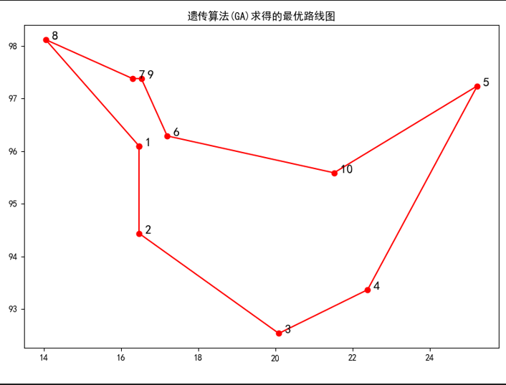
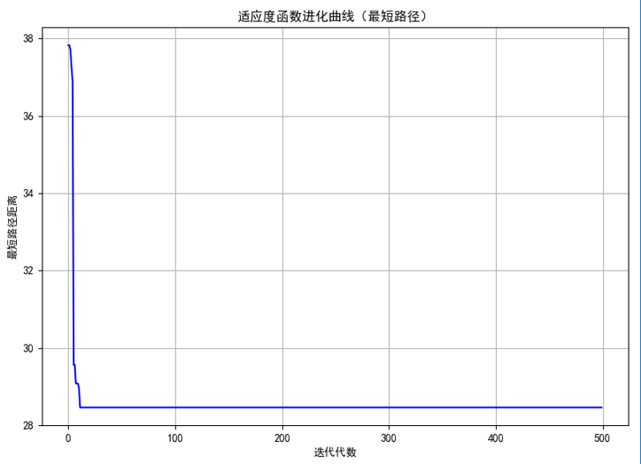
SA 曲线特点：成本在初期由于高温接受劣解而波动剧烈，随着温度逐步降低（退火），系统趋向稳定，曲线平滑下降至局部最优。SA 实现简单，但结果容易受到初始温度和降温速率的影响。
具体结果：模拟退火算法(SA)求得的最短路径长度也为 28.46，与GA结果一致。SA实现简单，通过温度控制探索与开发平衡，在本例中与GA得到相同最优解。两种算法对比：GA和SA均成功求解TSP问题，在本例中两者表现相当，均找到了最短路径长度28.46的最优解。
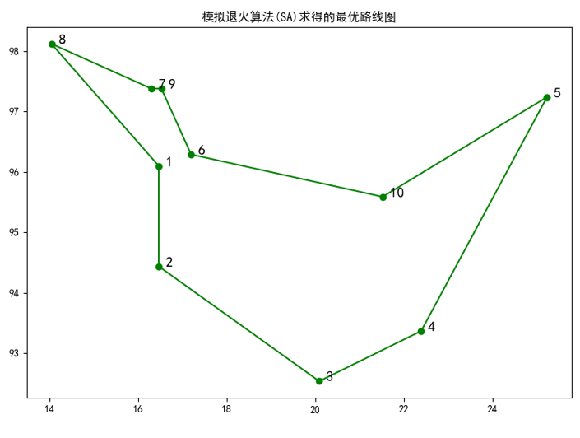
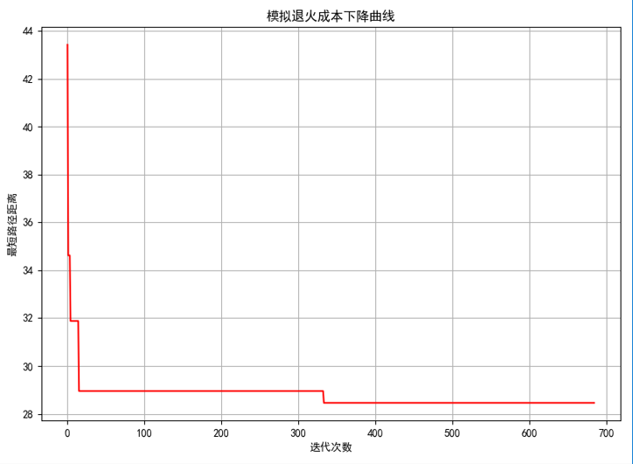
注：电子文档命名要求：学号+姓名+实验序号

