XIAO DENG

télécom Paristech

juin 2016

USER GUIDE

(graphic interface part)

# Introduction

To propose architectures for connected objects and show that they work well, the group has developed an ‘Internet of things’ (IoT) simulation environment using Specification and Description Language (SDL). Because SDL allows to model precisely software architectures. But in the beginning, to interact with the SDL server, we have to use command lines. For example, enter command ‘Create_AE()’ in the server terminal then reading system output to analyze the process, which is absolutely inconvenient and accessible only by people who knows well programing.

To accelerate the process of development and to make it more user-friendly, we developed a Graphical User Interface (GUI). This GUI aims at allowing users to interact with the SDL server by graphic interface instead of command lines: send commands to server according to users’ operations, analyze server’s output and present results graphically.

This GUI contains 1 web page, and it works on Chrome or Firefox. In this documentation, you will know how this interface looks like, all its functions and how to use it.

# Basic conceptions

In this simulation environment of IoT, there are **objects** which are connected to each other by some **rules**.

## Object and object class (node)

An **object** may be an electric appliance like a heater or a sensor, in the GUI, it is represented by a **node**.

To make adding nodes easier, we introduced the concept of **node class**. It’s like a template, users could create a node from a node class by providing only a node name and device state. Other fields will be copied from the node class.

## Rule (edge)

A rule is the connection between several objects. It’s represented graphically by **edges**, arrows from all sensors to all effectors. **Sensor** signifies the condition (like if) and **effector** represents the action (like then).

## Environment

In this simulation system, users could define some environment variables, like temperature. Objects could include them as variables.

## User/ Authentication

User is authenticated by his login username. To create connection to WAMP router, user must log in first. We offer the possibility of registering.

Since now we defined 2 different kinds of users: administrator (username is “admin”) and other users. Consequently, there exists 2 different user interfaces.

## Session

A session includes all object, object class, rule, environment data (data.txt), as well as history of commands sent to SDL server(cmds.txt), correspondences between nodes’ IDs (graph) and PIDs (SDL server). User could save a session, new a session or reload a session.

# How to run

* Open the terminal, go to the directory …/PRIM
* Run command ‘crossbar start’
* Open a browser, go to ‘localhost:8080’

# Graphic interface

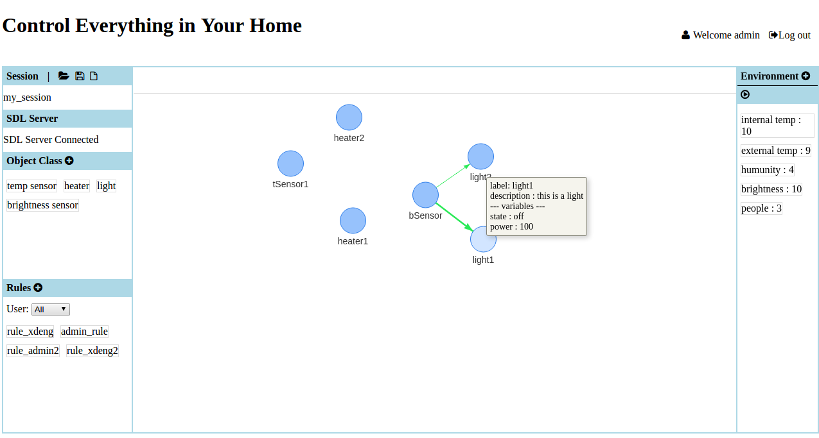

*Figure 1. Administrator view*

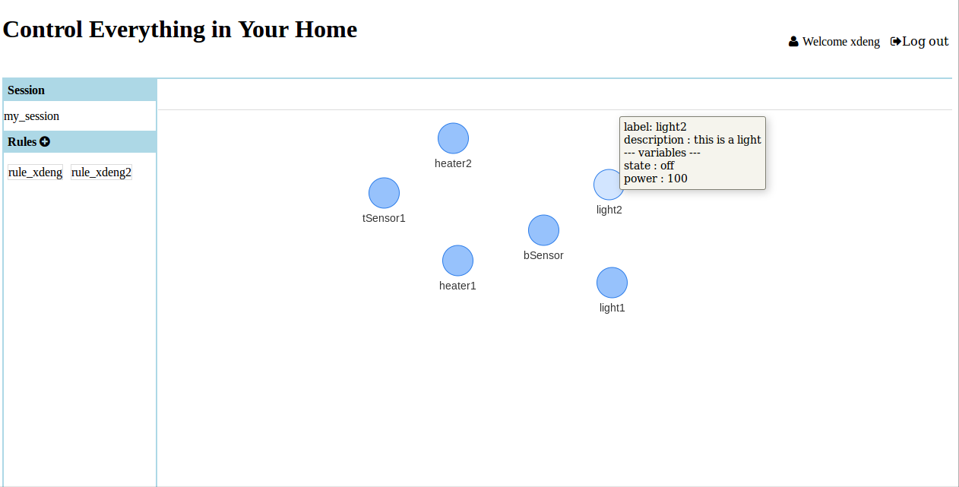

*Figure 2. Other users’ view*

The page can be divided into 3 parts: left menu, middle block and right menu.(Figure 1)

In the right top, user could log in sign up. A welcome message and log out button show when user logs in successfully.

In the left menu, there are 4 sub menus.

* **Session**

Show the current session name.

Open, Save and New a session: click 1 of 3 icons.

*The default session name is ‘untitled’. Every time when you open or new a session, a popup will appear to ask you whether you want to save current session or not.

* **SDL server**

Message showing whether this web application is connected to SDL server or not. If not, a button appears.

* **Object class**

Here lists all created node classes.

Add node class: click the “plus” icon.

Edit node class: double click target class node.

Delete node class: double click target class node, then click ‘delete’ button.

Add node: click a node class.

* **Rule**

Here lists all created rules. The user drop list is used to filter rules, only rules created by selected users are shown.

Add rule: click “plus” icon => choose at least 1 sensor and 1 effector, click ‘done’ => set conditions (blue variables are environment variables) and actions, click ‘save’.

Edit rule: double click target rule.

Delete rule: double click target rule then click ‘delete’ button.

Show edges: click target rule to show its edges. Click anywhere blank in the graph to hide them.

For users except administrator, only ‘Rules’ submenu is shown. And user could only see the rules created by himself.

In the middle block, a graph shows all nodes with name below. Note that all edges are hidden unless clicking a rule.

Delete node: select one or several nodes, then click ‘Delete Selected’ in the top.

Edit node: double click a node.

See node information: hover over a node.

Only administrator can delete or edit nodes.

In the right menu, lists all environment variables.

Add variable: click ‘plus’ icon.

Edit variable: double click target variable.

Delete variable: double click target variable then click ‘delete’ button.

Run simulation: click ‘play’ icon.

Variables with ‘Evolution’ checked will evolve according to program setting. A progress bar will appear in the place of ‘play’ icon, and change of variables values will be shown.

This menu is hidden for users except administrator.

# Other information

* All the popups (except login) could be submitted by entering key ‘Enter’, and they are all draggable.
* Synchronization

The view is synchronized for browsers by MVC mode, including nodes, node positions and sessions. Certain menus are shown only to administrator, and other users could see only rules and corresponding edges defined by himself.

In addition, the object class list, rule list and environment variable list (in the right menu and some popups) are all synchronized.

* All current session data is stored in local text files in the folder /tmp. They will be created automatically if not exist. Files corresponding to sessions are stored in separate folders in /tmp/saveSessions. So it’s possible to reload a session after restarting the crossbar.io server or refresh the web page.

**Note that when you restart your computer, all data in /tmp will be lost.**

* By default, administrator is the user whose name is “admin”, so sign up by using this username to create an administrator.