使用Sepcam_ipc_api获取海思VI数据方法
(v1.02)

sepcam_ipc_init 初始化SDK 2
VI数据获取接口 3
VI数据释放接口 4
ipcam_sys_mmap和ipcam_sys_munmap 5
STREAM_FRAME_INFO_t 6
VI_FRAME_INFO_t 7
VI_FRAME_t 8
H264E_NALU_TYPE_E 10
H265E_NALU_TYPE_E 11

sepcam_ipc_init 初始化SDK
使用Sepcam_ipc_api前需要先调用sepcam_ipc_init进行初始化

VI数据获取接口
int ipcam_get_viframe(
STREAM_FRAME_INFO_t *frameinfo,
char *buffer,
unsigned int bufflen,
int *getframeIndex
);

参数说明：
Frameinfo：帖参考信息，详见STREAM_FRAME_INFO_t
Buffer： 获取数据的缓冲，由调用都提供buffer，ipcam_get_viframe接口获取到的数据内容是VI内存信息——VI_FRAME_INFO_t，此内存信息是海思提供, 详见VI_FRAME_INFO_t
Bufflen： Buffer的长度
getframeIndex： 对应获取到的buffer在内存中的序号，序号范围是0~127。正常情况是累增的，如果出现跳跃，则说明有丢帧的情况

VI数据释放接口
int ipcam_free_viframe(char *buffer);

ipcam_sys_mmap和ipcam_sys_munmap
ipcam_get_viframe获得到的是VI数据海思内存池的信息，并不是内存数据，要使用数据需要调用ipcam_sys_mmap进行内存映射，使用完后需调用ipcam_sys_munmap进行释放

STREAM_FRAME_INFO_t
typedef struct
{
uint16_t vench; //流数据通道号
uint16_t payload; //负载: 96:H.264, 265:H.265
uint16_t frame_type; //帧类型, 分别参考H264E_NALU_TYPE_E和H265E_NALU_TYPE_E
uint16_t frame_no; //帧序号
uint32_t frame_size; //帧长
uint32_t reserve;
uint64_t timestamp; //时间戳, 毫秒单位
}STREAM_FRAME_INFO_t;

VI_FRAME_INFO_t
typedef struct
{
VI_FRAME_t stVFrame; //参考VI_FRAME_t
uint32_t u32PoolId;
} VI_FRAME_INFO_t;

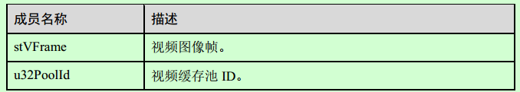

VI_FRAME_t

typedef struct
{
uint32_t u32Width;
uint32_t u32Height;
uint32_t u32Field;
uint32_t enPixelFormat;

uint32_t enVideoFormat;
uint32_t enCompressMode;

uint32_t u32PhyAddr[3];
void* pVirAddr[3];
uint32_t u32Stride[3];

uint32_t u32HeaderPhyAddr[3];
void* pHeaderVirAddr[3];
uint32_t u32HeaderStride[3];

int16_t s16OffsetTop; /* top offset of show area */
int16_t s16OffsetBottom; /* bottom offset of show area */
int16_t s16OffsetLeft; /* left offset of show area */
int16_t s16OffsetRight; /* right offset of show area */

uint64_t u64pts;
uint32_t u32TimeRef;

uint32_t u32PrivateData;
VIDEO_SUPPLEMENT_t stSupplement;

} VI_FRAME_t;

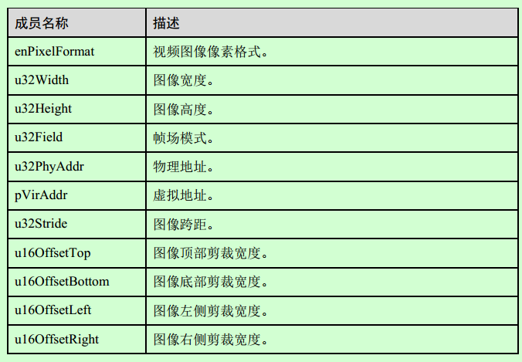
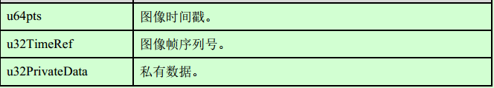

H264E_NALU_TYPE_E
typedef enum
{
H264E_NALU_PSLICE = 1, /*PSLICE types*/
H264E_NALU_ISLICE = 5, /*ISLICE types*/
H264E_NALU_SEI = 6, /*SEI types*/
H264E_NALU_SPS = 7, /*SPS types*/
H264E_NALU_PPS = 8, /*PPS types*/
H264E_NALU_IPSLICE = 9,
H264E_NALU_BUTT
} H264E_NALU_TYPE_E;

H265E_NALU_TYPE_E
typedef enum
{
H265E_NALU_PSLICE = 1, /*P SLICE types*/
H265E_NALU_ISLICE = 19, /*I SLICE types*/
H265E_NALU_VPS = 32, /*VPS types*/
H265E_NALU_SPS = 33, /*SPS types*/
H265E_NALU_PPS = 34, /*PPS types*/
H265E_NALU_SEI = 39, /*SEI types*/
H265E_NALU_BUTT
} H265E_NALU_TYPE_E;

